Umatilla River Anadromous Fish Habitat Project

Annual Report

January 1, 2018 – December 31, 2018

BPA Project Number 1987-100-01
Contract Numbers 73982 REL 60
December 2019

Prepared by:
Richard L. Christian

Confederated Tribes Umatilla Indian Reservation
Department Natural Resources Fish and Wildlife Programs
Nixyaawii Governance Center
46411 Timíne Way
Pendleton, Oregon 97801

Reporting Period:
January 1, 2018 to December 31, 2018

Prepared for:
U.S. Department of Energy
Bonneville Power Administration
Division of Fish and Wildlife
P.O. Box 3621
Portland, Oregon 97208-3621

Suggested Citation:
Christian, Richard L. 2019. The Umatilla Anadromous Fish Habitat Project: 2018 Annual Report. Confederated Tribes of the Umatilla Indian Reservation, report submitted to Bonneville Power Administration, Project No. 1987-100-01.

This report was funded by the Bonneville Power Administration (BPA), U.S. Department of Energy, as part of BPA's program to protect, mitigate, and enhance fish and wildlife affected by the development and operation of hydroelectric facilities on the Columbia River and its tributaries. The views in this report are the author's and do not necessarily represent the views of BPA.

ACRONYMS
BA biological assessment
B&G Bauer & Gustafson
BDSS beaver dam support structure
BIA Bureau of Indian Affairs
BPA Bonneville Power Administration
cfs cubic feet per second
COTR Contracting Officer Technical Representative
CREP Conservation Reserve Enhancement Program
CTUIR Confederated Tribes of the Umatilla Indian Reservation
cy Cubic Yards
dbh diameter at breast height
EPA United States Environmental Protection Agency
ESA Federal Endangered Species Act
ft foot/feet
FY fiscal year
in inch/inches
JPA Joint Permit Application
km kilometer/kilometers
LWD large woody debris
m meters
mi mile/miles
MOA Memorandum of Agreement
NOAA National Oceanic and Atmospheric Administration
NMFS National Marine Fisheries Service
NPPC Northwest Power Planning Council
NPCC Northwest Power and Conservation Council
NRCS Natural Resource Conservation Service
ODA Oregon Department of Agriculture
ODEQ Oregon Department of Environmental Quality
ODFW Oregon Department of Fish and Wildlife
ODSL Oregon Department of State Lands
OWEB Oregon Watershed Enhancement Board
OWRD Oregon Water Resources Department
PCSRF Pacific Coastal Salmon Recovery Fund
RM river mile
SOW Statement of Work
SE Standard error
TMDL total maximum daily load
UBAFHP Umatilla Basin Anadromous Fisheries Habitat Project
UBNPME Umatilla Basin Natural Production Monitoring and Evaluation Project
UBWC Umatilla Basin Watershed Council
USDA-FS United States Department of Agriculture Forest Service
USFWS United States Fish and Wildlife Service
USGS United States Geological Survey
UPRR Union Pacific Railroad

TABLE OF CONTENTS
LIST OF FIGURES i
LIST OF TABLES ii
INTRODUCTION 1
Project Area 5
COMPLETED WORK 8
Contract 73982 REL 13 (CY 2017) 8
Contract 73982 REL 33 (CY 2018) 23
Discussion 44
LESSONS LEARNED AND ADAPTIVE MANAGEMENT 46
Lessons Learned 46
Adaptive Management 47
SUMMARY AND CONCLUSIONS 49
LITERATURE CITED 55
APPENDIX A: USE OF DATA AND PRODUCTS 64
APPENDIX B: LIST OF METRICS AND INDICATORS 65

LIST OF FIGURES
Figure 1. Umatilla River Subbasin 6
Figure 2. Umatilla River Basin FY 2017-18 UBAFHP Project Sites 7
Figure 3. CTUIR semi-annual report for the Umatilla Subbasin Fish Habitat Restoration Project, January – June, 2017. 12
Figure 4. UBAFHP outreach and education activities. Clockwise from top left: Whitman College service learning field trip searching for weeds in Meacham Creek; CRITFC Salmon Camp attendees learning about noxious weeds and salmon habitat; UBAFHP summer intern observing a recreational rock dam, a potential summer fish passage barrier, prior to obliteration; UBAFHP staff assisting local elementary school students plant native plants at the annual Watershed Field Days. 13
Figure 5. Before (2011) and after (2017) photos of the Meacham Creek Floodplain Restoration and In-stream Enhancement Project RM 6-7 taken at photo point monitoring locations. 15
Figure 6. Proportion of vegetated bankfull channel length within the Meacham Creek Floodplain Restoration and In-stream Enhancement Phase I project area by year based on grid-intersect analysis of photo point data. 16
Figure 7. Maps of the Isquúlktpe Creek watershed, property ownership, and surveyed roads. 19
Figure 8. Drone imagery of the Dillon Dam Removal Project before (A), during (B), and after implementation (C). 21
Figure 9. CTUIR semi-annual report for the Umatilla Subbasin Fish Habitat Restoration Project, August – December, 2018. 27
Figure 10. UBAFHP outreach and education activities. Clockwise from top left: UBAFHP staff presenting to visiting scientists from the Geological Survey of Japan; CTUIR staff participating in the Outdoor School program; UBAFHP staff participating in an Oregon Lottery media shoot; UBAFHP staff assisting local elementary school students plant native plants at the annual Watershed Field Days. 28
Figure 11. Summary of vegetation statistics across the period of record from 2014 to 2018 within the Meacham Creek Floodplain Restoration and In-stream Enhancement project phases I & II. Clockwise from top left: A) Mean stem density per m² by year; B) mean species richness by year; C) mean Shannon-Wiener diversity index value by year; D) mean species evenness by year. Error bars represent standard error. 30
Figure 12. Before (2011) and after (2018) photos of the Meacham Creek Floodplain Restoration and In-stream Enhancement Project RM 6-7 taken at photo point monitoring locations. 32
Figure 13. Proportion of vegetated bankfull channel length within the Meacham Creek Floodplain Restoration and In-stream Enhancement Phase I project area by year based on grid-intersect analysis of photo point data. 33
Figure 14. Precast, prestressed concrete bridge deck planks delivered to Mission, OR, in December 2018. 34
Figure 15. Areas within the Meacham Creek Bonifer Reach Floodplain Reconnection and In-stream Enhancement Project where native vegetation was planted by UBAFHP staff. Background is drone orthography captured by the CTUIR post-implementation in September 2018. 36
Figure 16. UBAFHP staff planting wetland plants in the riparian area of the Meacham Creek Bonifer Reach Floodplain Reconnection and In-stream Enhancement Project. 37
Figure 17. CTUIR staff conducting total station surveys of the Taylor Diversion Dam to support BPA engineering staff in designing the removal of the dam. 39

LIST OF TABLES
Table 1. Summary of Implementation work accomplished in 2017-18. 3
Table 2. Major designs and project planning for the 2019 field season. 4
Table 3. Invasive weed species detected in Meacham Creek Floodplain Restoration and In-stream Enhancement Phase I and II planting areas in 2016 and relative priority for control efforts. 31
Table 4. Noxious weed treatments completed by location within the Umatilla River Basin, 2017. 41
Table 5. Noxious weed treatments completed by location within the Umatilla River Basin, 2018. 41
Table 6. Planting materials and grass seed by species, quantity, and size, planted and established at Umatilla River Basin existing and new project sites, 2017-18. 42
Table 7. Habitat passage structures monitored and maintained by CTUIR to meet design specifications. 44
Table 8. Meacham Creek Bonifer Reach implementation schedule. 44
Table 9. The Umatilla Anadromous Fish Habitat Project objectives relative to the Umatilla River Vision touchstones (Jones et al. 2008), BPA 2008 Fish Accords primary limiting factors (Fish Accords 2008) and NOAA’s ecological concerns (NMFS 2009). 45
Table 10. The CTUIR UBAFHP restoration project descriptions by location, treated primary limiting factors (NMFS 2009) by CTUIR River Vision touchstones (Jones et al. 2008) and accomplishments; 2007-2016. 51

INTRODUCTION

The CTUIR retain aboriginal and treaty rights related to fishing, hunting, pasturing of livestock, and gathering of traditional plants within the Umatilla River Subbasin. The CTUIR Department of Natural Resources (DNR) has developed and accepted a First Foods organization and approach to ecosystem management based on the cultural traditions and practices of the Longhouse. The organization follows the serving order of food and conceptually “Extends the Table” to manage for sustainability within the Umatilla River Subbasin. The First Foods are considered to be the minimum ecological products necessary to sustain CTUIR culture (Quaempts et al. 2018). The order is watershed-based beginning with water at the first and lowest point and progresses up to salmon, deer, cous, and huckleberry. This creates clear links to treaty rights and resources and sets direction and goals that relate to the community culture. In addition the DNR developed the Umatilla River Vision that provides a description of the processes and conditions needed to protect and provide for First Foods. The River Vision describes physical and biological processes in support of 5 touchstones; hydrology, geomorphology, connectivity, riparian vegetation, and aquatic biota. The work accomplished through this project is directly related to the First Foods of water and salmon and the 5 touchstones, which incorporates goals of restoring high water quality and healthy and sustainable salmonid fish populations.

CTUIR’s right to fish in its historical fishing places was acknowledged in the Treaty of 1855 that stated: “the exclusive right of taking fish in the streams running through and bordering said reservation is hereby secured to said Indians, and at all other usual and accustomed stations…” (Treaty of 1855, Articles of Agreement, Article 1, page 3). Decreased salmonid abundance has significantly impacted the livelihood of the Tribal community and altered their way of life.

Overfishing, sweeping changes to rivers and streams, and policies that changed the landscape have endangered salmon and created a “salmon crisis” (Montgomery 2003). It is the challenging duty of the CTUIR Umatilla Basin Anadromous Fisheries Habitat Project (UBAFHP) to restore and sustain healthy conditions of local watersheds to both assist in salmon recovery and ensure they provide adequate quantities of sustainable natural resources to satisfy the CTUIR’s needs and preserve opportunities for traditional ways of life.

As part of the Northwest Power Conservation Council’s Columbia Basin Fish and Wildlife Program, this project is one of Bonneville Power Administration’s (BPA) many efforts at off-site mitigation for damage to salmon and steelhead runs, their migration, and wildlife habitat caused by the construction and operation of FCRPS dams. The Umatilla Anadromous Fish Habitat Project (UBAFHP; #1987-100-01) initiated by CTUIR in 1987 is an integral component of the Umatilla River Subbasin Salmon and Steelhead Production Plan (NPPC 1990), and project work is supported both locally and regionally by multiple planning documents: Umatilla/Willow Subbasin Plan (NPCC 2005), Umatilla River Basin TMDL and Water Quality Management Plan (2001), CTUIR TMDL (2005), Umatilla River Vision (Jones et al. 2008; Existing Project Document ID: P130339), Conservation and Recovery Plan for Oregon Steelhead Populations in the Middle Columbia River Steelhead Distinct Population Segment (NMFS 2009), Recovery Plan for the Coterminous United States Population of Bull Trout (Salvelinus confluentus) (USFWS 2015), Meacham Creek Watershed Analysis and Action Plan (Andrus and Middel 2003), Umatilla and Meacham Watershed Assessment (UNF 2001), and the Birch Creek Watershed Action Plan (CTUIR 2016).

The Final Umatilla/Willow Subbasin Plan (NPCC 2005; Subbasin Plan) provided a systematic vision of a healthy ecosystem with abundant, productive, viable, and diverse populations of aquatic and terrestrial species with goals, objectives, and management strategies necessary to reach the subbasin vision. The vision entails several broad goals for habitat: 1) Protect existing high quality fish and wildlife habitat and strongholds, 2) restore and enhance degraded and diminished fish and wildlife habitats to support population restoration goals and to mitigate impacts from the construction and operation of the Columbia basin hydropower system and other anthropogenic impacts, and 3) restore the health and function of ecosystems in the Umatilla subbasin to ensure continued viability of their natural resources (Management Plan, page 5-3). Specific aquatic qualitative objectives and strategies were developed in to support the subbasin vision and goals. Quantitative management objectives relative to the UBAFHP work activities include 1) maintain and enhance natural production, productivity, abundance, life history characteristics and genetic diversity of fish and mussels throughout the Umatilla Subbasin using habitat protection and improvement and 2) maintain and enhance passage of adult and juvenile steelhead and Chinook throughout the Umatilla Subbasin with passage protection and restoration (Management Plan, page 5-5). The Umatilla Subbasin Plan (NPCC 2005) determined that the limiting factors could be addressed through habitat restoration and implementation (“Phase III”) of the Umatilla Basin Project (pages 5-10). An identification and analysis of limiting factors/conditions and priority areas for action are fully described within the Subbasin Plan (Section 3.5) including passage barriers/entrainment, in-channel characteristics, habitat diversity (LWD), floodplain confinement, high water temperatures, high turbidity, inadequate flows, and poor riparian/floodplain vegetation. Priority management strategies are being conducted by the UBAFHP in accordance with the Final Umatilla Willow Subbasin Plan (NPCC 2005; pages 5-8 & 5-9) to address limiting factors within the subbasin:
• Increase water conservation and irrigation efficiency
• Large Wood/Boulder Structure Placement
• Fence/Plant Riparian Zones
• Modify Channel Floodplain Function
• Construct Pool/Riffle – In-stream Modification
• Modify Detrimental Land use Activities
• Restore Upstream/Headwater Attributes to Improve Downstream Conditions
• Increase Passage Efficiency

The UBAFHP continues to protect, enhance, and restore functional floodplain, channel, and watershed processes to provide sustainable and healthy habitat for aquatic species in the Umatilla River Subbasin. Habitat restoration efforts fit within a holistic watershed approach supporting capacity building and long-term progress towards 1) achievement of the CTUIR DNR River Vision and First Foods mission statements, 2) Endangered Species Act delisting of Columbia River bull trout and middle Columbia River steelhead, and 3) addresses water quality limiting factors per the Clean Water Act 303d list.

During the 31-year project history, the CTUIR has helped administer and implement a number of fisheries habitat enhancement projects in the Umatilla River Subbasin. The CTUIR maintains partnership habitat enhancement projects along Meacham Creek, Isquúlktpe Creek, Birch Creek, Wildhorse Creek, East and West Birch Creek and the mainstem Umatilla River, among other sites. The CTUIR has developed effective interagency partnerships and is effectively working at the policy and project levels with various federal, state, and county agencies and private landowners.

The UBAFHP is an integral component of the Umatilla River Subbasin Salmon and Steelhead Production Plan (1990) and is well integrated into the framework of the Umatilla Subbasin Plan (NPCC 2005) established by the NPCC to better coordinate habitat restoration work in the Umatilla River Basin. The CTUIR, ODFW, Natural Resource Conservation Service (NRCS), Umatilla National Forest, Umatilla Basin Watershed Council (UBWC), and other participating agencies and organizations have made significant progress towards restoring and protecting vital salmonid habitat in the basin.

The major project accomplishments during the 2017-18 contract periods are described in Table 1 below. This only includes the major implementation activities. The planning and design related activities for future implementation projects are contained in Table 2.

Table 1. Summary of Implementation work accomplished in 2017-18.
Work Element | Location | Description
Conservation Agreements | Wildhorse Creek | Executed 2 new conservation agreements.
Conservation Agreements | Wildhorse, Birch, EFK Birch, WFK Birch, Cottonwood, & Umatilla River | Maintain current conservation agreement terms and conditions on 16 agreements, including maintaining fencing and watering plantings.
Weed Treatment | Meacham Creek | Controlled noxious weeds on 236 acres of conservation agreements and previously implemented habitat projects using chemical and mechanical treatments. Biological control treatments are ongoing.
Planting | Meacham Creek | 1,000 willow/dogwood cuttings were installed.
Planting | Meacham Creek | 9,209 containerized plants were installed.
Meacham Creek – Bonifer Project (Project Areas 3 & 4) | Meacham Creek | Removed 3,385 linear feet of levees and dikes, constructed 2,340 linear feet of stream channel to reconnect and additional 3,206 linear feet of relic channel, and installed 550 pieces of large wood (plus tops) individually and in 69 engineered log jams.
Dillon Dam Removal | Umatilla River | Collaborated with ODFW and the UBWC to remove Dillon Dam on the mainstem Umatilla River and develop and alternative water delivery system for water users.
Athena Fish Passage Mitigation | Wildhorse Creek | Purchased a prefabricated modular bridge to be installed at the crossing of 3rd Street and Wildhorse Creek in Athena, OR to rectify a major passage barrier. Contracted installation in 2019.

Table 2. Major designs and project planning for the 2019 field season.
Project | Description
Athena Fish Passage Mitigation | Completed an engineered design to remove a fish passage barrier and construct a roughened riffle passage channel through the project reach on Wildhorse Creek. Partnered with the UBWC and ODFW to produce designs for a prefabricated, modular concrete bridge structure to replace the current passage barrier.
East Birch Creek Floodplain Restoration and In-stream Enhancement Project | Began the design process to produce an engineered design for a floodplain reconnection and in-stream habitat enhancement project on East Birch Creek. Design anticipated to be completed in 2019 and implementation in 2020.
Taylor Dam Removal | Collaborated with BPA engineering staff to begin the process of producing an engineered design for removal of the defunct Taylor Dam on the mainstem Umatilla River. Design anticipated in early 2019 and implementation to take place during the 2019 in-water work window.
UmaBirch Conservation Easement | Collaborated with the landowner and began scoping and planning tasks to complete a conservation easement on the UmaBirch property. Conservation Easement anticipated to be completed in 2019.
Isquúlktpe Creek Road Impact Evaluation | Surveyed and inventoried roads in the Isquúlktpe Creek watershed.
Isquúlktpe Creek Road Relocation Project | Produced a design to relocate the Isquulktpe Creek Road away from the creek where it consistently washes out. Provided design to CTUIR Public Works for implementation.
Umatilla River Assessment | Began collecting existing data, identifying data gaps, and scoping the assessment within CTUIR. Assessment anticipated to be completed in 2020.
Wildhorse Creek Beaver Dam Support Structure Complex | Coordinated with the Umatilla County SWCD to design and begin permitting a beaver dam support structure (BDSS) pilot project on a recently acquired property on Wildhorse Creek. Implementation is anticipated in 2019.

Project results are reported in various BPA formats including Pisces status reports, project completion reports, and annual reports. The CTUIR maintains a complete database on project planning, proposals, permitting, implementation, and results through the completion of required project deliverables. For a complete list of reports submitted by the CTUIR’s UBAFHP since 1989, please consult the following website at URL: http://www.efw.bpa.gov/integratedfwp/reportcenter.aspx.

Project Area

The UBAFHP is defined by the boundaries of the Umatilla River Subbasin, which is located in the northwest portion of the Blue Mountain Ecological Province in northeast Oregon. The Umatilla River Subbasin comprises 1,465,600 acres of the 6,400,000 acres of ceded CTUIR land (CTUIR 1995) as identified by the Treaty of 1855. Figure 1 illustrates the vicinity of the Umatilla River Subbasin within the Blue Mountain Province (Project map: http://www.cbfish.org/Project.mvc/Map/1987-100-01). The Umatilla River drains an area of approximately 2,540 square miles (mi.²) (6,579 square kilometers [km²]) and flows approximately 89 mi. (143 km) from where it branches into the north and south forks of the Umatilla River to the mouth at the confluence with the Columbia River. Each fork adds another approximately 10 mi. (16 km) of length. The Umatilla River originates at elevations up to 4,228 feet (ft.; 1,289 m) and flows west and north to its confluence with the Columbia River (USFWS 2002) at an elevation of about 269 ft. (82 m).Other major tributaries include Meacham Creek, Birch Creek, McKay Creek, Butter Creek, and Wildhorse Creek.

The Umatilla River Subbasin historically supported viable and harvestable populations of spring/summer and fall Chinook salmon (Oncorhynchus tshawytscha), coho salmon (O. kisutch), sockeye salmon (O. nerka), summer steelhead (O. mykiss), Pacific lamprey (Entosphenus tridentatus), bull trout (Salvelinus confluentus), steelhead-rainbow trout (O. mykiss sp.), mountain whitefish (Prosopium williamsoni) and a variety of additional native species. Anthropomorphic alterations have negatively impacted the watershed and caused significant reductions of endemic salmonid populations. Beginning in the late 1800s, fish populations started to decline due to habitat degradation. In fact sockeye and coho were extirpated by the early 1900s. Irrigation and agricultural development throughout the basin in the early 1900s is believed to be the primary cause of the decline of steelhead and the extinction of salmon. Since the signing of the Treaty of 1855, aquatic and riparian habitats have been degraded through irrigation diversions, water extractions, channelization, livestock grazing, logging, agriculture and urban development (NPCC 2004). Subsequently, the abundance of Chinook, steelhead, bull trout, and other fish species has also been dramatically reduced. The Umatilla River population of spring Chinook salmon was reported extinct in 1926 (Boyce 1986). With declining fish populations, Tribal governments, federal, state and international agencies were obligated to eliminate or significantly reduce subsistence and sport fisheries by the mid-1970s. The Federal government listed Middle Columbia River summer steelhead and Columbia River bull trout in the Umatilla Subbasin as threatened species under the ESA in 2006 and 1999, respectively.

In the mid-1980s, a successful, hatchery-based salmonid reintroduction effort for the Umatilla River was instituted using neighboring strains of various salmonid species. Although hatchery programs currently support subsistence and restricted sport fishing opportunities for steelhead and Chinook and coho salmon, there remains significant need to re-build viable, harvestable, and sustainable naturally-produced fish stocks throughout the basin.
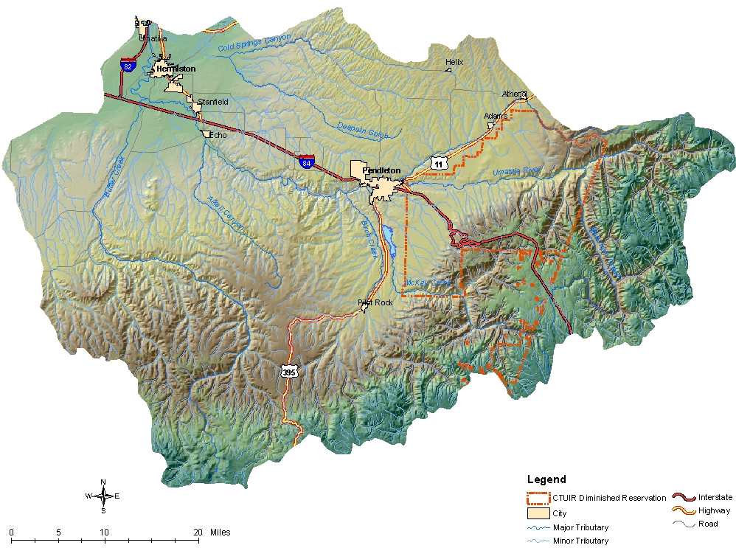
Figure 1. Umatilla River Subbasin

Our primary area of focus for restoration and monitoring work in FY 2017-18 was Meacham Creek, Birch Creek and mainstem Umatilla River (Figure 2).

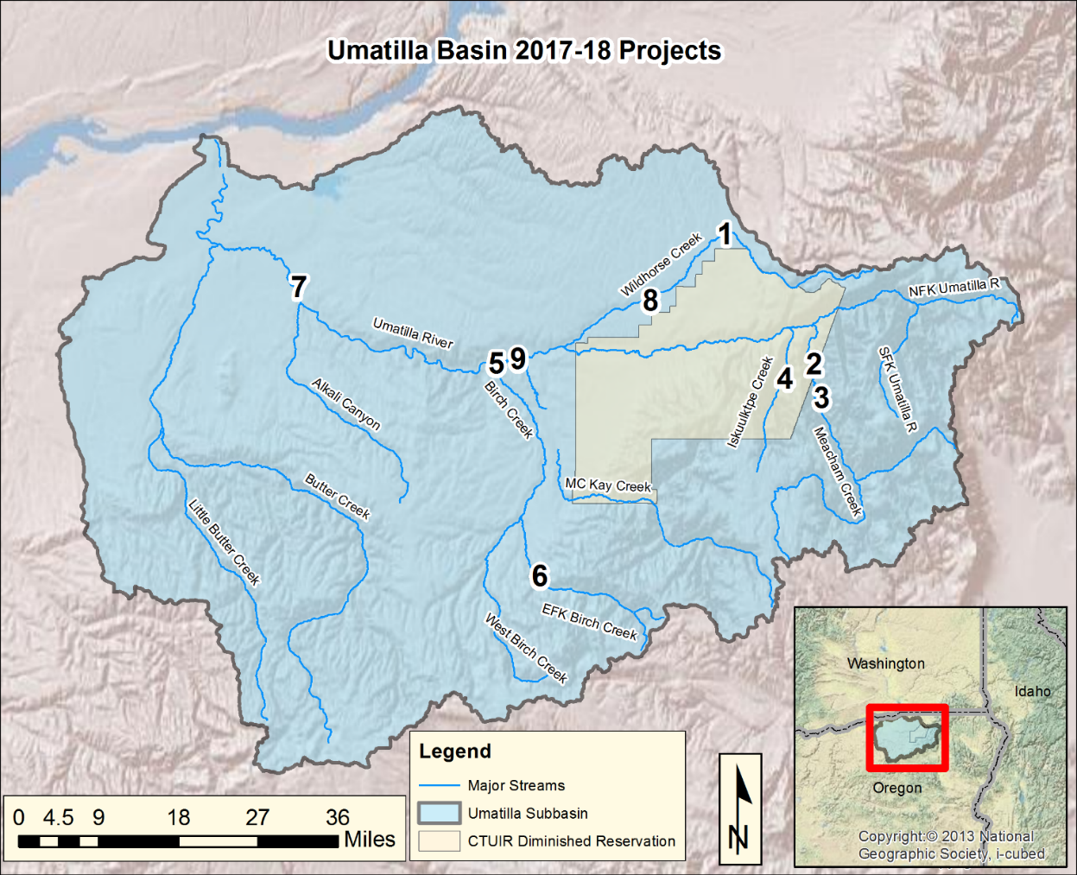

Figure 2. Umatilla River Basin FY 2017-18 UBAFHP Project Sites
1: Wildhorse Creek Fish Passage Rectification – 2017-18: Fish passage rectification and bridge replacement at 3rd Street crossing. | 2: Meacham Creek (Bonifer Reach) – 2017-18: Constructed nearly 2 miles of full floodplain restoration on Meacham Creek (Project Areas 3 and 4). | 3: Meacham Creek – 2017-18: Additional weed treatment, plantings as part of the 2011-13 Floodplain Restoration and In-stream Enhancement Project.
4: Isquúlktpe Creek Road Relocation Design and Transportation Network Survey - 2017: Designed a small road relocation and surveyed the existing transportation network in the watershed. | 5: UmaBirch Conservation Easement– 2017-18: Executed a Conservation Agreement and worked toward a conservation easement to protect over 300 acres of floodplain at the confluence of the Umatilla River and Birch Creek. Concurrently developing a restoration design. | 6: East Birch Creek Floodplain Restoration Design – 2017-18: Worked collaboratively with private landowner to execute a conservation agreement and design a floodplain restoration project on their property.
7: Dillon Dam Removal – 2017: Collaborated with partners to complete irrigation diversion change and complete full dam removal. | 8: Beaver Dam Support Structures – 2017-18: Designed a BDSS complex on Wildhorse Creek. | 9: Taylor Dam Removal Design – 2018: Worked collaboratively with BPA engineers to design removal of defunct Brown’s Dairy Dam on the Umatilla River.

COMPLETED WORK

This section highlights and describes completed work elements in an outline similar to our statement of work on CBFish.org. Each work element with associated identifier code and milestone are listed, followed by a comprehensive summary of completed work under each work element. In addition to a description of completed work elements specific to restoration activities, we briefly highlight habitat inventory results specific to UBAFHP efforts outlined for this contract period.

Contract 73982 REL 13 (CY 2017)
Work Element A: 132. Produce (Annual) Progress Report
Work Element Title: Produce Annual Progress Report CY16 (Jan. 1, 2016, thru Dec. 31, 2016)
Milestone Deliverable: Completed annual report

A. Review progress report format requirements
B. Upload finalized RM&E technical report for BPA to publish
C. Distribute progress report for BPA review and comment
D. Upload non-technical progress report to Pisces
E. Review progress report format requirements
F. Draft CY2016-17 RM&E technical report
G. Interagency/tribal review
H. Confirm BPA posted received

The CY2016 BPA Annual Progress Report was completed and was uploaded to BPA through Pisces in the fall of 2017.

Work Element B: 185. Produce Pisces Status Report
Work Element Title: Periodic Status Reports for BPA
Milestone Deliverable: Complete Periodic Pisces Status Reports

CTUIR reported to BPA periodically during the contract period on the status of each statement of work element, and milestones and deliverables using the computer program Pisces:
February-June (2/1/2017 - 6/30/2017)
July-September (7/1/2017 - 9/30/2017)
October-December (10/1/2017 - 12/31/2017)
Final January (1/1/2018 - 1/31/2018)

The BPA Contracting Officer Technical Representative (COTR) reviewed the Pisces status reports, recommended changes as necessary and accepted them electronically upon approval. Additionally, upon completion of each deliverable milestone, we provided metrics and final project location (latitude and longitude) when required. These Pisces status reports provide a tool for the BPA COTR and administrative staff to track project progress in meeting contract requirements.

Work Element C: 119. Manage and Administer Projects
Work Element Title: Manage and Administer Project
Milestone Deliverable: Upload Statement of Work, Budget, Property Inventory for Upcoming Contract Period to Pisces

A. Per COTR, revise/finalize the new contract package (statement of work, environmental compliance documentation, budget, and property inventory).
B. Accrual – submit September estimate to BPA.
C. Funding package – conduct internal review (e.g., supervisor or interagency).

This work element includes a suite of management actions required to administer the project, including preparation of annual operations and maintenance budgets, managing and preparing statements of work and budgets, and property inventory to the assigned BPA COTR for the following contract period. The project leader reports quarterly or as necessary on milestones and metrics to BPA using the BPA Pisces Program, supervises, trains, and directs staff activities, conducts vehicle and equipment maintenance and management, performs payroll, purchasing, obtains quotes and subcontracting for services, and administers habitat enhancement activities.

Work Element D: 114. Identify and Select Projects
Work Element Title: CTUIR Umatilla Subbasin Restoration Coordination
Milestone Deliverable: List of Final Projects

A. Coordinate regularly with project partners and landowners
B. List projects

CTUIR UBAFHP staff annually coordinated and planned projects with State, Federal, and local partners, and private landowners to develop habitat restoration and enhancement projects consistent with local planning documents. CTUIR project development is guided and prioritized by project activities that are supported by the Umatilla River Vision and the CTUIR Department of Natural Resources First Foods mission statements to enhance or protect ecological and physical processes thus sustaining biota production and (Jones et al. 2008). The CTUIR is guided in its habitat restoration activities by multiple planning documents:

Final Umatilla Willow Subbasin Plan (NPCC 2005),
Middle Columbia River Steelhead Recovery Plan (NMFS 2009),
Recovery Plan for the Coterminous United States Population of Bull Trout (Salvelinus confluentus) (USFWS 2015),
Meacham Creek Watershed Analysis and Action Plan (Andrus & Middel, 2003), and
Birch Creek Watershed Action Plan (CTUIR 2016).

Projects were identified, prioritized and developed with project partners (ODFW, UBWC, and SWCD) who implement restoration projects within the Umatilla River Basin. Projects that were ranked by priority, CTUIR identified funding sources and projects were prepared for planning, engineering design, permitting and implementation and included in the FY 2017 BPA statement of work and budget.

Work Element E: 191. Watershed Coordination
Work Element Title: Umatilla River Watershed Coordination Duties
Milestone Deliverable: Coordinate Watershed Association Activities

A. Coordinate with Umatilla Basin Watershed Council
B. Coordinate with NRCS and local conservation districts
C. Network with professionals in the field of habitat restoration
D. Coordinate with co-manager ODFW and other Federal agencies

CTUIR UBAFHP staff participated and coordinated with multiple agencies and stakeholders in the Umatilla River Subbasin through the Umatilla Subbasin Restoration Team (Restoration Team), including ODFW, USDA-FS, NRCS, the Umatilla County SWCD, Umatilla Basin Watershed Council and local stakeholders to enhance natural resources, identify problems and solutions, coordinate efforts to prevent duplication, enhance communication and cooperation and identify funding and cost share opportunities within the Umatilla River Subbasin. Staff further coordinated with other agencies (e.g. USFWS, NOAA, EPA, BPA and etc.) in planning and implementing partner habitat restoration and enhancement projects, ESA planning processes, and project prioritization and selection processes. The Restoration Team was established in 2010 and is an informal group formed of agency or entity representatives that do restoration work within the Umatilla River /Willow Creek Basin floodplain and riverine system. The Restoration Team coordinated several passage projects in Birch Creek, and upcoming project activities in the lower Umatilla River. CTUIR staff prepared agreements, if necessary, to assign duties and responsibilities to the appropriate entities. We also developed documents, press releases, web sites, and other communications to impart information to participating stakeholders and the public. Furthermore, CTUIR UBAFHP staff updated the Restoration Team, UBWC, CTUIR Committees and Commissions, and permitting agencies on project activities by presentation and in writing on project activities.

Work Element F: 122. Provide Technical Review
Work Element Title: Review and Provide Technical Input on Issues and Topics that Affect the Areas Natural Resources
Milestone Deliverable: Provide Technical Input and Summaries to Enhance or Protect Natural Resources in the Subbasin

A. Conduct review and provide input as necessary on natural resource preservation issues.
B. Review and provide technical input on issues that may adversely affect natural resources.

CTUIR UBAFHP staff reviewed and provided technical input as applicable on plans and proposals by entities within the Umatilla River Basin that may adversely impact floodplain or riverine processes and biota productivity, public project planning relevant to floodplain, river and wetland restoration or impacts, development and review of grant funding proposals, and proposed landowner projects. Project staff provided input to multiple CTUIR departments on annual activities relevant to work within the floodplain, rivers, and wetlands, US Army Corps of Engineers/Oregon Division of State Lands removal-fill permit applications, and CTUIR Stream Zone Alteration (SZA) Permit applications on work proposed within the floodplain on Reservation land.

Work Element G: 165. Produce Environmental Compliance Documentation
Work Element Title: Produce Environmental Compliance Documentation
Milestone Deliverable: Receipt of Environmental Compliance Clearance from BPA

The following milestones were completed for FY 2017 projects:
- Meacham Creek – Bonifer Reach Floodplain Reconnection
- Lower Mainstem Umatilla River – Dillon Dam Removal
- Wildhorse Creek – Athena Bridge Fish Passage Improvement

CTUIR successfully submitted many applicable documents to the appropriate federal, tribal, state, county entities for select implementation projects in a timely manner required under work elements related to producing environmental compliance documentation in FY2017. Secondary environmental compliance accomplishments during the reporting period included coordination with various compliance personnel to prepare supplemental documentation and reporting for ongoing and planned management actions. Environmental compliance methods include development of appropriate documentation under various federal, Tribal, state and county laws and regulations governing federally funded project work. Methods involve coordination with various federal and state entities agencies and development and submittal of permit applications, cultural clearances, biological assessments, National Environmental Policy Act checklists, etc., as necessary. Part of the environmental compliance work element includes planning and developing site-specific proposals tailored to accomplish fisheries goals and meet compliance standards. The details concerning the implementation of treatments and preparations for putting efforts on the ground, including preparations for subcontracting, and specifics in regarding the safeguarding of ESA-Listed species during the implementation process are outlined in the proposals.

Cultural Resource Protection and Preservation
CTUIR submitted a letter and attachments with necessary project descriptions and geo-referenced maps for assisting BPA with Section 106 National Historic Protection Act consultations and environmental compliance. The following projects were submitted for compliance:

- Dillon Dam Removal Fish Passage Improvement Project – Dam Removal;
- Meacham Creek Bonifer Reach Floodplain Reconnection and In-steam Enhancement Project;
- Wildhorse Creek – Athena Fish Passage Project

Cultural Resources protection and preservation compliance was ongoing during this contract period. The CTUIR Cultural Resources Protection Program is anticipated to deliver a final report to BPA in early 2018.

- UBAFHP Environmental Compliance Documentation
- ESA consultation with NMFS for FY 2017 project activities was covered under the Terms and Conditions of the HIP III Programmatic Biological Opinion (HIP III BO). Project activities covered under the HIP III BO included:
- Operate and Maintain Habitat/Passage/Structure (WE I: 186; WE J: 186): CTUIR monitored and maintained existing easements and habitat improvement sites. Maintenance included vegetation watering and installing bioengineering treatments to stabilize habitat features.
- Maintain/Remove Vegetation (WE L: 198): Project activities included watering and maintaining plants on NRCS CREP tracts and treating noxious weeds.
- Plant Vegetation (WE M: 47): Project activities included planting in the newly constructed Meacham Creek Bonifer Reach project and in the previously constructed Meacham Creek Phase I project are (RM 4.9-6.1).
- Install Fish Passage Structure (WE P: 184): CTUIR assisted in completing environmental compliance for the removal of Dillon Dam on the mainstem Umatilla River (RM 25.2).
- Meacham Creek Construction (WE Q: 180; WE S: 180; WE T: 29; WE U: 30): CTUIR began implementation of a nearly 4-mile reach of full floodplain restoration on Meacham Creek. Project activities included levee removal, side channel construction, off-channel habitat construction, and large wood addition.

Work Element H: 99. Outreach and Education
Work Element Title: Public Outreach and Education
Milestone Deliverable: Complete Outreach and Education Activities

CTUIR UBAFHP staff educated the public on natural resource protection and restoration principles, and communicated on project activities throughout the year. This work included giving project tours and presentations (field, written, and verbal) and participating in local and regional workshops, symposia, technical teams and/or conferences (training, project presentation, and memberships), newspaper articles and public education (local school districts or college programs).

CTUIR UBAFHP staff completed CTUIR semi-annual reports summarizing project objectives and outputs, expected outcomes, and resulting impacts of project restoration activities (Figure 3). These reports are used by the CTUIR Department of Natural Resources to inform CTUIR staff and government officials, other agencies and entities, and the public of project activities.

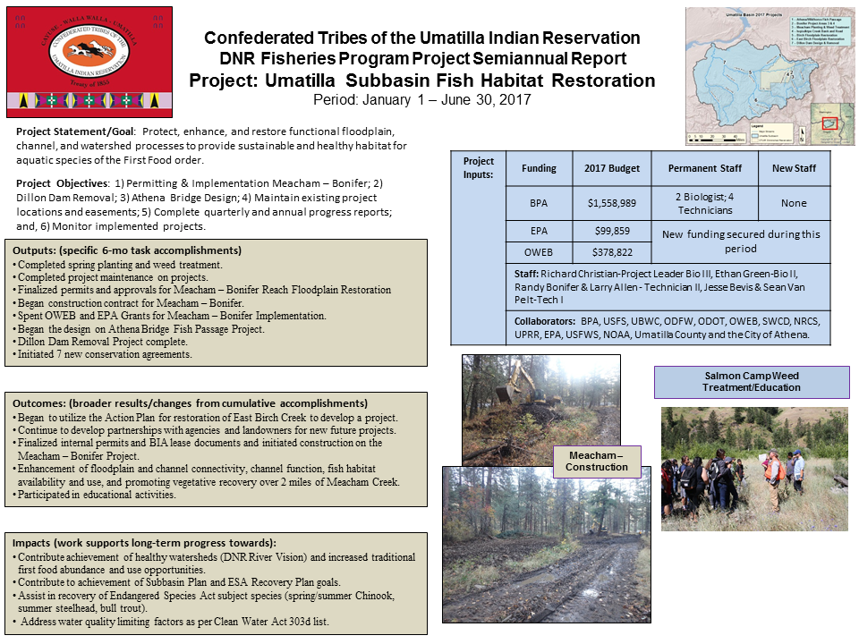
Figure 3. CTUIR semi-annual report for the Umatilla Subbasin Fish Habitat Restoration Project, January – June, 2017.

The UBAFHP participated in a number of community outreach and education opportunities in 2017. In March, 2017, the UBAFHP participated in a CTUIR Department of Natural Resources “open house.” During this event, the UBAFHP educated the tribal community about the work that the Project recently completed and work that was upcoming in the recent months, including the Meacham Creek Bonifer Reach Floodplain Restoration and In-stream Enhancement Project. Also in March the UBAFHP hosted a group of students from Whitman College on a service learning trip. The UBAFHP provided the group with a tour of the Meacham Creek floodplain restoration projects, educated them about the project and floodplain processes, and the group got hands-on restoration experience pulling noxious weeds in the Meacham Creek floodplain. The UBAFHP again participated in the Watershed Field Days program to educate local elementary school children about the importance of stream and watershed health. Additionally, the UBAFHP assisted in the annual CRITFC Salmon Camp in June, 2017, to educate middle school students on salmon habitat restoration. UBAFHP staff spent a day educating the Salmon Camp attendees on salmon habitat and the importance of restoration and conservation and spent a few hours hand pulling noxious weeds (Figure 4). The UBAFHP also participated in local media outreach for the Dillon Dam removal project resulting in print articles in the Confederated Umatilla Journal (Phinney 2017) and the East Oregonian (Plaven 2017).

Additionally, the UBAFHP hosted a summer intern in 2017 through the CTUIR Tribal Member Internship program. The intern spent over 400 hours getting hands-on work experience in fisheries habitat restoration and helped collect habitat inventory data in the 2017 field season. She returned to her studies at the end of the internship intending to complete a degree in natural resources conservation.
Numerous tours were also conducted of the previous work that has been completed on Meacham throughout the 2017 contract year. Some of these tours were for other resource professionals, while some of them were for educational purposes.

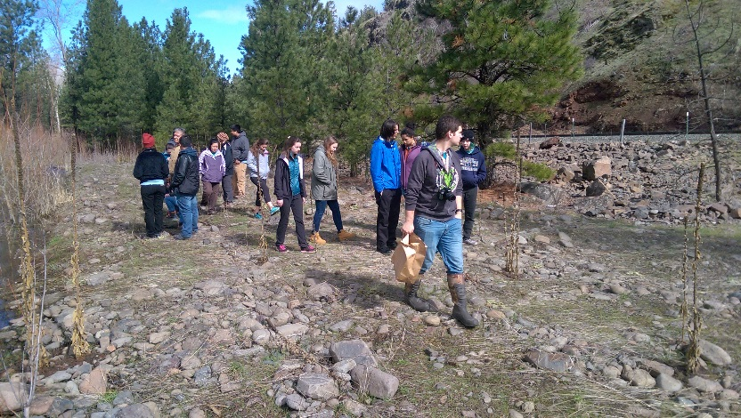 | 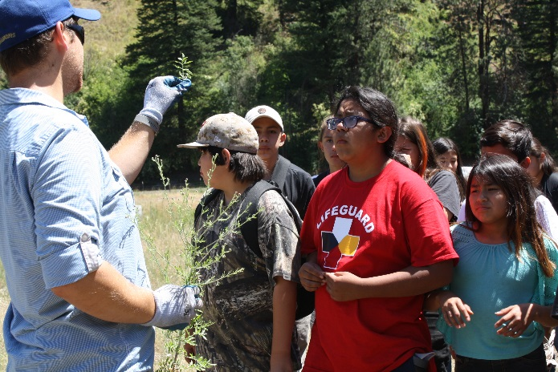
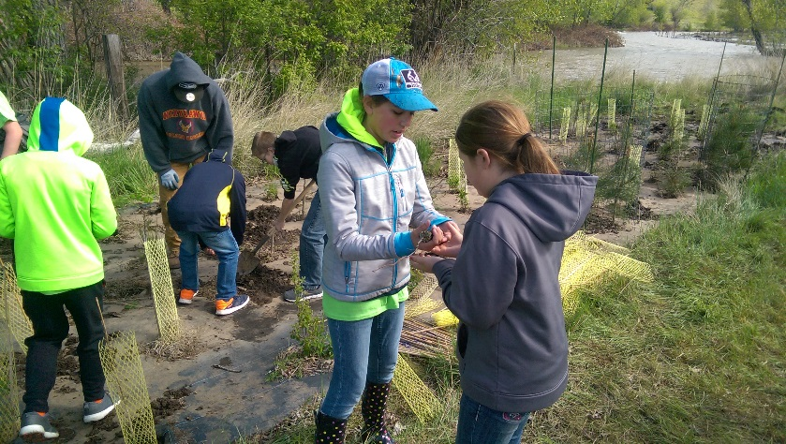 | 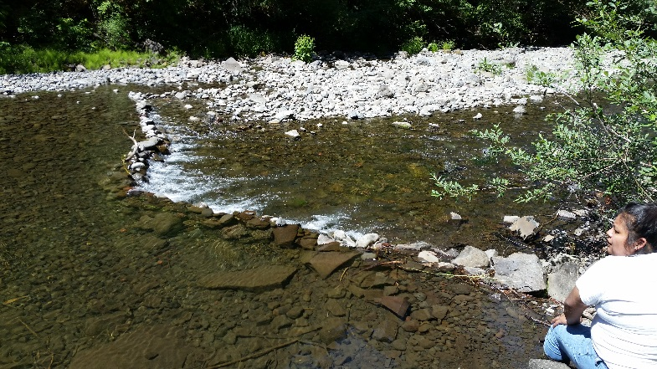
Figure 4. UBAFHP outreach and education activities. Clockwise from top left: Whitman College service learning field trip searching for weeds in Meacham Creek; CRITFC Salmon Camp attendees learning about noxious weeds and salmon habitat; UBAFHP summer intern observing a recreational rock dam, a potential summer fish passage barrier, prior to obliteration; UBAFHP staff assisting local elementary school students plant native plants at the annual Watershed Field Days.

Project staff also developed and fostered relationships with participating experts in related fields by attending training, professional workshops and working groups, and gained professional advancement and improved project success through informative, instructional interactions. CTUIR UBAFHP and DNR Fisheries Habitat Program staff attended multiple professional conferences and workshops, and participated in poster presentations of project activities including:

River Restoration Northwest (2017 – Poster)
Ecological Response to Floodplain Reconnection and In-stream Habitat Enhancement – Michael Lambert, Kaylyn Costi, David Wooster, Richard Christian, Ethan Green, and Craig Contor

Work Element I: 186. Operate and Maintain Habitat/Passage/Structure
Work Element Title: Inspect and Maintain Function of In-stream Improvement Structures
Milestone Deliverable: Maintain Proper Operation of In-stream Habitat Structures

A. Environmental compliance requirements complete.
B. The inspection, replacement and/or maintenance of passage and habitat structures.
C. Hire contractor to perform work.

CTUIR monitors 6 passage rectification projects to assure that treatments are effectively working and to insure that intrusive objects are not interfering with the designed function of the passage structures (Table 7). Routine quarterly scheduled site visits of individual projects are conducted either independently by the CTUIR or jointly with project partners such as ODFW. Site visits typically follow significant flow events or responses to landowner requests at project sites. Project maintenance included, but was not limited to, meeting specified conditional language in state and Federal permits, maintaining debris that is routinely captured or caught on in-stream structures, responses to landowner requests and concerns, and completion of post-treatment surveys to monitor and quantify changes to physical and ecological responses.

Work Element J: 186. Operate and Maintain Habitat/Passage/Structure
Work Element Title: Maintenance of Habitat Features Associated with Project Conservation Easements
Milestone Deliverable: Maintenance of Land or Structures Associated with Conservation Easements

A. Environmental compliance requirements complete.
B. Adhere to details of existing easements and/or initiate additional agreements as feasible.

The purpose of these conservation easements is to protect, enhance, and restore functional floodplain, channel, and watershed processes to provide sustainable and healthy habitat for aquatic species in the Umatilla River subbasin. The UBAFHP have and will continue to maintain the individual projects to ensure that project structures and fencing are functioning and habitat recovery is progressing towards meeting projects goals and objectives. The CTUIR currently maintains 16 conservation agreements. Current agreements provide secured access and protection of resources for functional floodplain, channel watershed processes to provide sustainable and healthy habitat for aquatic specifies 26 miles of stream. CTUIR routinely conducts custodial maintenance on individual projects to ensure that project structures and fencing are functioning and habitat recovery is progressing towards meeting projects goals and objectives. Activities include, but are not limited to, installing and repairing riparian cattle exclusion fences, maintaining or installing water gaps, riparian and floodplain plantings and maintenance, noxious weed control, maintenance of fish habitat improvement structures, and landowner coordination and education.

Work Element K: 157. Collect/Generate/Validate Field and Lab Data
Work Element Title: Project Effectiveness Photo Point Monitoring
Milestone Deliverable: Upload project effectiveness photo point photos to CTUIR data repository.

A. Environmental compliance requirements complete.
B. Review, revise, and publish protocol, study design and methods in monitoringmethods.org.
C. Conduct photo point documentation of project conditions related to specified project areas.
D. Upload photo point photos and site data to the CTUIR photo point data depository.

The CTUIR UBAFHP continued its intensive photo point monitoring in the 2017 contract years. Photo points were conducted in the spring of 2017 and uploaded to the UBAFHP internal photo point data depository (Figure 5).
2011 | 2017
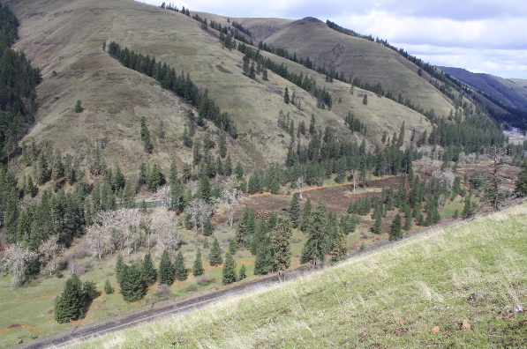 | 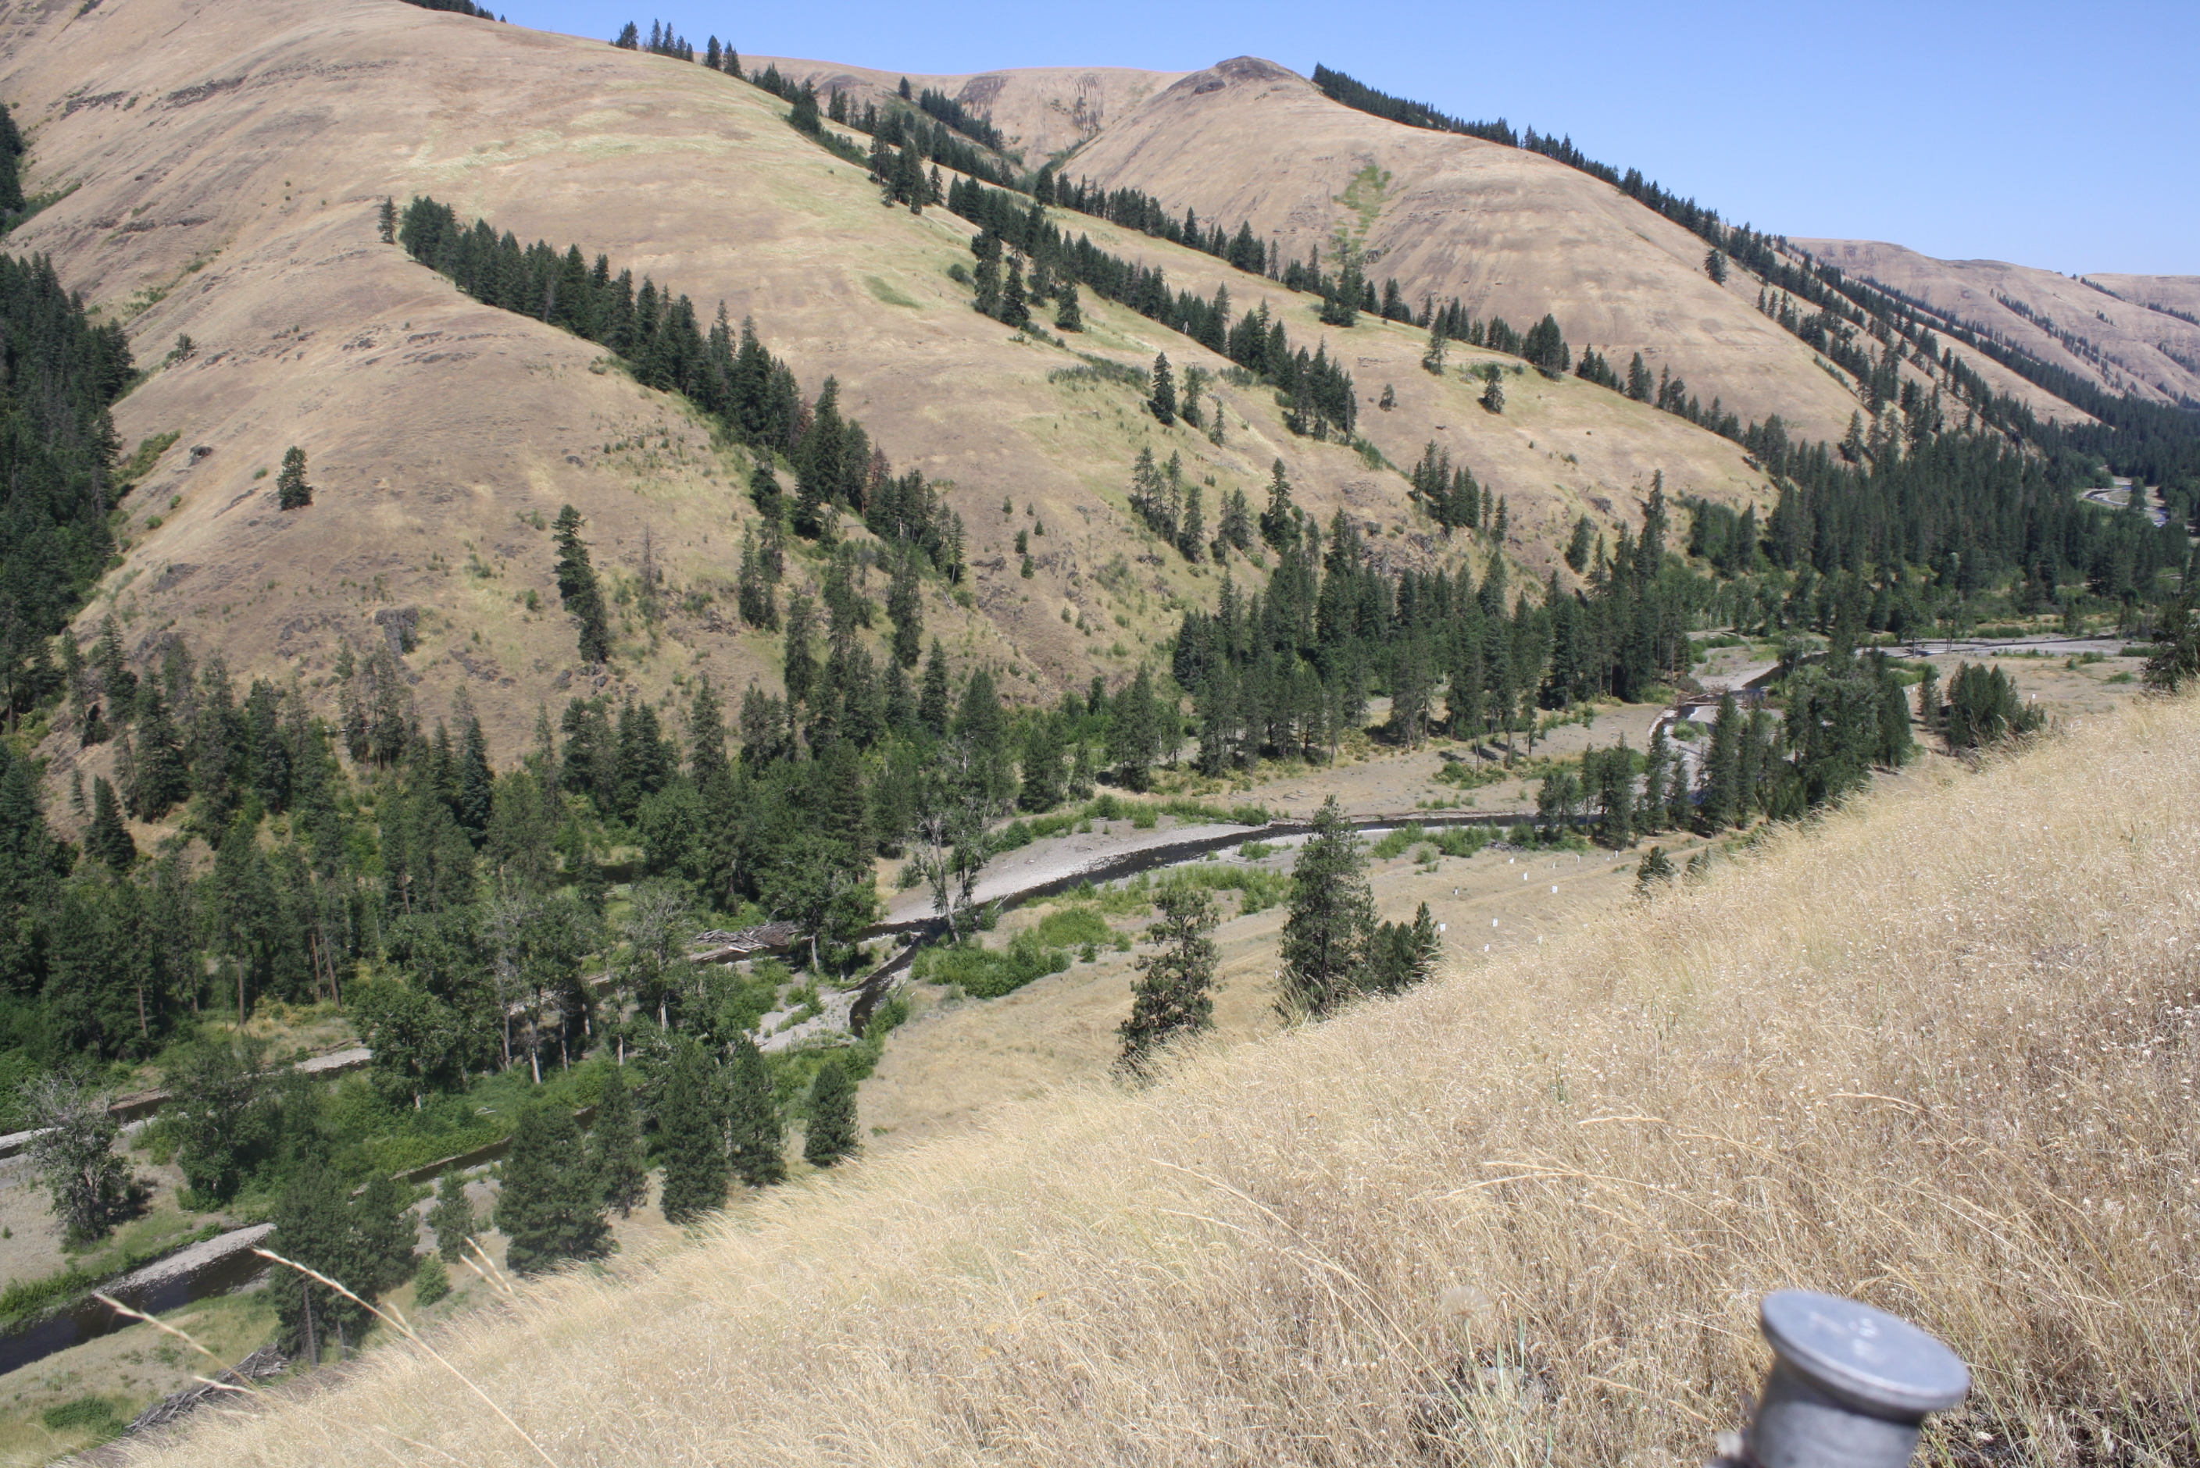
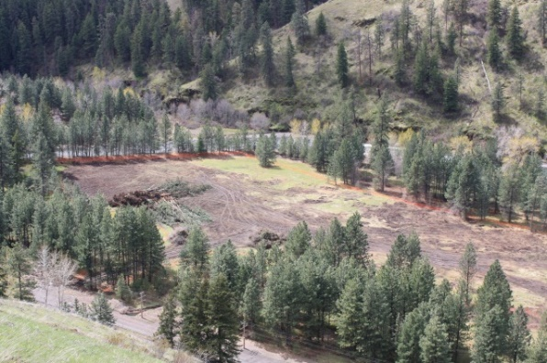 | 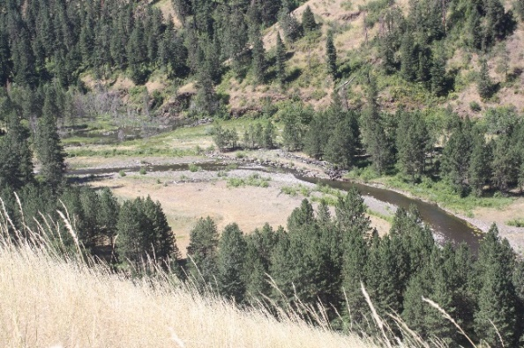
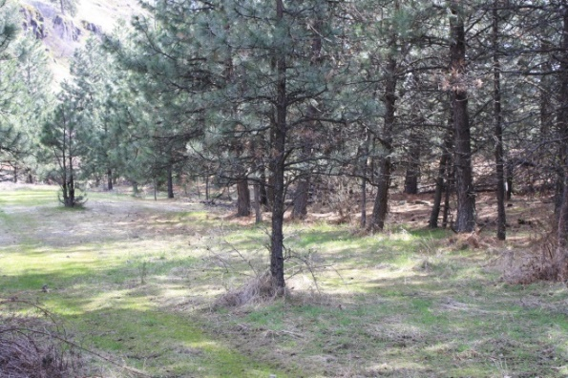 | 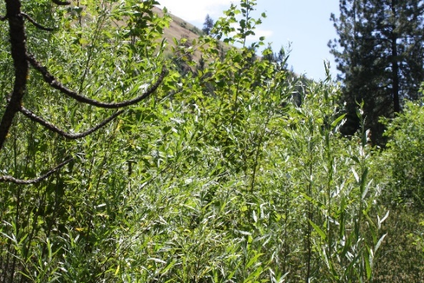
Figure 5. Before (2011) and after (2017) photos of the Meacham Creek Floodplain Restoration and In-stream Enhancement Project RM 6-7 taken at photo point monitoring locations.

Grid-intersect analysis of photo point data from 2011 to 2017 revealed that the proportion of the bankfull channel that supports perennial woody vegetation has been steadily increasing since the completion of the Meacham Creek Floodplain Restoration and In-stream Enhancement Phase I project in 2011. Immediately after construction, approximately 36.6% ± 4.9% (mean ± SE) of the bankfull channel supported perennial woody vegetation, whereas in 2017, 67% ± 9.8% was vegetated (Figure 6).
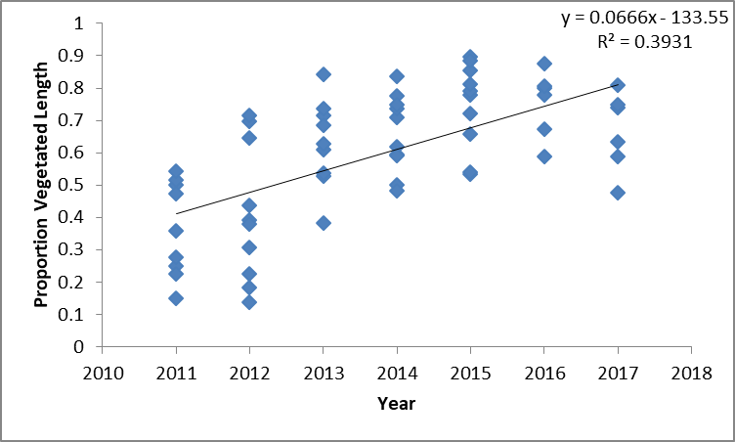
Figure 6. Proportion of vegetated bankfull channel length within the Meacham Creek Floodplain Restoration and In-stream Enhancement Phase I project area by year based on grid-intersect analysis of photo point data.

Work Element L: 198. Maintain Vegetation
Work Element Title: Maintain Vegetation and Control Noxious Weeds in Project Areas within the Umatilla River Subbasin
Milestone Deliverable: Maximize Survival of Native Vegetation in Enhancement Project Areas

A. Environmental compliance requirements complete.
B. Physical removal of non-preferred species of vegetative growth from project area.
C. Weed control in project areas by chemical means.
D. Water vegetation and reduce weed competition to improve survival at CTUIR project areas.
E. Till established weed areas as necessary for noxious weed control.

Project activities conducted in 2017 included the monitoring and maintenance of 16 conservation agreements on numerous individual landowner properties. Watering, weeding and maintenance methods for each conservation easement and project area is important for enhanced native vegetation and project site but maintenance varies by site conditions. Strategies to address weeds are included in agreements that are either completed by the landowner, CTUIR, subcontractor, and/or through the County Weed Control Board. CTUIR staff provides assistance to landowners by coordinating and managing herbicide application, providing funding, and developing treatment strategies. Manual, biological and chemical treatment options are utilized by CTUIR and may be employed when consistent with existing standards. Weed control is essential in establishing native grass and plant species. The UBAFHP maintains a licensed pesticide applicator on staff to spray/control noxious weeds on sites where chemical application is necessary. This staff member identifies problem weeds, determines the appropriate herbicide and selects the most effective application methods and rates in accordance with the National Oceanic and Atmospheric Administration's (NOAA) Biological Opinion under BPA's Habitat Improvement Program. The UBAFHP utilizes backpack spraying applications to treat perennial, annual and biennial weed species. All herbicide applications are consistent with Oregon Revised Statue (ORS).570.505 and Federal Insecticide, Fungicide and Rodenticide Act (FIFRA) Regulations. CTUIR complies with BPA standards and supplies a report to BPA detailing the types and quantities of herbicides applied to specified locations.

In 2017 the UBAFHP completed 93 acres of mechanical and chemical weed treatment on current and completed project areas (Table 4).

Work Element M: 47. Plant Vegetation
Work Element Title: Meacham Creek Floodplain Restoration and In-Stream Enhancement, RM’s 4.9-6.1
Milestone Deliverable: Complete Scheduled Tree and Shrub Plantings in Project Areas

A. Environmental compliance requirements complete.
B. Agreement with the Native Plant Nursery for Growing Plants and Developing Plant Protocol.
C. Establish Planting Locations in Existing Project Areas for Increased Recovery.

UBAFHP staff annually plant vegetation and distribute native grass seed in areas we have implemented existing or new habitat enhancement projects or have identified a need in maintained riparian conservation easement areas. In 2017, the UBAFHP completed a small spring planting effort within the previously implemented Meacham Creek Floodplain Restoration and In-stream Enhancement Project (Phase I & II) area, replanting areas where previous plantings failed to meet survival goals (Table 5). The majority of the UBAFHP planting effort took place in the fall immediately following disturbance from the 2017 construction season on the Meacham Creek Bonifer Reach Floodplain Reconnection and In-stream Enhancement Project. The fall 2017 planting effort included installing 984 containerized plants.

Planting tasks include site planning and development of planting strategies, collection and preparation of materials (pruning and conditioning of live willow material), pre-order coordination with the CTUIR Tribal Native Plant Nursery, and installation. Planting techniques are customized for conditions within each project area. Planting location, species, age, form (cuttings, saplings, bare-roots, potted, plugs), and soil/substrate conditions were considered and addressed during the implementation planning phase. The CTUIR UBAFHP staff work closely with the Tribal Native Plant Nursery to collect local seed and plant stock to provide native plants for particular project areas by elevation and planting zones.

Work Element N: 175. Produce Design and/or Specifications
Work Element Title: Collect Data on Roads and Culverts to Identify Aquatic Impacts
Milestone Deliverable: Collect Data on Roads in the Isquúlktpe Creek Watershed to Develop Treatment Options

Currently, the main access road for the Isquúlktpe Creek Watershed is an ATV trail that makes numerous crossings of the active stream channel. The number and extent of these crossings was largely unknown, as were the extent of existing and historic roads and stream crossings in the headwaters and on side roads off the main access. To answer address these data gaps and aid in planning of restoration actions, the CTUIR UBAFHP conducted a survey of the existing transportation network.

Methods

The UBAFHP used a modified Geomorphic Road Analysis and Inventory Package (GRAIP) data collection procedure to obtain physical characteristics of all roads that were physically surveyed within the watershed. Data collected on each road segment included the least capable vehicle that could travel on the road, estimated gradient, description, vegetation on the road, vegetation on cut slope, vegetation on fill slope, and road surface composition. Data collected on all stream crossings surveyed included crossing type, if live water was present at the time of the survey, bankfull width of the stream at the crossing, road width at the crossing, length of road on the fill of the crossing, stream length underneath the road, material, structure length, if fish were observed, if the stream is fish bearing, structure diameter, and depth of fill over structure. Data collected on all road saturation points included the source of saturation, the condition of the road (cut, fill, or road surface saturated), and any erosion present. Data collected on any erosion feature included the type of erosion, road width at the erosion feature, the length and width and depth of the erosion feature, the length and width and depth of any debris on the road, and if the erosion is connected to the stream. Data was also collected on any road closures that were encountered and all road junctions. On roads that were publicly accessible, data was collected in ESRI ArcPad software on Juniper Systems Archer2 mobile computers. On private roads that were not accessible to survey staff, data was collected via remote sensing (aerial imagery, LiDAR) in ESRI ArcMap software. All data collected was spatialized.

Results

Overall, the CTUIR UBAFHP physically surveyed 62.07 miles of roads and trails in the Isquúlktpe Creek watershed. An additional 67.45 miles of inaccessible roads were surveyed via remote sensing, bringing the total road miles in the Isquúlktpe Creek watershed to 129.5. The density of surveyed roads in the watershed was calculated to be 3.67 mi/mi². Of the 129.5 miles of roads in the watershed, 94.2 miles are located on private property, whereas 35.3 miles are located on public or Tribally owned lands. Nearly half of the road mileage (60.6 miles) in the watershed was located 100m from a stream and 33.1 miles were located 50m or less from water (Figure 7).

In the miles of stream surveyed, the UBAFHP identified 73 stream crossings including 1 bridge, 19 culverts, 49 fords, and 4 unknown stream crossings. The majority of these stream crossings were on the main access road up mainstem Isquúlktpe Creek.

In the course of the survey, 28 instances of road prism erosion were identified. Four cutslope failures were observed, none of which were connected to the stream network. Of the 17 fillslope failures identified, 9 were connected to the stream network. Seven instances of gully and other surface erosion were observed, including 3 that were directly connected to the stream network. Fourteen saturated road segments were also identified during the surveys. The source of road prism saturation was mostly due to inadequate drainage for seeps and springs on the cutslope.

UBAFHP staff also encountered 28 road closures including 13 access restriction points (i.e., gates and fences) and 15 permanent closures (i.e., boulders, tank traps). The majority of the road closures encountered were functional, but 6 were driven around and did not adequately prevent motor vehicles from accessing the road.

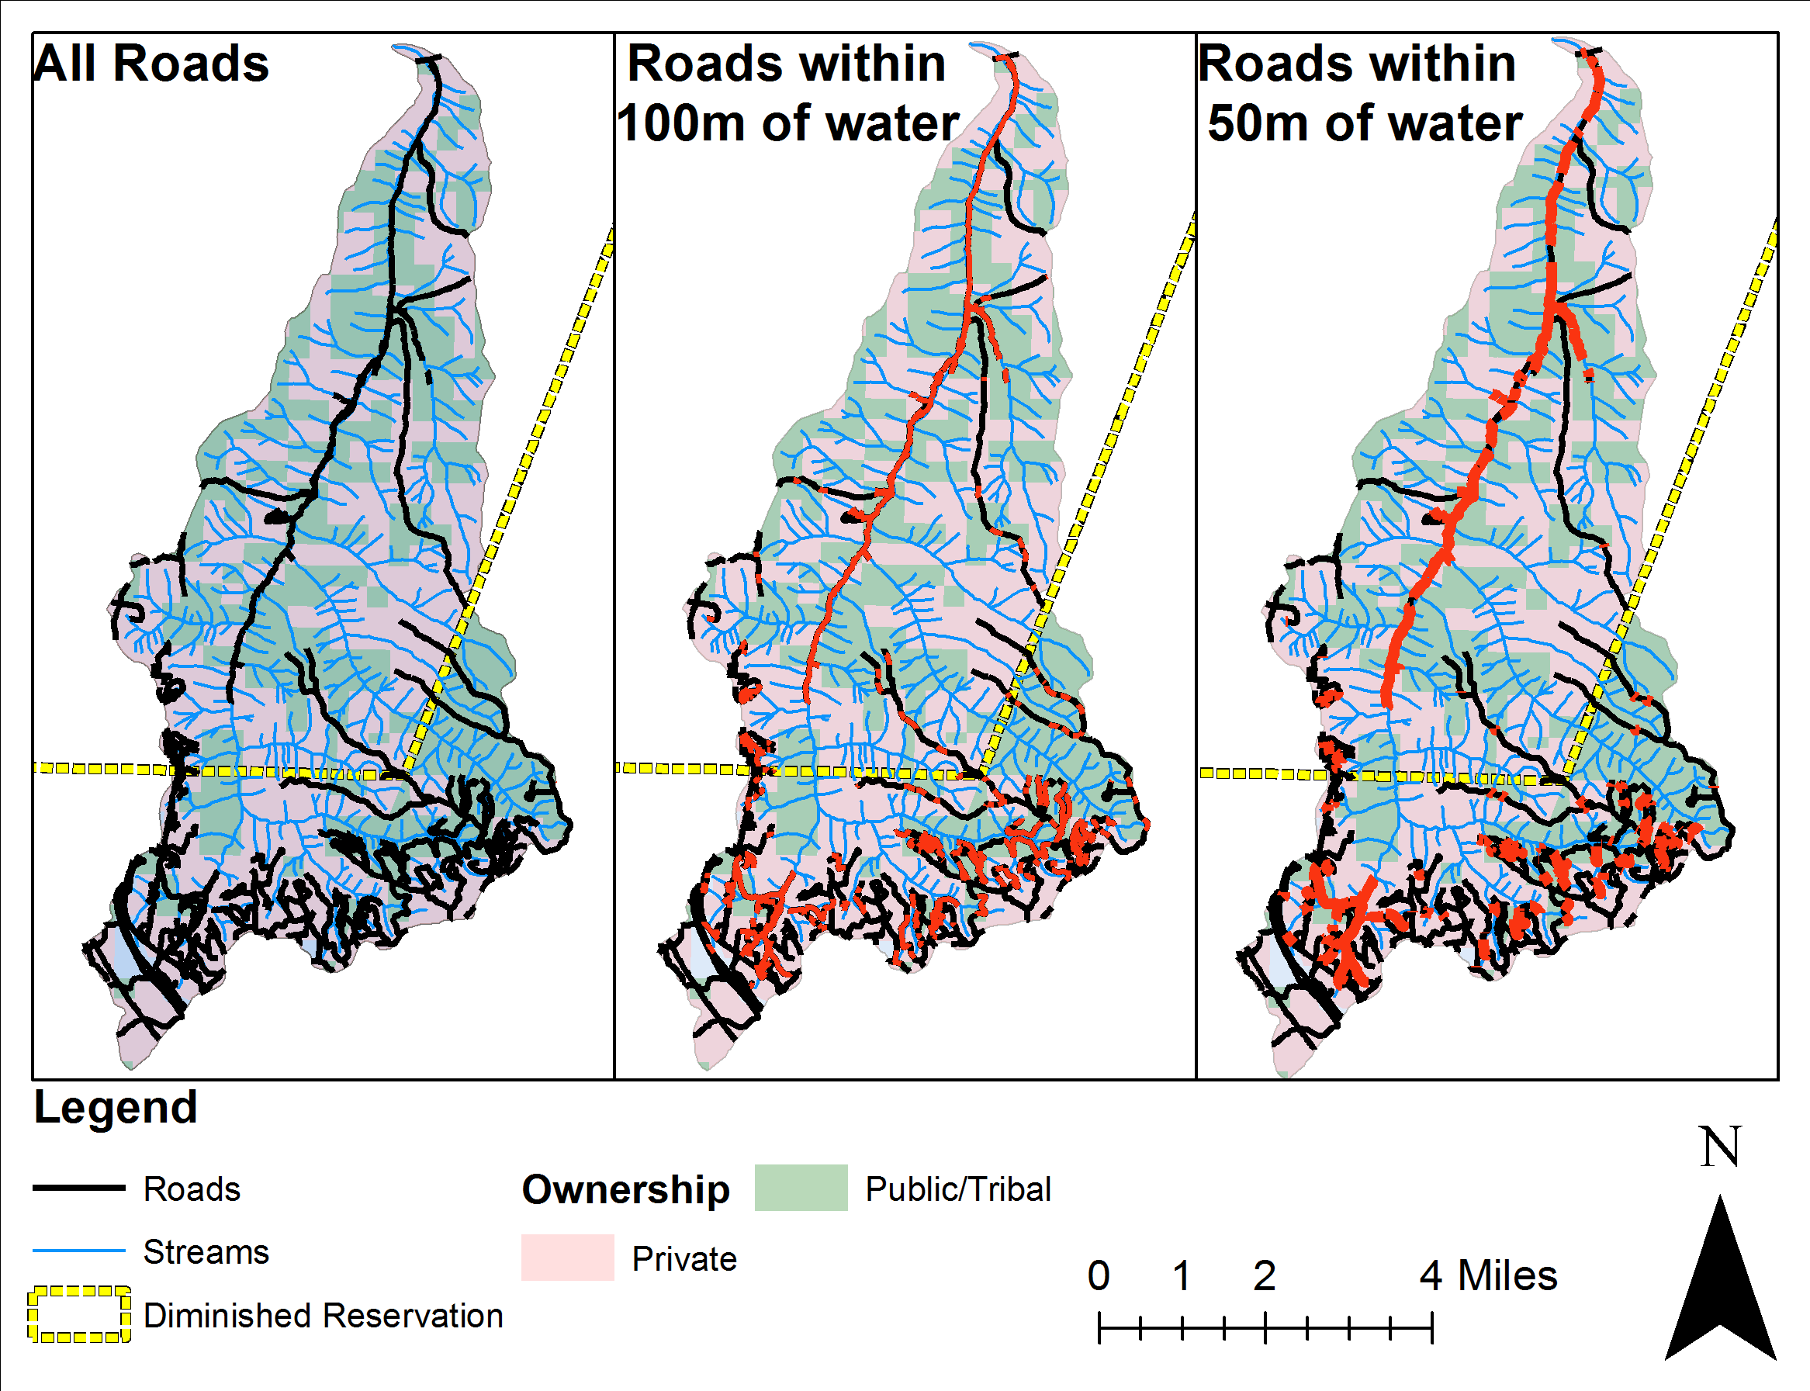
Figure 7. Maps of the Isquúlktpe Creek watershed, property ownership, and surveyed roads.

Discussion

The road densities observed in the Isquúlktpe Creek Watershed are higher than originally anticipated at the onset of this study. Guidelines from the National Marine Fisheries Service (1996) indicate that the watershed conditions of Isquúlktpe Creek are “not properly functioning” at the current road densities and locations. A “properly functioning” watershed should have a road density of less than 2 mi/mi² and have no roads confining the stream on the valley bottom.

Much of the road network in Isquúlktpe Creek is located in close proximity to perennial or ephemeral stream channels. The potential for these roads to contribute sediment to stream network is a question that merits further study. The results from this survey may be useful in a small modelling exercise to determine potential sediment contribution from the road network in the Isquúlktpe Creek watershed. Additionally, a road network in such close proximity to the stream likely confines the stream to some degree, limiting floodplain connection and impeding watershed function.

Road Relocation Design

As a part of the effort to inventory the road network in Isquúlktpe Creek watershed, a priority location for work was identified on the Isquúlktpe Creek Road. The creek approaches the road prism and has consistently caused erosion issues. The UBAFHP produced a small design to relocate the road prism away from the creek toward the toe slope of the valley and incorporate some large wood habitat features to increase in-stream habitat complexity while maintaining protection of the newly constructed road. This design was provided to CTUIR Public Works for implementation at a later date.

Work Element O: 184. Install Fish Passage Structure (Cancelled in CCR 39065)
Work Element Title: Wildhorse Creek – Athena Fish Passage Project Implementation
Milestone Deliverable: The CTUIR will work collaboratively with the ODFW, UBWC, City of Athena and Umatilla County to replace an aging bridge on 3rd Street in Athena, OR, to restore upstream fish passage through the project reach.

CTUIR selected a contractor to produce an engineered design for this project in the previous contract year. Due to unanticipated delays in the design process, this project was unable to be completed in the 2017 contract year. Construction was rescheduled for the 2018 contract year.

Work Element P: 184. Install Fish Passage Structure
Work Element Title: Dillon Dam Irrigation Diversion Passage Project
Milestone Deliverable: The CTUIR will work collaboratively with the ODFW, UBWC, and water users to remove an aging diversion dam at RM 25.2 on the Umatilla River to restore full fish passage through the project reach.

The CTUIR UBAFHP collaborated with ODFW and UBWC to fund and implement the removal of the defunct Dillon irrigation diversion dam at River Mile 25.2 on the mainstem Umatilla River. CTUIR provided project funding, in-kind contributions for cultural resources surveying, technical design review, and fish salvage assistance. ODFW provided partial project funding and labor and equipment necessary for removal of the structure. The UBWC provided funding and design for the replacement water delivery system to ensure uninterrupted service to the water users that previously relied on the Dillon diversion dam. Water users also contributed funding for the replacement water delivery system. The dam was fully removed in the 2017 in-water work window (Figure 8).

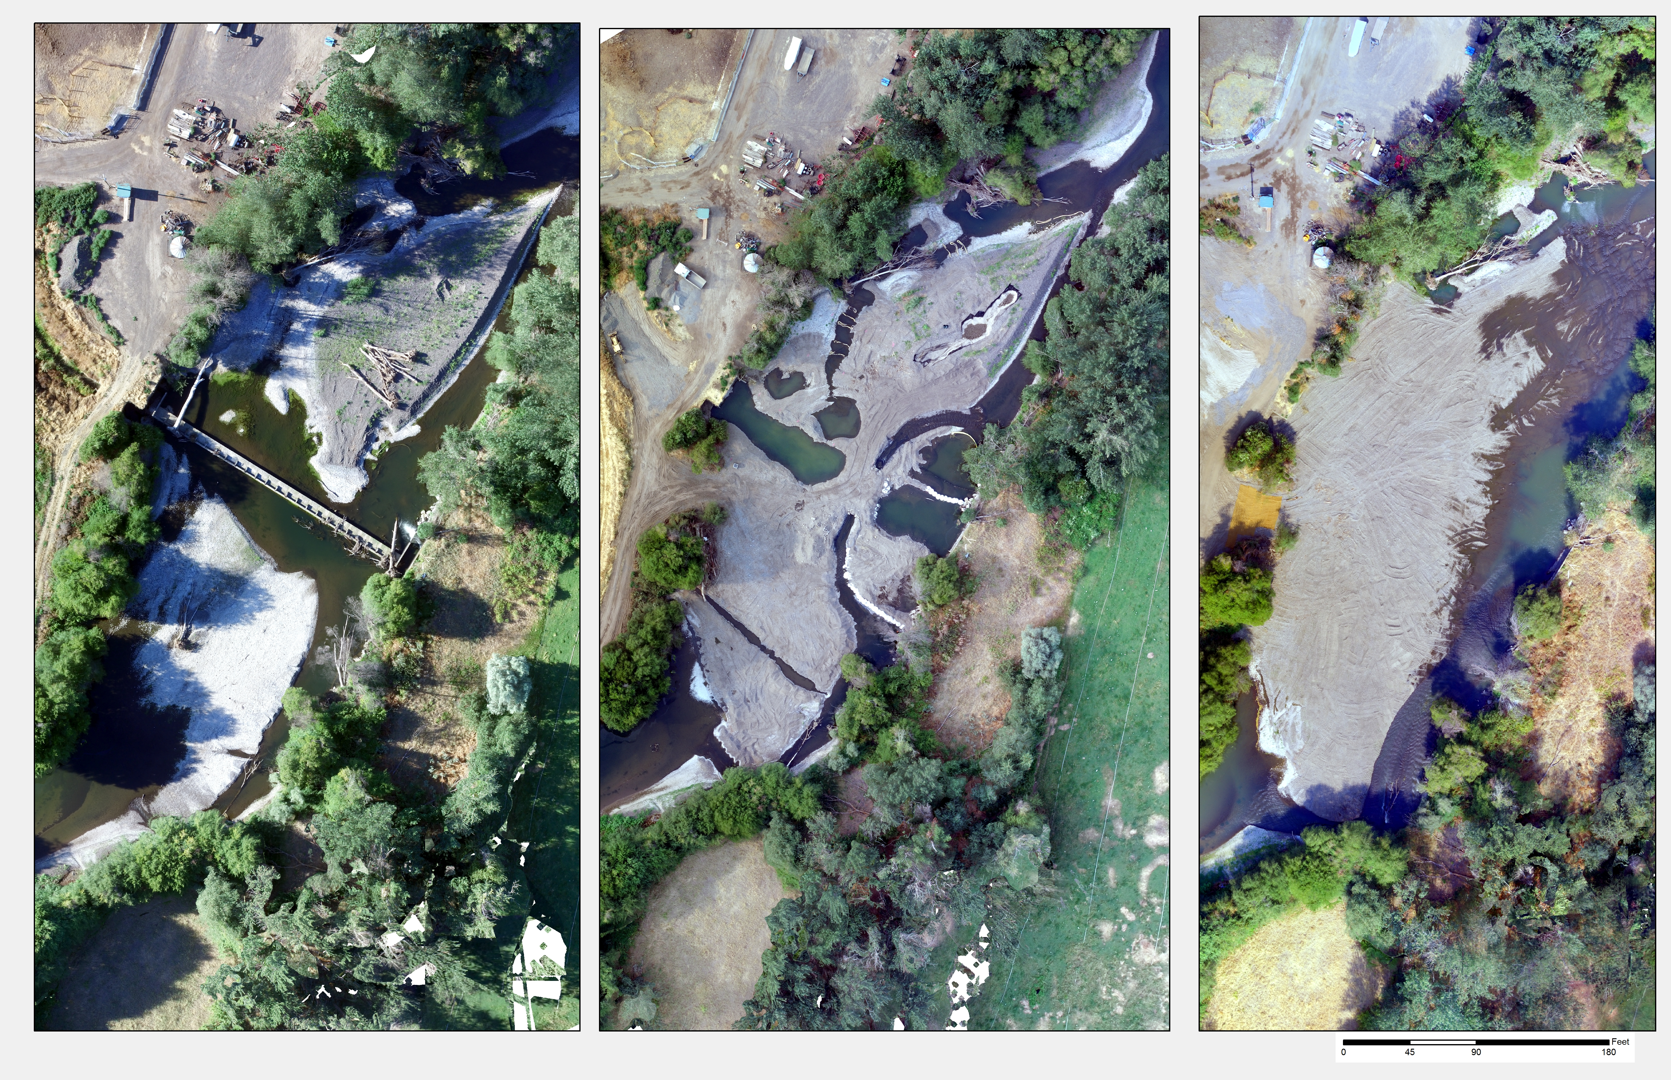
C
B
A
Figure 8. Drone imagery of the Dillon Dam Removal Project before (A), during (B), and after implementation (C).

Work Element Q: 180. Enhance Floodplain/Remove, Modify, Breach Dike
Work Element Title: Pre-construction – Bonifer Floodplain Restoration and In-stream Enhancement
Milestone Deliverable: Complete revised design for Project Areas 3 and 4, finalized permits, and completed construction staking.

All pre construction activities were completed in summer of 2017 including finalizing all permits and permissions, construction staking, and all design changes.

Work Element R: 175. Produce Design and/or Specifications
Work Element Title: Wildhorse Creek – Athena Fish Passage Project Design
Milestone Deliverable: Complete a design and implementation schedule for one fish passage project on Wildhorse Creek in the city of Athena, OR.

CTUIR solicited proposals for an engineering firm to design the preferred alternative proposed in the Athena Bridge feasibility report. The selected design firm began producing the design in the 2017 contract year and will complete the design early in the 2018 contract year.

Work Element S: 180. Enhance Floodplain/Remove, Modify, Breach Dike
Work Element Title: Construction – Bonifer Floodplain Reconnection and In-stream Enhancement – PA 3 & 4
Milestone Deliverable: Complete removal of 3,385 linear feet of levees and dikes in the Meacham Creek Bonifer Reach Project Areas 3 and 4.

CTUIR subcontracted construction services to complete removal of levees and dikes in the Meacham Creek Bonifer Reach Project Areas 3 and 4 as part of the Bonifer Reach Floodplain Reconnection and In-Stream Enhancement Project. Due to a later than anticipated start to construction, no levees below ordinary high water were able to be removed in 2017. Partial implementation did occur in 2017 and CTUIR was able to remove 2,535 linear feet of levees and dikes. The remainder of the levee removals in Bonifer Reach Project Areas 3 and 4 will be completed in contract year 2018.

Work Element T: 29. Increase Aquatic and/or Floodplain Complexity
Work Element Title: Construction – Bonifer Floodplain Restoration and In-stream Enhancement – PA 3 & 4
Milestone Deliverable: Complete installation of 550 pieces of large wood and install 69 engineered log jams.

CTUIR subcontracted construction services to complete installation of large wood structures in the Meacham Creek Bonifer Reach Project Areas 3 and 4 as part of the Bonifer Reach Floodplain Reconnection and In-Stream Enhancement Project. Due to a later than anticipated start to construction, no large wood below ordinary high water was able to be installed in 2017. Partial implementation did occur in 2017 and CTUIR was able to install 38 pieces of large wood including 10 engineered log jams. The remainder of the large wood in Bonifer Reach Project Areas 3 and 4 will be installed in contract year 2018.

Work Element U: 30. Realign, Connect, and/or Create Channel
Work Element Title: Construction – Bonifer Floodplain Restoration and In-stream Enhancement – PA 3 & 4
Milestone Deliverable: Complete construction of 2,770 linear feet of primary and secondary channel.

CTUIR subcontracted construction services to complete construction of primary and secondary pilot channels in the Meacham Creek Bonifer Reach Project Areas 3 and 4 as part of the Bonifer Reach Floodplain Reconnection and In-Stream Enhancement Project. Due to a later than anticipated start to construction, only a small segment of side channel below ordinary high water was able to be installed in 2017. Partial implementation did occur in 2017 and CTUIR was able to construct 500 feet of side channel to reconnect an additional 996 feet of relic side channel habitat. The remainder of the designed channel construction in Bonifer Reach Project Areas 3 and 4 will be installed in contract year 2018.

Work Element V: 92. Lease Land (added in CCR 39580)
Work Element Title: Grazing lease Bonifer Floodplain Restoration PA 3&4
Milestone Deliverable: 10-year lease of grazing rights on private property within the Bonifer Project boundary.

CTUIR worked with the Bureau of Indian Affairs (BIA) Realty program to secure business leases on several individual allotments within the boundary of the Meacham Creek Bonifer Reach Floodplain Reconnection and In-stream Enhancement Project. As a result of these leases, the grazing rights within the project boundary were leased. The leases preclude grazing on approximately 65.2 acres of floodplain within the project boundary for a period of 10 years.

Contract 73982 REL 33 (CY 2018)

Work Element A: 185. Produce Pisces Status Report
Work Element Title: Periodic Status Reports for BPA
Milestone Deliverable: Complete Periodic Pisces Status Reports

CTUIR reported to BPA periodically during the contract period on the status of each statement of work element, and milestones and deliverables using the computer program Pisces:
February-June (2/1/2018 - 6/30/2018)
July-September (7/1/2018 - 9/30/2018)
October-December (10/1/2018 - 12/31/2018)
Final January (1/1/2019 - 1/31/2019)

The BPA Contracting Officer Technical Representative (COTR) reviewed the Pisces status reports, recommended changes as necessary and accepted them electronically upon approval. Additionally, upon completion of each deliverable milestone, we provided metrics and final project location (latitude and longitude) when required. These Pisces status reports provide a tool for the BPA COTR and administrative staff to track project progress in meeting contract requirements.

Work Element B: 132. Produce (Annual) Progress Report
Work Element Title: Produce Annual Progress Report CY17 and CY18 (Jan. 1, 2017, thru Dec. 31, 2018)
Milestone Deliverable: Completed annual report

A. Review progress report format requirements
B. Write non-technical progress report
C. Upload non-technical progress report to Pisces
D. Confirm BPA posted received

The CY2017-18 BPA Annual Progress Report was completed and was uploaded to BPA through Pisces in the winter of 2018.

Work Element C: 119. Manage and Administer Projects
Work Element Title: Manage and Administer Project
Milestone Deliverable: Upload Statement of Work, Budget, Property Inventory for Upcoming Contract Period to Pisces

A. Per COTR, revise/finalize the new contract package (statement of work, environmental compliance documentation, budget, and property inventory).
B. Accrual – submit September estimate to BPA.
C. Funding package – conduct internal review (e.g., supervisor or interagency).

This work element includes a suite of management actions required to administer the project, including preparation of annual operations and maintenance budgets, managing and preparing statements of work and budgets, and property inventory to the assigned BPA COTR for the following contract period. The project leader reports quarterly or as necessary on milestones and metrics to BPA using the BPA Pisces Program, supervises, trains, and directs staff activities, conducts vehicle and equipment maintenance and management, performs payroll, purchasing, obtains quotes and subcontracting for services, and administers habitat enhancement activities.

Work Element D: 114. Identify and Select Projects
Work Element Title: CTUIR Umatilla Subbasin Restoration Coordination
Milestone Deliverable: List of Final Projects

A. Coordinate regularly with project partners and landowners
B. List projects

CTUIR UBAFHP staff annually coordinated and planned projects with State, Federal, and local partners, and private landowners to develop habitat restoration and enhancement projects consistent with local planning documents. CTUIR project development is guided and prioritized by project activities that are supported by the Umatilla River Vision and CTUIR Department of Natural Resources First Foods mission statements to enhance or protect ecological and physical processes thus sustaining biota production (Jones et al. 2008). The CTUIR is guided in its habitat restoration activities by multiple planning documents:

Final Umatilla Willow Subbasin Plan (NPCC 2005),
Middle Columbia River Steelhead Recovery Plan (NMFS 2009),
Recovery Plan for the Coterminous United States Population of Bull Trout (Salvelinus confluentus) (USFWS 2015),
Meacham Creek Watershed Analysis and Action Plan (Andrus & Middel, 2003), and
Birch Creek Watershed Action Plan (CTUIR 2016).

Projects were identified, prioritized and developed with project partners (ODFW, UBWC, and SWCD) who implement restoration projects within the Umatilla River Basin. Projects that were ranked by priority, CTUIR identified funding sources and projects were prepared for planning, engineering design, permitting and implementation and included in the FY 2017 BPA statement of work and budget.

Work Element E: 191. Watershed Coordination
Work Element Title: Umatilla River Watershed Coordination Duties
Milestone Deliverable: Coordinate Watershed Association Activities

A. Coordinate with Umatilla Basin Watershed Council
B. Coordinate with NRCS and local conservation districts
C. Network with professionals in the field of habitat restoration
D. Coordinate with co-manager ODFW and other Federal agencies

CTUIR UBAFHP staff participated and coordinated with multiple agencies and stakeholders in the Umatilla River Subbasin through the Umatilla Subbasin Restoration Team (Restoration Team) including ODFW, USDA-FS, NRCS, conservation districts, USFWS, Umatilla Basin Watershed Council and local stakeholders to enhance natural resources, identify problems and solutions, coordinate efforts to prevent duplication, enhance communication and cooperation and identify funding and cost share opportunities within the Umatilla River Subbasin. Staff further coordinated with other agencies in planning and implementing partner habitat restoration and enhancement projects, ESA planning processes, and project prioritization and selection processes. The Restoration Team was established in 2010 and is an informal group formed of agency or entity representatives that do restoration work within the Umatilla River /Willow Creek Basin floodplain and riverine system. The Restoration Team coordinated several passage projects in Birch Creek, and upcoming project activities in the lower Umatilla River. CTUIR staff prepared agreements, if necessary, to assign duties and responsibilities to the appropriate entities. We also developed documents, press releases, web sites, and other communications to impart information to participating stakeholders and the public. Furthermore, CTUIR UBAFHP staff updated the Restoration Team, UBWC, CTUIR Committees and Commissions, and permitting agencies on project activities by presentation and in writing on project activities.

Work Element F: 122. Provide Technical Review
Work Element Title: Review and Provide Technical Input on Issues and Topics that Affect the Areas Natural Resources
Milestone Deliverable: Provide Technical Input and Summaries to Enhance or Protect Natural Resources in the Subbasin

A. Conduct review and provide input as necessary on natural resource preservation issues.
B. Review and provide technical input on issues that may adversely affect natural resources.

CTUIR UBAFHP staff reviewed and provided technical input as applicable on plans and proposals by entities within the Umatilla River Basin that may adversely impact floodplain or riverine processes and biota productivity, public project planning relevant to floodplain, river and wetland restoration or impacts, development and review of grant funding proposals, and proposed landowner projects. Project staff provided input to multiple CTUIR departments on annual activities relevant to work within the floodplain, rivers, and wetlands, US Army Corps of Engineers/Oregon Division of State Lands removal-fill permit applications, and CTUIR Stream Zone Alteration (SZA) Permit applications on work proposed within the floodplain on Reservation land.

Work Element G: 165. Produce Environmental Compliance Documentation
Work Element Title: Produce Environmental Compliance Documentation
Milestone Deliverable: Receipt of Environmental Compliance Clearance from BPA

The following milestones were completed for CY 2018 projects:
Meacham Creek – Bonifer Reach Floodplain Reconnection
Wildhorse Creek – Athena Bridge Fish Passage Improvement

CTUIR successfully submitted many applicable documents to the appropriate federal, tribal, state, county entities for select implementation projects in a timely manner required under work elements related to producing environmental compliance documentation in CY2018. Secondary environmental compliance accomplishments during the reporting period included coordination with various compliance personnel to prepare supplemental documentation and reporting for ongoing and planned management actions. Environmental compliance methods include development of appropriate documentation under various federal, Tribal, state and county laws and regulations governing federally funded project work. Methods involve coordination with various federal and state entities agencies and development and submittal of permit applications, cultural clearances, biological assessments, National Environmental Policy Act checklists, etc., as necessary. Part of the environmental compliance work element includes planning and developing site-specific proposals tailored to accomplish fisheries goals and meet compliance standards. The details concerning the implementation of treatments and preparations for putting efforts on the ground, including preparations for subcontracting, and specifics in regarding the safeguarding of ESA-Listed species during the implementation process are outlined in the proposals.

Cultural Resource Protection and Preservation
CTUIR submitted a letter and attachments with necessary project descriptions and geo-referenced maps for assisting BPA with section 106 National Historic Protection Act consultations and environmental compliance. The following projects were submitted for compliance:

- UmaBirch Floodplain Restoration and In-stream Enhancement
- East Birch Creek RM 5.3-5.8 Habitat Enhancement Project
- Taylor Dam Removal – Dam Removal
- Wildhorse Creek Beaver Dam Support Structure Pilot Project
- USDA-FS Hazard Tree Harvesting for Large Wood Addition

Cultural Resources protection and preservation compliance was ongoing during this contract period. The CTUIR Cultural Resources Protection Program is anticipated to deliver a final report to BPA in early 2019.

UBAFHP Environmental Compliance Documentation

ESA consultation with NMFS for CY 2018 project activities was covered under the Terms and Conditions of the HIP III Programmatic Biological Opinion (HIP III BO). Project activities covered under the HIP III BO included:
- Operate and Maintain Habitat/Passage/Structure (WE I: 186; WE J: 186): CTUIR monitored and maintained existing easements and habitat improvement sites. Maintenance included vegetation watering and installing bioengineering treatments to stabilize habitat features.
- Maintain/Remove Vegetation (WE L: 198): Project activities included watering and maintaining plants on NRCS CREP tracts and treating noxious weeds.
- Plant Vegetation (WE O: 47): Project activities included planting in the newly constructed Meacham Creek Bonifer Reach project.
- Install Fish Passage Structure (WE N: 184): CTUIR assisted in completing environmental compliance for the replacement of the Athena, OR, 3rd Street Bridge on Wildhorse Creek (RM 18.8).
- Meacham Creek Construction (WE P: 180; WE Q: 29; WE R: 30): CTUIR continued implementation of a nearly 4-mile reach of full floodplain restoration on Meacham Creek. Project activities included levee removal, side channel construction, off-channel habitat construction, and large wood addition.
- Wildhorse Creek Beaver Dam Support Structure Pilot Project (WE W: 29): CTUIR designed and planned implementation of a small BDSS pilot project in coordination with the Umatilla County SWCD.

Work Element H: 99. Outreach and Education
Work Element Title: Public Outreach and Education
Milestone Deliverable: Complete Outreach and Education Activities

CTUIR UBAFHP staff educated the public on natural resource protection and restoration principles, and communicated on project activities throughout the year. This work included giving project tours and presentations (field, written, and verbal) and participating in local and regional workshops, symposia, technical teams and/or conferences (training, project presentation, and memberships), newspaper articles and public education (local school districts or college programs).

CTUIR UBAFHP staff completed CTUIR semi-annual reports summarizing project objectives and outputs, expected outcomes, and resulting impacts of project restoration activities (Figure 9). These reports are used by the CTUIR Department of Natural Resources to inform CTUIR staff and government officials, other agencies and entities, and the public of project activities.

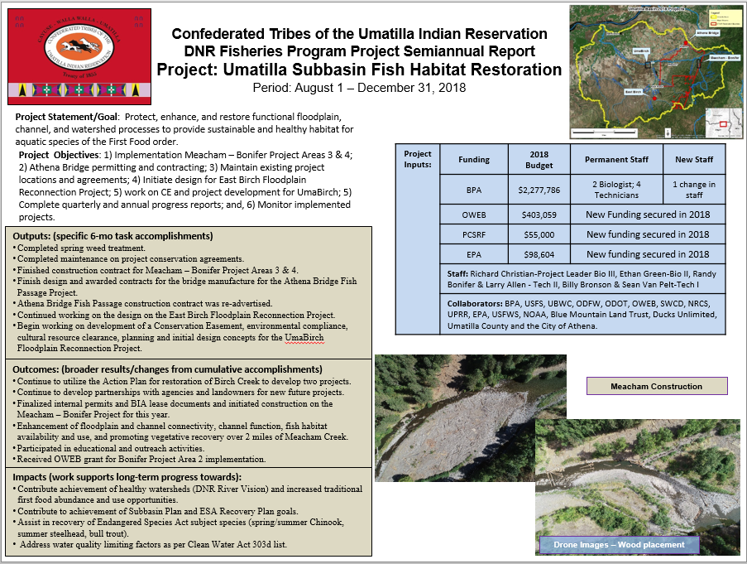
Figure 9. CTUIR semi-annual report for the Umatilla Subbasin Fish Habitat Restoration Project, August – December, 2018.

The UBAFHP participated in a number of community outreach and education opportunities in 2018. In March, 2018, the UBAFHP hosted a group of students from Whitman College on a service learning trip. The UBAFHP provided the group with a tour of the Meacham Creek floodplain restoration projects, educated them about the project and floodplain processes, and the group got hands-on restoration experience pulling noxious weeds in the Meacham Creek floodplain. The UBAFHP again participated in the Watershed Field Days program to educate local elementary school children about the importance of stream and watershed health. UBAFHP staff also participated in the annual Outdoor School program where local students learn about the Blue Mountains ecosystem. Finally, the UBAFHP participated in a media outreach program through the Oregon Lottery highlighting the salmonid habitat restoration work that the CTUIR has completed with OWEB funding.
Numerous tours were also conducted of the previous work that has been completed on Meacham throughout the 2018 contract year. Some of these tours were for other resource professionals, while some of them were for educational purposes. A notable tour included presenting on floodplain reconnection and hyporheic response to restoration to a group of visiting scientists from the Geological Survey of Japan (Figure 10).

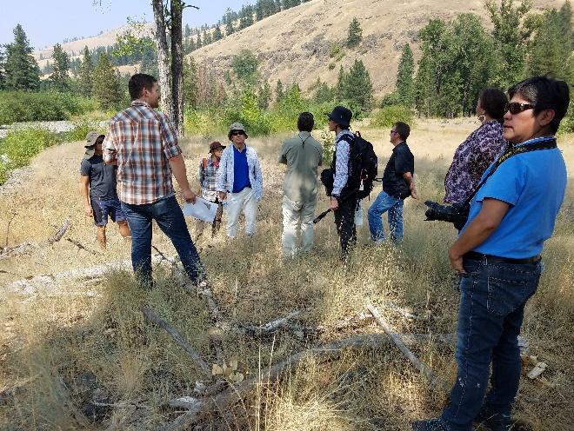 | 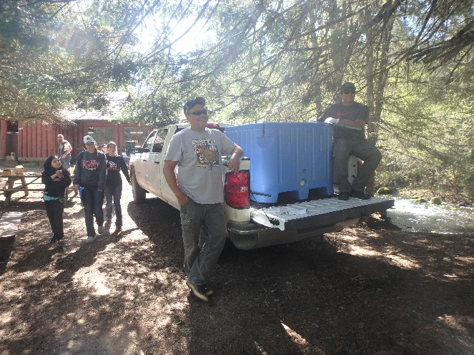
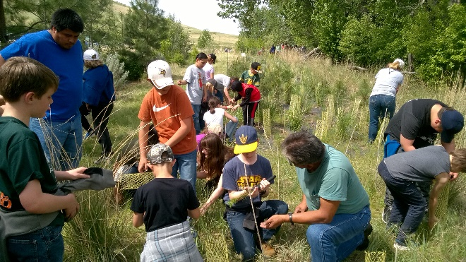 | 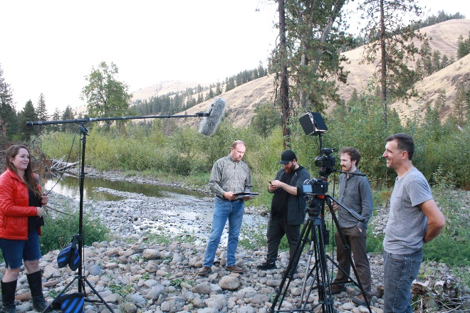
Figure 10. UBAFHP outreach and education activities. Clockwise from top left: UBAFHP staff presenting to visiting scientists from the Geological Survey of Japan; CTUIR staff participating in the Outdoor School program; UBAFHP staff participating in an Oregon Lottery media shoot; UBAFHP staff assisting local elementary school students plant native plants at the annual Watershed Field Days.

Project staff also developed and fostered relationships with participating experts in related fields by attending training, professional workshops and working groups, and gained professional advancement and improved project success through informative, instructional interactions. The CTUIR participated in the 2018 USDA-FS Ranger Summit where UBAFHP staff presented to District Rangers from across the Western United States on floodplain restoration efforts and interagency coordination.

CTUIR UBAFHP and DNR Fisheries Habitat Program staff attended multiple professional conferences and workshops in this review period. Staff from the UBAFHP attended the Western Division American Fisheries Society annual meeting to receive the Riparian Challenge Award for the Meacham Creek Floodplain Restoration and In-stream Enhancement Project – Phase I. The UBAFHP also participated in presentations of project activities including:

River Restoration Northwest (2018)
Designing Restoration for Climate Change Resiliency: Strategies for Meacham Creek – Richard Christian, Mike Lambert, and Chris James (Tetra Tech)

River Restoration Northwest (2018 – Poster)
Giving a Dam: An Implementation of the Beaver Restoration Assessment Tool in the Middle Columbia River Basin – Ethan Green

Work Element I: 186. Operate and Maintain Habitat/Passage/Structure
Work Element Title: Inspect and Maintain Function of In-stream Improvement Structures
Milestone Deliverable: Maintain Proper Operation of In-stream Habitat Structures

A. Environmental compliance requirements complete.
B. The inspection, replacement and/or maintenance of passage and habitat structures.
C. Hire contractor to perform work.

CTUIR monitors 6 passage rectification projects to assure that treatments are effectively working and to insure that intrusive objects are not interfering with the designed function of the passage structures (Table 7). Routine quarterly scheduled site visits of individual projects are conducted either independently by the CTUIR or jointly with project partners such as ODFW. Site visits typically follow significant flow events or responses to landowner requests at project sites. Project maintenance included, but was not limited to, meeting specified conditional language in state and Federal permits, maintaining debris that is routinely captured or caught on in-stream structures, responses to landowner requests and concerns, and completion of post-treatment surveys to monitor and quantify changes to physical and ecological responses.

Work Element J: 186. Operate and Maintain Habitat/Passage/Structure
Work Element Title: Maintenance of Habitat Features Associated with Project Conservation Easements
Milestone Deliverable: Maintenance of Land or Structures Associated with Conservation Easements

A. Environmental compliance requirements complete.
B. Adhere to details of existing easements and/or initiate additional agreements as feasible.

The purpose of these conservation easements is to protect, enhance, and restore functional floodplain, channel, and watershed processes to provide sustainable and healthy habitat for aquatic species in the Umatilla River subbasin. The UBAFHP have and will continue to maintain the individual projects to ensure that project structures and fencing are functioning and habitat recovery is progressing towards meeting projects goals and objectives. The CTUIR currently maintains 16 conservation agreements. Current agreements provide secured access and protection of resources for functional floodplain, channel watershed processes to provide sustainable and healthy habitat for aquatic specifies 26 miles of stream. CTUIR routinely conducts custodial maintenance on individual projects to ensure that project structures and fencing are functioning and habitat recovery is progressing towards meeting projects goals and objectives. Activities include, but are not limited to, installing and repairing riparian cattle exclusion fences, maintaining or installing water gaps, riparian and floodplain plantings and maintenance, noxious weed control, maintenance of fish habitat improvement structures, and landowner coordination and education.

Work Element K: 115. Produce Inventory or Assessment
Work Element Title: Field Data Collection
Milestone Deliverable: Summarized aquatic, physical habitat, and water quality data.

A. Environmental compliance requirements complete.
B. Environmental conditions
C. Interpretation and synthesis
D. Incorporate project effectiveness and regional data into project activities and annual BPA report

UBAFHP staff collected and maintained field data necessary to inform project tasks and habitat site management in 2018. Data collected included vegetation surveys from 34 previously and newly established transects in past planting sites to determine site survival, natural regeneration, as well as to survey for any noxious weeds that may require control.

In 2018, mean stem density in planting locations was approximately 0.13 stems per m² (Figure 11A). Mean Shannon-Weiner diversity index value of woody plants was 1.05 and mean woody plant species richness was 4.6 (Figure 11B and 11C). Mean species evenness was approximately 0.77 (Figure 11D). Additionally, naturally recruited plants made up approximately 29% ± 4.4% (mean ± SE) of the woody vegetation surveyed in 2018.

B
C
D
A
Figure 11. Summary of vegetation statistics across the period of record from 2014 to 2018 within the Meacham Creek Floodplain Restoration and In-stream Enhancement project phases I & II. Clockwise from top left: A) Mean stem density per m² by year; B) mean species richness by year; C) mean Shannon-Wiener diversity index value by year; D) mean species evenness by year. Error bars represent standard error.

Concurrently with vegetation transects, previously planted areas were surveyed for invasive weed species. Eleven major weed species were identified in the Meacham Creek Floodplain Restoration and In-stream Enhancement project area in 2018. The most abundant weed species found was Viper’s bugloss (Echinum vulgare) and the highest priority species for control identified was invasive blackberry (Rubus spp.; Table 3).

Table 3. Invasive weed species detected in Meacham Creek Floodplain Restoration and In-stream Enhancement Phase I and II planting areas in 2016 and relative priority for control efforts.
Species Common Name | Species Scientific Name | Priority | Frequency (# of sites present
Diffuse knapweed | Centaurea diffusa | High | 6
Spotted knapweed | Centaurea stoebe | High | 7
Eurasian blackberries | Rubus spp. | High | 12
Sulfur cinquefoil | Potentilla recta | High | 3
Yellow starthistle | Centaurea solstitialis | High | 1
Bull thistle | Cirsium vulgare | Moderate | 2
Multiflora rose | Rosa multiflora | Moderate | 2
St. John’s wart | Hypericum perforatum | Moderate | 3
Viper’s bugloss | Echinum vulgare | Moderate | 13
Wild carrot | Daucus carota | Moderate | 1
Curly dock | Rumex crispus | Low | 3

The CTUIR UBAFHP also continued its intensive photo point monitoring in the 2018 contract year. Photo points captures were conducted in the spring of 2018 and uploaded to the UBAFHP internal photo point data depository (Figure 12).
2011 | 2018
 | 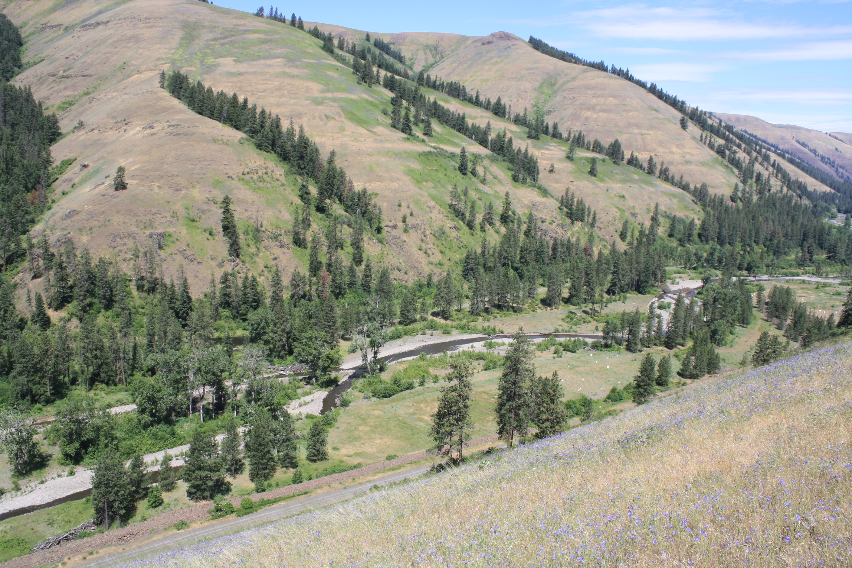
 | 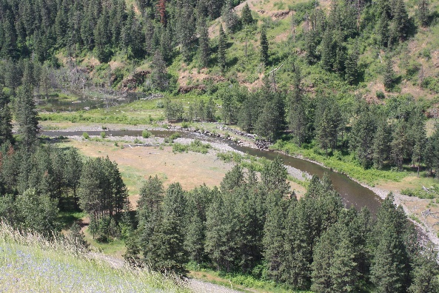
 | 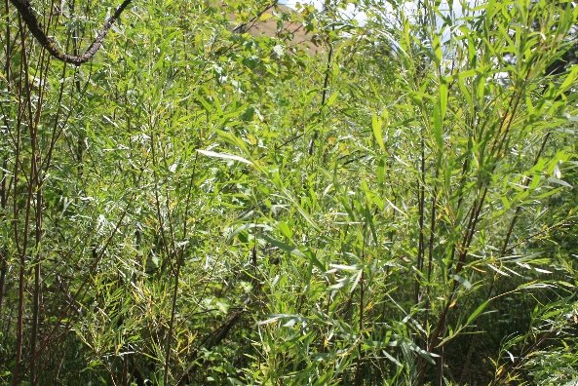
Figure 12. Before (2011) and after (2018) photos of the Meacham Creek Floodplain Restoration and In-stream Enhancement Project RM 6-7 taken at photo point monitoring locations.

Grid-intersect analysis of photo point data from 2011 to 2018 revealed that the proportion of the bankfull channel that supports perennial woody vegetation has been steadily increasing since the completion of the Meacham Creek Floodplain Restoration and In-stream Enhancement Phase I project in 2011. Immediately after construction, approximately 36.6% ± 4.9% (mean ± SE) of the bankfull channel supported perennial woody vegetation, whereas in 2018, 89% ± 1.5% was vegetated (Figure 13).
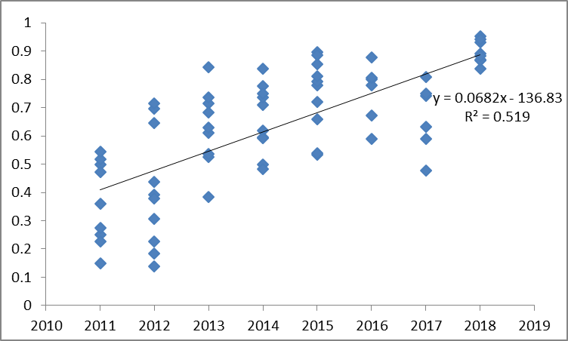
Figure 13. Proportion of vegetated bankfull channel length within the Meacham Creek Floodplain Restoration and In-stream Enhancement Phase I project area by year based on grid-intersect analysis of photo point data.

Work Element L: 198. Maintain Vegetation
Work Element Title: Maintain Vegetation and Control Noxious Weeds in Project Areas within the Umatilla River Subbasin
Milestone Deliverable: Maximize Survival of Native Vegetation in Enhancement Project Areas

A. Environmental compliance requirements complete.
B. Physical removal of non-preferred species of vegetative growth from project area.
C. Weed control in project areas by chemical means.
D. Water vegetation and reduce weed competition to improve survival at CTUIR project areas.
E. Till established weed areas as necessary for noxious weed control.

Project activities conducted in 2018 included the monitoring and maintenance of 16 conservation agreements on numerous individual landowner properties. Watering, weeding and maintenance methods for each conservation easement and project area is important for enhanced native vegetation and project site but maintenance varies by site conditions. Strategies to address weeds are included in agreements that are either completed by the landowner, CTUIR, subcontractor, and/or through the County Weed Control Board. CTUIR staff provides assistance to landowners by coordinating and managing herbicide application, providing funding, and developing treatment strategies. Manual, biological and chemical treatment options are utilized by CTUIR and may be employed when consistent with existing standards. Weed control is essential in establishing native grass and plant species. The UBAFHP maintains a licensed pesticide applicator on staff to spray/control noxious weeds on sites where chemical application is necessary. This staff member identifies problem weeds, determines the appropriate herbicide and selects the most effective application methods and rates in accordance with the National Oceanic and Atmospheric Administration's (NOAA) Biological Opinion under BPA's Habitat Improvement Program. The UBAFHP utilizes backpack spraying applications to treat perennial, annual and biennial weed species. All herbicide applications are consistent with Oregon Revised Statue (ORS).570.505 and Federal Insecticide, Fungicide and Rodenticide Act (FIFRA) Regulations. CTUIR complies with BPA standards and supplies a report to BPA detailing the types and quantities of herbicides applied to specified locations.

In 2018 the UBAFHP completed 237 acres of mechanical and chemical weed treatment on current and completed project areas (Table 5).

Work Element M: 175. Produce Design and/or Specifications
Work Element Title: Wildhorse Creek – Athena Fish Passage Project Design
Milestone Deliverable: Complete a design and implementation schedule for one fish passage project on Wildhorse Creek in the city of Athena, OR.

In 2017, the CTUIR selected an engineering firm to design the preferred alternative proposed in the Athena Bridge feasibility report. The selected design firm began producing the design in the 2017 contract year. The 100% final design was delivered to the CTUIR in May 2018.

Work Element N: 184. Install Fish Passage Structure
Work Element Title: Wildhorse Creek – Athena Fish Passage Project Implementation
Milestone Deliverable: The CTUIR will work collaboratively with the ODFW, UBWC, City of Athena and Umatilla County to replace an aging bridge on 3rd Street in Athena, OR, to restore upstream fish passage through the project reach.

In 2018, the CTUIR collaboratively worked with project partners to completed permitting, intergovernmental agreements, and secured funding to enable the completion of the Wildhorse Creek Athena Fish Passage Project. The CTUIR worked closely with the UBWC to purchase the prefabricated concrete bridge necessary to replace the current concrete box culvert. The CTUIR also solicited and issued a tentative award for construction of the project. Due to circumstances out of the control of the CTUIR, the selected contractor opted not to sign the contract to construct the project. The second contractor that responded to the Request for Proposals was not deemed responsible and a contract for construction was unable to be awarded in the 2018 contract year. The prefabricated modular concrete bride was able to be purchased and was delivered to a holding location in Mission, OR, in November-December 2018 (Figure 14).

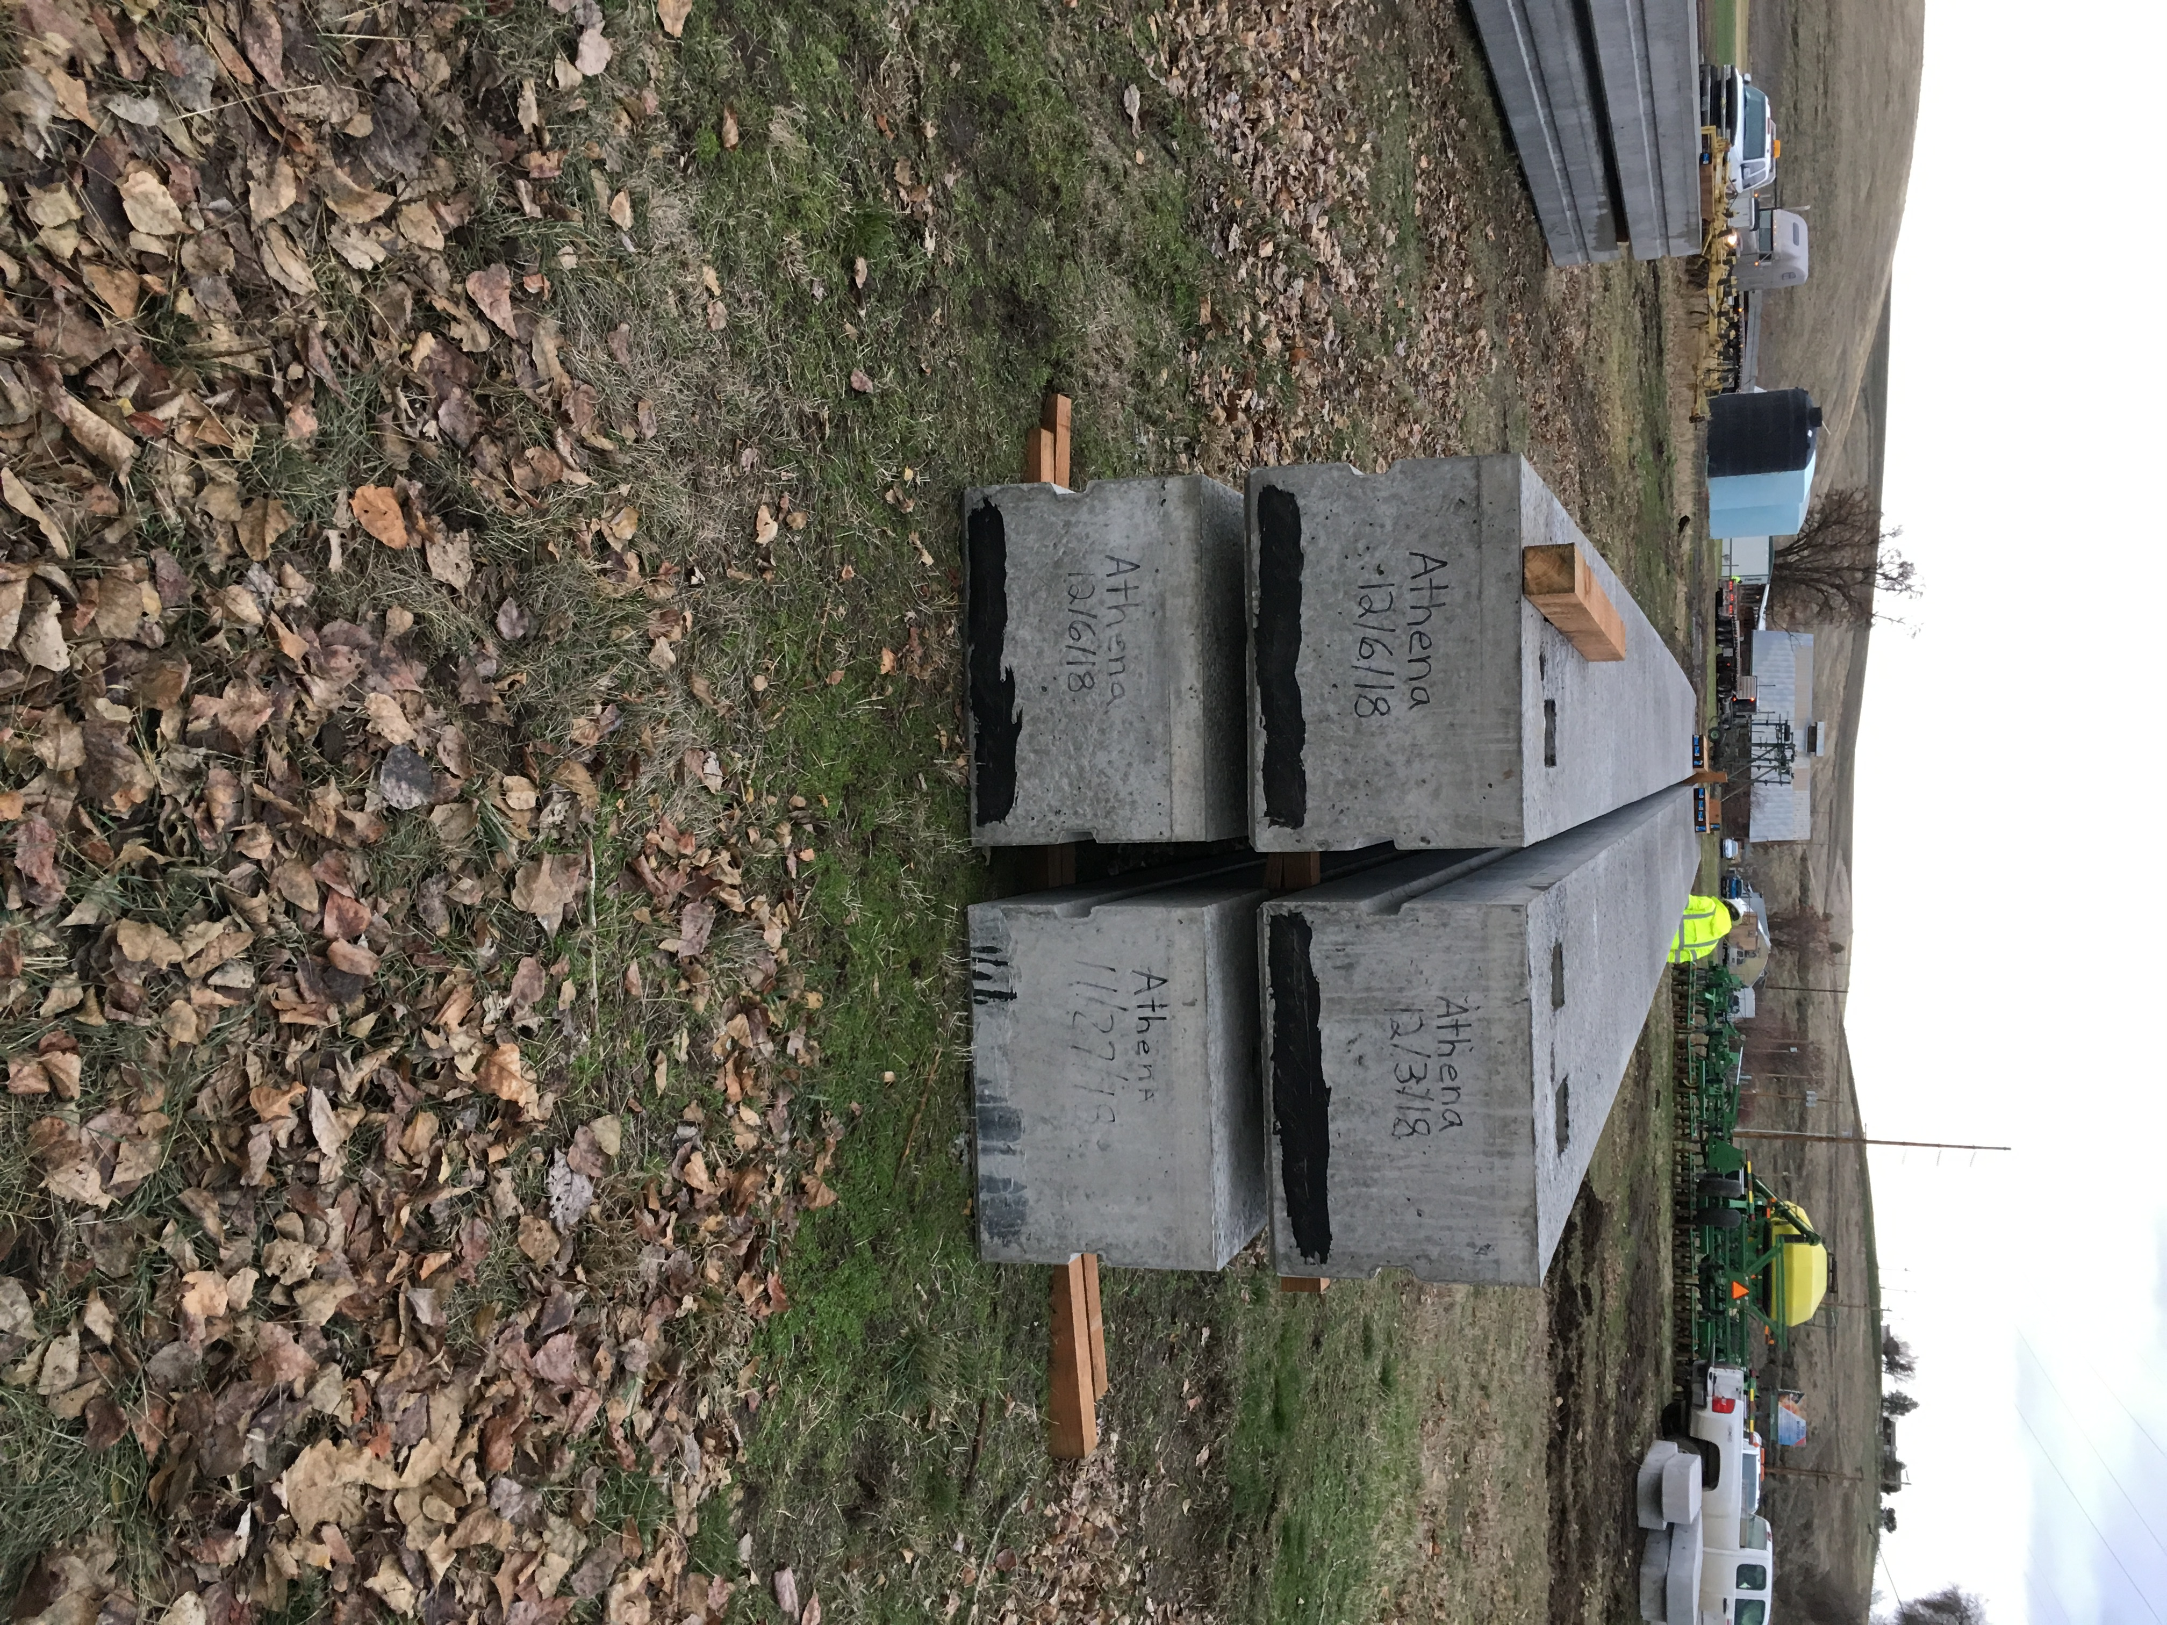
Figure 14. Precast, prestressed concrete bridge deck planks delivered to Mission, OR, in December 2018.

Work Element O: 47. Plant Vegetation
Work Element Title: Meacham Creek Floodplain Restoration and In-Stream Enhancement, RM’s 3.8-6.1
Milestone Deliverable: Complete Scheduled Tree and Shrub Plantings in Project Areas

A. Environmental compliance requirements complete.
B. Agreement with the Native Plant Nursery for Growing Plants and Developing Plant Protocol.
C. Establish Planting Locations in Existing Project Areas for Increased Recovery.

UBAFHP staff annually plant vegetation and distribute native grass seed in areas we have implemented existing or new habitat enhancement projects or have identified a need in maintained riparian conservation easement areas. In 2018, UBAFHP staff revegetated sensitive areas within Project Areas 3 and 4 of the Meacham Creek Bonifer Reach Floodplain Reconnection and In-steam Enhancement Project. Planted areas included wetland and riparian areas where immediate erosive potential is high and where immediate vegetative cover would be most beneficial for riparian shading and fish habitat. Overall, 8,225 containerized plants and 1,000 willow cuttings were planted over 4.7 acres in the fall 2018 planting effort. Native grass seed was spread on all disturbed areas, including all acres that were planted with containerized plants. The total acreage seeded in 2018 exceeded 15.8 acres (Figure 15).

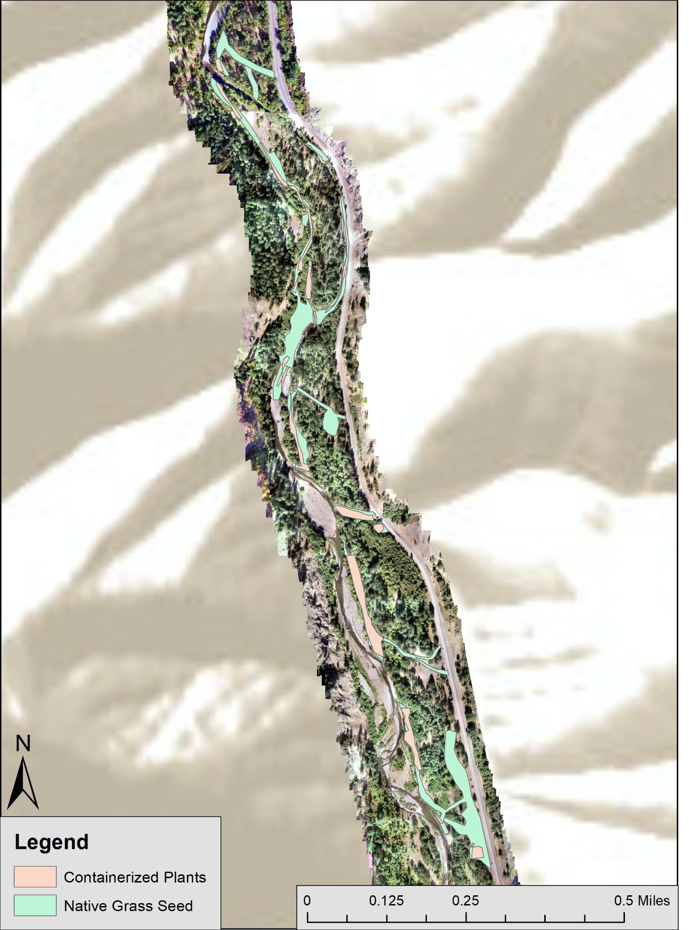
Figure 15. Areas within the Meacham Creek Bonifer Reach Floodplain Reconnection and In-stream Enhancement Project where native vegetation was planted by UBAFHP staff. Background is drone orthography captured by the CTUIR post-implementation in September 2018.

Planting tasks include site planning and development of planting strategies, collection and preparation of materials (pruning and conditioning of live willow material), pre-order coordination with the CTUIR Tribal Native Plant Nursery, and installation. Planting techniques are customized for conditions within each project area. Planting location, species, age, form (cuttings, saplings, bare-roots, potted, plugs), and soil/substrate conditions were considered and addressed during the implementation planning phase (Figure 16). The CTUIR UBAFHP staff work closely with the Tribal Native Plant Nursery to collect local seed and plant stock to provide native plants for particular project areas by elevation and planting zones.

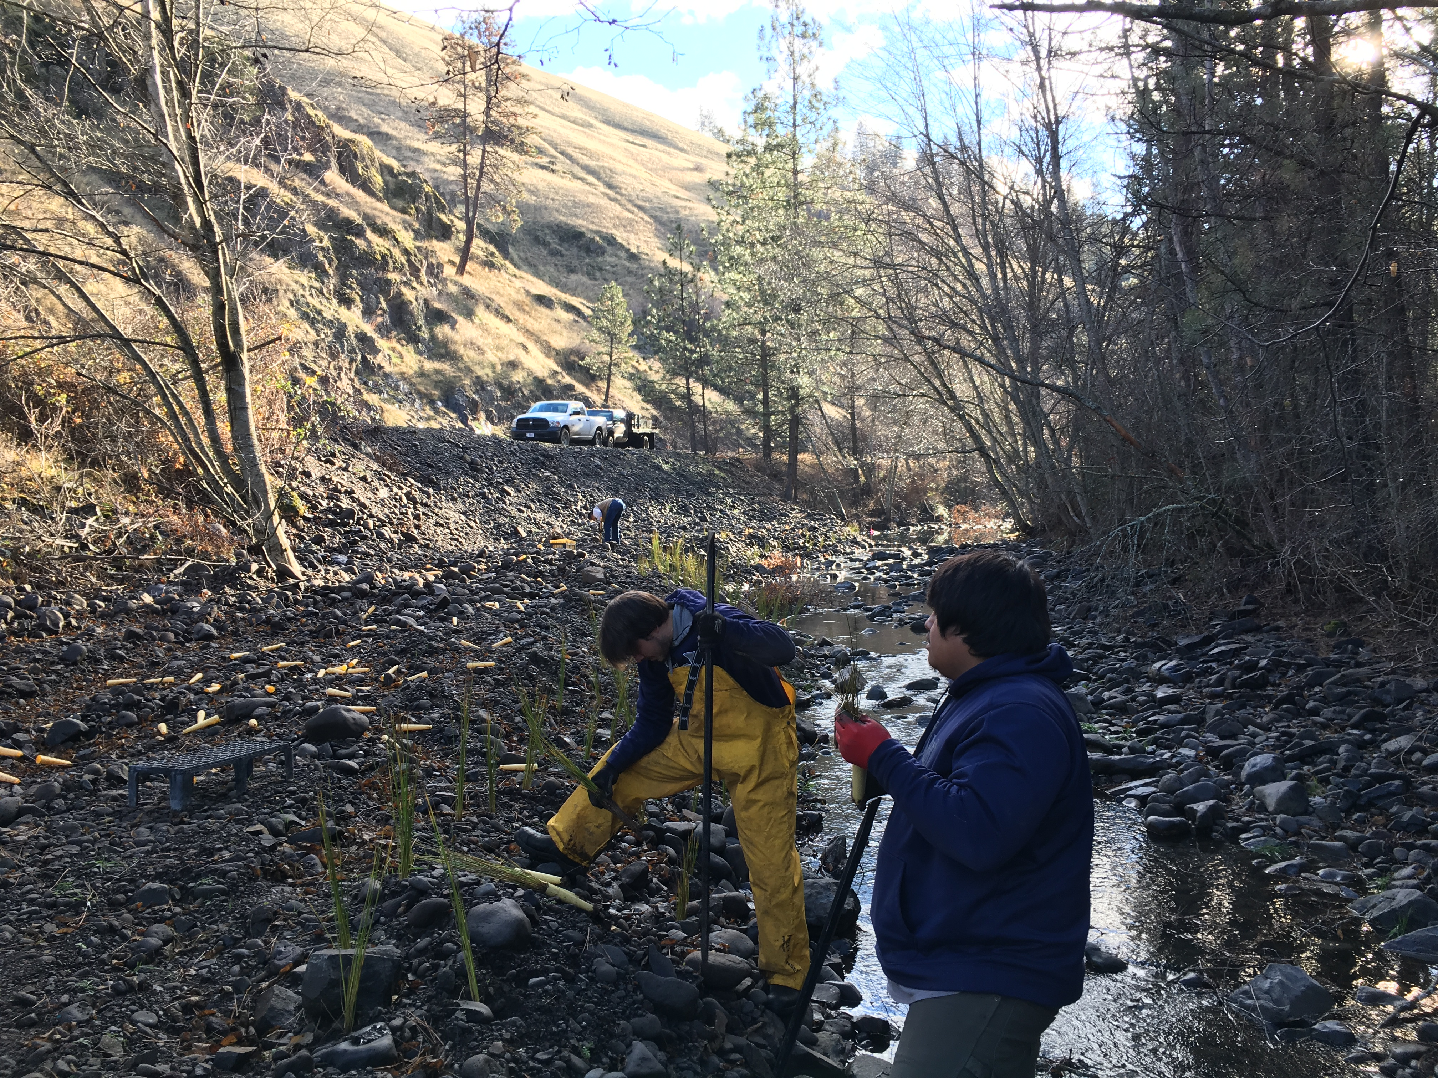
Figure 16. UBAFHP staff planting wetland plants in the riparian area of the Meacham Creek Bonifer Reach Floodplain Reconnection and In-stream Enhancement Project.

Work Element P: 180. Enhance Floodplain/Remove, Modify, Breach Dike
Work Element Title: Construction – Bonifer Floodplain Reconnection and In-stream Enhancement – PA 3 & 4
Milestone Deliverable: Complete removal of 2,130 linear feet of levees and dikes in the Meacham Creek Bonifer Reach Project Areas 3 and 4.

CTUIR subcontracted construction services to complete removal of levees and dikes in the Meacham Creek Bonifer Reach Project Areas 3 and 4 as part of the Bonifer Reach Floodplain Reconnection and In-Stream Enhancement Project. Partial implementation of Project Areas 3 and 4 occurred in 2017. The remainder of the levee removals in Bonifer Reach Project Areas 3 and 4 were completed in this contract year including approximately 2,130 linear feet of levees and dikes.

Work Element Q: 29. Increase Aquatic and/or Floodplain Complexity
Work Element Title: Construction – Bonifer Floodplain Restoration and In-stream Enhancement – PA 3 & 4
Milestone Deliverable: Complete installation of 499 pieces of large wood and install 59 engineered log jams.

CTUIR subcontracted construction services to complete installation of large wood structures in the Meacham Creek Bonifer Reach Project Areas 3 and 4 as part of the Bonifer Reach Floodplain Reconnection and In-Stream Enhancement Project. Partial implementation of Project Areas3 and 4 occurred in 2017. The remainder of the large wood in Bonifer Reach Project Areas 3 and 4 was installed in this contract year including 1049 pieces of large wood (499 logs with rootwads and 550 tops) and 59 engineered log jams.

Work Element R: 30. Realign, Connect, and/or Create Channel
Work Element Title: Construction – Bonifer Floodplain Restoration and In-stream Enhancement – PA 3 & 4
Milestone Deliverable: Complete construction of 1,810 linear feet of primary and secondary channel.

CTUIR subcontracted construction services to complete construction of primary and secondary pilot channels in the Meacham Creek Bonifer Reach Project Areas 3 and 4 as part of the Bonifer Reach Floodplain Reconnection and In-Stream Enhancement Project. Partial implementation of Project Areas 3 and 4 occurred in 2017. The remainder of the designed channel construction in Bonifer Reach Project Areas 3 and 4 was constructed in this contract year. Channel construction in 2018 included 560 feet of primary channel construction and 1,280 feet of side channel construction which functioned to reconnect an additional 2,210 feet of relic primary channel.

Work Element S: 172. Conduct Pre-Acquisition Activities
Work Element Title: Conduct pre-acquisition activities for Birch Creek-Umatilla River confluence, UmaBirch LLC Properties
Milestone Deliverable: Produce the necessary documents and conduct surveys necessary to move forward with purchasing a conservation easement on the UmaBirch properties.

Significant coordination and planning efforts were accomplished in the 2018 contract year to advance this project to the execution of a conservation easement. The UBAFHP has been working closely with the landowner, other CTUIR projects, the UBWC, and the Blue Mountain Land Trust to determine the scope and terms of the easement, as well as the steps necessary to complete a conservation easement. Over the course of this contract year, the CTUIR held several coordination meetings to discuss next steps, coordinated with the landowner to consolidate ownership of several taxlots into a more manageable format for the easement, and initiated the process to produce a preliminary title report for the taxlots subject to the conservation easement. While progress was made, the deliverable for the Work Element was not fully met in this contract year. However, the landowner and the CTUIR are very motivated to complete the easement and the consolidation of ownership should facilitate further steps to be taken in contract year 2019. The conservation easement is anticipated to be completed in 2019.

Work Element T: 175. Produce Design and/or Specifications
Work Element Title: UmaBirch Properties – Floodplain Restoration and Habitat Enhancement Design
Milestone Deliverable: Produce designs and constructible implementation plans for several phases of restoration work on the UmaBirch easement property.

In contract year 2018, due to the uncertainties with the timeline and ultimate scope of the UmaBirch conservation easement, a full design process was not initiated for the UmaBirch floodplain restoration and habitat enhancement project. Instead, the CTUIR coordinated with BPA engineering staff to begin designing a discrete portion of the UmaBirch project that could be completed independent of the rest of the larger project (Figure 17). The Taylor Dam (formerly referred to as the Brown’s Dairy Dam) is a defunct diversion dam that presents a partial barrier to some life stages of migrating fish at some life stages. The UmaBirch landowner and adjacent landowner were willing to remove the dam and the only remaining water right with the dam as the point-of-diversion irrigates the UmaBirch property. The last remaining water right is currently in the process of having the point-of-diversion moved. The CTUIR provided BPA engineering staff with LiDAR and physical survey data to support the design effort. The removal design is anticipated to be completed in spring 2019.

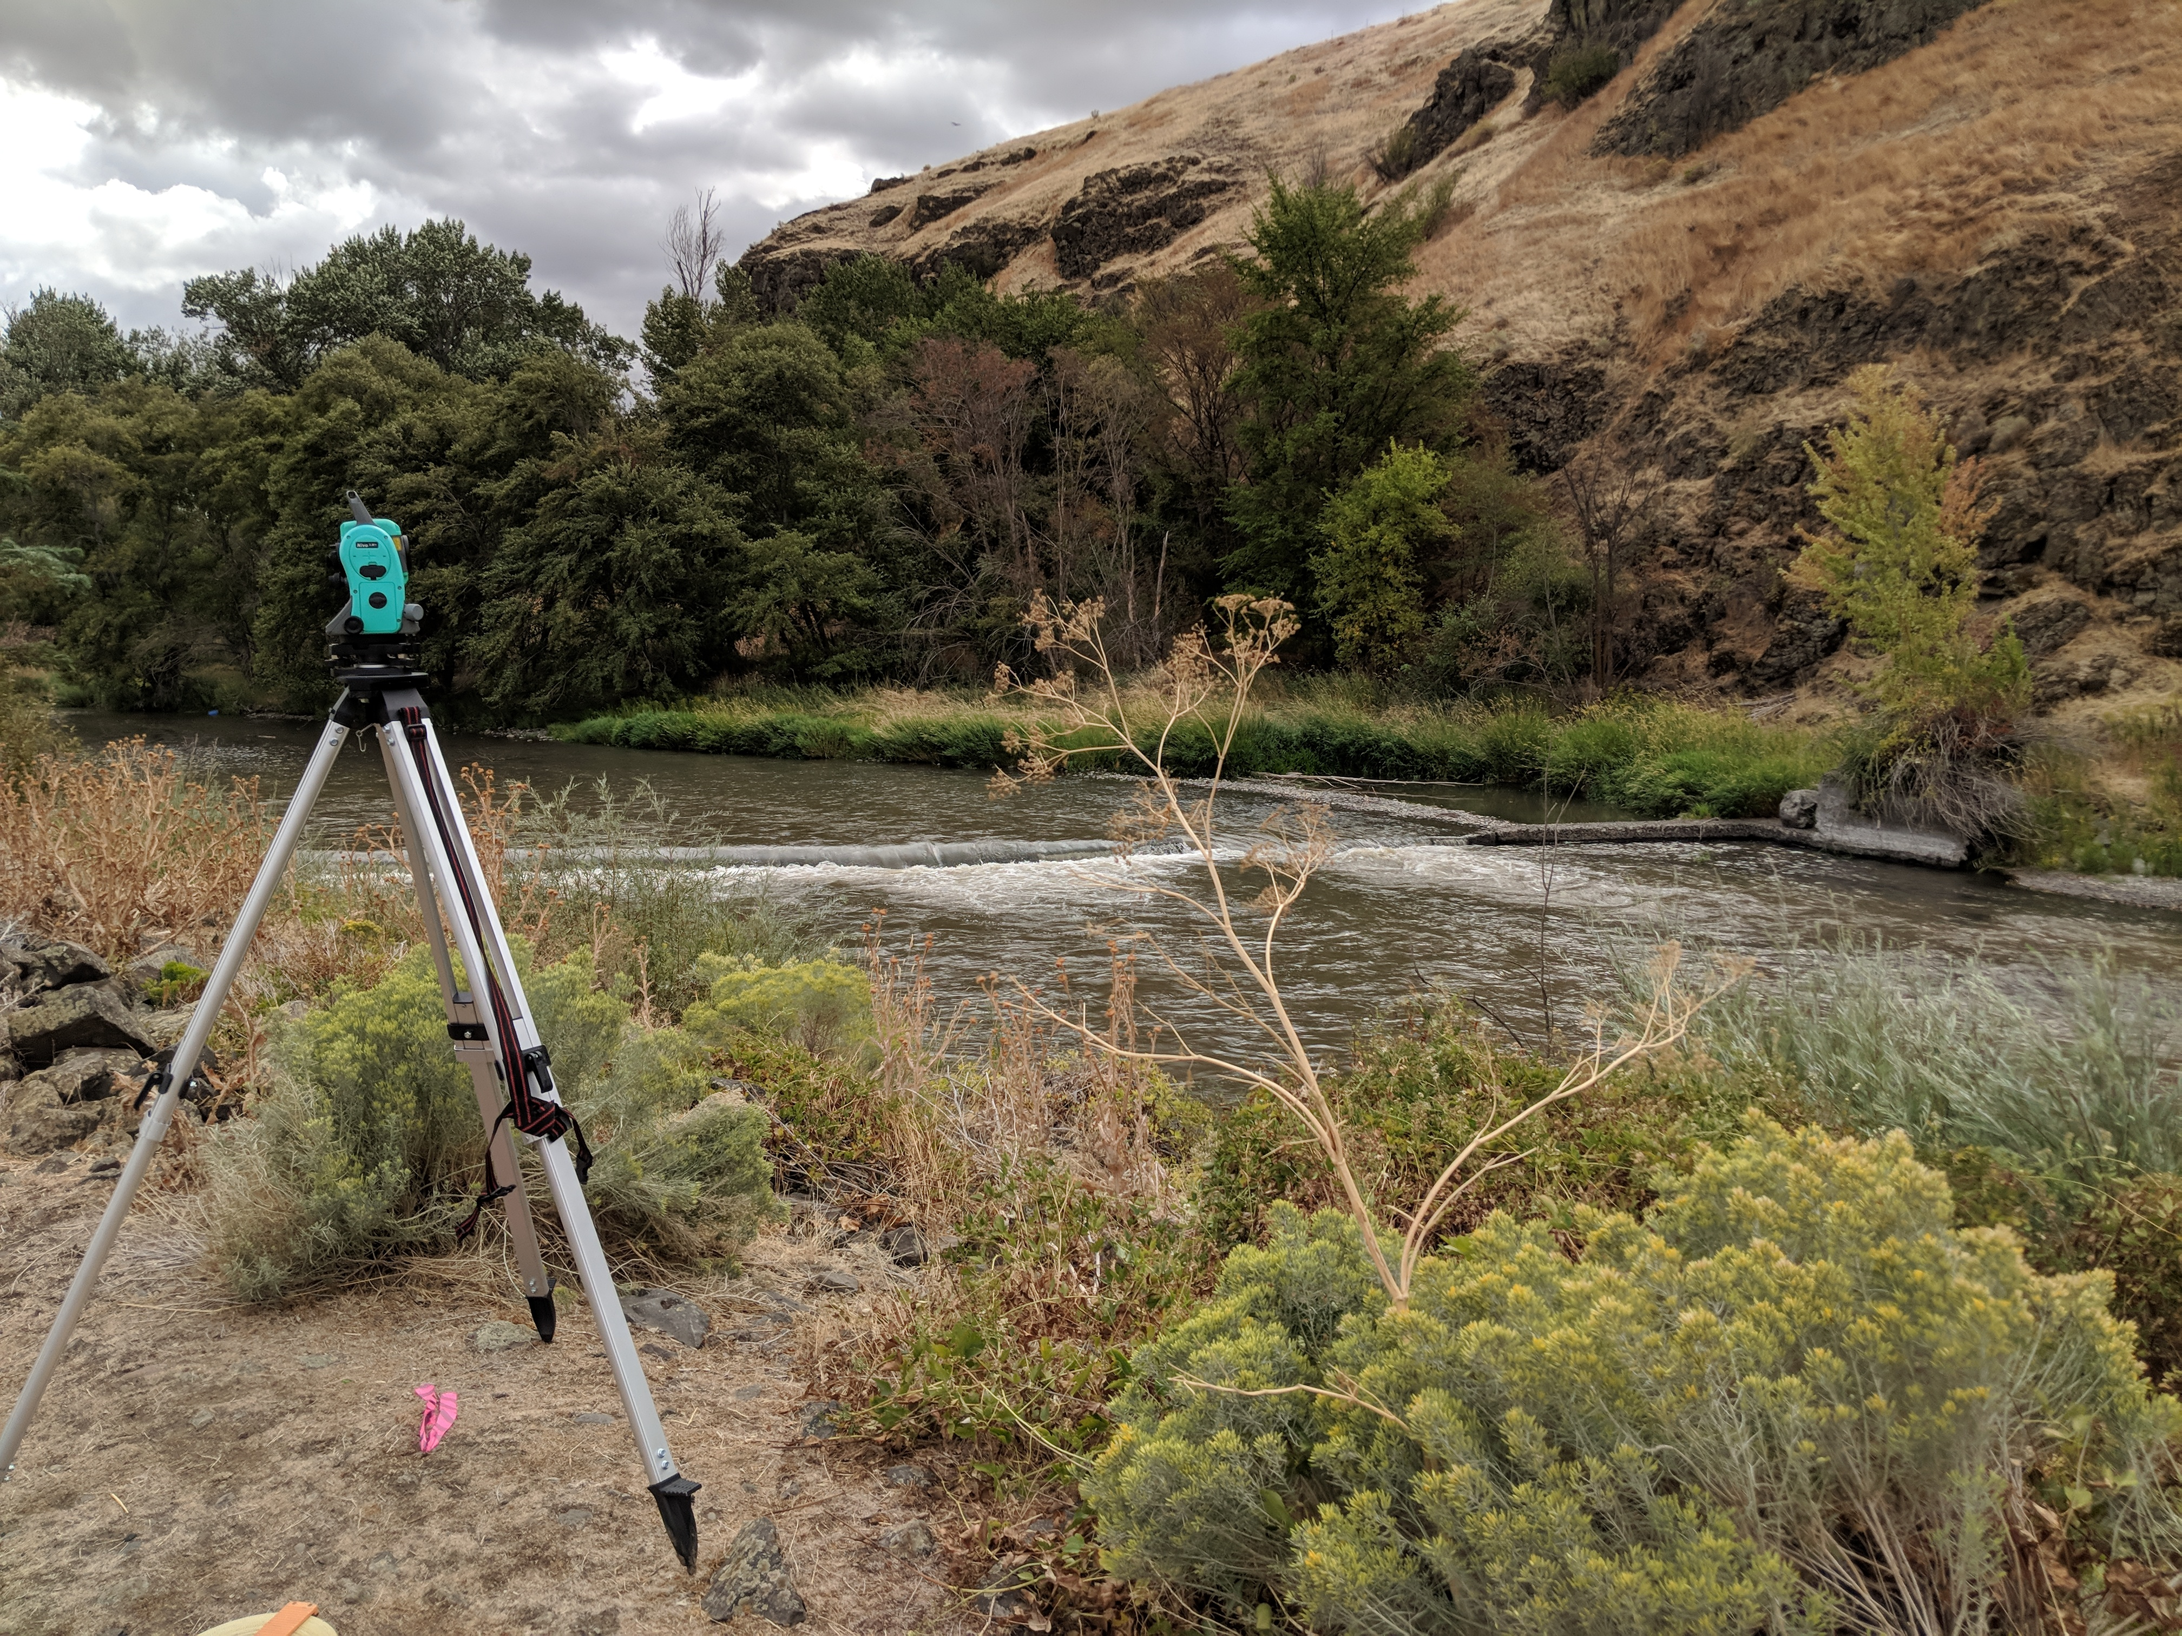
Figure 17. CTUIR staff conducting total station surveys of the Taylor Diversion Dam to support BPA engineering staff in designing the removal of the dam.

Work Element U: 115. Produce Inventory or Assessment
Work Element Title: Produce Umatilla River Subbasin Assessment
Milestone Deliverable: Deliver a partial assessment including draft vision statement, draft objectives, data gaps, outline, and approach.

In this contract year, the CTUIR focused on identifying data gaps, developing an internal technical team, scoping the assessment, and weighing different approaches to the Umatilla River assessment. The UBAFHP worked closely with the CTUIR GIS department to identify existing data in the CTUIR repositories and in public databases as well as determining where critical data gaps exist. This information will be rolled into contract year 2019 where the UBAFHP will solicit proposals to begin composing the assessment document. In contract year 2018 the UBAFHP also began coordinating with stakeholders including various tribal government departments, federal and state agencies, local governments, and local nonprofits to begin assembling a core technical team and several smaller teams to work on specific components of the assessment (e.g. Fisheries Committee).

Work Element V: 175. Produce Design and/or Specifications
Work Element Title: East Birch Creek RM 5.3 – 5.8 Habitat Enhancement Project Design
Milestone Deliverable: Complete a design and implementation plan for a floodplain reconnection and habitat enhancement project.

In this contract year, the UBAFHP solicited proposals for engineering firms to create the design and implementation plan. A firm was selected and the design process began in this contract year. The UBAFHP worked closely with the selected engineering firm and the landowner to determine project elements and a more detailed footprint that would both satisfy the needs of the landowner and provide the fisheries uplift required for the UBAFHP. A 15% design was produced in contract year 2018, which led to additional concerns from the landowner and further discussions. The UBAFHP consulted with the BPA RRT for guidance on what quantity of fisheries benefit would be required for continued funding and consideration. After going through several rounds of comments with RRT, the UBAFHP and the landowner decided to move forward to a 30% design and revisit the recommendations from RRT and determine if it is acceptable for the landowner to feel comfortable moving forward with the project. The design and implementation plan is anticipated to be completed in contract year 2019 with implementation anticipated in 2020.

Work Element W: 29. Increase Aquatic and/or Floodplain Complexity
Work Element Title: Install Wildhorse Creek Beaver Dam Support Structures
Milestone Deliverable: Work cooperatively with the SWCD to install 8 beaver dam support structures.

The CTUIR entered into a partnership with the Umatilla County SWCD to design and install a pilot project for BDS structures. The CTUIR was responsible for providing a design and completing cultural resources surveys (if necessary) and ESA consultation through the BPA HIP III programmatic. The Umatilla County SWCD was responsible for securing OWEB small grant funding and completing any state and local permits. The UBAFHP completed a design and consulted with the RRT to develop a low-risk beaver dam support structure project. The UBAFHP also requested cultural resource surveys and was provided a report from a survey that was previously completed in the area. The SWCD did secure funding for installation in this contract period, but was unsuccessful in obtaining permits to implement the project in contract year 2018. Due to permitting uncertainties with the Oregon Department of State Lands, ODFW, and USACE, it was decided to permit the project through a full Joint Permit Application and abandon attempting to permit the project at a lower level. A JPA will be developed in early 2019 and implementation is anticipated in summer of 2019

Table 4. Noxious weed treatments completed by location within the Umatilla River Basin, 2017.
Stream Name | Latitude | Longitude | Acres Treated | Method | Species Targeted
Meacham Creek | 45.6222 | -118.35 | 35.9 | Chemical | Potentilla recta, Centaurea spp.
Wildhorse Creek | 45.7483 | -118.58 | 2 | Mowing | Conium maculatum
Umatilla River | 45.661 | -118.99 | 56.7 | Chemical | Lepidium spp., Centaurea spp.
Total Acres Treated |  |  | 94.6

Table 5. Noxious weed treatments completed by location within the Umatilla River Basin, 2018.
Stream Name | Latitude | Longitude | Acres Treated | Method | Species Targeted
Meacham Creek | 45.6222 | -118.35 | 136 | Chemical | Potentilla recta, Centaurea spp.
East Birch Creek | 45.7483 | -118.58 | 1 | Mowing | Rosa multiflora, Rubus spp.
Umatilla River | 45.661 | -118.99 | 99 | Chemical | Lepidium spp., Centaurea spp.
Total Acres Treated |  |  | 236.0

Table 6. Planting materials and grass seed by species, quantity, and size, planted and established at Umatilla River Basin existing and new project sites, 2017-18.
Stream | Date Planted | Project Site Location | Species (Common Name) | Quantity
Meacham Creek | May 2017 | Meacham Creek Floodplain Reconnection Phase I | Mountain Alder | 99
Meacham Creek | May 2017 | Meacham Creek Floodplain Reconnection Phase I | Serviceberry | 54
Meacham Creek | May 2017 | Meacham Creek Floodplain Reconnection Phase I | Red Osier Dogwood | 99
Meacham Creek | May 2017 | Meacham Creek Floodplain Reconnection Phase I | Douglas’ Hawthorn | 50
Meacham Creek | May 2017 | Meacham Creek Floodplain Reconnection Phase I | Baltic Rush | 31
Meacham Creek | May 2017 | Meacham Creek Floodplain Reconnection Phase I | Mock Orange | 45
Meacham Creek | May 2017 | Meacham Creek Floodplain Reconnection Phase I | Mallow Ninebark | 54
Meacham Creek | October 2017 | Meacham Creek Bonifer Project Area 3 & 4 | Thinleaf Alder | 75
Meacham Creek | October 2017 | Meacham Creek Bonifer Project Area 3 & 4 | Red Osier Dogwood | 96
Meacham Creek | October 2017 | Meacham Creek Bonifer Project Area 3 & 4 | Oceanspray | 38
Meacham Creek | October 2017 | Meacham Creek Bonifer Project Area 3 & 4 | Mallow Ninebark | 39
Meacham Creek | October 2017 | Meacham Creek Bonifer Project Area 3 & 4 | Douglas’ Hawthorn | 51
Meacham Creek | October 2017 | Meacham Creek Bonifer Project Area 3 & 4 | Juncus spp. | 411
Meacham Creek | October 2017 | Meacham Creek Bonifer Project Area 3 & 4 | Bigleaf Sedge | 103
Meacham Creek | October 2017 | Meacham Creek Bonifer Project Area 3 & 4 | Water Sedge | 103
Meacham Creek | October 2017 | Meacham Creek Bonifer Project Area 3 & 4 | Seep Monkeyflower | 68
Meacham Creek | November 2018 | Meacham Creek Bonifer Project Area 3 & 4 | Mountain Alder | 210
Meacham Creek | November 2018 | Meacham Creek Bonifer Project Area 3 & 4 | White Alder | 54
Meacham Creek | November 2018 | Meacham Creek Bonifer Project Area 3 & 4 | Red Osier Dogwood | 848
Meacham Creek | November 2018 | Meacham Creek Bonifer Project Area 3 & 4 | Black Cottonwood | 88

Stream | Date Planted | Project Site Location | Species (Common Name) | Quantity
Meacham Creek | November 2018 | Meacham Creek Bonifer Project Area 3 & 4 | Bigleaf Sedge | 1531
Meacham Creek | November 2018 | Meacham Creek Bonifer Project Area 3 & 4 | Water Sedge | 365
Meacham Creek | November 2018 | Meacham Creek Bonifer Project Area 3 & 4 | Juncus spp. | 3034
Meacham Creek | November 2018 | Meacham Creek Bonifer Project Area 3 & 4 | Seep Monkeyflower | 400
Meacham Creek | November 2018 | Meacham Creek Bonifer Project Area 3 & 4 | Common Tule | 535
Meacham Creek | November 2018 | Meacham Creek Bonifer Project Area 3 & 4 | Douglas’ Spirea | 300
Meacham Creek | November 2018 | Meacham Creek Bonifer Project Area 3 & 4 | Douglas’ Hawthorn | 98
Meacham Creek | November 2018 | Meacham Creek Bonifer Project Area 3 & 4 | Mallow Ninebark | 577
Meacham Creek | November 2018 | Meacham Creek Bonifer Project Area 3 & 4 | Oceanspray | 111
Meacham Creek | November 2018 | Meacham Creek Bonifer Project Area 3 & 4 | Common Snowberry | 74
Meacham Creek | November 2018 | Meacham Creek Bonifer Project Area 3 & 4 | Willow spp. | 1000
Total Potted Plants |  |  |  | 9,641
Total Willow Cuttings |  |  |  | 1,000
Total Plants |  |  |  | 10,641

Table 7. Habitat passage structures monitored and maintained by CTUIR to meet design specifications.
Year | Stream | Stream Location | Project Description
2007 | Meacham Creek | RM 1.7 | Passage rectified by removing large cabled boulders (improved adult passage)
2007 | Meacham Creek | RM 20.2 | Partial dam removed (juvenile and adult passage)
2007 | Camp Creek | RM 0.3 | Partial dam removal (juvenile and adult passage)
2007 | Greasewood Creek | RM 0.4 | Partial dam removal (juvenile and adult passage)
2007 | West Birch Creek | RM 3.2 | Roughened channel to restore proper gradient and reduce step height at road bridge crossing for adult passage
2008 | West Birch Creek | RM 2.7 | Hoeft Dam fish passage rectification (juvenile and adult passage)

Table 8. Meacham Creek Bonifer Reach implementation schedule.
Implementation Year | Project Areas | Stream Location | Project Description
2017-18 | 3 & 4 | RM 4.05 – 5.7 | Remove levees/dikes, create primary and secondary channel, enhance pool/alcove habitat, construct large woody jams, add large wood, construct embankments
2019 | 2 | RM 3.25 – 4.05 | Create primary and secondary channel, add large wood
2020 | 1 & 5 | RM 1.9 – 3.25, Bonifer Pond | Reconnect Bonifer Pond to Boston Canyon Creek, remove levees/dikes, create side channel, add large wood, construct embankments

Discussion

The projects implemented in this reporting period were carefully designed in previous years to mitigate for the identified ecological concerns and align with local assessments. The CTUIR approaches restoration utilizing the Umatilla River Vision, previously described (Jones et al. 2008). The process-based philosophy of the River Vision encourages development of projects that address multiple River Vision Touchstones, limiting factors, and ecological concerns (Table 9).

Table 9. The Umatilla Anadromous Fish Habitat Project objectives relative to the Umatilla River Vision touchstones (Jones et al. 2008), BPA 2008 Fish Accords primary limiting factors (Fish Accords 2008) and NOAA’s ecological concerns (NMFS 2009).
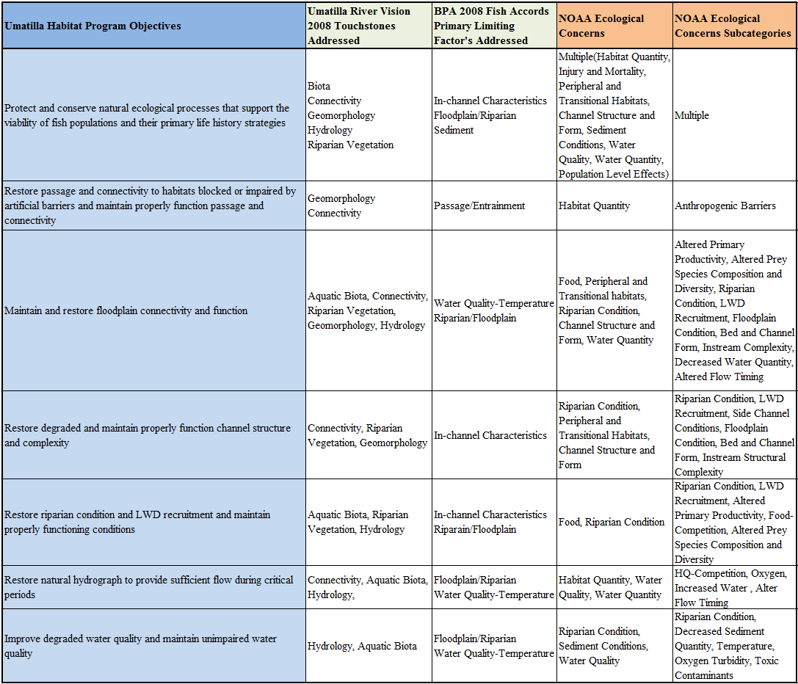

Habitat protection and restoration actions, like those completed during this review period, were identified in numerous local assessments and planning documents. The Umatilla River Basin TMDL and WQMP (ODEQ and CTUIR 2001), Umatilla/Willow Subbasin Plan (NPCC 2005), Middle Columbia Steelhead DPS ESA Recovery Plan (2009), and the Recovery Plan for the Coterminous United States Population of Bull Trout (USFWS 2015) all identify one or more habitat restoration or protection actions implemented by the UBAFHP in this reporting period as a way to address issues facing ESA-listed fish species and/or water quality concerns. In addition to the subbasin-scale planning documents, the restoration activities completed by the UBAFHP in this reporting period are also supported by several smaller scale watershed assessments. The Meacham Creek Watershed Analysis and Action Plan (Andrus and Middel 2003) and the Birch Creek Watershed Action Plan (CTUIR 2016) both specifically support the restoration actions completed in those watersheds.

LESSONS LEARNED AND ADAPTIVE MANAGEMENT

Lessons Learned

During this reporting period, the UBAFHP completed work in areas with multiple jurisdictions, subcontracted several large design and construction contracts, and maintained complex partnerships with landowners and local action agencies. The wide variety of work presented a number of unique challenges. As a result of working through these challenges, the UBAFHP has learned several lessons that will inform future project work.

During the planning and permitting stage of the Meacham Creek Bonifer Reach Floodplain Reconnection and In-stream Enhancement Project in CY2017, the UBAFHP had to work through a novel scenario. At no time in the past has the CTUIR completed a large-scale floodplain restoration project within the boundaries of the Umatilla Indian Reservation. The project also incorporated several different land ownerships including tribally-owned simple fee and tribal trust and individual trust allotments with fractionated ownership that are administered by the BIA. Permitting the project required the UBAFHP to “blaze a trail” through the regulatory processes of the various jurisdictions of Tribal, Federal, State, and local governments. The uncertainty of how to move forward with landowner permissions did ultimately delay implementation of the Bonifer Reach project in CY2107 and lead to a two-year implementation of Project Areas 3 & 4. However, UBAFHP projects will benefit from the process outlined for permitting and gaining landowner permissions through the BIA and future project delays may be avoided more easily.

Several of the projects in this reporting period included working closely with agency partners and participating landowners. Cultivating these partnerships has led to rewarding outcomes as well as occasionally limiting progress on project work. One of the successes in this project period that required close coordination with agency and landowner stakeholders in the basin was the completed removal of the Dillon Diversion Dam in CY2017. The UBAFHP worked with the subbasin co-managers at ODFW, the UBWC, water users at the Dillon Irrigation Company, and surrounding landowners to complete the project. This complex project required leveraging the strengths of the different stakeholders and strategically targeting funding sources for different components of the project as a whole. By collaborating and working as a restoration team, a longstanding barrier was removed from the Umatilla River.

Conversely, not all of the collaborative projects proposed in this reporting period have gone exactly as planned. The UBAFHP also partnered with partner agencies to implement a beaver dam support structure pilot project. The UBAFHP completed ESA consultation and designed the project, whereas partners were responsible for permitting and securing funding. While the roles of each organization were identified at the outset of the partnership, UBAFHP staff failed to maintain close coordination and follow-up with project partners during the height of the field season and as a result, permitting began too late for implementation in this reporting period. In the future, the UBAFHP will clearly identify project goals and timelines to potential partner organizations at the beginning of projects and maintain coordination throughout to ensure all parties complete their assigned tasks. In a similar vein, the UBAFHP also faced some challenges with landowner partnerships on some projects. The UBAFHP has been developing and designing a floodplain reconnection project on East Birch Creek on a private landowner’s property. The CTUIR and the landowner entered into an agreement to pursue a mutually-beneficial project, but there have been significant differences in stakeholder priorities since the design began in CY2018. Design firm and UBAFHP staff have been attempting to balance floodplain connection, fisheries benefit, and the concerns of the landowner and the time and effort put into landowner engagement and negotiation has led to the design being delayed. At present, the design is proceeding to a 30% design of the preferred alternative with the understanding that the landowner and CTUIR will agree to the project footprint and general project elements at that stage and continue with the design. In the future, the UBAFHP will make an effort to complete more landowner education when entering into a partnership, as well as clearly define the goals of all groups as well as the timeline for the project and relevant deadlines.

Finally, one project during the reporting period was delayed as a result of the selected contractor rescinding their proposal before the project initiation, leaving little time to get a contract in place with another firm. Part of the issue was that the one other firm that submitted a proposal did not submit a technically adequate proposal and was disqualified from further consideration. In order to maximize the number of responses to solicitations in the future, the UBAFHP is attempting to advertise IFBs and RFPs as early as possible before implementation. The hope is that if the UBAFHP encounters the situation again, there will be a second responsible contractor able to complete the work without incurring any undue delays to the project.

Adaptive Management

The UBAFHP places a heavy weight on adaptive management, applying lessons learned in past years, and using research and action effectiveness monitoring data to support project decision making.

Lessons learned identified in previous year’s annual reports play a large part in the management of habitat restoration site and the development of future projects. For example, in the CY2016 annual report, we identified recommendations for increasing planting survival and increasing revegetation success following restoration projects. In this reporting period, the UBAFHP has incorporated those recommendations into the annual planting plan. For example, the CTUIR has adopted a planting methodology that prioritizes immediate planting of wetland and riparian areas and letting heavily disturbed upland/floodplain areas settle for two years prior to planting containerized plants. The plant mix that UBAFHP staff planted was also much more targeted to the microsites available in the planting locations, ensuring that more hydrophilic species are planted in the most sensitive sites. The UBAFHP continues to improve the species mix based on ecological suitability and enhancement of First Foods species. Similarly, all plantings were completed in fall, taking advantage of a longer dormancy window in the plants and allowing containerized plant’s roots to infiltrate the soil early and quickly in the spring and take advantage of seasonally high groundwater elevations.

The UBAFHP also kept revegetation in mind during implementation. Based on observed conditions in previous year’s projects, projects completed in this reporting period included enhanced floodplain topography creation to help increase plating survival and natural vegetative regeneration. In any area of disturbed floodplain encountered in UBAFHP project areas (e.g. the floodplain surface following a levee removal), 2-5 foot deep depressions were excavated to mimic natural floodplain features such as relic channels. Excavating these depressions allows groundwater to be nearer to the ground surface, becoming more available to young plants. Additionally, the floodplain topography creates microsites that collect floodwaters and precipitation and provide cover from insolation and wind that may help plants naturally establish and become a seed source and additional cover for other plants.

The UBAFHP also incorporated lessons learned in past years into project development and implementation methodology. During the design process for the Meacham Creek Bonifer Reach Floodplain Reconnection and In-stream Enhancement project, the UBAFHP and the design firm engaged in a lessons learned exercise to improve the design process from the Meacham Creek Phase I and Phase II projects. One of the recommendations of this exercise was to make more efficient and judicious use of large woody material. This recommendation was also supported by CTUIR biomonitoring reporting that concluded that most of the large wood installed in previous project was not in contact with the water during summer baseflow. During this reporting period, staff made a concerted effort to place individual pieces of large wood directly in contact with baseflow and “seed” the upper end of the project area with unanchored pieces of wood in the anticipation of the creek self-sorting wood into more natural aggregations.

In addition to the lessons learned from previous project years, project staff also incorporate data collected by other CTUIR projects and from annual project data inventories of previously implemented projects. The UBAFHP annually inventories plant survival and revegetation progress, as well as noxious weed presence and extent of infestations. The UBAFHP is responsible for treating noxious weeds on several hundred acres of project areas and staffing and time constraints mean that treatment areas and species must be prioritized in order to achieve project objectives of promoting native plant growth in project areas. The UBAFHP sets priorities and manages conservation agreement properties using a rich dataset collected by project staff as well as incorporating data from the Oregon Department of Agriculture, USDA-FS, and Umatilla County Public Works. Using this dataset, the UBAFHP is able to identify the highest priority weeds in priority areas, direct staff time to the most important areas, and apply the least invasive and most ecologically benign treatment while remaining effective.

The UBAFHP also integrates data collected from research, monitoring, and evaluation efforts by the CTUIR and ODFW to inform future project development. Monitoring of outmigrating steelhead smolt survival from the Meacham Creek and Birch Creek screw traps to Three Mile Dam suggest that the mainstem Umatilla River is a source of significant mortality. Survival rates between Meacham Creek and Three Mile Dam have been recorded as low as 22% (Contor et al. 2016). Recognizing that many of the juvenile salmonids currently being produced in the system are not successfully migrating to the mainstem Columbia River and the Pacific Ocean beyond, the UBAFHP has begun planning more habitat improvements in the mainstem Umatilla River. The objective is to improve habitat conditions in the mainstem Umatilla River to provide outmigrating smolts habitat to rear over winter, refuge from high flow events, cover from predators, and increased water quality.

SUMMARY AND CONCLUSIONS

In accordance with the 2006 NPCC solicitation outline, the CTUIR UBAFHP since 2007 focused its restoration activities primarily on Meacham Creek, Birch Creek, and mainstem Umatilla River. However, project restoration activities occur in other areas of the basin where floodplain and riverine processes are treated with outcomes that are beneficial to ecological processes, water quality and fish production. The Meacham Creek Watershed has long been a primary focal point of the CTUIR effort to improve habitat conditions in the Umatilla Basin because of its location, size, historical significance, and recovery potential. Table 10 highlights the CTUIR Umatilla Anadromous Fish Habitat Project restoration accomplishments since 2007.

Proposed restoration actions have focused on protection, enhancement, and restoration of functional floodplain, channel and watershed processes at multiple scales using passive and active restoration techniques. Over the past decade, the CTUIR Department of Natural Resources and UBAFHP have transitioned from restoration toward a fixed endpoint to address symptoms to a restoration of processes. Restoration of process is more likely to address causes of river ecosystem degradation, whereas restoration toward a fixed endpoint addresses only symptoms. Specific restoration actions proposed for completion by CTUIR, partnering agencies and hired independent contractors include levee and dike removal and or modification, floodplain and channel construction, in-stream and floodplain large wood debris additions, in-stream structure placement, wetland enhancement, floodplain and riparian plantings, noxious weed removal, riparian management through fencing, and removal of physical migration barriers. The UBAFHP have and will continue to maintain project areas under secured conservation agreements with landowners on private properties for protection and enhancement of floodplain and riparian habitat and investments from past passage and in-stream structure projects. Completed project activities are described below in more detail in the context of the watershed with reference to annual progress reports.

During this reporting period, the UBAFHP continued to implement habitat improvement projects at a high level. The Dillon Dam Removal was a long-discussed project in the subbasin that had never been implemented in the past. The CTUIR UBAFHP was able to work with agency partners and private stakeholders to implement the removal and rectify a partial barrier to upstream salmonid migration that had been recognized as a significant issue in the subbasin. The UBAFHP was also able to complete over 1.6 miles of floodplain reconnection and in-stream enhancement in the Meacham Creek Bonifer Reach. The project included levee removals, relic channel reconnection, and large wood addition that will “jumpstart” natural floodplain processes and set the reach on a recovery trajectory. In addition to project implementation, UBAFHP staff completed maintenance of ongoing riparian enhancement and passage projects at properties where the CTUIR has pre-existing riparian conservation agreements. This maintenance included noxious weed treatment, maintenance of built structures, and additional riparian plantings as needed.

The CTUIR UBAFHP completed several design documents that will serve to inform projects in the long and near term future of the UBAFHP. First, the UBAFHP also completed a full design and implementation plan to rectify a fish passage barrier at the 3rd Street Bridge in Athena, Oregon. This project is crucial to reconnect over 24 kilometers of potential spawning habitat for Middle Columbia River Steelhead. The UBAFHP also completed an in-house design for a BDSS pilot project. While the project itself is small, it is an important step in determining the feasibility and usability of beaver restoration strategies in the Umatilla River subbasin and will help determine if a larger-scale beaver restoration program is an effort worth undertaking. Lastly, the UBAFHP produced a preliminary design for a floodplain reconnection and in-stream enhancement project on East Birch Creek. This project is a direct result of the Birch Creek Watershed Action Plan process and is an important first step in the watershed.

A principal strength and focus of the CTUIR UBAFHP project is the ability to work cooperatively with the various entities throughout the restoration process. Staff participated and cooperated with multiple agencies and stakeholders in the Umatilla Basin Watershed including ODFW, USDA-FS, Natural Resource Conservation Service, Umatilla Basin Watershed Council, Umatilla County Soil and Water Conservation District, and local stakeholders to enhance or protect natural resources, identify problems and solutions, coordinate efforts to prevent duplication, enhance communication and cooperation and identify funding and cost share opportunities within the Umatilla River Subbasin.

The Umatilla Basin Anadromous Fisheries Habitat Project is an ongoing effort to protect, enhance and restore functional floodplain, channel and watershed processes to provide sustainable and healthy habitat for aquatic species in the Umatilla River Basin, including Threatened Middle Columbia River Steelhead. Project work further supports the CTUIR Department of Natural Resource River Vision and First Foods mission statements to sustain production. The River Vision principles have been successfully applied in effort to reestablish the salmonids to self-sustaining levels. We expect a substantial positive response of salmonid populations once habitat floodplain and channel function is addressed and improved. We believe a positive correlation between habitat improvement, salmonid density, and fitness levels will shift the status of ESA-Listed species towards a safer level of sustainability in the Umatilla River Basin
Table 10. The CTUIR UBAFHP restoration project descriptions by location, treated primary limiting factors (NMFS 2009) by CTUIR River Vision touchstones (Jones et al. 2008) and accomplishments; 2007-2016.
Subbasin, Stream and Years | Project Description | Species | CTUIR River Vision Touchstones/ Habitat Limiting Factors (PLF’s shaded in yellow-NOAA BiOP) |  |  |  |  |  |  |  | Comment/  Accomplishments
Subbasin, Stream and Years | Project Description | Species | Biota-Connectivity | Geomorphology | Connectivity |  | Hydrology |  |  | Riparian Vegetation | Comment/  Accomplishments
Subbasin, Stream and Years | Project Description | Species | Passage Barriers/ Entrainment | In-channel Characteristics | Habitat Diversity (LWD) | Floodplain Confinement | High Temps | High  Turbidity | Low Flows | Riparian/  Floodplain | Comment/  Accomplishments
Meacham Creek and Camp Creek, Tributary of Meacham Creek (2007) | Fish passage rectifications, pool development with rock structures, and plantings | STS | X |  |  |  | X |  |  | X | Rectified two diversion dams and one in-stream structure providing unimpeded access to the entire watershed, development of pools with boulder cross vanes, 335 ft of streambank stabilization with added wood complexity, 0.3 miles livestock exclusion fence, and 500 riparian plantings.
West Birch Creek (2007-2008) | Fish passage rectification, riparian protection fencing and plantings | STS | X |  | X |  | X |  |  | X | Rectification of the Cunningham and Hoeft Dams providing 2.4 miles unimpeded habitat, 335 ft of streambank stabilization with added wood complexity, 0.3 miles livestock exclusion fence, and 5,000 riparian plants.

Mainstem Umatilla River (Initiated 2008-2012) | Treated and maintained 3.5 miles of floodplain and channel; riparian and uplands | CHS, CHF, STS, Coho |  |  | X |  | X | X | X | X | Conservation easement on B&G Property to maintain 355 (61 riparian and 294 upland acres; installation of 60.7 acres of CREP tract’s), 2 off-channel water wells, 13,400 seedling trees planted, 1,335 lbs of native grass seed and noxious weed control; Installation of an access restriction fence (3 additional riparian acres protected).
Meacham Creek (2009) | Floodplain improvement with levee setback, initiation of off-channel rearing habitat, large wood placement, and riparian plantings | CHS, STS,BT, Pacific Lamprey | X | X | X | X | X |  | X | X | Restored 40 acres of floodplain connectivity over 1-mile of stream by removal or modification of 3 levees and 1 dike (3,200 linear ft, 24,000 cubic yards); distribution of large wood on floodplain; 15,000 planted hardwood and conifer seedlings (30acres).
Meacham Creek (Initiated 2008-2012) | Riparian protection fencing and plantings | CHS, STS,BT, Pacific Lamprey |  | X | X |  | X |  | X | X | Built 9.8 miles of livestock exclusion fence between RM 2.0-8.5 (~350 acres protected).
Birch Creek (2010-2016) | Bank stabilization and large wood habitat complexity and riparian plantings | STS |  | X | X | X | X | X |  | X | Restoration of 335 ft of streambank stabilization with large wood and boulders over 0.1 miles of stream, 2 large wood in-channel habitat structures, and planted 5,000 riparian plantings over the 1-mile property.
Meacham Creek Floodplain Restoration and In-Stream Enhancement Phase I Project RM 6-7.1 (2011-2012) | Floodplain and channel improvement with levee setback, large wood placement, side-channel connectivity, wetland enhancement, and riparian plantings. | STS, CHS, BT, Pacific Lamprey |  | X | X | X | X | X | X | X | Reconnected 67 acres of floodplain over 1-mile of stream by removing a 2,800 foot levee and modification of two spur dikes (600 ft removed), realigned historic channel with meanders in the floodplain, developed 3 secondary channels and 3,568 ft of off-channel habitat, 12 large pool structures, 10 major and 286 medium rock and log features, and installed 38,290 plantings.
Birch Creek (2012) | Fish passage rectification and habitat restoration project. | STS, Coho | X | X |  | X | X | X |  | X | Removed two abandoned irrigation diversions (Taylor Property-ODFW lead agency) providing unimpeded access to 2.7 river miles of stream. Included channel reshaping, setback of leveed road adjacent to the channel; and reshaping of the channel and banks, two j-hook rock structure placements and riparian plantings over 0.6 miles of stream.
West Birch Creek (2012) | Fish passage rectification and habitat restoration project. | STS | X | X | X |  | X | X |  | X | Removed one abandoned irrigation diversion (Low Property-ODFW lead agency) providing unimpeded access to 5.0 river miles of stream, installation of rock and large wood structures, channel re-shaping and plantings over 1-mile of stream.
Dillon Diversion Dam Removal (2017) | Fish passage rectification | STS, CHS, CHF, Coho, BT, Pacific Lamprey | X | X |  |  |  |  |  |  | Removed a longstanding partial barrier to upstream migration and opened an additional 3.65 miles of river to unimpeded travel for anadromous salmonids.
Meacham Creek Bonifer Reach Floodplain Reconnection and In-stream Enhancement – Project Areas 3 & 4 (2017-2018) | Floodplain and channel improvement with levee removal, channel reconnection, large wood placement, and riparian plantings | STS, CHS, BT, Pacific Lamprey |  | X | X | X | X | X | X | X | Treated over 1.6 miles of Meacham Creek by removing 3,385 linear feet of levees and dikes, reconnecting 3,766 linear feet of primary and secondary channel habitat, and installing 69 engineered log jams with more than 537 logs with rootwads attached.
Basin-wide easements O&M  (2008-2018) | Ongoing maintenance of 17 riparian conservation agreements including livestock exclusion fencing, tree planting and weed control | CHS, CHF, STS, Coho, BT, Pacific Lamprey | X | X | X | X | X | X | X | X | 552 acres protected and maintained, 15.15 miles of riparian fence protection (184 ac.), 7,300 planted hardwood seedling trees.

LITERATURE CITED

Alt, D. and D.W. Hyndman 1995. Northwest Exposures: A Geologic Story of the Northwest. Mountain Press Publishing Company, Missoula, MT.

Andrus, C. & J. Middel 2003. Meacham Creek Watershed Analysis and Action Plan; Final Report. pp. 125, Prepared for the Confederated Tribes of the Umatilla Indian Reservation.

Arrigoni, A.S., Alicia S., Poole, G.C., Mertes, L.A.K., O'Daniel, S.J., Woessner, W.W., Thomas, S.A. 2008. Buffered, lagged, or cooled? Disentangling hyporheic influences on temperature cycles in stream channels. WATER RESOURCES RESEARCH, VOL. 44, W09418, 13 PP

Arscott, D. B., K. Tockner, and J. V. Ward. 2000. Aquatic habitat diversity along the corridor of an alpine floodplain river (the Fiume Tagliamento, Italy). Archiv Fur Hydrobiologie 149:679-704.

Arscott, D. B., K. Tockner, and J. V. Ward. 2001. Thermal heterogeneity along a braided floodplain river (Tagliamento River, northeastern Italy). Canadian Journal of Fisheries and Aquatic Sciences 58:2359-2373.

Baxter, C. V., and Hauer, F. R. 2000. Geomorphology, hyporheic exchange, and selection of spawning habitat by bull trout (Salvelinus confluentus): Canadian Journal of Fisheries and Aquatic Sciences 57:1470-1481.

Beechie, T., and Bolton, S., 1999. An approach to restoring salmonid habitat-forming processes in Pacific Northwest watersheds: Fisheries 24:6-15.

Beechie, T.J., G. R. Pess, P. Roni, G. Giannico. 2008. Setting river restoration priorities: a review of approaches and a general protocol for identifying and prioritizing actions. North American Journal of Fisheries Management 28:891-905.

Beechie, T.J., Sear, D.A., Olden, J.D., Pess, G.R., Buffington, J.M., Moir, H., Roni, P., and Pollock, M.M., 2010, Process-based principles for restoring river ecosystems: Bioscience, v. 60, p. 209-222.

Bencala, K.E., and Walters, R.A., 1983, Simulation of solute transport in a mountain pool-and-riffle stream: A transient storage model: Water Resources Research, v. 19, p. 718-724.

Bernhardt, E.S., Palmer, M.A., Allan, J.D., Alexander, G., Barnas, K., Brooks, S., Carr, J., Clayton, S., Dahm, C., Follstad-Shah, J., Galat, D., Gloss, S., Goodwin, P., Hart, D., Hassett, B., Jenkinson, R., Katz, S., Kondolf, G.M., Lake, P.S., Lave, R., Meyer, J.L., O'Donnell, T.K., Pagano, L., Powell, B., and Sudduth, E., 2005, Ecology - Synthesizing US river restoration efforts: Science, v. 308, p. 636-637.

Boulton, A.J., Datry, T., Kasahara, T., Mutz, M., and Stanford, J.A., 2010, Ecology and management of the hyporheic zone: stream-groundwater interactions of running waters and their floodplains: Journal of the North American Benthological Society, v. 29, p. 26-40.

BOR (Bureau of Reclamation). 1988. Umatilla Basin Project, Oregon. Planning report, final environmental impact statement. Boise, Idaho.

Boyce, R. R. 1986. A comprehensive plan for rehabilitation of anadromous fish stocks in the Umatilla river basin. Final report of the Oregon Department of Fish and Wildlife to Bonneville Power Administration, Portland, Oregon. Publication DOE/BP-18008-1.

Brown, A. G. 1997. Biogeomorphology and diversity in multiple-channel river systems. Global Ecology and Biogeography Letters 6:179-185.

Buchanan, D.V. and S.V. Gregory 1997. Development of water temperature standards to protect and restore habitat for bull trout and other cold water species in Oregon. Proceedings of the Friends of the Bull Trout Conference. Calgary, Alberta.

Buffington, J.M., and Tonina, D., 2009. Hyporheic exchange in mountain rivers II: Effects of channel morphology on mechanics, scales and rates of exchange: Geography Compass, 3(3): 1038–1062.

Burkholder, B. K., Grant, G. E., Haggerty, R., Khangaonkar, T., and Wampler, P. J., 2008. Influence of hyporheic flow and geomorphology on temperature of a large, gravel-bed river, Clackamas River, Oregon, USA: Hydrological Processes 22: 941-953.

CHaMP (Columbia Habitat Monitoring Program). 2011. CHaMP 2011 training version 1.1.

CHaMP (Columbia Habitat Monitoring Program). 2012. Scientific protocol for salmonid habitat surveys within the Columbia Habitat Monitoring Program. Prepared by the Integrated Status and Effectiveness Monitoring Program and published by Terraqua, Inc., Wacounda, WA.

Contor, C. R. Editor. 2012. Umatilla Basin Natural Production Monitoring and Evaluation, 2011 Annual Progress Report. Confederated Tribes of the Umatilla Indian Reservation, 46411 Ti’Mine Way, Pendleton, OR. Report submitted to Bonneville Power Administration, Project No. 1990-005-01

Contor, C. R. Editor. 2016. Umatilla Basin Natural Production Monitoring and Evaluation, 2016 Annual Progress Report. Confederated Tribes of the Umatilla Indian Reservation, 46411 Ti’Mine Way, Pendleton, OR. Report submitted to Bonneville Power Administration, Project No. 1990-005-01

Crispell, J.K., Endreny, T.A., 2009, Hyporheic exchange flow around constructed in-channel structures and implications for restoration design: Hydrologic Processes: 23(8), 1158–1168.

CTUIR 1994. Umatilla Basin Natural Production Monitoring and Evaluation, Annual Progress Report 1992-1993. Prepared by Confederated Tribes of the Umatilla Indian Reservation and submitted to Bonneville Power Administration, Project No. 90-005-01.

CTUIR 1995. Umatilla Basin Natural Production Monitoring and Evaluation, Annual Report, 1993-1994, Prepared by Confederated Tribes of the Umatilla Indian Reservation for U.S. Department of Energy, Bonneville Power Administration, Environment, Fish and Wildlife, Portland, OR, April 1995, Project No. 90-005-01.

CTUIR 2000. Umatilla Basin Natural Production Monitoring and Evaluation Project, Annual Progress Report 1997-1998. Confederated Tribes of the Umatilla Indian Reservation, BPA Project No. 1990-005-01.

CTUIR 2005. Confederated Tribes of the Umatilla Indian Reservation Water Code. Prepared by the Confederated Tribes of the Umatilla Indian Reservation, Department of Natural Resources, as amended through Resolution No. 05-027 (March 7, 2005).

CTUIR 2005. Confederated Tribes of the Umatilla Indian Reservation Total Maximum Daily Load for temperature and turbidity. Prepared by the Confederated Tribes of the Umatilla Indian Reservation, Department of Natural Resources, Issued by the US Environmental Protection Agency, Region 10, July 2005. Available online at URL:
http://yosemite.epa.gov/R10/WATER.NSF/TMDLs/Approved+TMDLs.

CTUIR 2007. Biological Assessment, Birch Creek Salmonid Passage Improvements, Umatilla River Basin. Prepared by the Confederated Tribes of the Umatilla Indian Reservation. July 2007.

CTUIR 2008. Umatilla River Basin Anadromous Fish Habitat Enhancement Project, Annual Report, February 1, 2007 – January 31, 2008, Fiscal Year 2007, Document ID# P109208, Contract # 32047. Confederated Tribes of the Umatilla Indian Reservation. Submitted to Bonneville Power Administration, January 2008. Available online as accessed January 22, 2009 at URL: http://pisces.bpa.gov/release/documents/documentviewer.aspx?doc=P109208.

CTUIR 2012. Meacham Creek Floodplain Restoration and In-stream Enhancement Project Completion Report. Published by Tetra Tech, Inc., Bothell, Washington. December 2012.

CTUIR 2012. Umatilla Basin Natural Production Monitoring and Evaluation, 2011 Annual Progress Report. Confederated Tribes of the Umatilla Indian Reservation, 46411 Ti’Mine Way, Pendleton, OR. Report submitted to Bonneville Power Administration, Project No. 1990-005-01

CTUIR 2016. Birch Creek Watershed Action Plan. Mission, Oregon. 115 pp.

CTUIR, ODEQ and UBWC. 2000. Umatilla River Basin Water Quality Analysis in Preparation for the Total Maximum Daily Load (TMDL). Umatilla Stakeholders and Technical Committee.

CTUIR, ODEQ and UBWC. 2000b. Public Comment Draft of the Umatilla River Basin Total Maximum Daily Load (TMDL) and Water Quality Management Plan (WQMP).

CTUIR and ODFW 2006. Five-Year Action Plan for the Development and Maintenance of Habitat Improvement Projects in the Umatilla Subbasin: 2006-2010, Prepared for/Funded by: U.S. Department of Energy, Bonneville Power Administration, and Division of Fish and Wildlife, March 2006.

Downes, B.J., L.A. Barmuta, P.G. Fairweather, D.P. Faith, M.J. Keough, P.S. Lake, B.C. Mapstone, G.P. Quinn. 2002. Monitoring Ecological Impacts: Concepts and Practices in Flowing Waters. Cambridge University Press, Cambridge, UK.

Ebersole, J. L., Liss, W. J., and Frissell, C. A., 2001, Relationship between stream temperature, thermal refugia, and rainbow trout Oncorhynchus mykiss abundance in arid-land streams in the northwestern United States: Ecology of Freshwater Fishes 10:1-10.

Environmental Protection Agency (1986). Quality Criteria for Water. http://water.epa.gov/scitech/swguidance/standards/criteria/aqlife/upload/2009_01_13_criteria_goldbook.pdf

Evans, E. C., and Petts, G. E., 1997, Hyporheic temperature patterns within riffles: Hydrological Sciences Journal 42:199-213.

Fernald, A. G., Landers, D. H., and Wigington, P. J., 2006, Water quality changes in hyporheic flow paths between a large gravel bed river and off-channel alcoves in Oregon, USA: River Research and Applications 22:1111-1124.

Fetter, C. W., Applied Hydrogeology, 3rd ed., 691 pp., Prentice-Hall, Englewood Cliffs, N. J., 1994. Geist, D. R. 2000. Hyporheic discharge of river water into fall Chinook salmon (Oncorhynchus tshawytscha) spawning areas in the Hanford Reach, Columbia River. Canadian Journal of Fisheries and Aquatic Sciences 57:1647-1656.

Freeze, A. R., and Cherry, J. A. (1979). Groundwater. Prentice Hall.

Geist, D. R., Hanrahna, T. P., Arntzen, E. V., McMichael, G. A., Murray, C. J., and Chien, Y., 2002, Physiochemical characteristics of the hyporheic zone affect redd site selection by chum salmon and fall Chinook salmon in the Columbia River: North American Journal of Fisheries Management, 22: 1107-1085.

Gooseff, M.N., Anderson, J.K., Wondzell, S., LaNier, J., and Haggerty, R., 2006, A modeling study of hyporheic exchange pattern and the sequence, size, and spacing of stream bedforms in mountain stream networks, Oregon, USA (Retraction of vol 19, pg 2915, 2005): Hydrological Processes, v. 20, p. 2441-+.

Haggerty, R., Wondzell, S.M., and Johnson, M.A., 2002, Power-law residence time distribution in the hyporheic zone of a 2nd-order mountain stream: Geophysical Research Letters, v. 29. Hanrahan, T. P., 2008, Effects of river discharge on hyporheic exchange flows in salmon spawning areas of a large gravel-bed river: Hydrological Processes 22:127-141.

Harbaugh, A.W., 2005, MODFLOW-2005, The U.S. Geological Survey modular ground-water model—the Ground-Water Flow Process: U.S. Geological Survey Techniques and Methods 6- A16

Harman, W., R. Starr, M. Carter, K. Tweedy, M. Clemmons, K. Suggs, C. Miller. 2012. A Function-Based Framework for Stream Assessment and Restoration Projects. US Environmental Protection Agency, Office of Wetlands, Oceans, and Watersheds, Washington, DC EPA 843-K-12-006.

Hester, E.T., and Gooseff, M.N., 2010, Moving Beyond the Banks: Hyporheic restoration is fundamental to restoring ecological services and functions of streams: Environmental Science and Technology: 44, 1521–1525.

Hester, E. T., Doyle, M. W., and Poole, G. C., 2009, The influence of in-stream structures on summer water temperature via induced hyporheic exchange: Limnology and Oceanography 51:355-367.

Hillman, T. W. 2003. Monitoring Strategy for the Upper Columbia Basin. BioAnalysts, Inc., Eagle, Idaho.

Hoehn, E., and Cirpka, O.A., 2006, Assessing residence times of hyporheic ground water in two alluvial flood plains of the Southern Alps using water temperature and tracers: Hydrology and Earth System Sciences, v. 10, p. 553-563.

Hoverson, Eric D. and Webster, James G. 2009. CTUIR Umatilla Anadromous Fisheries Habitat Project Annual Report, Fiscal Year 2008. Confederated Tribes of the Umatilla Indian Reservation, report submitted to Bonneville Power Administration, Project No. 1987-100-01.

Hubler, S. 2008. PREDATOR: Development and use of RIVPACS-type macroinvertebrate models to assess the biotic condition of wadeable Oregon streams. DEQ08-LAB-0048-TR.

Huff D.D., S.L. Hubler, Y. Pan, and D.L. Drake. 2006. Detecting Shifts in Macroinvertebrate Community Requirements: Implicating Causes of Impairment in Streams. Oregon Department of Environmental Quality. DEQ06-LAB-0068-TR.

Jones, K. L., G. C. Poole, E. J. Quaempts, S. O’Daniel, T. Beechie, 2008. Umatilla River Vision. Prepared for the Confederated Tribes of the Umatilla Indian Reservation, 31 pp.

Karr, J.R. and E.W. Chu. 1999. Restoring Life in Running Waters: Better Biological Monitoring. Island Press, Covelo, California.

Kasahara, T., Hill, A.R., 2006, Hyporheic exchange flows induced by constructed riffles and steps in lowland streams in southern Ontario, Canada: Hydrologic Processes: 20 (20), 4287–4305.

Kondolf, G.M., D.R. Montgomery, H. Piegay, and L. Schmitt. 2003. Geomorphic classification of rivers and streams, in Tools in Fluvial Geomorphology, edited by G.M. Kondolf and H. Piegay, pp. 171-204, John Wiley, Hoboken, NJ.

Lambert, Michael B. and Keith Karoglanian. 2012. The Umatilla Anadromous Fish Habitat Project: 2011 Annual Progress Report. Confederated Tribes of the Umatilla Indian Reservation, report submitted to Bonneville Power Administration, Project No. 1987-100-01.

Lambert, Michael B., James G. Webster, and Eric D. Hoverson. 2011. The Umatilla Anadromous Fish Habitat Project: 2009-2010 Annual Report. Confederated Tribes of the Umatilla Indian Reservation, report submitted to Bonneville Power Administration, Project No. 1987-100-01.

Lamontagne, S., and Cook, P.G., 2007, Estimation of hyporheic water residence time in situ using Rn-222 disequilibrium: Limnology and Oceanography-Methods, v. 5, p. 407-416.

Lucier, A., M. Palmer, H. Mooney, K. Nadelhoffer, D. Ojima, and F. Chavez. 2006. Ecosystems and Climate Change Research Priorities for the U.S. Climate Change Science Program, Special Series No. SS-92-06 of the University of Maryland Center for Environmental Science, Chesapeake Biological Laboratory, Ref. No. [UMCES] CBL 06-038. 50 pp.

Malcolm, I. A., Soulsby, C., Youngson, A. F., and Petry, J., 2003, Heterogeneity in ground water-surface water interactions in the hyporheic zone of a salmonid spawning stream: Hydrological Processes 17:601-617.

Merritt, R.W., K.W. Cummins, and M.B. Berg (eds.) 2008. An Introduction to the Aquatic Insects of North America, 4th edition. Kendall/Hunt Publishing Company, Dubuque, IA.

Miller, S.W., P. Budy, and J.C. Schmidt. 2010. Quantifying macroinvertebrate responses to in-stream habitat restoration: applications of meta-analysis to river restoration. Restoration Ecology 18: 8-19.

Montgomery, D.R., and J.M. Buffington, 1997. Channel-reach morphology in mountain drainage basins. Geological Society of America Bulletin 109(5):596-611.

Montgomery, David R. 2003. King of Fish: The Thousand Year Run of Salmon. Westview Press, Perseus Books Group, Boulder, Colorado.

Moore, Kelley M.S., Jones, Kim, K. Dambacher, Jeffrey M. 2002. Methods for stream habitat surveys version 12.1: Oregon Department of Fish and Wildlife, Aquatic Inventory Project. Corvallis, OR 97730.

Morrill JC, Bales RC, Conklin MH (2005) Estimating stream temperature from air temperature: implications for future water quality. J Environ Eng 131:139–145

Nagle, G. 1998. Report on research project on environmental history of riparian areas in the Umatilla basin. U.S. Forest Service, Pacific Northwest Research Station, Corvallis, Oregon.

NMFS 1996. Making Endangered Species Act determinations of effect for individual or grouped actions at the watershed scale. NMFS Environmental and Technical Services Division, Habitat Conservation Branch.

NMFS 2008. National Marine Fisheries Service Northwest Region. Endangered Species Act – Section 7 Programmatic Consultation Biological Opinion and Magnuson-Stevens Fishery Conservation and Management Act Essential Fish Habitat Consultation. Habitat Improvement Program, Oregon, Washington, and Idaho, CY2007-CY2012 (HIP II).

NMFS (National Marine Fisheries Service) Northwest Region. 2009. Middle Columbia Steelhead distinct Population Segment ESA Recovery Plan. Final Listing November 30, 2009. Available on the internet: http://www.nwr.noaa.gov/Salmon-Recovery-Planning/Recovery-Domains/Interior-Columbia/Mid-Columbia/upload/Mid-C-Plan.pdf

NPCC 1990. Northwest Power Planning Council. Umatilla River Subbasin Salmon and Steelhead Production Plan. Northwest Power Planning Council and the Agencies of the Indian Tribes of the Columbia Basin Fish and Wildlife Authority.

NPCC (Northwest Power Conservation Council). 2004. Draft Willow/Umatilla Subbasin Plan, Prepared by the Umatilla/Willow Subbasin Planning Team. Prepared for the Northwest Power and Conservation Council, May 28, 2004. Available online from the following URL as accessed November 19, 2008: http://www.nwcouncil.org/fw/subbasinplanning/umatilla/plan/.

NPCC (Northwest Power Conservation Council). 2005. Final Umatilla Willow Subbasin Plan. Prepared by the Umatilla/Willow Subbasin Planning Team, for the Northwest Power and Conservation Council, May, 2005.

NRC 1996. Upstream. Salmon and society in the Pacific Northwest. National Research Council, Washington D.C.

O'Daniel, S., J. 2005. Interactions between Regional-Scale Variation in Geomorphology and Potential for Hyporheic Exchange along the Umatilla River, Oregon. Geography. Santa Barbara, University of California.

O'Daniel, S.J., G.C. Poole and L.A.K. Mertes. 2003. Habitat diversity in alluvial rivers, Report to Bonneville Power Administration, #200100252, 39 pp.

ODEQ (Oregon Department of Environmental Quality) and Confederated Tribes of the Umatilla Indian Reservation. 2001. Umatilla River Basin Total Maximum Daily Load and Water Quality Management Plan. http://www.deq.state.or.us/wq/tmdls/docs/umatillabasin/umatilla/tmdl.pdf

ODFW/ODF (Oregon Department of Fish and Wildlife/Oregon Department of Forestry). 1995. A Guide to Placing Large Wood in Streams.

ODFW/ODF (Oregon Department of Fish and Wildlife/Oregon Department of Forestry). 1999. Oregon Aquatic Habitat Restoration and Enhancement Guide.

OWRD (Oregon Water Resource Department). 2006. Estimation of Peak Discharges for Rural, Unregulated Streams in Eastern Oregon. Salem, OR.

Peck, D.V., A.T. Herlihy, B.H. Hill, R.M. Hughes, P.R. Kaufmann, D.J. Klemm, J.M. Lazorchak, F.H. McCormick, S.A. Peterson, P.L. Ringold, T. Magee, and M.R. Cappaert. 2006. Environmental Monitoring and Assessment Program – Surface Waters; Western Pilot Study: Field Operations Manual for Wadeable Streams. U.S. Environmental Protection Agency 620/R-06/003. Office of Research and Development, U.S. Environmental Protection Agency, Washington D.C.

Phinney, W. 2017. Tribes play big role in Dillon Dam removal. Confederated Umatilla Journal. August 2017: 5A. Print.

Plaven, G. 2017 Dam near gone. East Oregonian. 22 July 2017: A1. Print

Pollock, D.W. 2008. User’s guide for MODPATH/MODPATH-PLOT, version 3: a particle tracking post-processing package for MODFLOW, the U.S. Geological Survey finite-difference ground-water flow model. USGS Open-File Report 94-464.

Poole, G.C., O'Daniel, S.J., Jones, K.L., Woessner, W.W., Bernhardt, E.S., Helton, A.M., Stanford, J.A., Boer, B.R., and Beechie, T.J. 2008. Hydrologic spiraling: The role of multiple interactive flow paths in stream ecosystems: River Research and Applications, v. 24, p. 1018-1031.

Purser, Michael D. 1994. Non-point Sources of Water Pollution Assessment and Management Plan. Submitted by the Confederated Tribes of the Umatilla Indian Reservation to the U.S. Environmental Protection Agency.

Quaempts, E. J., K. L. Jones, S. J. O’Daniel, T. J. Beechie, and G. C. Poole. 2018. Aligning environmental management with ecosystem resilience: a First Foods example from the Confederated Tribes of the Umatilla Indian Reservation, Oregon, USA. Ecology and Society 23(2):29.

Rollins, P.A., Editor. 1935. The Discovery of the Oregon Trail. Robert Stuart’s Narratives of His Overland Trip Eastwards from Astoria in 1812-13. University of Nebraska Press, Lincoln, Nebraska.

Roni, Phil, Beechie T. J., Bilby R. E., Leonetti F. E., Pollock M. M., and Pess G. R. 2002. "A review of stream restoration techniques and a hierarchical strategy for prioritizing restoration in Pacific Northwest watersheds." North American Journal of Fisheries Management.

Roni, Phil, Hanson K., and Beechie T. 2008. Global review of the physical and biological effectiveness of stream habitat restoration rehabilitation techniques. North American Journal of Fisheries Management.

Rosgen, D.L., 1994, A classification of natural rivers: Catena, v. 22, p. 169-199. Stanford, J. A., Ward, J. V., Liss, W. J., Frissell, C. A., Williams, R. N., Lichatowich, J. A., and Coutant, C. C., 1996, A general protocol for restoration of regulated rivers. Regulated Rivers: Research and Management 12:391-413.

Rosgen, D.L. (1996) Applied River Morphology. Wildland Hydrology, Pagosa Springs, CO.

Smith, E.P. 2002. BACI Design. pp. 141-148. In: A.H.E.-S.a.W.W. Piegorsc (ed.) Encyclopedia of Environmetrics, John Wiley & Sons, Ltd, Chichester, 2002.

Stanford, J. A., and Ward, J. V., 1993, An ecosystem perspective of alluvial rivers: connectivity and the hyporheic corridor: Journal of the North American Benthological Society 12:48-60.

Stonestrom, D. A. and Constantz, J. 2003. Heat as a tool for studying the movement of ground water near streams. U.S. Geological Survey Circular 1260, 96 p

Stillwater Sciences. 2011. Biological effectiveness monitoring and evaluation plan for fisheries habitat enhancement in CTUIR subbasins. Draft Report. Prepared by Stillwater Sciences, Portland, Oregon for Confederated Tribes of the Umatilla Indian Reservation, Pendleton, Oregon.

Taylor, George H. 1993. Normal Annual Precipitation, State of Oregon, Period 1961-1990, Map. Oregon Climate Service, 326 Strand Ag. Hall, Oregon State University, Corvallis, Oregon 97331-2209.

Tetra Tech 2010. Final Biological Assessment Meacham Creek Floodplain Restoration and In-stream Enhancement Project River Mile 6 to 7. Prepared for the Confederated Tribes of the Umatilla Indian Reservation, Pendleton, OR.

Tetra Tech 2012. Meacham Creek Vegetation Monitoring Strategy and Survey Protocol. Prepared for the Confederated Tribes of the Umatilla Indian Reservation, Pendleton, OR.

Tetra Tech 2013. Meacham Creek Floodplain Restoration and In-Stream Enhancement Design (Phase II) Implementation Plan (100 percent) Revision 1 Package.

Tetra Tech. 2013a. Meacham Creek Columbia Habitat Monitoring Program (CHaMP) Monitoring 2012 Baseline Report. Prepared for the Confederated Tribes of the Umatilla Indian Reservation. January 2013.

Tetra Tech. 2013b. Meacham Creek Floodplain Restoration and In-Stream Enhancement 2012 Monitoring Data. Prepared for the Confederated Tribes of the Umatilla Indian Reservation. January 2013.

Thorp, J.H. and Covich, A.P. (eds.) 2010. Ecology and Classification of North American Freshwater Invertebrates, 3rd edition. Academic Press, Inc., San Diego, CA.

Three Treaty Tribes & FCRPS Action Agencies. 2008. Columbia Basin Fish Accords, Memorandum of Agreement Among the Umatilla, Warm Springs and Yakama Tribes, Bonneville Power Adminstration, U.S. Army Corps of Engineers, and U.S. Bureau of Reclamation. Prepared collectively “the Parties”, May, 2008. Available online from the following URL as accessed January 28, 2013: www.salmonrecovery.gov/Files/BiologicalOpinions/MOA_ROD.pdf

Tonina, D., and Buffington, J.M., 2007, Hyporheic exchange in gravel bed rivers with pool-riffle morphology: Laboratory experiments and three-dimensional modeling: Water Resources Research, v. 43.

Tonina, D., and Buffington, J.M., 2009, Hyporheic exchange in mountain rivers I: mechanics and environmental effects: Geography Compass 3(3): 1063–1086.

Torgersen, C. E., D. M. Price, H. W. Li, and B. A. McIntosh. 1999. Multiscale thermal refugia and stream habitat associations of Chinook Salmon in northeastern Oregon. Ecological Applications 9:301-319.

Toth, J., 1963, A theoretical analysis of groundwater flow in small drainage basins: Journal of Geophysical Research, v. 68, p. 4795-4812.

Treaty of 1855. Treaty with the Wallawalla, Cayuse, etc., 1855, June 9, 1855, 12 Stats., 945, Ratified Mar. 8, 1859.

Umatilla National Forest. 2001. Umatilla and Meacham Ecosystem Analysis. https://scholarsbank.uoregon.edu/xmlui/bitstream/handle/1794/6779/Umatilla_Meacham_Vegetation_Analysis.pdf?sequence=1

USFWS 2002. Bull Trout (Salvelinus confluentus) Draft Recovery Plan. U. S. Fish and Wildlife Service, Portland, Oregon. Paged by section. Available online from URL: http://ecos.fws.gov/docs/recovery_plans/2002/021129.pdf.

USFWS 2007. Biological Opinion and Letter of Concurrence, USDA Forest Service, USDI Bureau of Land Management and the Coquille Indian Tribe for Programmatic Aquatic Habitat Restoration Activities in Oregon and Washington that Affect ESA-listed Fish, Wildlife, and Plant Species and their Critical Habitats. US Fish and Wildlife Service, Lead Office: Oregon Fish and Wildlife Office, Portland, Oregon.

USFWS 2015. Recovery plan for the coterminous United States population of bull trout (Salvelinus confluentus). U.S. Fish and Wildlife Service, Portland, Oregon. Avaialable online from: https://www.fws.gov/pacific/bulltrout/pdf/Final_Bull_Trout_Recovery_Plan_092915.pdf

USGS (U.S. Geological Survey). 2006. User’s Manual for Program PeakFQ, Annual Flood-Frequency Analysis Using Bulletin 17B Guidelines.

USGS 2008. United States Geological Survey. “Columbia Plateau, Columbia River Basalt”, as accessed November 19, 2008 from URL: http://vulcan.wr.usgs.gov/Volcanoes/ColumbiaPlateau/description_columbia_plateau.html.

Walker, George W. and Norman S. MacLeod. 1991. Geologic Map of Oregon, U.S. Geological Survey, U.S. Department of the Interior, U.S. Geological Survey Map Distribution, Box 25286, Federal Center, Denver, CO 80225.

Ward, J. V., 1989, The four-dimensional nature of lotic ecosystems: Journal of the North American Benthological Society 8:2-8.

White, D. S., Elzinga, C. H., and Hendricks, S. P., 1987, Temperature patterns within the hyporheic zone of a northern Michigan river: Journal of the North American Benthological Society 6:85-91.

White, T., Jewett, S., Hanson, J., Carmichael, R., 1989, Evaluation of juvenile salmonid outmigration and survival in the lower Umatilla River basin: Project No. 1989- 02401, 122 electronic pages, (BPA Report DOE/BP-00004340-3).

Whitney, L. 2007. Upper Grande Ronde Basin, Section 319, National Monitoring Program Project: Summary Report. Oregon Department of Environmental Quality Technical Report DEQ07-LAB-0058-TR. Oregon Department of Environmental Quality, Portland, Oregon.

Whittier, T.R. and J. Van Sickle. 2010. Macroinvertebrate tolerance values and an assemblage tolerance index (ATI) for western USA streams and rivers. Journal of the North American Benthhological Society 29: 852-866.

Wiggins, G.B. 2000. Larvae of the North American Caddisfly General (Trichoptera), 2nd edition. University of Toronto Press, Toronto.

Wilcock, Peter; John Pitlick; Yantao Cui. 2009. Sediment transport primer: estimating bed-material transport in gravel-bed rivers. Gen. Tech. Rep. RMRS-GTR-226. Fort Collins, CO: U.S. Department of Agriculture, Forest Service, Rocky Mountain Research Station. 78 p.

Wohl, E., Angermeier, P.L., Bledsoe, B., Kondolf, G.M., MacDonnell, L., Merritt, D.M., Palmer, M.A., Poff, N.L., and Tarboton, D., 2005, River restoration: Water Resources Research, v. 41.

Wondzell, S.M., and Swanson, F.J., 1996, Seasonal and storm dynamics of the hyporheic zone of a 4th-order mountain stream .2. Nitrogen cycling: Journal of the North American Benthological Society, v. 15, p. 20-34.

Wondzell, S.M., LaNier, J., and Haggerty, R. 2009. Evaluation of alternative groundwater flow models for simulating hyporheic exchange in a small mountain stream. Journal of Hydrology, v. 364, p. 142-151.

APPENDIX A: USE OF DATA AND PRODUCTS

Umatilla Projects Review

http://pisces.bpa.gov/release/documents/documentviewer.aspx?doc=P130848

APPENDIX B: LIST OF METRICS AND INDICATORS

Category | Subcategory | Subcategory Focus 1 | Subcategory Focus 2 | Specific Metric Title
Classification of Ecological or Geological Attribute | Form/Morphology | Habitat Type: Channels |  | Channel Complexity
Classification of Ecological or Geological Attribute | Form/Morphology | Habitat Type: Channels |  | Channel Score
Classification of Ecological or Geological Attribute | Form/Morphology | Habitat Type: Channels |  | Channel Unit Volume
Classification of Ecological or Geological Attribute | Form/Morphology | Habitat Type: Channels |  | Residual Pool Volume
Fish | Prey Availability for Fish Species |  |  | Growth Potential
Hydrology/Water Quantity | Flow |  |  | Discharge
Hydrology/Water Quantity | Flow |  |  | Velocity Heterogeneity
Landscape Form & Geomorphology | Composition/Structure of Habitat Types | Habitat Type: Channels |  | Channel Unit Complexity
Landscape Form & Geomorphology | Composition/Structure of Habitat Types | Habitat Type: Channels |  | Channel Unit Volumes
Landscape Form & Geomorphology | Composition/Structure of Habitat Types | Habitat Type: Channels |  | Channel Unit Complexity
Landscape Form & Geomorphology | Cover | Habitat Type: Channels |  | Percent fish cover
Landscape Form & Geomorphology | Cover | Habitat Type: Channels |  | Fish Cover
Landscape Form & Geomorphology | Density of Habitat Type | Habitat Type: Channels |  | Pool Frequency
Landscape Form & Geomorphology | Density of Instream Wood |  |  | Channel unit large wood volume
Landscape Form & Geomorphology | Density of Instream Wood |  |  | Channel unit large wood volume/count in log jams
Landscape Form & Geomorphology | Density of Instream Wood |  |  | Site large wood volume
Landscape Form & Geomorphology | Depth: Bathymetry |  |  | Thalweg Profile
Landscape Form & Geomorphology | Depth: Pool |  |  | Residual Pool Depth
Landscape Form & Geomorphology | Distribution of Habitat Type | Habitat Type: Channel: Pools |  | Percent Pools
Landscape Form & Geomorphology | Distribution of Habitat Type | Habitat Type: Channel: Pools |  | Pool Frequency
Landscape Form & Geomorphology | Distribution of Instream Wood |  |  | LWD Volume
Landscape Form & Geomorphology | Edge/Density/Sinuosity | Habitat Type: Channels |  | Sinuosity
Landscape Form & Geomorphology | Gradient |  |  | Gradient
Landscape Form & Geomorphology | Size: Wood Structure |  |  | Residual Pool Volume
Landscape Form & Geomorphology | Width to Depth Ratio |  |  | Bankfull width-to-depth ratio
Landscape Form & Geomorphology | Width to Depth Ratio |  |  | Wetted width-to-depth ratio
Landscape Form & Geomorphology | Width: Bankfull |  |  | Bankfull Width
Light | Light Concentration |  |  | Riparian cover
Light | Light Concentration |  |  | Solar Input
Macroinvertebrates | Drift Density | Habitat Type: Channels |  | Drift biomass
Macroinvertebrates | Drift Density | Habitat Type: Channels |  | Total Drift Biomass
Sediment/Substrate/Soils | Composition: Substrate/Soil-Dominant Size |  |  | Percentage substrate composition
Sediment/Substrate/Soils | Composition: Substrate/Soil-Dominant Size |  |  | Riffle Particle Size (D16, D50, D84)
Sediment/Substrate/Soils | Composition: Substrate/Soil-Dominant Type |  |  | Percent Fines
Sediment/Substrate/Soils | Depth-Fines |  |  | Subsurface Fines
Sediment/Substrate/Soils | Distribution of Sediment |  |  | Riffle Particle Size (D16, D50, D84)
Sediment/Substrate/Soils | Embeddedness |  |  | Percent cobble embedded
Sediment/Substrate/Soils | Embeddedness |  |  | Embeddedness of Fast water Cobble
Vegetation/Plants | Composition: Vegetative Species Assemblage |  |  | Riparian Structure
Vegetation/Plants | Density of Vegetation |  |  | Riparian Structure
Water Quality | Alkalinity | Habitat Type: Channels |  | Alkalinity
Water Quality | Alkalinity | Habitat Type: Channels |  | Average Alkalinity
Water Quality | Conductivity |  |  | Conductivity
Water Quality | Conductivity |  |  | Average Conductivity
Hydrology/Water Quantity | Flow |  |  | Radon 222 Geochemistry
Hydrology/Water Quantity | Ground Water Level Change |  |  | Groundwater Surface Elevation
Hydrology/Water Quantity | Hyporheic Flow |  |  | Groundwater Budget Model
Water Quality | Water Temperature |  |  | Groundwater Temperature
Water Quality | Water Temperature |  |  | Surface Water Temperature

