THE UMATILLA RIVER ANADROMOUS FISH HABITAT PROJECT

2012 ANNUAL REPORT

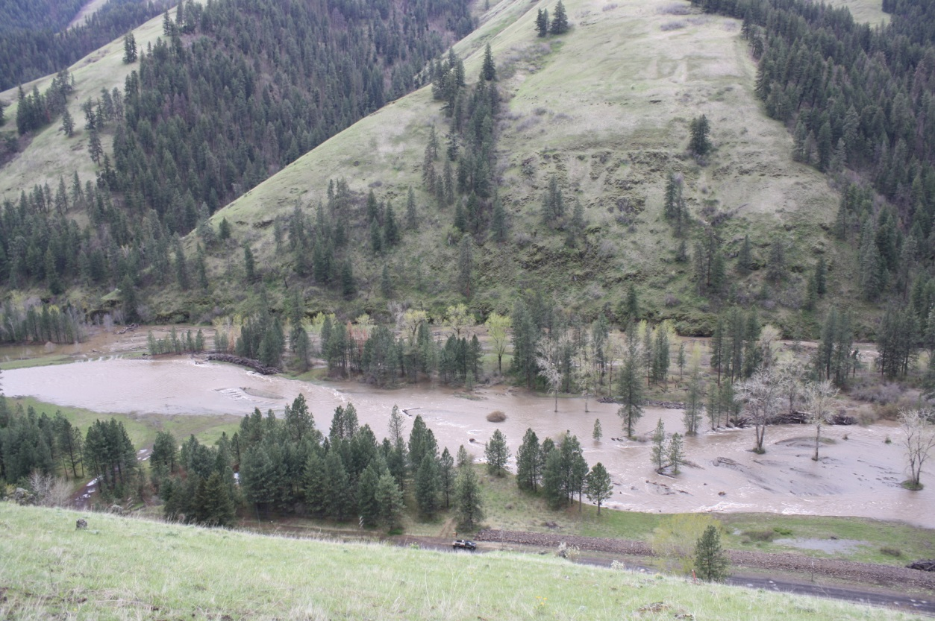

Prepared by:
Michael B. Lambert

Confederated Tribes Umatilla Indian Reservation
Department Natural Resources Fish and Wildlife Programs
Nixyaawii Governance Center
46411 Ti’Mine Way
Pendleton, Oregon 97801

Reporting Period
January 1, 2012 to December 31, 2012

Prepared for:
U.S. Department of Energy
Bonneville Power Administration
Division of Fish and Wildlife
P.O. Box 3621
Portland, Oregon 97208-3621

BPA Project Number 1987-100-01
Contract Numbers 57257

January 2014
Administrative Summary

Project Headquarters:
Confederated Tribes of the Umatilla Indian Reservation
Department of Natural Resources
Fish and Wildlife Programs
46411 Ti’Mine Way
Pendleton, OR 97801

Administrative Contact:
Julie Burke
Fish and Wildlife Administrative Manager
Phone: 541-429-7292
E-mail: julieburke@ctuir.org
Fax: 541-429-7292

Technical Contacts:
Michael Lambert
Fish Habitat Biologist/Project Leader
Phone: 542-429-7283
E-mail: mikelambert@ctuir.org
Fax: 541-429-7283

Suggested Citation:
Lambert, Michael B. 2014. The Umatilla Anadromous Fish Habitat Project: 2012 Annual Report. Confederated Tribes of the Umatilla Indian Reservation, report submitted to Bonneville Power Administration, Project No. 1987-100-01.

Cover Image: Photograph image of the Meacham Creek Floodplain Restoration and In-stream Enhancement Project RM 6-7.1, April 2013, flows at 3,090 cfs (designed bank full flow 1.5 RI, 1427 cfs), image by CTUIR

This report was funded by the Bonneville Power Administration (BPA), U.S. Department of Energy, as part of BPA's program to protect, mitigate, and enhance fish and wildlife affected by the development and operation of hydroelectric facilities on the Columbia River and its tributaries. The views in this report are the author's and do not necessarily represent the views of BPA.

ACRONYMS

BA biological assessment
B&G Bauer & Gustafson
BIA Bureau of Indian Affairs
BMHRC Blue Mountain Habitat Restoration Council
BPA Bonneville Power Administration
cfs cubic feet per second
COTR Contracting Officer Technical Representative
CREP Conservation Reserve Enhancement Program
CTUIR Confederated Tribes of the Umatilla Indian Reservation
cy Cubic Yards
dbh diameter at breast height
EPA United States Environmental Protection Agency
ESA Federal Endangered Species Act
ft foot/feet
FY fiscal year
gpm gallons per minute
in inch/inches
JPA Joint Permit Application
km kilometer/kilometers
LWD large woody debris
m meters
mi mile/miles
MOA Memorandum of Agreement
mph miles per hour
NMFS National Marine Fisheries Service
NPPC Northwest Power Planning Council
NWPCC Northwest Power and Conservation Council
NRCS Natural Resource Conservation Service
ODEQ Oregon Department of Environmental Quality
ODFW Oregon Department of Fish and Wildlife
ODSL Oregon Department of State Lands
OWEB Oregon Watershed Enhancement Board
OWRD Oregon Water Resources Department
PCSRF Pacific Coastal Salmon Recovery Fund
RM river mile
SOW Statement of Work
TMDL total maximum daily load
UAFHP Umatilla Anadromous Fisheries Habitat Project
UBNPME Umatilla Basin Natural Production Monitoring and Evaluation Project
UBWC Umatilla Basin Watershed Council
USFS United States Forest Service
USFWS United States Fish and Wildlife Service
USGS United States Geological Survey
UPR Union Pacific Railroad
WHIP Wildlife Habitat Incentive Program

Table of Contents

EXECUTIVE SUMMARY 5
INTRODUCTION 6
Noteworthy accomplishments for the CTUIR UAFHP during FY2012: 8
F&W Program Management Question: What are the tributary habitat limiting factors (ecological impairments) or threats preventing the achievement of desired tributary habitat performance objectives? 8
F&W Program Management Question: How has your work supported exchange and dissemination of fish and wildlife data or the development of a database to manage data that may be shared regionally, relative to the RM&E data management strategies roadmap? 9
PROJECT AREA 12
METHODS: Protocols, Study Designs, and Study Area 13
RESULTS 16
Work Element A: 185. Produce Pisces Status Report 16
Work Element B: 119. Manage and Administer Projects 16
Work Element C: 165. Produce Environmental Compliance Documentation 16
Work Element D: 132. Produce Annual Progress Report 19
Work Element E: 132. Produce Annual Progress Report 19
Work Element F: 114. Identify and Select Projects 20
Work Element G: 122. Provide Technical Review 20
Work Element H: 191. Watershed Coordination 21
Work Element I: 99. Outreach and Education 21
Work Element J: 197. Maintain/Remove Vegetation 25
Work Element K: 47. Plant Vegetation 26
Work Element L: 186. Operate and Maintain Habitat/Passage/Structure 27
Work Element M: 186. Operate and Maintain Habitat/Passage/Structure 30
Work Element N: 175. Produce Design and/or Specifications 30
Work Element O: 197. Maintain/Remove Vegetation 33
Work Element P: 100. Construction Management 35
Work Element Q: 100. Construction Management 36
SYNTHESIS OF FINDINGS: DISCUSSION/CONCLUSIONS 39
Background/Rationale 39
Monitoring Objectives 39
Key Assumptions 40
Project Feasibility and Development Monitoring 40
Project Implementation/Compliance Monitoring 42
Action Effectiveness Monitoring 43
SUMMARY AND CONCLUSIONS 68
LITERATURE CITED 74
APPENDIX A: USE OF DATA AND PRODUCTS 84
APPENDIX B: LIST OF METRICS AND INDICATORS 85

List of Tables

Table 1. The Umatilla Anadromous Fish Habitat Project objectives relative to the Umatilla River Vision touchstones (Jones et al 2008), BPA 2008 Fish Accords primary limiting factors (Fish Accords 2008) and NOAA’s ecological concerns (NMFS 2009). 10
Table 2. BPA form annually submitted by CTUIR listing actual herbicide application, both the active ingredient and adjuvant, by location within the Umatilla River Basin, 2012. 28
Table 3. Planting materials and grass seed by species, quantity, and size, planted and established at Umatilla River Basin existing and new project sites, 2012. 29
Table 4. Habitat passage structures monitored and maintained by CTUIR to meet design specifications. 30
Table 5. B&G Resources Project Actions, Dates of Work, Contracting Agencies and Contractors. 34
Table 6. Characteristic Flows for Meacham Creek at the Meacham Creek Floodplain Restoration and In-stream Enhancement Phase II RM 6-8.5 Project. 42
Table 7. Monthly Flows for Meacham Creek at the Meacham Creek Floodplain Restoration and In-stream Enhancement Phase II RM 6-8.5 Project. 42
Table 8. Flood Flows for Meacham Creek at the Meacham Creek Floodplain Restoration and In-stream Enhancement Phase II RM 6-8.5 Project. 42
Table 9. Geomorphic characteristics, floodplain connectivity and sediment comparisons RM 6.0 to 7.1 (2009-2012). 48
Table 10. Location of the six macroinvertebrate sites on Meacham Creek, the Phase I project boundaries, and the two macroinvertebrate sites on the North Fork Umatilla River. 62
Table 11. T-test results comparing macroinvertebrate metrics between control and impact sites. Values are averaged over all six years of sampling (n=18). 65
Table 12. Results of regression analyses for each metric and for control and impact sites separately. Analyses are for the pre-restoration period only with year as the independent variable. 65
Table 13. The CTUIR UAFHP restoration project descriptions by location, treated primary limiting factors (NMFS 2009) by CTUIR River Vision touchstones (Jones et al. 2008) and accomplishments; 2007-2012. 70

List of Figures

Figure 1. Umatilla River Subbasin 14
Figure 2. Umatilla River Basin FY2012 UAFHP Project Sites 15
Figure 3. CTUIR semi-annual report for the Umatilla Subbasin Fish Habitat Restoration Project, July – December, 2012. 22
Figure 4. Community Education and Involvement on the Meacham Creek Floodplain Restoration and In-stream Enhancement Project RM 6-7.1, 2012. 23
Figure 5. Staff poster presented at the AGU 2012 Annual Conference, November 2012, San Francisco, California. 24
Figure 6. Partner Montana State University poster presented at the SFS 2012 Annual Conference, May 2012. 25
Figure 7. Screen shot of the UBAFH Project conservation easement locator web map. 31
Figure 8. Meacham Creek Floodplain Restoration and In-stream Enhancement Phase II Project Design Features, RM 6-8.5. 32
Figure 9. Before-after photo points of the Birch Creek Taylor Diversion Dams Removal and Habitat Restoration Project, RM 0.0-0.5. 38
Figure 10. Before-after photo points of the West Birch Creek Low Barrier Removal, RM 5.4. 38
Figure 11. Meacham Creek turbidity plot (NTU’s), 2009-2012. 41
Figure 12. Number of events whereas during a 3-day period from June to August when minimum turbidity of 30 NTU is exceeded, Umatilla River Water Years 2002-2013. 41
Figure 13. Before and after photos of the Meacham Creek Floodplain Restoration and In-stream Enhancement Project RM 6-7. 44
Figure 14. CHaMP sediment and hydraulics comparisons between selected Meacham Creek locations. The locations selected for monitoring included between RM 2.5 to 3.0 (Lower Site; future treatment reach, RM 5.5 to 6 (Middle Site; treated reach) and RM 8.5 to 9 (Upper Site; untreated reach). 45
Figure 15. CHaMP geomorphic assessment comparisons between selected Meacham Creek locations. The locations selected for monitoring included between RM 2.5 to 3.0 (Lower Site; future treatment reach, RM 5.5 to 6 (Middle Site; treated reach) and RM 8.5 to 9 (Upper Site; untreated reach). 46
Figure 16. Potential spring Chinook salmon, summer steelhead and bull trout spawning habitat determined from modeled depth and velocity preferences before Meacham Creek Floodplain Restoration and In-stream Enhancement Project: potential spawning habitat and observed redds 2009. 50
Figure 17. Potential spring Chinook salmon, summer steelhead and bull trout spawning habitat determined from modeled depth and velocity preferences following Meacham Creek Floodplain Restoration and In-stream Enhancement Project: potential spawning habitat and observed redds 2012. 51
Figure 18. Potential spring Chinook salmon, summer steelhead and bull trout rearing habitat determined from modeled depth and velocity preferences before Meacham Creek Floodplain Restoration and In-stream Enhancement Project: potential rearing habitat 2009. 52
Figure 19. Potential spring Chinook salmon, summer steelhead and bull trout rearing habitat determined from modeled depth and velocity preferences following Meacham Creek Floodplain Restoration and In-stream Enhancement Project implementation: potential rearing habitat 2012. 53
Figure 20. Results from MODFLOW simulation showing expected influence of restoration on hyporheic flow paths (grey lines) on the Meacham Cr. restoration site. Dots show locations of installed monitoring wells in the project site area. 56
Figure 21. Simulated hyporheic flow-path residence time distributions based on MODFLOW groundwater models depicted in Figure 1. 56
Figure 22. The location of surface water temperature logger and groundwater monitoring wells at the Meacham Creek Restoration site in 2012. 57
Figure 23. The location of easily observed groundwater upwelling features along the restored reach of Meacham Creek observed in summer 2012. 58
Figure 24. An actively flowing groundwater spring and seep (note filimentaous algae growing in nutrient-rich outflow) along the restored reach of Meacham Creek in summer 2012. 59
Figure 25. Google Earth image of the six macroinvertebrate sampling sites on Meacham Creek. Control sites are illustrated with yellow thumbtacks and sites within the Phase I project area with blue. The Phase I project boundaries are illustrated with flags. Image downloaded 3/18/14. 61
Figure 26. An expanded Google Earth image of the Meacham Creek macroinvertebrate study sites designed to show the location of two study sites on the North Fork Umatilla River. Image downloaded on 3/18/14. 62
Figure 27. Values for each of the five macroinvertebrate metrics. The pre-restoration period was 2005 to 2010 and is separated from the post-restoration period (2011 and 2012) by the dashed vertical line. □ = Control Sites, ♦ = Project/Impact sites, x = North Fork Umatilla sites. 66

EXECUTIVE SUMMARY

The Umatilla Anadromous Fish Habitat Project (UAFHP) is an ongoing effort to protect, enhance, and restore functional floodplain, channel, and watershed processes to provide sustainable and healthy habitat for aquatic species in the Umatilla River Subbasin, including Threatened Mid-Columbia summer steelhead and Columbia River bull trout. Flow quantity, water temperature, passage, and lack of in-stream channel complexity have been identified as the key limiting factors in the subbasin. During the 2012 fiscal year (FY) reporting period (February 1, 2012-January 31, 2013) primary project activities focused on improving passage, in-stream and riparian habitat complexity and restoring natural channel morphology and floodplain function. Project activities focused on longitudinal connectivity in Birch Creek and West Birch Creek with removal of three abandoned irrigation diversions, setback of levees, channel reshaping, and input of rock and large wood structures resulting in unimpeded access to 7.7 river miles of stream for adult and juvenile fish, and increased channel and fish habitat complexity directly benefiting Threatened Mid-Columbia summer steelhead. The UAFHP completed vegetation plantings associated with the Meacham Creek Floodplain Restoration and In-Stream Enhancement Project (RM 6-7.1) planting plan following 2011 construction. The CTUIR UAFHP and U.S. Forest Service (USFS) staff developed construction design and specification documents for the Meacham Creek Floodplain Restoration and In-stream Enhancement Project (RM 6-8.5; Phase II), and completed environmental compliance and permitting for 2013 construction. Additional planning/assessment tasks were accomplished on Meacham Creek, Wildhorse Creek, Birch Creek, West Birch Creek, McKay Creek, Iskúulktpe Creek and the Umatilla River including monitoring and maintenance of 10 conservation easements on 15 individual landowners properties, control of noxious weeds on 355 acres (61 riparian, 294 upland) within project areas and easements through hand and mechanical removal, biological control and chemical application, and technical input on plans and proposals by entities within the Umatilla River Basin that may adversely impact floodplain or riverine processes and biota productivity, public project planning relevant to floodplain, river and wetland restoration or impacts, development and review of grant funding proposals, and proposed landowner projects. Given the ongoing project activities in Meacham Creek and the accumulative value of project activities within the lower river focus area (lower 15 miles) CTUIR focused monitoring efforts to evaluate the effects on biotic and abiotic ecological processes as a result of habitat restoration efforts. Habitat and aquatic assessment inventories were conducted at project sites prior to and following implementation. Action effectiveness and project implementation/compliance monitoring will continue prior to and following each project to oversee progression and inspire timely managerial actions. Project work is supported both locally and regionally by multiple planning documents: Umatilla/Willow Subbasin Plan (NPCC 2005), Five-Year Action Plan for the Development and Maintenance of Habitat Improvement Projects in the Umatilla Subbasin: 2006-2010 (CTUIR and ODFW 2006), Umatilla River Basin TMDL and Water Quality Management Plan (2001), CTUIR TMDL (2005), Umatilla River Vision (Jones et al. 2008; Existing Project Document ID: P130339), Conservation and Recovery Plan for Oregon Steelhead Populations in the Middle Columbia River Steelhead Distinct Population Segment (NMFS 2009), Bull Trout Draft Recovery Plan within the Umatilla-Walla Walla Recovery Unit (USFWS 2002), Meacham Creek Watershed Analysis and Action Plan (Andrus and Middel 2003) and Umatilla and Meacham Watershed Assessment (UNF 2001).

INTRODUCTION

The Confederated Tribes of the Umatilla Indian Reservation (CTUIR) retain aboriginal and treaty rights related to fishing, hunting, pasturing of livestock, and gathering of traditional plants within the Umatilla River Subbasin. The CTUIR Department of Natural Resources (DNR) has developed and accepted a First Foods organization and approach to ecosystem management based on the cultural traditions and practices of the Longhouse. The organization follows the serving order of food and conceptually “Extends the Table” to manage for sustainability within the Umatilla River Subbasin. The First Foods are considered to be the minimum ecological products necessary to sustain CTUIR culture. The order is watershed-based beginning with water at the first and lowest point and progresses up to salmon, deer, cous, and huckleberry. This creates clear links to treaty rights and resources and sets direction and goals that relate to the community culture. In addition the DNR developed the Umatilla River Vision that provides a description of the processes and conditions needed to protect and provide for First Foods. The River Vision describes physical and biological processes in support of 5 touchstones; hydrology, geomorphology, connectivity, riparian vegetation, and aquatic biota. The work accomplished through this project is directly related to the First Foods of water and salmon and the 5 touchstones, which incorporates goals of restoring high water quality and healthy and sustainable salmonid fish populations.

CTUIR’s right to fish in its historical fishing places was acknowledged in the Treaty of 1855 that stated: “the exclusive right of taking fish in the streams running through and bordering said reservation is hereby secured to said Indians, and at all other usual and accustomed stations…” (Treaty of 1855, Articles of Agreement, Article 1, page 3). Decreased salmonid abundance has significantly impacted the livelihood of the Tribal community and altered their way of life.

Overfishing, sweeping changes to rivers and streams, and policies that changed the landscape have endangered salmon and created a “salmon crisis” (Montgomery 2003). It is the challenging duty of the CTUIR Umatilla Anadromous Fisheries Habitat Project (UAFHP) to restore and sustain healthy conditions of local watersheds to both assist in salmon recovery and ensure they provide adequate quantities of sustainable natural resources to satisfy the CTUIR’s needs and preserve opportunities for traditional ways of life.

The Bonneville Power Administration (BPA) funds the CTUIR and other Pacific Northwest Tribes to restore salmonid habitat as part of its mitigation activities due to the harmful effects and loss of habitat caused by the massive Columbia River hydroelectric dams. The Umatilla Anadromous Fish Habitat Project (UAFHP; #1987-100-01) initiated by CTUIR in 1987 is an integral component of the Umatilla River Subbasin Salmon and Steelhead Production Plan (NPPC 1990) and project work is supported both locally and regionally by multiple planning documents: Umatilla/Willow Subbasin Plan (NPCC 2005), Five-Year Action Plan for the Development and Maintenance of Habitat Improvement Projects in the Umatilla Subbasin: 2006-2010 (CTUIR and ODFW 2006), Umatilla River Basin TMDL and Water Quality Management Plan (2001), CTUIR TMDL (2005), Umatilla River Vision (Jones et al. 2008; Existing Project Document ID: P130339), Conservation and Recovery Plan for Oregon Steelhead Populations in the Middle Columbia River Steelhead Distinct Population Segment (NMFS 2009), Bull Trout Draft Recovery Plan within the Umatilla-Walla Walla Recovery Unit (USFWS 2002), Meacham Creek Watershed Analysis and Action Plan (Andrus and Middel 2003) and Umatilla and Meacham Watershed Assessment (UNF 2001).

The Final Umatilla Willow Subbasin Plan (Umatilla/Willow Subbasin Planning Team 2005;
http://www.nwcouncil.org/fw/subbasinplanning/umatilla/plan/ ; Management Plan) provided a systematic vision of a healthy ecosystem with abundant, productive, viable, and diverse populations of aquatic and terrestrial species with goals, objectives, and management strategies necessary to reach the subbasin vision. The vision entails several broad goals for habitat: 1) Protect existing high quality fish and wildlife habitat and strongholds, 2) restore and enhance degraded and diminished fish and wildlife habitats to support population restoration goals and to mitigate impacts from the construction and operation of the Columbia basin hydropower system and other anthropogenic impacts, and 3) restore the health and function of ecosystems in the Umatilla subbasin to ensure continued viability of their natural resources (Management Plan, page 5-3). Specific aquatic qualitative objectives and strategies were developed in to support the subbasin vision and goals. Quantitative management objectives relative to the UAFHP work activities include 1) maintain and enhance natural production, productivity, abundance, life history characteristics and genetic diversity of fish and mussels throughout the Umatilla Subbasin using habitat protection and improvement and 2) maintain and enhance passage of adult and juvenile steelhead and Chinook throughout the Umatilla Subbasin with passage protection and restoration (Management Plan, page 5-5). The Umatilla Subbasin Plan 2005 determined that the limiting factors could be addressed through habitat restoration and implementation (“Phase III”) of the Umatilla Basin Project (pages 5-10). An identification and analysis of limiting factors/conditions and priority areas for action are fully described within the Subbasin Plan (Section 3.5) including passage barriers/entrainment, in-channel characteristics, habitat diversity (LWD), floodplain confinement, high water temperatures, high turbidity, inadequate flows, and poor riparian/floodplain vegetation. Priority management strategies are being conducted by the UAFHP in accordance with the Final Umatilla Willow Subbasin Plan (Umatilla/Willow Subbasin Planning Team 2005; pages 5-8 & 5-9) to address limiting factors within the subbasin:
• Increase water conservation and irrigation efficiency
• Large Wood/Boulder Structure Placement
• Fence/Plant Riparian Zones
• Modify Channel Floodplain Function
• Construct Pool/Riffle – In-stream Modification
• Modify Detrimental Land use Activities
• Restore Upstream/Headwater Attributes to Improve Downstream Conditions
• Increase Passage Efficiency

The UAFHP is an ongoing effort to protect, enhance, and restore functional floodplain, channel, and watershed processes to provide sustainable and healthy habitat for aquatic species in the Umatilla River Subbasin. Habitat restoration efforts fit within a holistic watershed approach supporting capacity building and long-term progress towards 1) achievement of the CTUIR DNR ecological river vision and first foods mission statements, 2) Endangered Species Act delisting of Columbia River bull trout and middle Columbia River steelhead, and 3) addresses water quality limiting factors per the Clean Water Act 303d list.

During the 25-year project history, the CTUIR has helped administer and implement a number of fisheries habitat enhancement projects in the Umatilla River Subbasin. In FY 2012, the CTUIR maintained 23 partnership habitat enhancement projects along Meacham Creek, Iskúulktpe Creek, Birch Creek, Wildhorse Creek, West Birch Creek and the mainstem Umatilla River, among other sites. The CTUIR has developed effective interagency partnerships and is effectively working at the policy and project levels with various federal, state, and county agencies and private landowners.

The UAFHP is an integral component of the Umatilla River Subbasin Salmon and Steelhead Production Plan (NPPC 1990) and is well integrated into the framework of the Umatilla Subbasin Plan (Umatilla/Willow Subbasin Planning Team 2005) established by the NWPCC to better coordinate habitat restoration work in the Umatilla River Basin. The CTUIR, ODFW, Natural Resource Conservation Service (NRCS), Umatilla Basin Watershed Council (UBWC), and other participating agencies and organizations have made significant progress towards restoring and protecting vital salmonid habitat in the basin.

Noteworthy accomplishments for the CTUIR UAFHP during FY2012:
- Completion of the Birch Creek Diversion Dams Removal and Habitat Restoration Project (RM 0-0.5) including removal of two abandoned irrigation diversions providing unimpeded access to 2.7 river miles of stream, channel reshaping, setback of leveed road, reshaping of channel morphology, structure placement and riparian plant restoration.
- Completion of the West Birch Creek Barrier Removal Habitat Restoration Project (RM 5.0-6.0) including removal of one abandoned irrigation diversions providing unimpeded access to 5.0 river miles of stream, installation of rock and large wood structures, channel reshaping, and riparian plant restoration.
- Developed construction design and specifications document for the Meacham Creek Restoration and In-stream Enhancement Phase II Project RM 6-8.5 for 2013 implementation.
- Maintaining 10 conservation easements on 15 individual landowner properties, and partnering with the NRCS Wildlife Habitat Incentives Program (WHIP) and Conservation Reserve Enhancement Program (CREP). Enhance native vegetation growth using hand and mechanical, biological and chemical controls to treat 355 Acres (61 Riparian, 294 Upland) in project areas.
- Planted approximately 2,754 potted plants, 390 plugs, 2,010 willow cuttings and seeded 200 lbs of native grass seed at the Meacham Creek Floodplain Restoration and In-Stream Enhancement Project (RM 6-7.1).
- Conducting project maintenance activities at all sites.

Subbasin planning teams utilized information from a variety of resource assessment sources to classify existing habitat status, determine limiting factors, and identify priority areas for restoration activities. A combination of both passive and active restoration strategies were then developed to address habitat deficiencies. Collection of aquatic habitat, geomorphology, water quality, and fish abundance data is ongoing and utilized for optimizing adaptive restoration plans at project areas.

Project results are reported in various BPA formats including Pisces status reports, project completion reports, and annual reports. The CTUIR maintains a complete database on project planning, proposals, permitting, implementation, and results through the completion of required project deliverables. For a complete list of reports submitted by the CTUIR’s UAFHP since 1989, please consult the following website at URL: http://www.efw.bpa.gov/integratedfwp/reportcenter.aspx and search publications, typing 1987-100-01 in the project number box provided.

F&W Program Management Question: What are the tributary habitat limiting factors (ecological impairments) or threats preventing the achievement of desired tributary habitat performance objectives?

Habitat protection and restoration needs in the Subbasin have been recognized in numerous reviews, planning processes, and reports (CTUIR 1993; CTUIR 2000; Umatilla/Willow Subbasin Planning Team 2004; 2005). The National Marine Fisheries Service (NMFS) has recently restarted the recovery planning effort for Chinook salmon and steelhead and tributary habitat restoration. The National Research Council (1996) notes the importance of protecting and rehabilitating freshwater habitat as part of salmon recovery and specifically notes the importance of riparian areas. This body recommended that habitat reclamation or enhancement should emphasize rehabilitation of ecological processes and function (NRC 1996). The United States Fish and Wildlife Service (USFWS) draft bull trout recovery plan (USFWS 2002) also recognized the importance of habitat protection and restoration and specifically noted the need to improve water quality, reduce or eliminate fish passage barriers, and restore impaired in-stream and riparian habitat. Pre-project implementation aquatic habitat inventory surveys conducted by CTUIR revealed that habitat quality ranked poor in 85% of areas surveyed and fair in 15% in the Umatilla River.

The Oregon Department of Environmental Quality (ODEQ) listed the Umatilla River Subbasin on the State’s list of water quality limited water bodies’ 303(d) list (Please see the ODEQ website at URL http://www.deq.state.or.us/wq/assessment/rpt0406/results.asp for details). A Total Maximum Daily Load (TMDL) was also written for waters within reservation boundaries (CTUIR 2005) that, in combination with CTUIR’s habitat enhancement work, should lead to water quality improvements over the long term (Please see http://yosemite.epa.gov/R10/WATER.NSF/TMDLs/Approved+TMDLs#OR, select “Oregon”, and navigate to “Umatilla Tribal TMDL” for a copy of this report.).

Throughout much of the Subbasin, maximum water temperatures exceed lethal limits for bull trout and approach lethal limits for Chinook salmon and rainbow/steelhead trout. The high stream temperatures potentially limit carrying capacity, adversely affect fish fitness, and should be considered as a primary factor limiting salmonid production in the Subbasin. In addition, passage barriers and entrainment, in-channel characteristics, habitat diversity (LWD), floodplain confinement, high turbidity, flow quantity, and poor riparian/floodplain vegetation were identified as other key limiting factors/ecological impairments.

The UAFHP ecological objectives are derived from planning documents and processes relative to limiting factors/ecological impairments (Table 1).

F&W Program Management Question: How has your work supported exchange and dissemination of fish and wildlife data or the development of a database to manage data that may be shared regionally, relative to the RM&E data management strategies roadmap?

The UAFHP is currently working with the local Geographical Informational System (GIS)/ Information Technologies (IT) staff to develop a database that is central to all CTUIR Department of Natural Resource (DNR) programs. Due to the rapid increase in DNR programs in the past 5 years, and the data being collected, it has been deemed a priority to review and organize all data collection efforts. The CTUIR DNR Program recently hired a “data steward” whom is tasked with this duty. Currently, the most requested data from outside agencies is our annual temperature data. Since 1995 CTUIR has managed a publicly accessible website/database that houses all temperature data (back to 1993), water quality data (back to 1989) and fish survey data (back to 1987) collected on an annual basis. Additional information on conservation easements, water quality study sites, and floodplain area is also housed on this website (http://data.umatilla.nsn.us/index.aspx).

Recently the UAFHP has created a GIS based geodatabase to store and display all monitoring that they have conducted within the Umatilla Subbasin. The database contains point location information and is linked to files that house all the data for the coinciding location. This database is used to maintain consistency for monitoring and monitoring locations and to leave a “paper trail” for biologist that leave or enter the program. Past monitoring locations have been lost through changing program managers and
Table 1. The Umatilla Anadromous Fish Habitat Project objectives relative to the Umatilla River Vision touchstones (Jones et al 2008), BPA 2008 Fish Accords primary limiting factors (Fish Accords 2008) and NOAA’s ecological concerns (NMFS 2009).
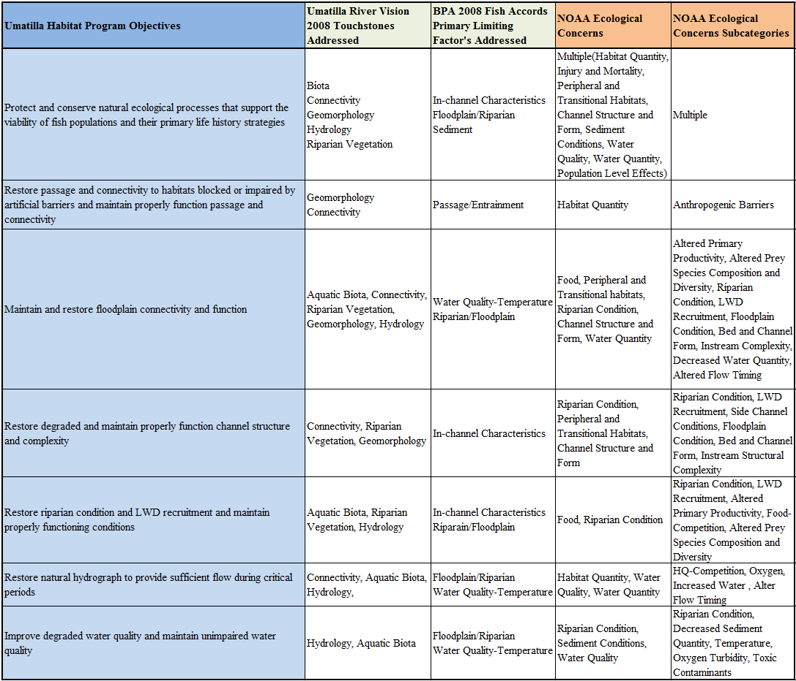

scattered monitoring efforts within the subbasin. As mentioned throughout this document, the UAFHP has drastically increased the amount of and the scale of restoration within the subbasin, as expected increased restoration calls for increased monitoring. With this increase in monitoring the CTUIR and UAFHP are continuing to refine and strive for more continuous and concentrated monitoring.

Data that is collected and housed by CTUIR and CTUIR staff that is to be shared must go through a data sharing agreement with specific details on how the data is to be used and translated. All CTUIR data is to be collected in the NAD83 zone 11N coordinate system. If data is received from outside resources the information and coordinate system is translated into the CTUIR coordinate system in order to avoid data translation errors. When outside data is collected for CTUIR programs, a requirement within the contract is to have the data translated to NAD83 11N or to state what coordinate system the data was collected.

Data collected for CTUIR through outside agencies or contractors is required to contain an attachment stating the protocol used and the data standards for processing the data. Data collected by CTUIR is collected using standardized data sheets generated internally with specific requirements on coordinate system, system of measurements (English vs. metric), and specific attributes that are important to the data set.

The CTUIR’s IT Department houses a significant amount of data for the CTUIR DNR programs. Efforts are currently underway, through an on-site data coordinator, to standardize and better document many sets of data that are used throughout the CTUIR Fisheries Habitat Program related to projects. Once fully established, this system will improve our ability to store, query, and share data. Currently all data are kept in a MS SQL database using sing a format conducive to existing reporting needs.

Most monitoring data compiled by the UAFHP is collected locally within the program. Temperature and sediment data related to TMDLs within the Umatilla Subbasin are collected by and coordinated through the Umatilla Watershed Council and then distributed to the UAFHP for review and project report addition. Fisheries biological life cycle information (smolt trap, redd surveys, and fish population) that the UAFHP uses for project or action effectiveness monitoring are collected by the CTUIR Natural Production Monitoring and Evaluation Program (BPA contract 1990-005-01) which is coordinated with local ODFW Juvenile Salmonid Outmigration Program (BPA contract 1989-024-01). Both the CTUIR and ODFW programs coordinate data and provide results for the UAFHP. For large restoration projects topographic survey work is required for effectiveness monitoring and project design surfaces. In these instances the work is contracted out and the UAFHP project works with the data internally or builds additional analysis into the contracted survey work. In past projects the UAFHP contracted work to private firms to complete full topographic surveys, CHaMP habitat surveys, sediment analysis, geomorphic analysis and modeled flow analysis. In most instances UAFHP staff does not have the capacity to complete this work in addition to their daily work requirements within the local CTUIR agency.

All data collect by the UAFHP is housed on a local backed up server and is protected through user privilege agreements. Only UAFHP staff is able to view and manipulate this data. All data is linked to the aforementioned GIS geodatabase so it can be easily viewed spatially. Metadata for this information is stored in an IGDC metadata standard format and attribute information is populated within the GIS geodatabase. Additional metadata is documented within the UAFHP protocol on MonitoringMethods.org
(https://www.monitoringmethods.org/Protocol/Details/681). The UAFHP strives to use regional standards for data collection whenever applicable, however we do develop our own data collection methods and/or protocols for certain aspects of project effectiveness monitoring. These locally developed protocols are housed internally and are attached to all data collected using the protocol as well as attached to the GIS geodatabase.

The UAFHP directly contributes and submits data and information to the following FCRPS BiOp programs: PNAMP, CHaMP, Columbia Basin Pit Tag Information (through our M&E Program), PIBO and indirectly contributes to the Integrated Status and Effectiveness Program through required BPA submittals. The only local staff with access to raw data associated with PNAMP, CHaMP, PIBO and the Columbia Basin Pit Tag Information is project managers and assistant managers directly related to the information collected and the project in which it is collected for. CHaMP data is collected by a contracted agency and they are responsible for entering the data into the CHaMP system and providing the UAFHP with the associated raw data and summarized data. For data sharing databases like PNAMP “colleague permission” is granted to counterparts within the organization and project collaborators for information sharing and collaborative data analysis/review purposes. Once information is put on the respective database viewing permissions are set to database manager discretions.

PROJECT AREA

Umatilla River Subbasin

The Umatilla River Subbasin is located in the northwest portion of the Blue Mountain Ecological Province in northeast Oregon. The Umatilla River Subbasin comprises 1,465,600 acres of the 6,400,000 acres of ceded CTUIR land (CTUIR 1995) as identified by the Treaty of 1855. Figure 1 illustrates the vicinity of the Umatilla River Subbasin within the Blue Mountain Province (Project map: http://www.cbfish.org/Project.mvc/Map/1987-100-01). The Umatilla River drains an area of approximately 2,540 square miles (mi.²) (6,579 square kilometers [km²]) and flows approximately 89 mi. (143 km) from its mouth to where it divides into the north and south forks of the Umatilla River. Each fork adds another approximately 10 mi. (16 km) of length. Major tributaries in addition to the north and south forks include Meacham Creek, Birch Creek, McKay Creek, Butter Creek, and Wildhorse Creek. The Umatilla River originates at elevations up to 4,228 feet (ft.; 1,289 m) and flows to an elevation of about 269 ft. (82 m) at its confluence with the Columbia River (USFWS 2002).

The Umatilla River Subbasin historically supported viable and harvestable populations of spring/summer and fall Chinook salmon (Oncorhynchus tshawytscha), coho salmon (O. kisutch), sockeye salmon (O. nerka), summer steelhead (O. mykiss), Pacific lamprey (Entosphenus tridentatus), bull trout (Salvelinus confluentus), steelhead-rainbow trout (O. mykiss sp.), and mountain whitefish (Prosopium williamsoni). Human-caused alterations have negatively impacted the watershed and caused significant reductions of endemic salmonid populations. Beginning in the late 1800s, fish populations started to decline due to habitat degradation; sockeye and coho were extirpated in the early 1900s. Irrigation and agricultural development throughout the basin in the early 1900s is believed to be the primary cause of the decline of steelhead and the extinction of salmon. Since the completion of the Treaty of 1855, aquatic and riparian habitats have been degraded through irrigation diversions, water extractions, channelization, livestock grazing, logging, agriculture and urban development (Umatilla/Willow Subbasin Planning Team 2004). Subsequently, the abundance of Chinook, steelhead, bull trout, and other fish species has also been dramatically reduced. With declining fish populations, Tribal governments, federal, state and international agencies were obligated to eliminate or significantly reduce subsistence and sport fisheries by the mid-1970s. The Federal government listed Columbia River spring Chinook salmon, summer steelhead, and bull trout as threatened species under the ESA in 1973, 1992, 1997, and 1998, respectively.

The following species listed under the ESA currently occur in the Umatilla River Basin: Columbia River bull trout Critical Habitat (designated), Columbia River bull trout (threatened), and Mid-Columbia River steelhead (threatened). In the mid-1980s, a successful, hatchery-based salmonid reintroduction effort for the Umatilla River was instituted using neighboring strains of various salmonid species. Although hatchery programs currently support subsistence and restricted sport fishing opportunities for steelhead and Chinook salmon, there remains significant need to re-build viable, harvestable, and sustainable fish stocks throughout the basin.

Our primary area of focus for restoration and monitoring work in FY 2012 was Meacham Creek, Birch Creek and mainstem Umatilla River (Figure 2; contract map: http://www.cbfish.org/Contract.mvc/Map/57257).

METHODS: Protocols, Study Designs, and Study Area

Protocol Title: Meacham Creek Geomorphic-Hyporheic Flow Study v1.0
Protocol Link: http://www.monitoringmethods.org/Protocol/Details/677
Protocol Summary:
CTUIR proposes to strategically implement enhancement work on Meacham Creek river miles 5 to 7.3 to enhance floodplain and stream morphology, while providing enhanced habitat for fish. Enhancement techniques include, but are not limited to, woody debris placement in channel and in floodplain, levee setback or removal, channel reconstruction for increased in-stream habitat complexity and stabilization, and native plant and grass restoration. Project actions are expected to improve physical functions by 1) diversifying channel morphology and 2) increasing connectivity between surface and subsurface features. With time, we expect watershed treatments will lead to increased abundance and diversity of riparian vegetation, and increased fish habitat diversity. This includes project goals of: 1. Quantify water residence time distribution both prior to and after restoration actions to assess changes in recharge and discharge between Meacham Creek and its alluvial aquifer (hyporheic exchange). 2. Establish a monitoring network of stream thermographs to measure changes in surface and subsurface water temperature due to restoration actions. 3. Pilot a new method of stream restoration monitoring that will have broad utility to other restoration efforts in the region. 4. Produce and submit manuscripts for peer reviewed publication describing the results of the study.

Protocol Title: Scientific Protocol for Salmonid Habitat Surveys within the Columbia Habitat Monitoring Program (CHaMP) v1.0
Protocol Link: http://www.monitoringmethods.org/Protocol/Details/416
Protocol Summary:
CHaMP is designed as a Columbia River basin-wide habitat status and trends monitoring program built around a single protocol with a programmatic approach to data collection and management (RM&E Workgroup 2010). CHaMP will result in the collection and analysis of systematic habitat status and trends information that will be used to assess basin-wide habitat conditions. When coupled with biological response indicators, this status and trends information will be used to evaluate habitat management strategies. This program will be integrated with ongoing Pacific Northwest Aquatic Monitoring Program (PNAMP) recovery planning efforts and will be part of the collaborative process across Columbia Basin fish management agencies and tribes and other state and federal agencies that are monitoring anadromous salmonids and/or their habitat. The implementation of CHaMP will characterize stream responses to watershed restoration and/or management actions in at least one population within each steelhead and spring Chinook Major Population Group (MPG) which have, or will have, “fish-in” and “fish-out” monitoring (identified in RPA 50.6), thereby meeting the requirements of RPA 56.3, RPA 57, and RPA 3. CHaMP was designed to deliver trends in habitat indicators and requires that monitoring occurs for three cycles of a sampling panel (see section 1.6), at least 9 years.

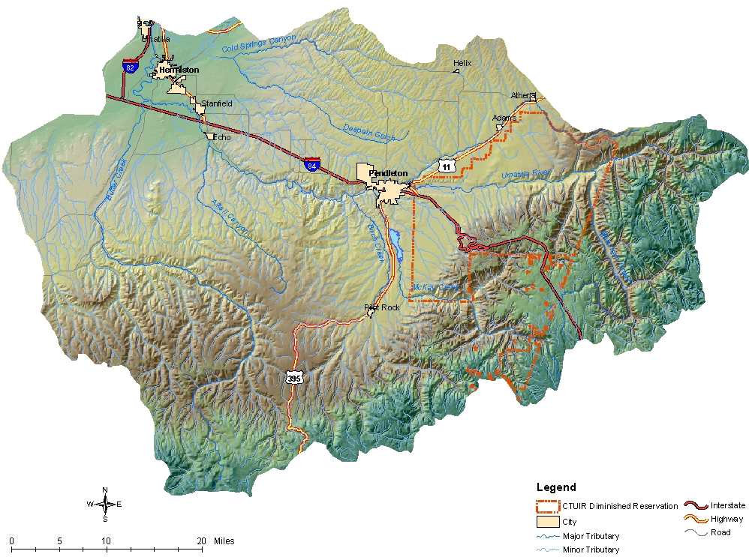
Figure 1. Umatilla River Subbasin

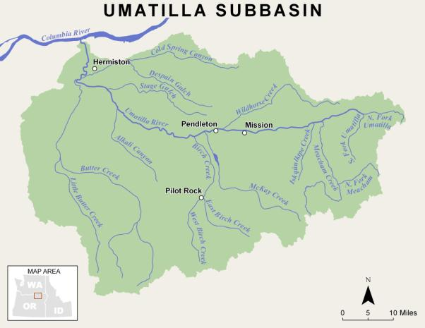
5
4
3
2
1
Figure 2. Umatilla River Basin FY2012 UAFHP Project Sites

1: Birch Creek, RM 0-0.5; 2012 Diversion Dams Removal and Habitat Restoration Project. 2.7 river miles unimpeded access. | 2: West Birch Creek, RM 5.0-6.0; 2012 Low Barrier Removal and Habitat Restoration Project. 5.0 river miles unimpeded access. | 3: Meacham Creek, RM 6-7; 2012 Additional plantings and seeding as part of the 2011 Floodplain Restoration and In-stream Enhancement Project.
4: Meacham Creek, RM 6.0-8.5; 2012; Developed construction design and specifications document for the Meacham Creek Restoration and In-stream Enhancement Phase II Project. | 5: Meacham Creek Project Implementation/Compliance and Action Effectiveness Monitoring; 2012 Synthesis of monitoring methodologies to evaluate the effects on biotic and abiotic ecological processes as a result of habitat restoration efforts.

RESULTS

This section highlights and describes completed work elements in an outline similar to our statement of work in Pisces. Each work element with associated identifier code and milestone are listed, followed by a comprehensive summary of completed work under each work element. In addition to a description of completed work elements specific to restoration activities, we highlight monitoring results specific to tributary habitat RM&E, coordination and data management for RM&E and tributary habitat restoration and protection.

Work Element A: 185. Produce Pisces Status Report
Work Element Title: Periodic Status Reports for BPA
Milestone Deliverable: Complete Periodic Pisces Status Reports

CTUIR reported to BPA periodically during the contract period on the status of each statement of work element, and milestones and deliverables using the computer program Pisces:
February-March (2/1/2012-3/31/2012)
April-June 2012 (4/1/2012 - 6/30/2012)
July-September 2012 (7/1/2012 - 9/30/2012)
October-December 2012 (10/1/2012 - 12/31/2012)
Final January 2013 (1/1/2013 - 1/31/2013)

The BPA Contracting Officer Technical Representative (COTR) reviewed the Pisces status reports, recommended changes as necessary and accepted them electronically upon approval. Additionally, upon completion of each deliverable milestone, we provided metrics and final project location (latitude and longitude) when required. These Pisces status reports provide a tool for the BPA COTR and administrative staff to track project progress in meeting contract requirements.

Work Element B: 119. Manage and Administer Projects
Work Element Title: Manage and Administer Project
Milestone Deliverable: Upload Statement of Work, Budget, Property Inventory for Upcoming Contract Period to Pisces

A. Per COTR, revise/finalize the new contract package (statement of work, environmental compliance documentation, budget, and property inventory).
B. Accrual – submit September estimate to BPA.
C. Funding package – conduct internal review (e.g., supervisor or interagency).

This work element includes a suite of management actions required to administer the project, including preparation of annual operations and maintenance budgets, managing and preparing statements of work and budgets, and property inventory to the assigned BPA COTR for the following contract period. The project leader reports quarterly or as necessary on milestones and metrics to BPA using the BPA Pisces Program, supervises, trains, and directs staff activities, conducts vehicle and equipment maintenance and management, performs payroll, purchasing, subcontracting for services, and administers habitat enhancement activities.

Work Element C: 165. Produce Environmental Compliance Documentation
Work Element Title: Produce Environmental Compliance Documentation
Milestone Deliverable: Receipt of Environmental Compliance Clearance from BPA

The following milestones were contracted for FY2012 projects:
- Meacham Creek Natural Channel Design and Levee Modification Project RM 2.4-4.4 environmental compliance package.
- Meacham Creek Natural Channel Design and Levee Modification Project RM 7.0-8.5 environmental compliance package.
- Birch Creek Peterson Dam Removal Project environmental compliance.
- Birch Creek Broun (Garton) Dam Removal Project environmental compliance.
- Birch Creek Taylor Dam Removal and Habitat Restoration Project environmental compliance package.
- Herbicide use proposals and application summaries for project.

CTUIR successfully submitted all applicable and required documents to the appropriate federal, tribal, state, county entities for select implementation projects in a timely manner required under work elements related to producing environmental compliance documentation in FY2012. Secondary environmental compliance accomplishments during the reporting period included coordination with various compliance personnel to prepare supplemental documentation and reporting for ongoing and planned management actions. Environmental compliance methods include development of appropriate documentation under various federal, Tribal, state and county laws and regulations governing federally funded project work. Methods involve coordination with various federal and state entities agencies and development and submittal of permit applications, cultural clearances, biological assessments, National Environmental Policy Act checklists, etc., as necessary. Part of the environmental compliance work element includes planning and developing site-specific proposals tailored to accomplish fisheries goals and meet compliance standards. The details concerning the implementation of treatments and preparations for putting efforts on the ground, including preparations for subcontracting, and specifics in regarding the safeguarding of ESA-Listed species during the implementation process are outlined in the proposals.

Cultural Resource Protection and Preservation
CTUIR submitted a letter and attachments with necessary project descriptions and geo-referenced maps for assisting BPA with section 106 National Historic Protection Act consultations and environmental compliance. The following projects were submitted for compliance:
- Meacham Creek Floodplain Restoration and In-stream Enhancement Project RMs 7.0 to 8.5,
- Meacham Creek Natural Channel Design and Levee Modification Project RM 2.4-4.4,
- Birch Creek Taylor Diversion Dams Removal and Habitat Restoration Project RM 0-1.0, and
- Birch Creek Taylor Dam Removal and Habitat Restoration Project environmental compliance package.

The CTUIR DNR Cultural Resource staff completed the cultural resource project area surveys and reports and submitted to BPA for cultural resource compliance with the State Historic Preservation Office (SHPO) and Tribal Historic Preservation Office (THPO) for all projects with the exception of the Birch Creek Peterson Dam Removal Project given lack of landowner participation and the Meacham Creek Natural Channel Design and Levee Modification Project RM 2.4-4.4. The survey on the Meacham project area was completed but the report will be completed at a later date.

UAFHP Environmental Compliance Documentation
ESA consultation with NMFS for FY 2012 project activities was covered under the Terms and Conditions of the HIP II Programmatic Biological Opinion (HIP II BO). Project activities covered under the HIP II BO included:
- Plant Vegetation (J:47): No project planting activities occurred under the HIP II BO consultation. Project staff focused the entire 2012 spring and fall planting season within the newly implemented 2011 Meacham Creek Floodplain Restoration and In-stream Enhancement Project (RM 6.0-7.0 area. The planting plan was covered under a Biological Opinion specific to the project.
- Operate and Maintain Habitat/Passage/Structure (K:186): CTUIR monitored 7 passage rectification projects to assure that treatments are effectively working and to insure that intrusive objects are not interfering with the designed function of the passage structures (Table 1). Routine quarterly scheduled site visits of individual projects were conducted either independently by the CTUIR or jointly with project partners such as ODFW. Site visits typically follow significant flow events or responses to landowner requests at project sites. Project maintenance included, but was not limited to, meeting specified conditional language in state and Federal permits, maintaining debris that is routinely captured or caught on in-stream structures, responses to landowner requests and concerns, and completion of post-treatment surveys to monitor and quantify changes to physical and ecological responses. A work plan was developed and contractor hired for completion for project activities greater than routine maintenance. In 2012, maintenance was necessary on Birch Creek (RM 2.8) to stabilize a 20 ft footer log as part of the Peterson In-stream Habitat and Bank Stabilization Project area. The 20 ft footer log was stabilized with placement of nine large boulders about 2-3 ft in diameter with an excavator along the upper end of the upper most structure to prevent loss of the footer log and long-term erosion and provide necessary stability while the planted vegetation recovers for increased bank stability and protection. The bank was already stabilizing and recovering and no in-stream work or area fish isolation was necessary.
- Operate and Maintain Habitat/Passage/Structure (L:186): CTUIR complied with terms of 27 existing conservation easements. The purpose of these conservation easements is to protect, enhance, and restore functional floodplain, channel, and watershed processes to provide sustainable and healthy habitat for aquatic species in the Umatilla River subbasin. CTUIR routinely conducted custodial maintenance on the individual projects to ensure that project structures and fencing are functioning and habitat recovery is progressing towards meeting projects goals and objectives. Project work included, but was not limited to, repairing riparian cattle exclusion fences, maintaining or installing water gaps, riparian and floodplain plant maintenance, noxious weed control by hand, and landowner coordination and education.
- Maintain/Remove Vegetation (N:197): Project activities included watering and maintaining plants on NRCS CREP tracts and maintaining noxious weeds. Plant watering, weeding and mowing on CREP tracts were maintained four times during the summer.

Meacham Creek Floodplain Restoration and In-stream Enhancement Phase II Project RMs 7.0-8.5 Environmental Compliance Documentation
The Meacham Creek Floodplain Restoration and In-stream Enhancement Project RMs 6.0-7.0 project implementation was completed in December 2011. Following completion of the project, CTUIR and USFS, began design and permitting in 2012 for Phase II Project (RMs 7.0-8.5) activities. Funding for the Meacham Creek project is provided by the Bonneville Power Administration (BPA), a federal agency under the Department of Energy. This project area occurs on both National Forest System land and CTUIR fee lands. Under Section 7 of the Endangered Species Act (ESA) all federal agencies must, through consultation with the USFWS and the NMFS, ensure that that actions which they authorize, fund, or conduct are not likely to jeopardize the continued existence of threatened or endangered species or adversely modify their habitats. Therefore, both CTUIR and the USFS had to demonstrate Section 7 compliance.

Habitat for endangered and threatened species listed under the ESA was identified in the Meacham project focus area: bull trout (and designated critical habitat; project area is within the Umatilla-Walla Walla recovery area) and steelhead (middle Columbia River DPS).

The following permits and approvals were required for the project:
- NMFS. Endangered Species Act Biological Opinion and Magnuson-Stevens Fishery Conservation and Management Act Essential Fish Habitat Conservation Recommendations for the Meacham Creek Floodplain Restoration Project. Issued December 3, 2010 and Reinitiated on April 25, 2013.
- USFWS. Biological Opinion for the Meacham Creek Restoration Project. Issued December 14, 2010 and Extension Letter on March 19, 2013.
- U.S. Army Corps of Engineers Regional General Permit No. 4 (Aquatic Habitat Restoration, Establishment, and Enhancement Activities). Issued February 3, 2011 and Extension April 9, 2012.
- USFS Categorical Exclusion Decision Memo. Issued April 8, 2011.
- Oregon Department of State Lands Removal/Fill Permit No. 42104-GP. Issued December 31, 2013.

Work Element D: 132. Produce Annual Progress Report
Work Element Title: Produce Annual Progress Report for the Fiscal Year 2011 Period (February 2011) to (January 2012)
Milestone Deliverable: Attach 2011 Annual Progress Report in Pisces

A. Review progress report format requirements
B. Internal agency/tribal review of draft
C. Revisions in response to review of draft
D. Submit progress report for external review
E. Submit draft for technical/co-manager review
F. Finalize report

The FY 2011 BPA Annual Progress Report was completed and uploaded to BPA through Pisces.

Work Element E: 132. Produce Annual Progress Report
Work Element Title: Submit Combined 2009/2010 Progress Report-Carried Over from FY2011 Contract
Milestone Deliverable: Attach FY2009-2010 Annual Progress Report in Pisces

A. Review progress report format requirements
B. Internal agency/tribal review of draft
C. Revisions in response to review of draft
D. Submit progress report for external review
E. Submit draft for technical/co-manager review
F. Finalize report

CTUIR UAFHP staff combined the FY 2010 BPA Annual Report for contract period (February 2010 to January 2011) with the FY 2009 contract period report (Work Element D:132) as one report. The FY 2009-2010 BPA Annual Progress Report was completed and uploaded to BPA through Pisces in September 2012.

Work Element F: 114. Identify and Select Projects
Work Element Title: CTUIR Umatilla Subbasin Restoration Coordination
Milestone Deliverable: List of Final Projects

A. Coordinate regularly with project partners and landowners
B. List projects

CTUIR UAFHP staff annually coordinated and planned projects with State, Federal, and local partners, and private landowners to develop habitat restoration and enhancement projects consistent with local planning documents. CTUIR project development is guided and prioritized by project activities that are supported by the CTUIR Department of Natural Resources ecological and First Foods mission statements to enhance or protect ecological and physical processes thus sustaining biota production (Jones et al., 2008). The CTUIR is guided in its habitat restoration activities by multiple planning documents:

- Final Umatilla Willow Subbasin Plan (Umatilla/Willow Subbasin Planning Team 2005),
- Middle Columbia River Steelhead Recovery Plan (NMFS 2009),
- Bull Trout (Salvelinus confluentus) Draft Recovery Plan (USFWS 2002), and
- Five-Year Action Plan for the Development and Maintenance of Habitat Improvement Projects in the Umatilla Subbasin: 2006-2010 for BPA-Funded Fish Habitat Improvement Programs sponsored by: Oregon Department of Fish and Wildlife (ODFW) and Confederated Tribes of the Umatilla Indian Reservation (CTUIR and ODFW 2006).
- Meacham Creek Watershed Analysis and Action Plan (Andrus & Middel, 2003)

Projects were identified, prioritized and developed with project partners (ODFW, UBWC, and SWCD) who implement restoration projects within the Umatilla River Basin. Projects that were ranked by priority, CTUIR identified funding sources and projects were prepared for planning, engineering design, permitting and implementation and included in the FY 2013 BPA statement of work and budget.

Work Element G: 122. Provide Technical Review
Work Element Title: Review and Provide Technical Input on Issues and Topics that Affect the Areas Natural Resources
Milestone Deliverable: Provide Technical Input and Summaries to Enhance or Protect Natural Resources in the Subbasin

A. Conduct review and provide input as necessary on natural resource preservation issues.
B. Review and provide technical input on issues that may adversely affect natural resources.

CTUIR UAFHP staff reviewed and provided technical input as applicable on plans and proposals by entities within the Umatilla River Basin that may adversely impact floodplain or riverine processes and biota productivity, public project planning relevant to floodplain, river and wetland restoration or impacts, development and review of grant funding proposals, and proposed landowner projects. Project staff provided input to multiple CTUIR departments on annual activities relevant to work within the floodplain, rivers, and wetlands, US Army Corps of Engineers/Oregon Division of State Lands removal-fill permit applications, and CTUIR Stream Zone Alteration (SZA) Permit applications on work proposed within the floodplain on Reservation land.
Work Element H: 191. Watershed Coordination
Work Element Title: Umatilla River Watershed Coordination Duties
Milestone Deliverable: Coordinate Watershed Association Activities

A. Coordinate with NRCS and local conservation districts
B. Coordinate with Umatilla Basin Watershed Council
C. Coordinate with co-manager ODFW and other Federal agencies
D. Network with professionals in the field of habitat restoration

CTUIR UAFHP staff participated and coordinated with multiple agencies and stakeholders in the Umatilla River Subbasin through the Umatilla Subbasin Restoration Team (Restoration Team) including ODFW, USFS, NRCS, conservation districts, USFWS, Umatilla Basin Watershed Council and local stakeholders to enhance natural resources, identify problems and solutions, coordinate efforts to prevent duplication, enhance communication and cooperation and identify funding and cost share opportunities within the Umatilla River Subbasin. Staff further coordinated with other agencies in planning and implementing partner habitat restoration and enhancement projects, ESA planning processes, and project prioritization and selection processes. The Restoration Team was established in 2010 and is an informal group formed of agency or entity representatives that do restoration work within the Umatilla River /Willow Creek Basin floodplain and riverine system. The Restoration Team coordinated several passage projects in Birch Creek, and upcoming project activities in McKay Creek and the lower Umatilla River. CTUIR staff prepared agreements, if necessary, to assign duties and responsibilities to the appropriate entities. We also developed documents, press releases, web sites, and other communications to impart information to participating stakeholders and the public. Furthermore, CTUIR UAFHP staff updated the Restoration Team, UBWC, CTUIR Committees and Commissions, and permitting agencies on project activities by presentation and in writing on project activities.

Work Element I: 99. Outreach and Education
Work Element Title: Public Outreach and Education
Milestone Deliverable: Complete Outreach and Education Activities

CTUIR UAFHP staff educated the public on natural resource protection and restoration principles, and communicated on project activities throughout the year. This work included giving project tours and presentations (field, written, and verbal) and participating in local and regional workshops, symposia and/or conferences (training, project presentation, and memberships), newspaper articles and public education (local school districts or college programs).

CTUIR UAFHP staff completed CTUIR semi-annual reports summarizing project objectives and outputs, expected outcomes, and resulting impacts of project restoration activities (Figure 3). These reports are used by the CTUIR Department of Natural Resources to inform CTUIR staff and government officials, other agencies and entities, and the public of project activities.

Meacham Creek Floodplain Restoration and In-stream Enhancement Project RM 6-7.1
The Meacham Creek Floodplain Restoration and In-stream Enhancement Project RM 6-7.1 was a historic partnership between CTUIR and USFS that restored processes in Meacham Creek that create and maintain habitat complexity (CTUIR 2012). The restoration effort in relationship to past efforts in Meacham Creek highlights efforts by CTUIR and project partners to restore floodplain processes. A partnership and project of this significance and magnitude was one that demanded the spotlight. A high level of coordination between the USFS and CTUIR went into ensuring a consistent, common, and clear

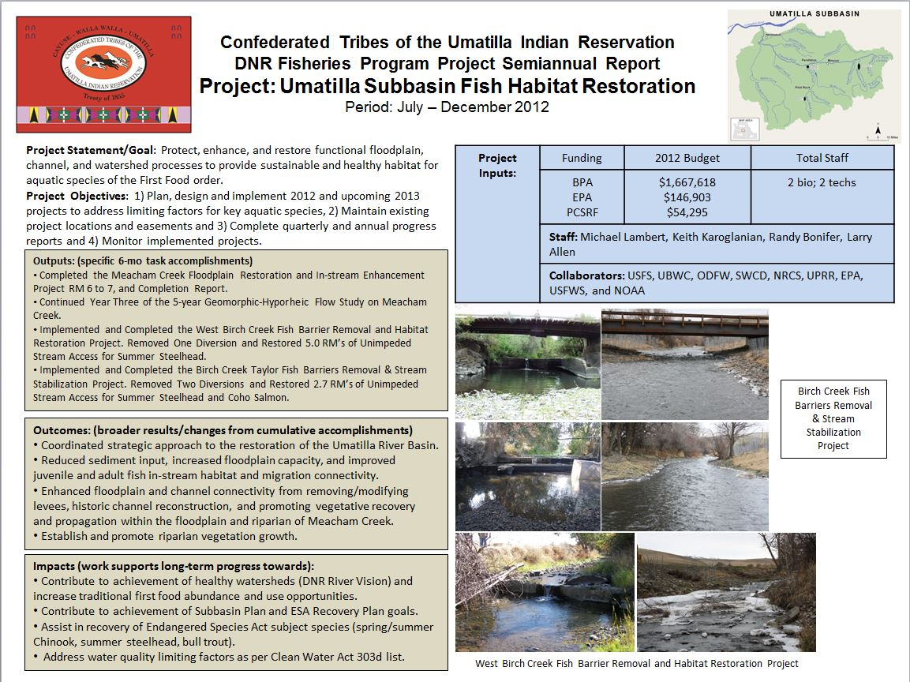
Figure 3. CTUIR semi-annual report for the Umatilla Subbasin Fish Habitat Restoration Project, July – December, 2012.

message was portrayed to our local communities. This project received attention throughout the region and country for its success. Project and educational tours were led by CTUIR staff throughout 2012 to government and agency officials and employees, education groups, policy and management staff, funding partners. A professional handout outlining a common message of the project including background, partners, strategies, goals, objectives and monitoring was developed for message consistency amongst agencies.

Community Education
CTUIR UAFHP staff has participated in educational activities in the Umatilla River Basin specific to floodplain and riverine restoration. Two annual educational opportunities that we participate in include the 5th Grade Watershed Field Days organized by the Umatilla County SWCD and the CTUIR organized Seeds of the Future Building Workshop with University of Idaho (U of I). The 5th Grade Watershed Field Days are multiple workshops throughout Umatilla County where 5th grade classes from all local school districts participate in a one-day outside workshops in April. Students rotate hourly through stations that cover hands-on educational material on plants, soils, macro-invertebrates, water quality, orienteering, and streambank stabilization. Our staff teaches the streambank stabilization class where we educate students on natural streambank processes and benefits of stable riparian vegetation. We show comparisons between an unstable and stable bank and discuss reasons for the differences. Lastly, kids participate with CTUIR staff in planting 300 native plant 12 cubic inch plugs within the riparian. About 250 students and 25 adult teachers and assistants participate in the educational workshop.

Each October, the natural resource students from U of I and CTUIR DNR staff participate in a two day Seeds for the Future Building Workshop in Pendleton, Oregon. This is an annual service learning partnership to foster a significant means of integrating student learning from the Tribes perspective and sharing about our community across state, cultural, and landscape boundaries. U of I students assisted in CTUIR UAFHP staff in planting native vegetation at the Meacham Creek Floodplain Restoration and In-stream Enhancement Project for an entire day on October 24th, 2012 (Figure 4). About 40 college students and several professors participate in the workshop.

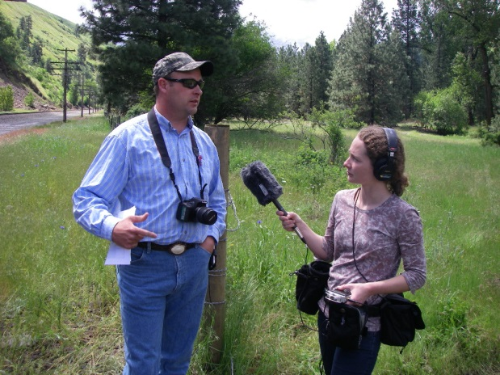 | 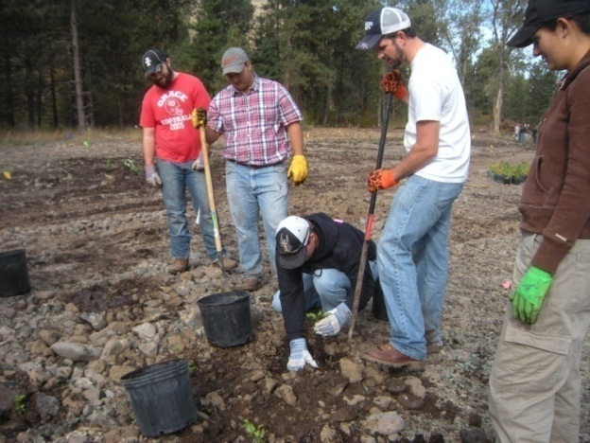
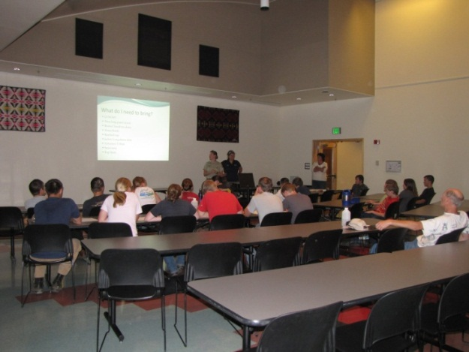 | 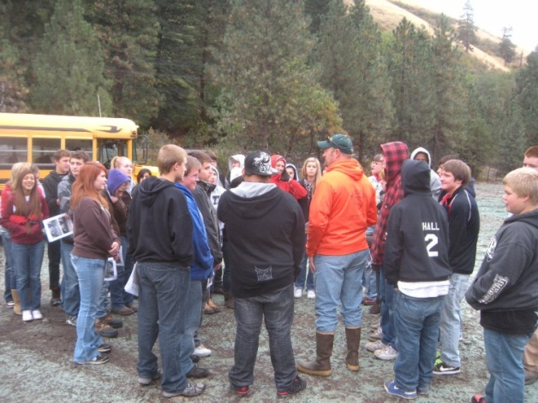
Figure 4. Community Education and Involvement on the Meacham Creek Floodplain Restoration and In-stream Enhancement Project RM 6-7.1, 2012.

In addition to student education, CTUIR participated in technical expertise to an educational video of the National Oceanic and Atmospheric Administration (NOAA) video. The educational video was a collaborative effort with CTUIR, ODFW, UBWC and other local partners working within the community on restoration projects to improve and restore degraded tributary and floodplain habitat to promote education for recovery of salmon and steelhead and Tribal cultural importance. CTUIR Department of Natural Resources now uses the video for Tribal members and community education purposes.

Professional Workshops and Working Groups
Project staff also developed and fostered relationships with participating experts in related fields by attending training, professional workshops and working groups, and gained professional advancement and improved project success through informative, instructional interactions. CTUIR UAFHP and DNR Fisheries Habitat Program staff attended multiple professional conferences and workshops, and participated in oral and poster presentations of project activities including:

American Geophysical Union (AGU) Annual Conference (November 2012)
Reconfigured Groundwater Hydrology and Energy Dynamics in a Restored Western River – Scott O’Daniel, CTUIR, Pendleton, OR (co-authors: Byron E. Amerson and Geoffrey C. Poole (Figure 5)

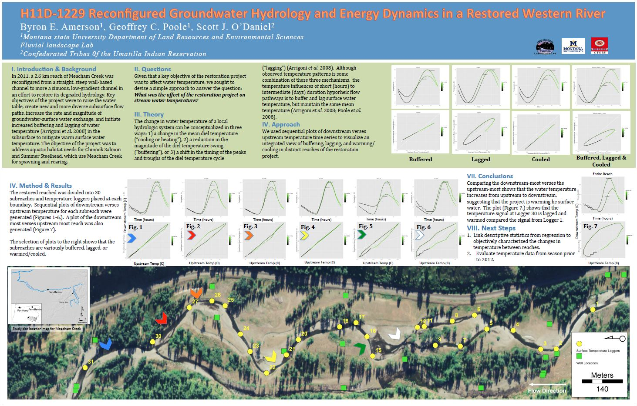
Figure 5. Staff poster presented at the AGU 2012 Annual Conference, November 2012, San Francisco, California.
Society for Freshwater Science (SFS) Annual Conference (May 2012)
Restructuring of Hyporheic Hydrology in Response to Stream Restoration – Byron E. Amerson, Montana State University (co-author: Geoffrey C. Poole (Figure 6)

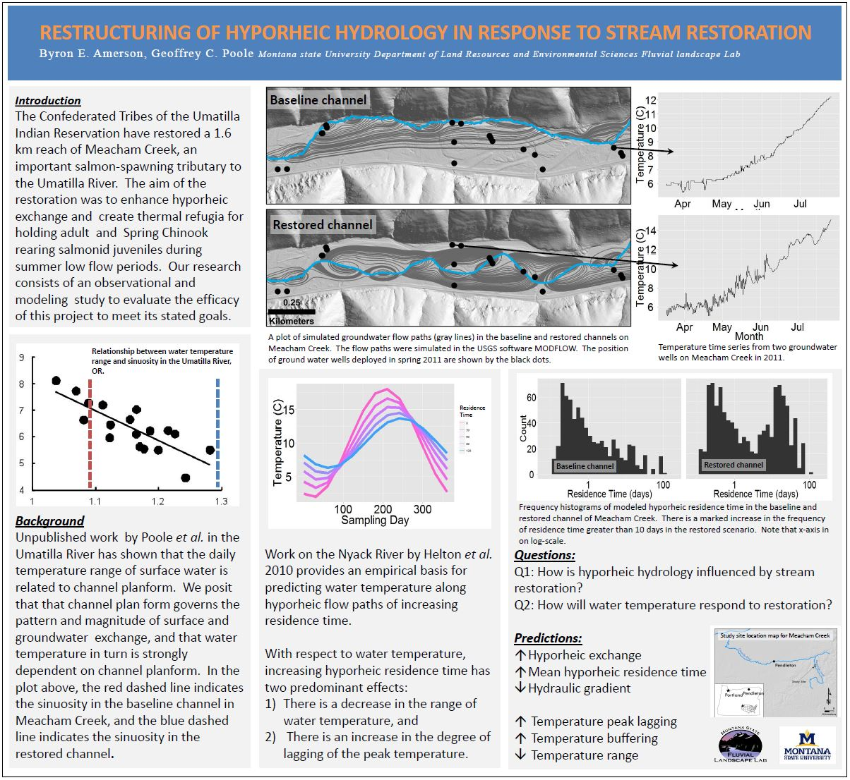
Figure 6. Partner Montana State University poster presented at the SFS 2012 Annual Conference, May 2012.

Work Element J: 197. Maintain/Remove Vegetation
Work Element Title: Maintain Vegetation and Control Noxious Weeds in Project Areas Within the Umatilla River Subbasin
Milestone Deliverable: Maximize Survival of Native Vegetation in Enhancement Project Areas

A. Environmental compliance requirements complete.
B. Weed control in project areas by chemical means.
C. Physical removal of non-preferred species of vegetative growth from project area.
D. Water vegetation and reduce weed competition to improve survival at CTUIR pre-existing project areas.
E. Water vegetation; reduce weeds to maximize survival of riparian plantings at new project sites.

Project activities conducted in FY2012 included the monitoring and maintenance of 10 conservation easements on 15 individual landowner properties. Watering, weeding and maintenance methods for each conservation easement and project area is important for enhanced native vegetation and project site but maintenance varies by site conditions. Strategies to address weeds are included in agreements that are either completed by the landowner, CTUIR, subcontractor, and/or through the County Weed Control Board. CTUIR staff provides assistance to landowners by coordinating and managing herbicide application vendors, providing funding, and developing treatment strategies. Manual, biological and chemical treatment options are utilized by CTUIR and may be employed when consistent with existing standards. Weed control is essential in establishing native grass and plant species. CTUIR subcontracts a professional, licensed applicator to spray/control noxious weeds on sites where chemical application is necessary. The contractor identifies problem weeds, determines the appropriate herbicide and selects the most effective application methods and rates in accordance with the National Oceanic and Atmospheric Administration's (NOAA) Biological Opinion under BPA's Habitat Improvement Program. The contractor utilizes handgun spraying, backpack spraying and wiper applications to treat perennial, annual and biennial weed species. All herbicide applications are consistent with Oregon Revised Statue (ORS).570.505 and Federal Insecticide, Fungicide and Rodenticide Act (FIFRA) Regulations. CTUIR complies with BPA standards and supplies a report to BPA detailing the types and quantities of herbicides applied to specified locations. Biological controls are used in advantageous areas.

In FY2012, CTUIR removed noxious and/or undesirable weeds through mechanical, biological, or chemical means. CTUIR is obligated to control noxious weeds on 121 riparian non-wetland habitat and 465 upland non-wetland habitat acres in Wildhorse Creek, Umatilla River, McKay Creek, Spring Hollow Creek, Birch Creek and Meacham Creek. CTUIR complied with BPA standards and supplied a report to BPA detailing the types and quantities of herbicides applied to specified locations. CTUIR chemically treated 27 riparian non-wetland habitat and 15 upland non-wetland habitat acres (Table 2). These are ongoing work sites where environmental compliance has been cleared in prior contract periods.

In addition to the CTUIR UAFHP, the CTUIR DNR Range Department used goat grazing for biological control treatment of yellow starthistle along the canyon walls and floodplain of Meacham Creek from river mile 1.0 to 6.0.

Work Element K: 47. Plant Vegetation
Work Element Title: Supplement Riparian Areas of Existing and New Projects with Additional Vegetation
Milestone Deliverable: Complete Scheduled Tree and Shrub Plantings in Project Areas

A. Environmental compliance requirements complete.
B. Agreement with the Native Plant Nursery for Growing Plants and Developing Plant Protocol.
C. Establish Planting Locations in Existing Project Areas for Increased Recovery.
D. Establish Improved Vegetative Conditions in New Project Areas.

Project activities conducted in FY2012 included the monitoring and maintenance of managed properties under conservation easements and specific project areas. CTUIR personnel routinely maintain and replant vegetation, water and weed plantings, and maintain structural integrity of riparian enclosure and livestock fencing at project sites. In FY2012, UAFHP staff manually maintained noxious weeds around plants on tarps within CREP project areas. In addition to tarp maintenance, UAFHP staff annually plant vegetation and distribute native grass seed in areas we have implemented existing or new habitat enhancement projects or have identified a need in maintained riparian conservation easement areas. In 2012, CTUIR focused most of the spring and fall planting season within the newly implemented Meacham Creek Floodplain Restoration and In-stream Enhancement Project (RM 6.0-7.1) area finishing planned project plantings (CTUIR 2012). Staff also assisted BPA and CTUIR DNR staff in planting vegetation as part of the Thornhollow Facility Streambank Protection and Habitat Enhancement Project on the upper mainstem Umatilla River and some conservation easement planting on Birch Creek. As part of the project planting plan, CTUIR staff planted 2,904 potted and 390 plugs of various native plant species, and 2,810 willow cuttings by hand and mechanical means. Native grass seed (300 lbs) was distributed by staff as well (Table 3).

Planting tasks include site planning and development of planting strategies, collection and preparation of materials (pruning and conditioning of live willow material), pre-order coordination with the CTUIR Tribal Native Plant Nursery, and installation. Planting techniques are customized for conditions within each project area. Planting location, species, age, form (cuttings, saplings, bare-roots, potted, plugs), and soil/substrate conditions were considered and addressed during the implementation planning phase. The CTUIR UAFHP staff work closely with the Tribal Native Plant Nursery to collect local seed and plant stock to provide native plants for particular project areas by elevation and planting zones.

Work Element L: 186. Operate and Maintain Habitat/Passage/Structure
Work Element Title: Inspect and Maintain Function of In-stream Improvement Structures
Milestone Deliverable: Maintain Proper Operation of In-stream Habitat Structures

A. Environmental compliance requirements complete.
B. The inspection, replacement and/or maintenance of passage and habitat structures.
C. Hire contractor to perform work.
Deliverable: D. Maintain proper operation of in-stream habitat structures.

CTUIR monitors 6 passage rectification projects to assure that treatments are effectively working and to insure that intrusive objects are not interfering with the designed function of the passage structures (Table 4). Routine quarterly scheduled site visits of individual projects are conducted either independently by the CTUIR or jointly with project partners such as ODFW. Site visits also follow significant flow events or responses to landowner requests at project sites.

Project maintenance includes, but is not limited to, meeting specified conditional language in state and Federal permits, maintaining debris that is routinely captured or caught on in-stream structures, responses to landowner requests and concerns, and completion of post-treatment surveys to monitor and quantify changes to physical and ecological responses. If necessary a work plan is developed and contractor hired for completion for project activities greater than routine maintenance. The 2012 project activities involved routine maintenance. At the request of a private landowner, the Hoeft Dam fish ladder was inspected by an engineer to confirm adequate passage of bed load sediment material and wood. Inspection indicated passage through the fish ladder was working appropriately but at increased maintenance to remove gravel from the diversion gate. CTUIR will work with landowner for resolution to ongoing maintenance.

Table 2. BPA form annually submitted by CTUIR listing actual herbicide application, both the active ingredient and adjuvant, by location within the Umatilla River Basin, 2012.

Table 3. Planting materials and grass seed by species, quantity, and size, planted and established at Umatilla River Basin existing and new project sites, 2012.

Table 4. Habitat passage structures monitored and maintained by CTUIR to meet design specifications.
Year | Stream | Stream Location | Project Description
2007 | Meacham Creek | RM 1.7 | Passage rectified by removing large cabled boulders (improved adult passage)
2007 | Meacham Creek | RM 20.2 | Partial dam removed (juvenile and adult passage)
2007 | Camp Creek | RM 0.3 | Partial dam removal (juvenile and adult passage)
2007 | Greasewood Creek | RM 0.4 | Partial dam removal (juvenile and adult passage)
2007 | West Birch Creek | RM 3.2 | Roughened channel to restore proper gradient and reduce step height at road bridge crossing for adult passage
2008 | West Birch Creek | RM 2.7 | Hoeft Dam fish passage rectification (juvenile and adult passage)

Work Element M: 186. Operate and Maintain Habitat/Passage/Structure
Work Element Title: Maintenance of Habitat Features Associated with Project Conservation Easements
Milestone Deliverable: Maintenance of Land or Structures Associated with Conservation Easements

A. Environmental compliance requirements complete.
B. Adhere to details of existing easements and/or initiate additional agreements as feasible.
Deliverable: C. Maintenance of land or structures associated with conservation easements.

The UAFHP have and will continue to maintain project areas under secured conservation agreements with landowners on private properties for protection and enhancement of floodplain and riparian habitat and investments from past passage and in-stream structure projects. CTUIR currently maintains 23 conservation easements on 19 individual landowner properties. Current easements provide secured access and protection of resources for functional floodplain, channel watershed processes to provide sustainable and healthy habitat for aquatic specifies 26 miles of stream (http://data.umatilla.nsn.us/maps/ConservationEasements/index.html; (Figure 7). CTUIR routinely conducts custodial maintenance on individual projects to ensure that project structures and fencing are functioning and habitat recovery is progressing towards meeting projects goals and objectives. Activities include, but are not limited to, installing and repairing riparian cattle exclusion fences, maintaining or installing water gaps, riparian and floodplain plantings and maintenance, noxious weed control, maintenance of fish habitat improvement structures, and landowner coordination and education.

Work Element N: 175. Produce Design and/or Specifications
Work Element Title: Meacham Creek Restoration Reach Design, River Miles 7.0 to 8.5
Milestone Deliverable: Meacham Creek Restoration Design and Implementation Plan, River Miles 7.0-8.5

A. Write specifications.
B. Select contractor.
C. Complete topographic survey and collect and summarize baseline geomorphic and hydrologic data.
D. Determine cost estimate, including cultural surveys, permitting, construction and M&E.
E. Complete design (conceptual, 60%, 90%, and Final).
F. Complete Implementation Plan.
Deliverable: G. Meacham Creek Restoration Design and Implementation Plan, River Miles 7.0-8.5.

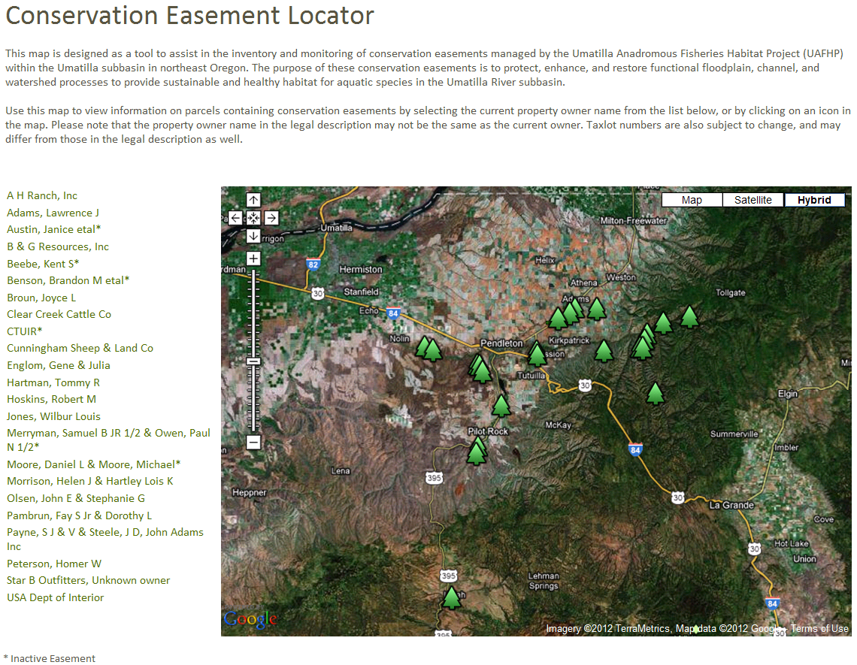
Figure 7. Screen shot of the UBAFH Project conservation easement locator web map.

The Meacham Creek Floodplain Restoration and In-stream Improvement Phase II Project (RM 6-8.5) is planned for 2013-2014 construction (Figure 8). The purpose of the project is to improve floodplain connectivity and in-stream and riparian habitat for listed and non-listed fish species in Meacham Creek by restoring channel morphology and hydrologic, riparian, and in-stream processes. The need for the project has resulted from past impacts and current factors limiting aquatic productivity; specifically, levees and spur dikes limit floodplain connectivity and riparian shade, and lack of large wood or other structures limits in-stream habitat complexity and quantity. Based on post-construction assessments and monitoring of the Phase I project between RM 6 and 7.1, and the existence of additional levees and spur dikes between RM 6 and 8.5 affecting geomorphic and hydrologic processes, the following needs were identified:
- Address placing backfill material in the floodplain between RM 6 to 7 to provide more representative floodplain characteristics and to reduce the potential that Meacham Creek will recapture the 2010 channel location.
- Address channel geometry changes that resulted from flooding in 2011 prior to construction in the Phase I reach.
- Evaluate existing islands and bars in the Phase II reach to determine their current state and expected duration and their role in affecting channel grade and alignment, flood elevations, sediment transport and deposition, and habitat complexity.
- Evaluate removal of levees and spur dikes that continue to impact floodplain and riparian connectivity, aquatic habitat, and geomorphic processes in the Phase II reach.
- Evaluate the adequacy of 100-year flood protection to the UPRR access road based on removal of levees and spur dikes in the Phase II reach.
- Identify locations where the addition of LWD will improve habitat complexity in the Phase II reach.
- Address habitat complexity, including off-channel and side channel habitat, floodplain connectivity, and riparian function in the Phase II reach.

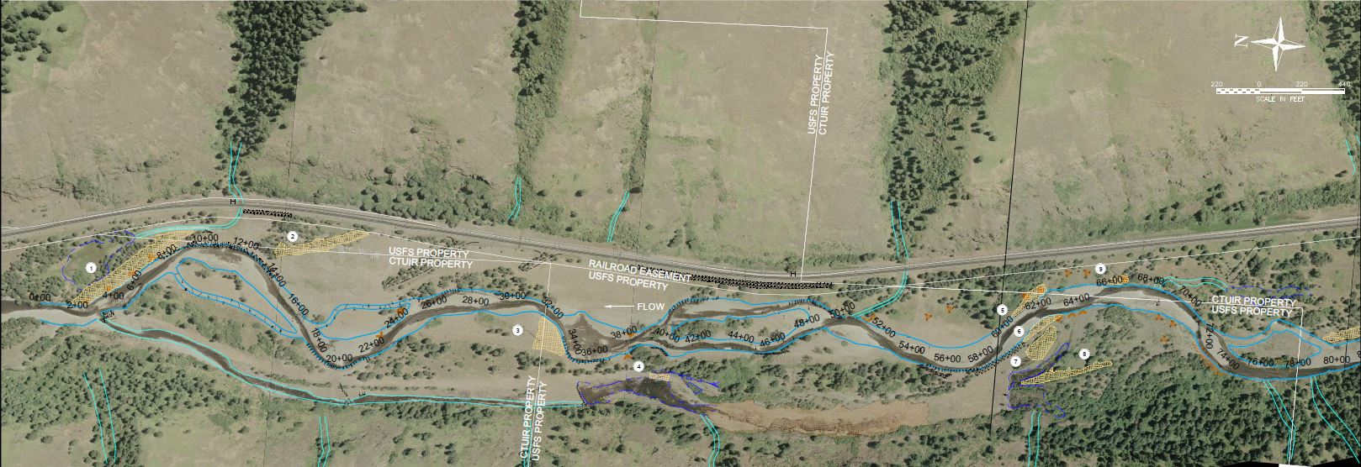
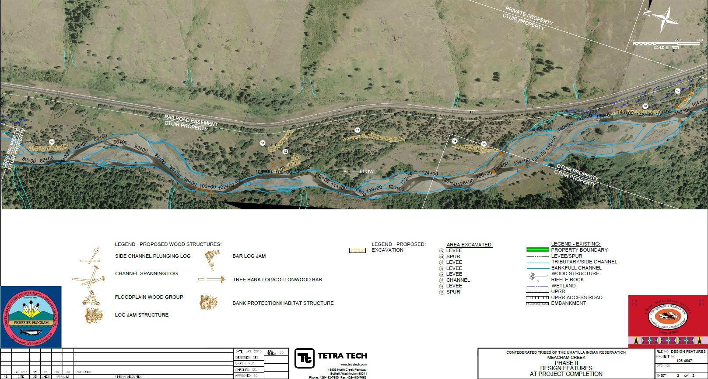
Figure 8. Meacham Creek Floodplain Restoration and In-stream Enhancement Phase II Project Design Features, RM 6-8.5.

As described above, the need for the project has resulted from past impacts and current factors limiting aquatic productivity. To address these, specific project actions were designed into the project area and include (Tetra Tech 2013):
- Placing backfill material in a portion of the floodplain of the Phase I reach.
- Removing or modifying levees and spur dikes in the Phase II reach to increase floodplain connectivity.
- Placing log jams and LWD structures in the Phase II reach to increase habitat complexity and side channel habitat.
- Lowering the elevation of the floodplain in a portion of the reach between RM 6 to 7.
- Excavating a portion of floodplain between RM 7 to 8.5 reach to reinitiate a side channel to increase off-channel and side channel habitat.
- Re-vegetating areas disturbed by Project activities with native plant species.

The proposed actions will help meet the overall project objectives of improving floodplain connectivity and in-stream and riparian habitat for listed and non-listed fish species in Meacham Creek by restoring channel morphology and hydrologic, riparian, and in-stream processes.

Work Element O: 197. Maintain/Remove Vegetation
Work Element Title: Enhance Native Vegetation Growth in the B&G Resources Property, Umatilla River (River Miles 41-44)
Milestone Deliverable: Maintain 355 Acres (61 Riparian, 294 Upland) in Project Area

A. Environmental compliance requirements complete.
B. Till established weed areas of the B&G Property.
C. Manual and mowing application to retard weed growth.
D. Truck water 13,400 plants on CREP riparian tracts (61 acres).
Deliverable: E. Maintain 355 acres (61 riparian, 294 upland) in project area.

The B&G Resources Property project site consists of a property parcel along the Umatilla River between river miles 41-44, about 10 miles downstream of Pendleton, Oregon. The landscape setting ranges from active channel floodplain to abandoned floodplain terrace and upland. In October 2004, CTUIR and B&G Resources signed a Riparian Conservation Agreement for the purpose of promoting sound riparian management that will achieve benefits for fish and wildlife habitat, soil and water conservation and increased productivity of adjacent lands. A total of 355 acres (61 riparian and 294 upland acres) have been treated with, but not limited to, riparian fence enclosure or protection, planting native vegetation in riparian, weed control, watering planted vegetation, and alternative water developments (CTUIR 2008).

In spring 2009, NRCS CREP tracts were replanted with 13,400 sapling trees by CTUIR using a local contractor encompassing 61 acres (Lambert et al. 2011). Original 2006 CREP plantings failed for multiple reasons: 1) poor preparation by original contractor to prepare soil for CREP tract plantings, 2) plantings occurred on high terraces where significant channel incision had occurred resulting in plants largely devoid of water due to the distance from the water table and arid climate at this location, 3) a typical NRCS CREP tract planting plan was developed with no consideration of planting riparian and upland plant species viable at the designated area elevations and low moisture growing environments, and 4) lack of necessary CREP tract maintenance, such as manual and chemical noxious weed control.

Following plantings in FY 2009, the CTUIR strategy with the landowner was for increased survival of NRCS CREP tract plantings further established a maintenance approach to watering plants during the hot summer months for several years to establish root systems for short- and long-term survival. An approach was established to deliver supplemental water to the plants within the CREP tracts. CTUIR applied to the Oregon Water Resources Department and received a Limited Water Use License for using well #1 and well #2 established on the property in FY 2008 for off-site livestock watering. The permit allowed the landowner manager and CTUIR to draw water from the well to water plantings for increased growth and survival through 30-September 2013.

With the increased watering, CTUIR set a minimum targeted survival of 70% over two years with a target goal of 80% for the 2011 growing season. On October 15 2009 CTUIR conducted a survival survey and found that we had a survival rate of 72.4%, project-wide. Although we would expect a typical 10% plant loss on CREP tract projects following planting we had a slightly lower survival than our original 2009 target survival. However, the intent of CTUIR was to maintain NRCS CREP tarp plantings until the project was certified. The NRCS CREP Project was certified in 2011 allowing CTUIR to reduce the need for manually watering during low moisture summer months resulting in a reduction in maintenance costs significantly.

In 2012, CTUIR continued to provide maintenance within the designated area of the landowner conservation agreement. Project activities included weeding around plants, mowing around tarps, and controlling noxious weeds on NRCS CREP tracts (Table 5).
Table 5. B&G Resources Project Actions, Dates of Work, Contracting Agencies and Contractors.
Date | Action | Contracting Agency | Contractor
10/2004 | CTUIR Easement signed | CTUIR | B&G Resources
12/2004 | CREP contract signed | NRCS/FSA | B&G Resources
7/2005 | Installed exclusion fence on east field near well #1. | CTUIR | CTUIR
7/2005 | Installed trespass fence on southeast side. | CTUIR | CTUIR
8/2005 | Prepare for work, cultural resource coordination. | CTUIR | CTUIR
12/2005 | Burn and mow fields | CTUIR | A2Z Engines
1/2006 | Riparian planting (CREP) | B&G | Wild West Riparian
3/2006 | Weed removal on tarp areas | B&G | Wild West Riparian
4/2006 | Mow areas around tarps | CTUIR | CTUIR
4/2006 | Weed control spraying in Zones 1 & 2 (Weed R, Milestone, Aqua neat) | CTUIR | Umatilla County
6/2006 | Weed control, aerial spraying of field (Tordon 22k, 2-4D Amine, R-11) | CTUIR | Cliff Hoeft
6/2006 | Watered riparian plants | CTUIR | CTUIR
7/2006 | Watered riparian plants | CTUIR | CTUIR
7/2006 | Weed control, targeting thistle (Clopyralid, Picloram, Chorsulfuron) | CTUIR | McLain Spraying
11/2006 | Weed control, aerial spraying (Roundup RT, Class Act, Coral Poly) | CTUIR | Cliff Hoeft
4/2007 | Mow in preparation for grass seeding. | CTUIR | Cliff Hoeft
4/2007 | Plant grass, no-till drill | CTUIR | Cliff Hoeft
5/2007 | Weed control (Clopyralid, Picloram, Chorsulfuron) | CTUIR | McLain Spraying
8/2007 | Mowed areas around tarps | CTUIR | CTUIR
1/2008 | Drilled 2 wells for livestock watering | CTUIR | Wallace Drilling
5/2008 | Noxious weed control – herbicides and physical removal | CTUIR | Ellis Ranch
6/2008 | Access Restriction Project, B&G and Becker Easement | CTUIR/ODFW | ODFW
7/2008 | Extensive soil preparation for future plantings | CTUIR | Ellis Ranch
1/2009 | CREP tract preparation by rod weeding | CTUIR | Ellis Ranch
1/2009 | Riparian planting (CREP) – 13,400 saplings | CTUIR | Ellis Ranch
1/2009 | Installed 2 solar panels and livestock watering tanks | CTUIR | Ellis Ranch
3/2009 | Chemical noxious weed control | CTUIR | Ellis Ranch
3/2009 | Apply native grass seed around tarps and mow to retard weed growth | CTUIR | Ellis Ranch
4/2009 | OWRD Limited Water Use License attained for watering CREP tracts | CTUIR | CTUIR
6/2009 | Installation of PVC experimental watering tubes for CREP tract saplings | CTUIR | Ellis Ranch
6/2009 | Well site setup for truck tank and ATV tank watering of CREP tracts | CTUIR | Ellis Ranch
6/2009 | Mowed areas around tarps to retard weed growth | CTUIR | Ellis Ranch
10/2009 | Watered and weeded sapling trees twice per week over five months to increase survival | CTUIR | CTUIR/Ellis Ranch
10/2009 | Mowed areas around tarps to retard weed growth | CTUIR | Ellis Ranch
6/2010 | Well site setup for truck tank and ATV tank watering of CREP tracts | CTUIR | Ellis Ranch
6/2010 | Mowed areas around tarps to retard weed growth | CTUIR | Ellis Ranch/CTUIR
6/2010 | Chemical noxious weed control | CTUIR | Ellis Ranch
10/2010 | Watered and weeded sapling trees twice per week over five months to increase survival | CTUIR | CTUIR/Ellis Ranch
10/2010 | Mowed areas around tarps to retard weed growth | CTUIR | Ellis Ranch
10/2011 | Mowed areas around tarps four times over 7 months to retard weed growth | CTUIR | CTUIR
10/2011 | Watered and weeded sapling trees three times over five months to increase survival | CTUIR | CTUIR
3/2012 | Static water level test on wells for OWRD limited water use License requirements. | CTUIR | Pendleton Electric
5/2012 | Mowed areas around tarps to retard weed growth | CTUIR | CTUIR
5/2012 | Manually weeded around plants on tarps to increase vegetation growth. | CTUIR | CTUIR
7/2012 | Manually weeded around plants on tarps to increase vegetation growth. | CTUIR | CTUIR

Work Element P: 100. Construction Management
Work Element Title: Construction Oversight of the Birch Creek Taylor Dam Removal and Habitat Restoration Project
Milestone Deliverable: Construction Technical Oversight of the Birch Creek Taylor Dam Removal and Habitat Restoration Project

A. Review contractor bid documents.
B. Award construction contract.
C. Provide construction inspection and technical input to project.
D. Recommend final approval.
Deliverable: E. Construction technical oversight of the Birch Creek Taylor Dam Removal and Habitat Restoration Project.

The Birch Creek Taylor Diversion Dams Removal and Habitat Restoration Project is located on private land along the lower half mile of Birch Creek, river miles 0-0.5, just above the confluence with the Umatilla River (Figure 2). The UAFHP staff worked in partnership with the ODFW Umatilla Habitat Project (1987-100-02) and Umatilla County Soil and Water Conservation District (UCSWCD) to implement this work. ODFW was the lead agency on the project and CTUIR through this project provided funding assistance and technical expertise in implementing the project. ODFW worked with the UCSWCD on project management for bid preparation and contractual requirements, oversaw the survey and design process and provided technical assistance. CTUIR provided cash match and technical assistance on the design process, project implementation and cultural resource investigations for environmental compliance.

The project activities included removal of two abandoned, full channel spanning, concrete irrigation diversion dams that were fish barriers near the mouth of Birch Creek (Figure 9). These dams limited the stream channel morphological function and the upstream and downstream movement of native migratory fish species which needed upstream accessibility to high quality spawning and rearing habitat in the headwaters of Birch Creek and its tributaries. The approximate length of the project area reach was 1500 ft and bankfull width 32 ft. Diversion dam #1 was located upstream from the confluence at river mile 0.5 and contained a concrete encased pipe with a jump height of 1.5 ft. Dam #2 was located 100 yards upstream from dam #1 with a jump height of 3.8 feet. In addition dam #2 contained a decadent three pool fish ladder which was located on the west bank of the dam; the dam acted as a control structure for the OR Dept. of Water Resources stream flow gauging station and also supports a wood bridge on an agricultural road. The landowners would normally drive their heavy agricultural equipment through Birch Creek because the prior bridge couldn’t support the equipment weight. The bridge was replaced with a longer fullspanning bridge providing improved channel sediment transport. The bridge was built adequately for transporting heavy farm equipment across the stream channel eliminating the need for the landowner to transport heavy equipment across the pre-existing fjord. The man-made structures were stream barriers, limiting the upstream and downstream movement of native migratory fish species like summer steelhead (Oncorhynchus mykiss), redband trout (O. mykiss), Pacific lamprey (Entosphenus tridentatus), and bridgelip sucker (Catostomus columbianus) which need upstream accessibility to prime rearing & spawning habitat in the headwaters of Birch Creek and tributaries.

An engineering firm specializing in stream restoration activities was hired in 2011 to provide surveys, engineering, and design. The designs provided a solution to remove the fish barriers and provide implementation techniques for stabilizing the channel and banks in order to restore three miles of stream connectivity. This project completed in 2012 restored fish passage, flood channel capacity, habitat fragmentation/connectivity, and habitat loss and the altered habitat structure and species composition was improved. Enhancement techniques included concrete dam removal, bridge removal and replacement, rock and woody debris placement in channel and floodplain, road setback, channel reconstruction for increased in-stream habitat complexity and stabilization, and native plant and grass restoration.

Work Element Q: 100. Construction Management
Work Element Title: Construction Oversight of the West Birch Creek Low Barrier Removal and Habitat Restoration Project
Milestone Deliverable: Construction Technical Oversight of the West Birch Creek Low Dam Removal and Habitat Restoration Project

A. Review contractor bid documents.
B. Award construction contract.
C. Provide construction inspection and technical input to project.
D. Recommend final approval.
Deliverable: E. Construction technical oversight of the Birch Creek Taylor Dam Removal and Habitat Restoration Project.

The West Birch Creek Low Barrier Removal and Habitat Restoration Project was located on private land along West Birch Creek (river miles 5.0-6.0). This UAFHP staff worked in partnership with the ODFW Umatilla Habitat Project (1987-100-02) and the UCSWCD to implement this work. ODFW was the lead agency on the project and CTUIR assisted with costs and technical expertise through implementation. The ODFW worked with the UCSWCD on project management for bid preparation and contractual solicitation and management, and oversaw the survey and design process and provided technical assistance. CTUIR provided cash match and technical assistance on the design process, project implementation and cultural resource investigations for environmental compliance.

The project activities included removal of one abandoned, full channel spanning, concrete irrigation diversion dam, and restoration and protection of stream bed banks in agricultural lands (Figure 10). The concrete dam was a barrier to fish passage under certain flow conditions and contributed to channel instability. This dam limited stream channel morphological function and the upstream and downstream movement of native migratory fish species. Removal of the diversion dam provided upstream accessibility to high quality spawning and rearing habitat at the headwaters of West Birch Creek and its tributaries. With the removal of this structure on West Birch Creek, the flood channel capacity was re-established, connectivity restored, and habitat function and complexity improved. Enhancement techniques included, but was not limited to, concrete dam removal, rock and woody debris placement in channel and floodplain, bank sloping, channel reconstruction for increased in-stream habitat complexity and stabilization, and native plant and grass restoration.

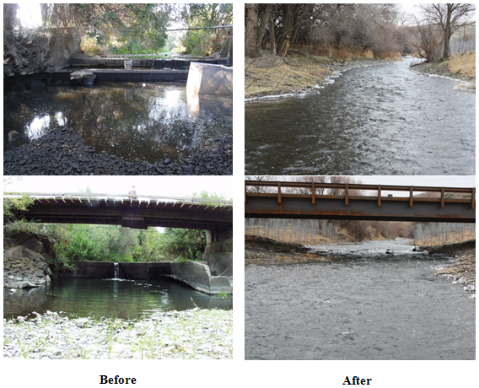
Figure 9. Before-after photo points of the Birch Creek Taylor Diversion Dams Removal and Habitat Restoration Project, RM 0.0-0.5.

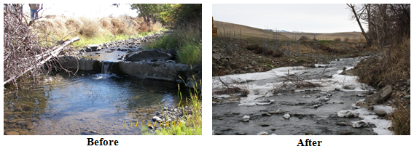
Figure 10. Before-after photo points of the West Birch Creek Low Barrier Removal, RM 5.4.

SYNTHESIS OF FINDINGS: DISCUSSION/CONCLUSIONS

Background/Rationale

The CTUIR-Umatilla Fisheries Habitat Program continues to invest substantial resources in restoring fisheries habitat within the Umatilla Subbasin and its tributaries. With time, we expect watershed treatments to improve stream functions by 1) diversifying channel morphology 2) increasing floodplain connectivity 3) decreasing annual maximum stream temperatures 4) increasing summer base flows 5) increasing abundance of and diversity of riparian vegetation and 6) increasing macroinvertebrate abundance and diversity.

Within the subbasin we have setup baseline monitoring to help understand relationships between our in-stream restoration efforts and aforementioned ecological processes. In order to accomplish this we continue to conduct a combination of monitoring activities and methods included within the Umatilla Subbasin Fish Habitat Restoration Monitoring Plan located at the Pacific Northwest Aquatic Monitoring Partnership website (Citation URL: http://www.monitoringmethods.org/Protocol/Details/681 ). This protocol is specific to physical monitoring (except for aquatic macroinvertebrate monitoring) and is continually being refined. The protocol does not include any information on monitoring fish populations. It is believed that measurable changes in physical habitat improvements are a predictor for improved changes to survival and productivity of various salmon and trout life stages.

Furthermore, in the context of habitat restoration actions, project staff must consolidate regional and local data in order to assist in project activities, such as local and regional project presentations, permitting, development of biological assessments and evaluations, design, pre- and post-project analysis, project effectiveness, and long-term biological and physical recovery response. The Umatilla Anadromous Fish Habitat Project coordinates with multiple CTUIR and ODFW research projects that monitor and evaluate the success of the Umatilla Fisheries Program as a whole. These projects deal with natural production monitoring (CTUIR Umatilla Basin Natural Production Monitoring and Evaluation Project; 1990-005-01 and ODFW Evaluation of Juvenile Salmonid Outmigration and Survival in the Lower Umatilla River; 1989-024-01) and are critical for evaluating natural production relative to sustainable habitat for salmonids. This project utilized data from research projects in the basin to identify trends in response to habitat management actions which will help prioritize future restoration actions. Juvenile production and adult spawn surveys from the above fish monitoring projects were used to examine relationships between production and restored function in the Umatilla River Basin and help to document fish benefits to restoration actions. In addition to biological and physical monitoring, project staff further coordinated with the CTUIR Water Quality Program to attain water quality data as environmental baseline and response for project activities.

In 2012, the majority of monitoring conducted by the Umatilla Fish Habitat Project was done on Meacham Creek. More specifically, the monitoring was focused on the 2011 Floodplain Restoration and In-stream Enhancement Project. Due to the large nature of the project, the large scale changes expected and limited time, 2012 monitoring focused on this project.

Monitoring Objectives

- Evaluate changes in water quality as a result of stream restoration within the Umatilla Subbasin
- Evaluate changes in summer low flow periods as a result of stream restoration within the Umatilla Subbasin
- Study changes in thermal regime as a result of stream restoration projects within the Umatilla Subbasin
- Evaluate changes in riparian stands as a result of stream restoration projects within the Umatilla Subbasin.
- Track changes in biotic and abiotic ecological process within the Umatilla Subbasin, specifically in and around restoration project areas.
- Track the effectiveness of designed stream restoration features within the Umatilla Subbasin
- Track the changes in macroinvertebrate populations and richness within the Umatilla Subbasin

Key Assumptions

Improvements in fish habitat and physical stream characteristics will result in improvements in sustainable fish populations.

Project Feasibility and Development Monitoring

Water Quality and Sediment Monitoring

CTUIR cost share operates with the USFS an automated water sampler (ISCO) near the mouth of Meacham Creek (RM 2.0). Water samples are analyzed under subcontract at the USFS Water Quality Laboratory for turbidity, total suspended solids (TSS), total dissolved solids, and specific conductivity. Data is entered into the CTUIR water quality data base. About 1,460 samples are processed yearly for Meacham Creek and approximately 6,550 samples are processed for other locations on the CTUIR ceded lands.

Analyzed data can measure changes in suspended solids and turbidity from watershed activities, and is a good measure of water quality. Samples for turbidity, TSS, and specific conductivity will be collected and transported to the USFS Water Quality Laboratory for analysis. Sampling procedures and water quality analysis will conform to the stipulations included in the latest edition of EPA’s Water Quality Criteria (1986) and A Guide to the Sampling and Analysis of Water and Wastewater (1987). All approved data is then uploaded to the CTUIR water quality data base semi-annually. Figure 11 is a summarized turbidity plot from 2009 to 2012. Meacham Creek is a low sediment input stream and not listed for turbidity, but this helps monitor for any significant changes in turbidity levels. Monitoring will continue to be used for evaluating habitat project effectiveness from long-term project ground disturbance. Major restoration actions were implemented in 2009, 2011, and 2013 on Meacham Creek

The hydrological analysis for the Meacham Creek Floodplain Restoration and In-stream Enhancement Phase II Project RM 6-8.5 site were determined by evaluating the USGS average daily stream flow data (Tables 6, 7 and 8). The annual flood-frequency analysis for the gage data was performed using the USGS PeakFQ software package (USGS 2006), which follows the Bulletin 17B methods. Discharge estimates for the Meacham Creek Floodplain Restoration and In-stream Enhancement Phase II RM 6-8.5 Project area were reduced from the recorded flows and calculated statistics at the USGS stream gage by applying the gage transfer equation using the ratio of the applicable drainage areas (OWRD 2006). The results from the hydrological analysis were incorporated into a hydraulic model to evaluate the existing adequacy of the 100-year flood protection to the Union Pacific Railroad (UPRR). In addition, the hydraulic model is used to evaluate the potential risks to the UPRR and restoration action response associated with changes

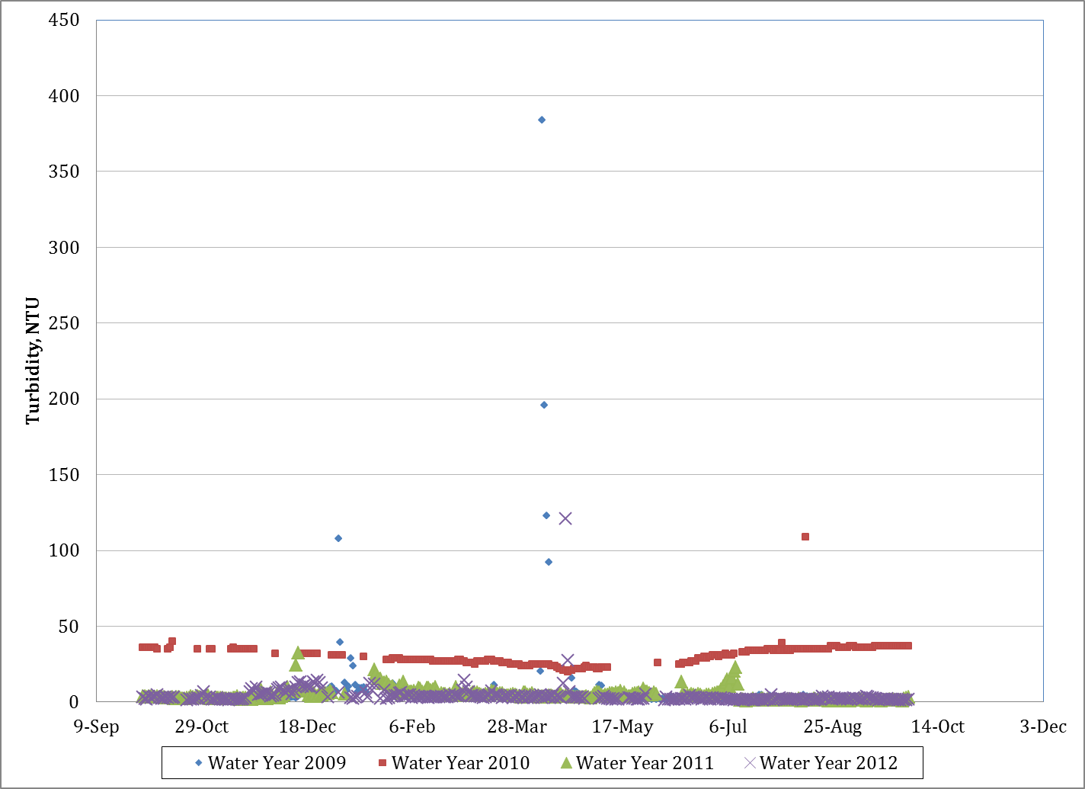
Figure 11. Meacham Creek turbidity plot (NTU’s), 2009-2012.

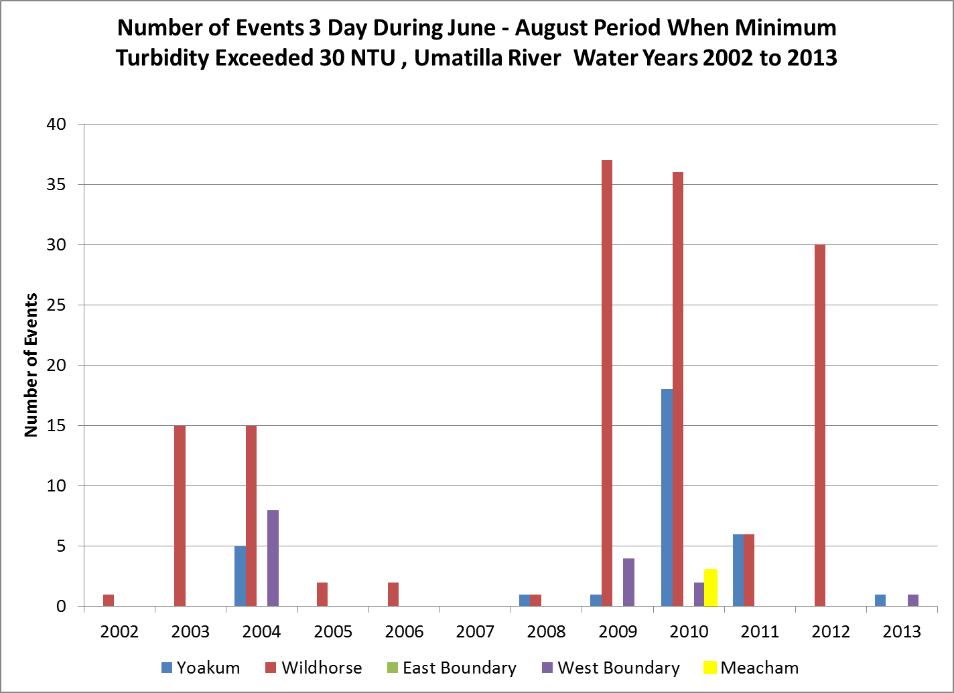
Figure 12. Number of events whereas during a 3-day period from June to August when minimum turbidity of 30 NTU is exceeded, Umatilla River Water Years 2002-2013.

in geomorphic, hydrologic, hydraulic, and habitat characteristics of the stream from removing levees and spur dikes throughout the project area.

Characteristic flows represent the typical range of flows that can be expected in a stream or river during the hydrologic year. Characteristic flows, shown in Table 6, include average annual flow, seven-day average low flow, and one-day average flood flow.

Monthly flows represent the range of flows to be expected during each month of the year. These flows, shown in Table 7, include average monthly mean, minimum, and maximum flows.

Table 6. Characteristic Flows for Meacham Creek at the Meacham Creek Floodplain Restoration and In-stream Enhancement Phase II RM 6-8.5 Project.
Average Annual Flow (cubic feet/second | 197
Seven-Day Average Low Flow (cubic feet/second | 8.8
One-Day Average Flood Flow 2 Year RI (cubic feet/second | 2,230
Bankfull Flow 1.5 RI (cubic feet/second | 1,761

Table 7. Monthly Flows for Meacham Creek at the Meacham Creek Floodplain Restoration and In-stream Enhancement Phase II RM 6-8.5 Project.
 | Monthly Flow (cubic feet/second)
 | Oct | Nov | Dec | Jan | Feb | Mar | Apr | May | Jun | Jul | Aug | Sep
Mean | 15 | 70 | 191 | 262 | 359 | 508 | 586 | 363 | 126 | 13 | 12 | 12
Minimum | 8 | 11 | 18 | 22 | 27 | 134 | 228 | 58 | 22 | 12 | 7 | 7
Maximum | 29 | 323 | 582 | 724 | 1,074 | 1,016 | 1,185 | 1,028 | 483 | 52 | 21 | 17

Flood flows represent the high flows that can be expected at different recurrence intervals. These flows, shown in Table 8, are instantaneous peak flood flows to be used in the Project design.

Table 8. Flood Flows for Meacham Creek at the Meacham Creek Floodplain Restoration and In-stream Enhancement Phase II RM 6-8.5 Project.
 |  | Recurrence Interval Flow (cubic feet/second)
 |  | 5 Year | 10 Year | 25 Year | 50 Year | 100 Year | 500 Year
Peak Flood |  | 3,561 | 4,552 | 5,941 | 7,082 | 8,322 | 11,665

Project Implementation/Compliance Monitoring

Photo Point Documentation

Protocol: CTUIR-Umatilla Basin Photo Points (URL Citation: https://www.monitoringmethods.org/Method/Details/1313

Photo point monitoring intensity varies depending on the magnitude of size and project type. We conduct selected photographic data points from about 150 photo locations over 24 habitat restoration project areas or conservation easement locations completed or managed by CTUIR. Photo points are taken prior to project initiation in order to capture pre project conditions and project progression. If possible photos will be taken showing high and low flow conditions. During project construction photos are taken in order to capture major changes within the project area. After project completion, photos are repeated opportunistically to capture major changes or during bankfull plus events, low flows and/or every 2-5 years. New projects typically have a higher intensity of photo point monitoring due to the high level of changes that can occur.

Currently, CTUIR is heavily monitoring the 2009 Meacham Creek Levee Removal Project (RM 5-6) and Meacham Creek Floodplain Restoration and In-stream Enhancement Project (RM 6-7.1) completed in 2011. Photo point sites are set up in order to track the progression of landscape features (i.e. vegetation, channel morphology) of past, present and future projects (i.e. Figure 13). Repeatable photo point documentation is used to monitor and quantify the general magnitude of change in habitat characteristics to distinguish trends and determine the relation to habitat enhancement projects as a means of effectiveness monitoring. Besides monitoring the Meacham Creek Project, CTUIR continues to use photo point monitoring to assess changes on past projects on Meacham Creek, Birch Creek, the Umatilla River, Wildhorse Creek and McKay Creek.

The CTUIR (Confederated Tribes of the Umatilla Indian Reservation)-Umatilla Basin Photo Points Method is based off of the 2002 USDA "Photo Point Monitoring Handbook" by Frederick C. Hall (http://www.fs.fed.us/pnw/pubs/gtr526/gtr526A1.pdf ). Photo points are uploaded and archived in the CTUIR photo point database depository (http://intranet/resources/dnr/fisheries/Photo%20Points/Forms/AllItems.aspx ) for comparable visuals for tracking physical appearance changes over time. This database is currently only accessible by CTUIR staff.

Action Effectiveness Monitoring

Physical and Ecological Assessment of Habitat Actions-Meacham Creek Case Study

Following completion of the Meacham Creek Floodplain and In-stream Enhancement Project RM 6-7.1 a detailed monitoring design was developed in 2012 to assess effectiveness of restoration actions addressing limiting factors and ecological concerns identified for Meacham Creek. Monitoring of hydrologic and geomorphic conditions, aquatic habitat, and fish distribution were conducted between 2009 and 2012. In addition, there has been pre- and post-implementation monitoring of the Meacham Creek Floodplain and In-stream Enhancement Project RM 6-7.1 from 2009 to 2012. In 2012, CHaMP baseline surveys were completed for three reaches on Meacham Creek.

Columbia Habitat Monitoring Program (CHaMP) Habitat Surveys

Utilizing the CHaMP protocols, Meacham Creek baseline conditions were surveyed in July 2012 to assess both the physical and biological state of three sites over time at an untreated reach where future actions are expected to occur (future project site; RM 2.5 to 3.0), treated reach (Meacham Phase I Project area; RM 5.5 to 6.0), and untreated reach (non-treatment control; RM 8.5 to 9.0). These surveys were selected to establish baseline geomorphic and aquatic habitat conditions in reaches which can be used for detecting change and evaluating the effectiveness of restoration actions over time. The data collected as part of these surveys provided a range of topographic, hydrologic, geomorphic, and aquatic information for which analyses can be undertaken and metrics reported beyond the metrics associated with the CHaMP protocols. Below is a summary of sediment, hydraulics, and geomorphic features within the three sites surveyed (Figure 14 and Figure 15). For a complete description of the methods and results of the 2012 CHaMP Baseline Surveys, refer to the Meacham Creek CHaMP Monitoring 2012 Baseline Report (Tetra Tech 2013a).

Before | After
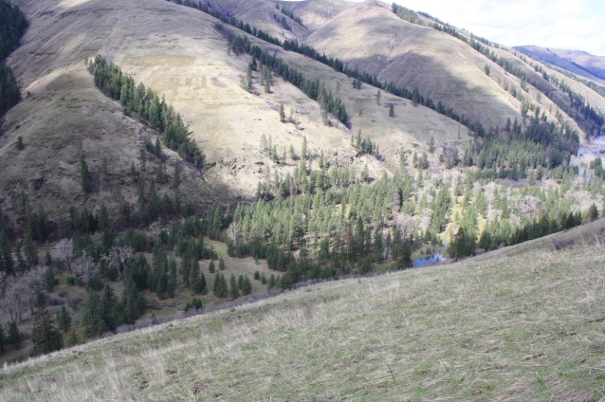 | 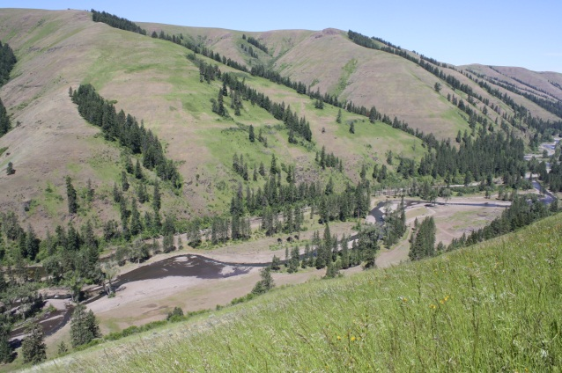
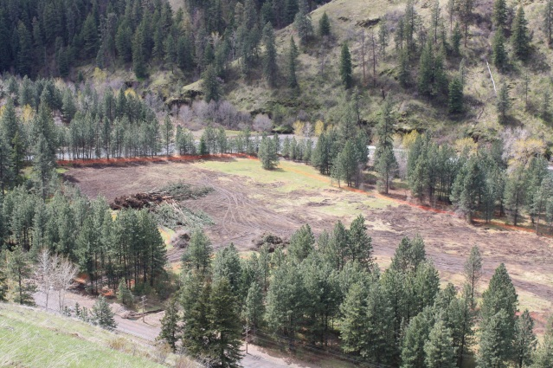 | 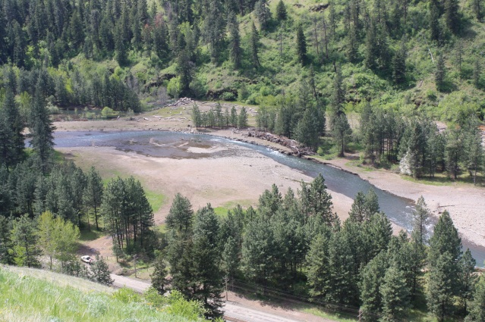
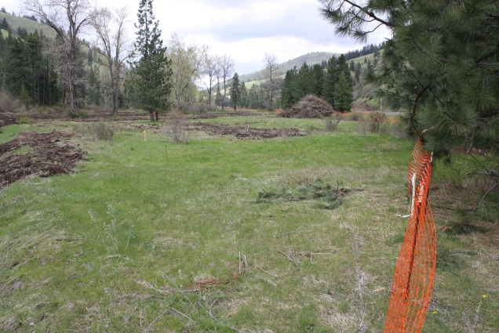 | 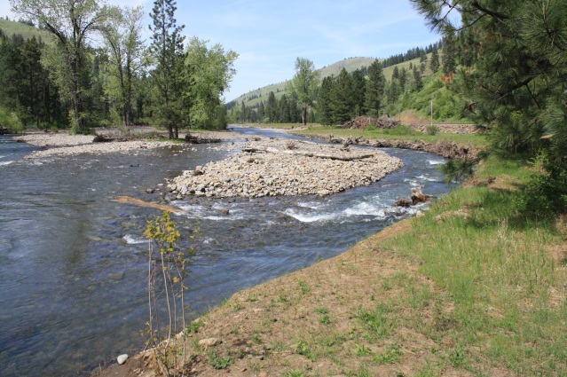
Figure 13. Before and after photos of the Meacham Creek Floodplain Restoration and In-stream Enhancement Project RM 6-7.

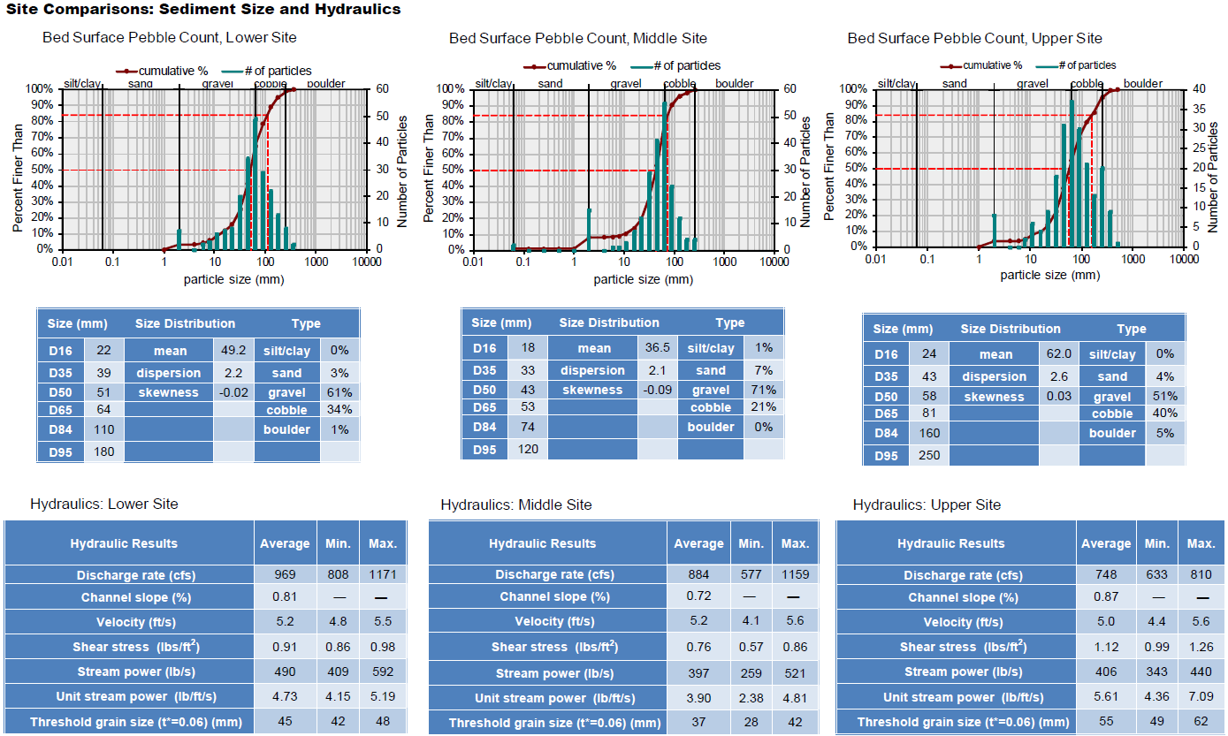
Figure 14. CHaMP sediment and hydraulics comparisons between selected Meacham Creek locations. The locations selected for monitoring included between RM 2.5 to 3.0 (Lower Site; future treatment reach, RM 5.5 to 6 (Middle Site; treated reach) and RM 8.5 to 9 (Upper Site; untreated reach).

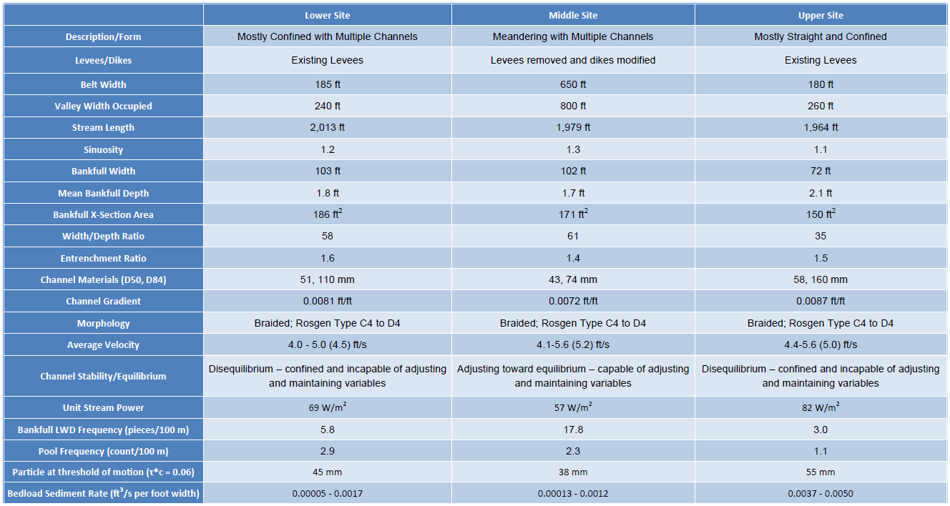
Figure 15. CHaMP geomorphic assessment comparisons between selected Meacham Creek locations. The locations selected for monitoring included between RM 2.5 to 3.0 (Lower Site; future treatment reach, RM 5.5 to 6 (Middle Site; treated reach) and RM 8.5 to 9 (Upper Site; untreated reach).

Meacham Project Phase I Pre- and Post-Implementation Monitoring Assessment

The monitoring assessment utilized the data from 2012 CHaMP surveys within the three reaches for analyses and comparisons. Data evaluated in these analyses included topographic and aquatic habitat characteristics from the CHaMP surveys, one-dimensional hydraulic modeling results, high-resolution aerial photography, light detection and ranging (LiDAR) imagery, pebble counts, LWD counts, and field observations of redds (Tetra Tech 2013b). Repeat topographic survey data in 2011, 2012, and 2013, observations of redds from 2009 to 2012, and snorkel surveys in 2012 were used to evaluate changes in aquatic habitat and fish distribution.

Potential spawning habitat for the Lower, Middle and Upper CHaMP sites as well as the Meacham Creek Floodplain Restoration and In-stream Enhancement Project (RM 6-7.1) was identified using spawning habitat depth and velocity preferences (Tetra Tech 2012b), one-dimensional hydraulic modeling, and model integration with spawning preferences. Spawning preferences were determined by life history descriptions and habitat utilization information gathered by the CTUIR and Tetra Tech. Utilizing the results from modeling, spatial analyses were performed to delineate potential spawning areas that satisfied the preference criteria at the range of flows when spawning typically occurs.

Hydraulic modeling was completed with a one-dimensional steady flow program developed by the United States Army Corps of Engineers (ACOE), commonly referred to as HEC-RAS. The stream flow data for Meacham Creek used in the HEC-RAS model was from a U.S. Geological Survey (USGS) stream gage near Gibbon, Oregon (14020300; referenced above), which has operated since 1975. Discharge estimates for the Monitoring Assessment reaches were reduced from the recorded flows at the USGS stream gage by applying the gage-transfer equation using the ratio of the applicable drainage areas (OWRD 2006).

Depth and velocity preferences were modeled for three potential spawning flows that represent the range of flows for the spawning periods of summer steelhead-rainbow trout, spring Chinook salmon, and bull trout. The low flow spawning conditions were calculated as the mean low flow for August through September [8 to 9 cubic feet per second (cfs)]. The middle flow spawning conditions represent moderate flows throughout the spawning period (104 to 119 cfs). The high flow spawning conditions were calculated as the mean of the maximum flows for the period March to May over the period of record (1,456 to 1,761 cfs). Water surface elevations and water velocities were modeled for each of the three flows.

Based on the habitat utilization preferences for fish species of interest, water depths of 0.4 to 2.7 feet (ft) and velocities of 0.2 to 1.6 ft/second (sec) were selected. Spatial analyses were completed to model, identify, and delineate areas of preferred depth and velocity at each of the three flows listed above. The potential spawning habitat areas identified were those that satisfied the preference criteria for modeled flow depth and velocity at any or all of the three representative flows.

Model validation and calibration was undertaken by evaluating modeled outputs versus field observations of Chinook redds collected by the CTUIR from 2009 to 2012. The locations of these observations were included on the map to provide a visual comparison with the potential spawning areas identified by the modeling.

Similar to the potential spawning habitat methods, modeling was completed for potential rearing habitat areas at the Lower, Middle, and Upper sites and Meacham Creek Floodplain Restoration and In-stream Enhancement Project (RM 6-7.1). The potential rearing habitat was identified using habitat depth and velocity preferences (Tetra Tech 2012b), HEC-RAS modeling results, and model integration with rearing habitat preferences.

Based on the habitat utilization preferences for fish species of interest for rearing habitat, water depths of 0.8 to 3.0 ft and velocities of 0.2 to 1.6 ft/sec were selected. The potential rearing habitat areas identified were those that satisfied the preference criteria for modeled flow depth and velocity at any or all of the three representative flows.

Based on modeling results a significant amount of habitat was created from implementation of the Meacham Creek Floodplain and In-stream Enhancement Project (RM 6-7.1). Potential spawning area went from 0.5 acres to 2.1 acres (320% increase; Figure 16 and Figure 17) and potential rearing area went from 0.1 acres to 6.3 acres (6,200% increase; Figure 18 and Figure 19)[Table 9].

Benefits to Target Salmon Species

The Meacham Creek Restoration and In-stream Enhancement Project RM 6-7.1 was implemented to address the limiting factors of flow, temperature, and habitat simplification for cold-water fish including listed Mid-Columbia River Steelhead and Columbia River bull trout, and spring Chinook salmon, Pacific lamprey and other resident fish. The newly created channel provides a significant increase in habitat diversity and hiding cover that salmonids and resident fish can take advantage of immediately (Table 9). The new channel was constructed across the floodplain with increased channel complexity and length, which resulted in a decreased gradient and overall flow velocity. The channel bed elevation was constructed higher than the existing channel and overbank flows are more accessible to the floodplain. With an increase in floodplain connectivity and channel complexity there is an increased connection between the surface channel and shallow water table (hyporheic zone), resulting in an increased diversity of water temperature with areas of low temperature for refuge and moderated daily temperature fluctuations. We expect lower stream temperatures as the project restoration site fully recovers from implementation. Surface and hyporheic temperature/flow response continues to be monitored as part of the Meacham Geomorphic/Hyporheic Flow Study (results presented below).

Table 9. Geomorphic characteristics, floodplain connectivity and sediment comparisons RM 6.0 to 7.1 (2009-2012).
Limiting Factor | Metrics | RM 6.0 to 7.1
Limiting Factor | Metrics | 2009 Baseline | 2012 Phase II Survey and As-Built
In-Channel  Characteristics | Primary Channel Length (ft) | 6,050 | 6,560
In-Channel  Characteristics | Secondary Channel Length^{1/} (ft) | 1,830 | 9,220
In-Channel  Characteristics | Bankfull Width (ft) | 99 | 96
In-Channel  Characteristics | Bankfull Depth (ft) | 3 | 2.0
In-Channel  Characteristics | Bankfull Cross-Sectional Area (ft²) | 297 | 187
In-Channel  Characteristics | Width/Depth Ratio (Wbkf/Dbkf) | 33 | 49
In-Channel  Characteristics | Gradient (ft/ft) | 0.0086 | 0.0078
In-Channel  Characteristics | Sinuosity (Lc/Lv) | 1.1 | 1.2
In-Channel  Characteristics | Average Meander Length (ft) | 1,550 | 1,490
In-Channel  Characteristics | Braided-Channel Ratio | 1.1 | 1.1
In-Channel  Characteristics | Channel Complexity Index | 0.0010 | 0.0030
In-Channel  Characteristics | Pool-to-Pool Spacing (ft) | 778 | 353
In-Channel  Characteristics | Percent Pool Area (%) | 28 | 26
In-Channel  Characteristics | Relative Habitat Abundance – Percent Riffles | Glides (%) | 72 | 0 | 57 | 17
In-Channel  Characteristics | Relative Feature Abundance^{2/} | -- | 39
In-Channel  Characteristics | LWD Counts^{3/} | -- | 964
Floodplain | Percent of Floodplain Disconnected (%) | 33.7 | 11.6
Floodplain | Floodplain Inundation (acres) | 60 | 80
Floodplain | Relative Abundance of Floodplain Habitats (acres) | 14.3 | 12.6
Floodplain | Channel Migration Rate (ft/yr) | 2 - 16 | 2 - 16
Sediment | Sediment Size Distribution, in channel – D50 (mm) | 68 | --
Sediment | Sediment Size Distribution, in bars – D50 (mm) | -- | 48
Sediment | Sediment Size Distribution, in floodplain | Poorly to well‐graded gravel with sand and cobbles with little or no fines. | Poorly to well‐graded gravel with sand and cobbles with little or no fines.
Sediment | Threshold Grain Size and Transport Rate (mm) | 78 | 51
Sediment | Fine Sediment Percentage in Bed Material (%) | 4 | 0-12
Sediment | Scour | Deposition (cy) | -- | 21,440 | 7,800
Sediment | Relative Abundance of Spawning Habitat (ft²) | 0.5 | 2.1
Sediment | Relative Abundance of Rearing Habitat (ft²) | 0.1 | 6.3
^{1/} Includes off-channel habitat length.
^{2/} Includes LWD structures with two or more pieces and boulder clusters. The 2013 Phase II As-built quantity includes both Phase I and Phase II structures.
^{3/} Quantity based on LWD count in design plans and does not include preexisting LWD. The 2013 Phase II As-built quantity includes both Phase I and Phase II LWD.

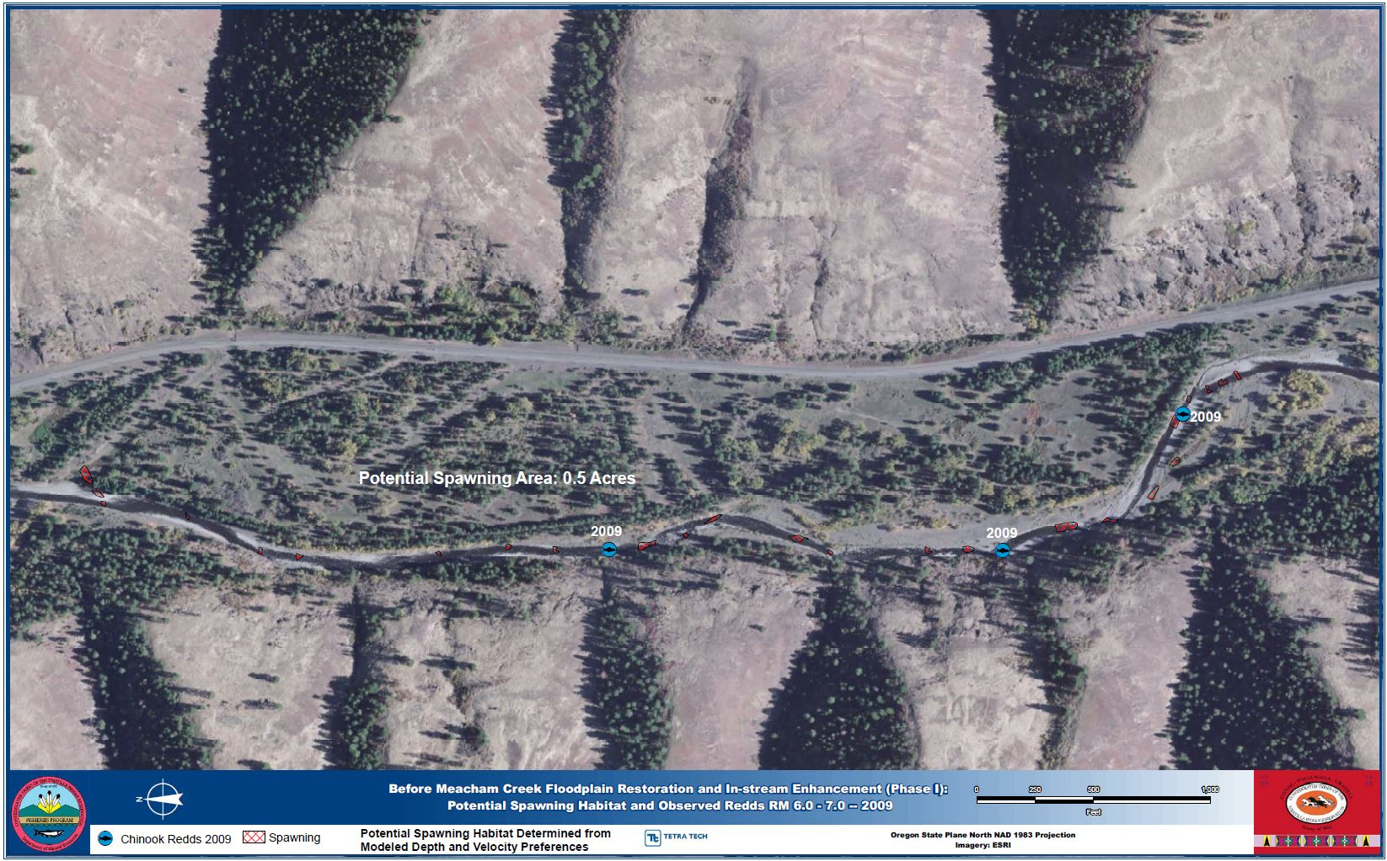
Figure 16. Potential spring Chinook salmon, summer steelhead and bull trout spawning habitat determined from modeled depth and velocity preferences before Meacham Creek Floodplain Restoration and In-stream Enhancement Project: potential spawning habitat and observed redds 2009.

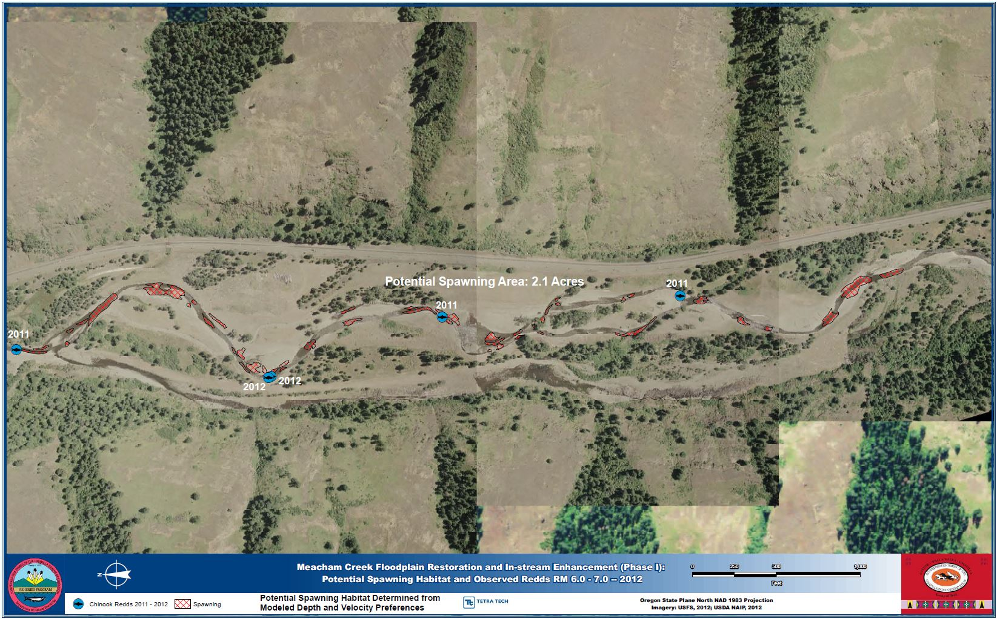
Figure 17. Potential spring Chinook salmon, summer steelhead and bull trout spawning habitat determined from modeled depth and velocity preferences following Meacham Creek Floodplain Restoration and In-stream Enhancement Project: potential spawning habitat and observed redds 2012.

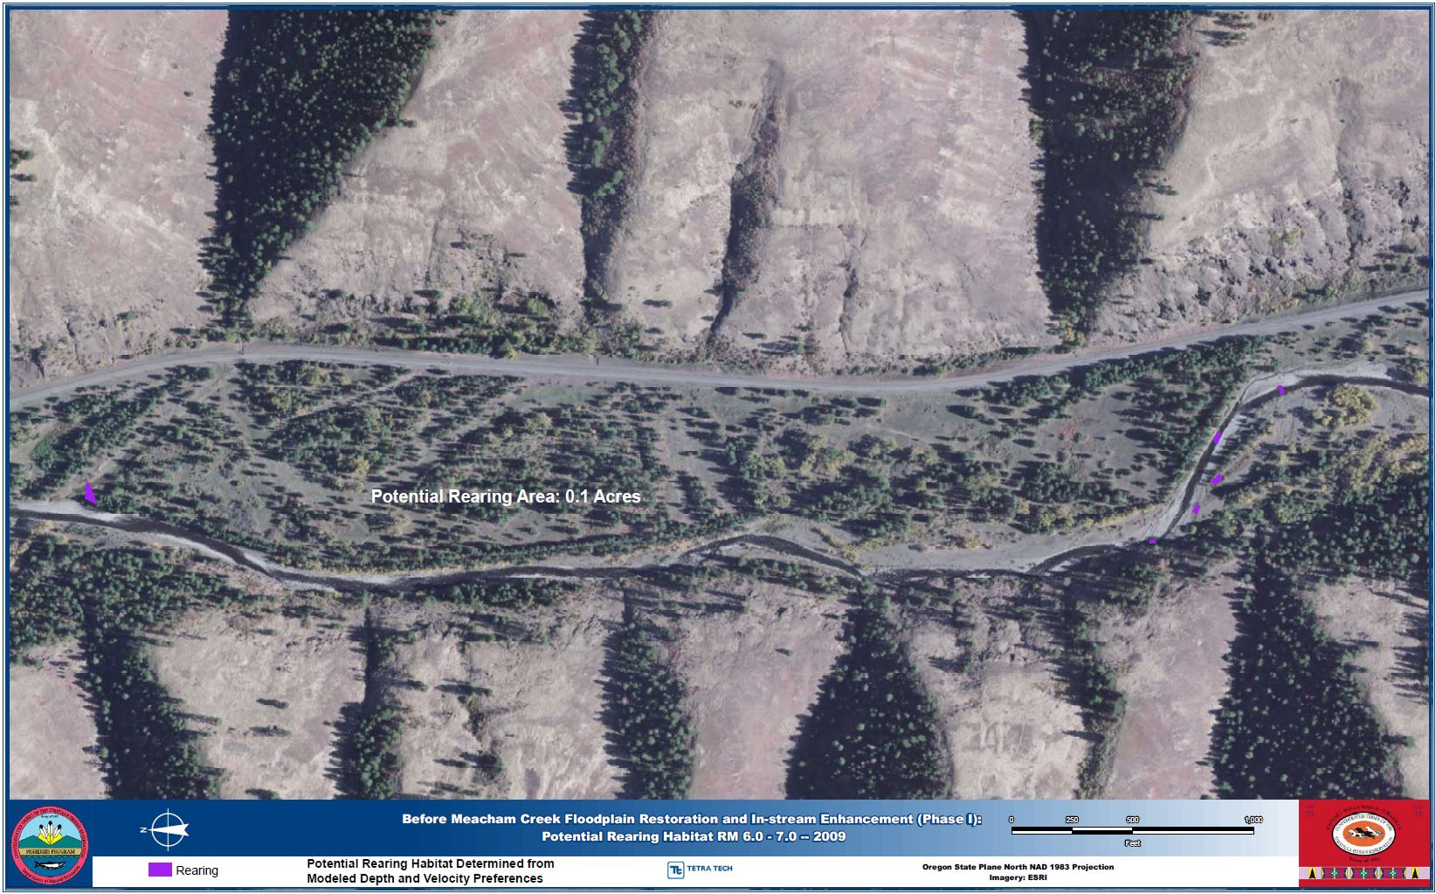
Figure 18. Potential spring Chinook salmon, summer steelhead and bull trout rearing habitat determined from modeled depth and velocity preferences before Meacham Creek Floodplain Restoration and In-stream Enhancement Project: potential rearing habitat 2009.

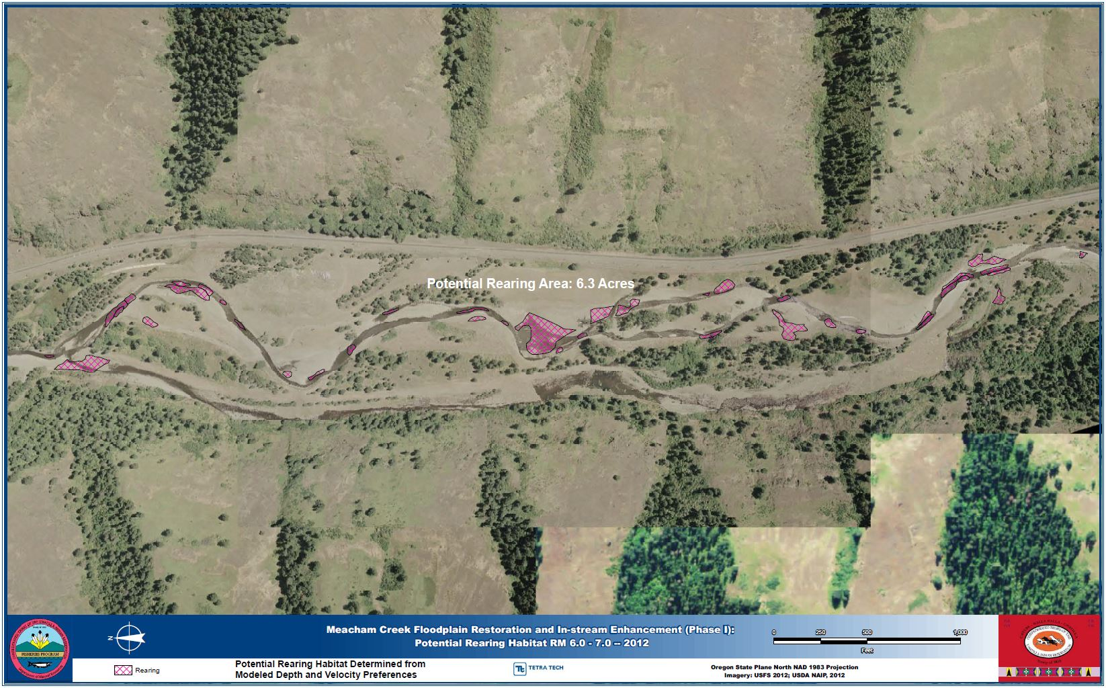
Figure 19. Potential spring Chinook salmon, summer steelhead and bull trout rearing habitat determined from modeled depth and velocity preferences following Meacham Creek Floodplain Restoration and In-stream Enhancement Project implementation: potential rearing habitat 2012.
Meacham Creek Geomorphic-Hyporheic Flow Study

Protocol: Meacham Creek Geomorphic-Hyporheic Flow Study (URL Citation: http://www.monitoringmethods.org/Protocol/Details/677 ).

Introduction

CTUIR recently completed a large scale restoration project on Meacham Creek (RM 6-7.1) that included, but is not limited to, channel realignment (re-meandering), reconstruction, addition of large woody debris and flood plain reconnection. This project has many goals, as portrayed throughout this document, one of which is to enhance hyporheic exchange and create thermal refugia for rearing salmonid juveniles during summer low flow periods.

The Meacham Creek Geomorphic-Hyporheic Flow Study combines a variety of field and numerical modeling techniques to create a complete picture of the residence time distribution for hyporheic water at the restoration site for both pre- and post- restoration conditions and will document the effects of channel re-alignment (restoration) on hyporheic exchange (rates, magnitude, and volume), hyporheic flow path lengths, residence time, and ultimately, channel temperature. The groundwater and surface water monitoring study was designed to meet the following three objectives:
- Quantify ground the rate and magnitude of surface water - groundwater exchange and groundwater residence time both prior to and after restoration actions to assess changes in recharge and discharge between Meacham Creek and its alluvial aquifer (hyporheic exchange).
- Establish a monitoring network of stream temperature loggers and water level loggers to measure changes in the surface and subsurface water elevation and temperature due to restoration actions.
- Pilot a new method of stream restoration monitoring that will have broad utility to other restoration efforts in the region.

This research is in partnership with Montana State University (MSU) and will be a critical first step in understanding the efficacy of conventional restoration strategies for hyporheic rehabilitation. Efforts will provide a first empirical test of whether geomorphic restoration is cost effective means of managing water temperature in streams that violate EPA’s water temperature standards for the region and nationally. This research will also provide the first reach-scale evaluation of a stream restoration specifically implemented to meet the objectives of hyporheic restoration and temperature mitigation. Finally, this work would serve as a model for partnership between academia and managers in developing research-based monitoring strategies that facilitate learning and thus adaptive identification of effective structural and process-based restoration strategies for reestablishing vertical connectivity (Ward 1989, Stanford and Ward 1993) by restoring hyporheic hydrology in river ecosystems.

Results

Groundwater Modeling Methods and Preliminary Model Analysis
In late 2010 and early 2011, groundwater hydrology of the baseline and restored channel alluvial aquifers was modeled using the USGS groundwater modeling software MODFLOW (Harbaugh, 2005), where the main input into the aquifer was the water surface elevation of the creek plan form. Surface water elevation was derived from first-return LiDAR for the baseline condition, and under the restored condition it was based on "filling" the design channel pools and the riffle ground elevations. In either case, aquifer thickness was assumed to be 5 m in the valley center, tapering to .5 m at the valley wall using the LiDAR terrain model as the surface. Once the potentiometric flow surface was developed, subsurface flow path lines through the potentiometric flow field were generated by releasing "particles" along the creek using the USGS solute modeling software MODPATH (Pollock, 1994)

The groundwater modeling results predicted that there would be a substantial shift in groundwater surface elevation, as well as in the pattern and magnitude of exchange between groundwater and surface water in the project reach. Based on these initial hydrologic simulations of the site (Figure 20), it is predicted that the residence time distribution of hyporheic water will shift to include a higher number of intermediate duration hyporheic flow paths, but that the magnitude of gross hyporheic exchange may either increase or decrease, depending on the change in hydraulic conductivity (Figure 21).

Groundwater Elevation and Temperature Monitoring
During the spring and summer of 2011 and 2012, a series of 32 monitoring wells were established prior to and during stream restoration activities. In each well a water temperature and level data logger was deployed (Onset HOBO U20 Water Level Data Logger model U20-001-01 [pressure accurate to 0.05% and temperature to 0.1 °C] or Solinst Model 3001 Levelogger Junior Edge [pressure accurate to 0.1% and temperature to 0.1 °C]). Twenty of the well loggers were deployed six weeks before the restoration project began, and another twelve were deployed just prior to diversion of flow to the new channel, and two were install in July 2012; 22 well loggers remain deployed, while the remainder were either accidentally broken during construction or were removed during construction or prior to the onset of seasonal high flows.

Results from the initial MODFLOW modeling (Figure 20) were used to select well locations that captured the expected range of hyporheic residence times across the alluvial aquifer, both prior to and after channel realignment. Because daily and seasonal temperature signals are useful tracers of groundwater movement as well as indicators of systematic changes in the temperature status of water as it moves through the hyporheic zone (Arrigoni et al., 2008; Hoehn & Cirpka, 2006; Stonestrom & Constantz, 2003), it is expected changes in the patterns of water temperature across this well network that reflect the restructuring of hyporheic hydrology within the alluvial aquifer.

Surface Water Temperature Monitoring
In 2011 thirty temperature loggers were deployed in surface water features along the restored stream channel prior to diversion of flow into it (Onset HOBO Pendant Temperature/Light Data Logger model 64K - UA-002-64 (accurate to 0.53 °C), or Maxim Dallas iButton model DS1922L (accurate to 0.5 °C) encased in waterproof resin (sold as iBcod by Alpha Mach, Inc)). In addition to those loggers deployed along the restored channel reach, approximately 20 more temperature loggers were deployed in the main channel above and below the project reach as well as in groundwater upwelling features near the channel and in the floodplain. The groundwater upwelling features include springs, flowing backwater areas, and spring brooks far-removed from the channel. In 2012, 54 surface water temperature loggers were deployed (Figure 22). Twenty-eight of those were placed in the main flow of Meacham Creek along the restored reach at hydrologic breaks roughly corresponding to typically-defined aquatic habitat features (e.g. pool, riffle, etc.). The remaining temperature loggers were deployed in groundwater upwelling features similar to 2011. In September 2012, all of the surface water loggers in the main channel were removed to protect them from being lost away in high winter flows. However, all of the loggers in off-channel springs far from the main channel were re-deployed after being downloaded. In addition, a temperature logger was placed in the open channel flow bolted to a bedrock outcrop. Theses latter deployments were to record over-winter temperatures and capture the full seasonal cycle of water temperature variation at the restoration site.

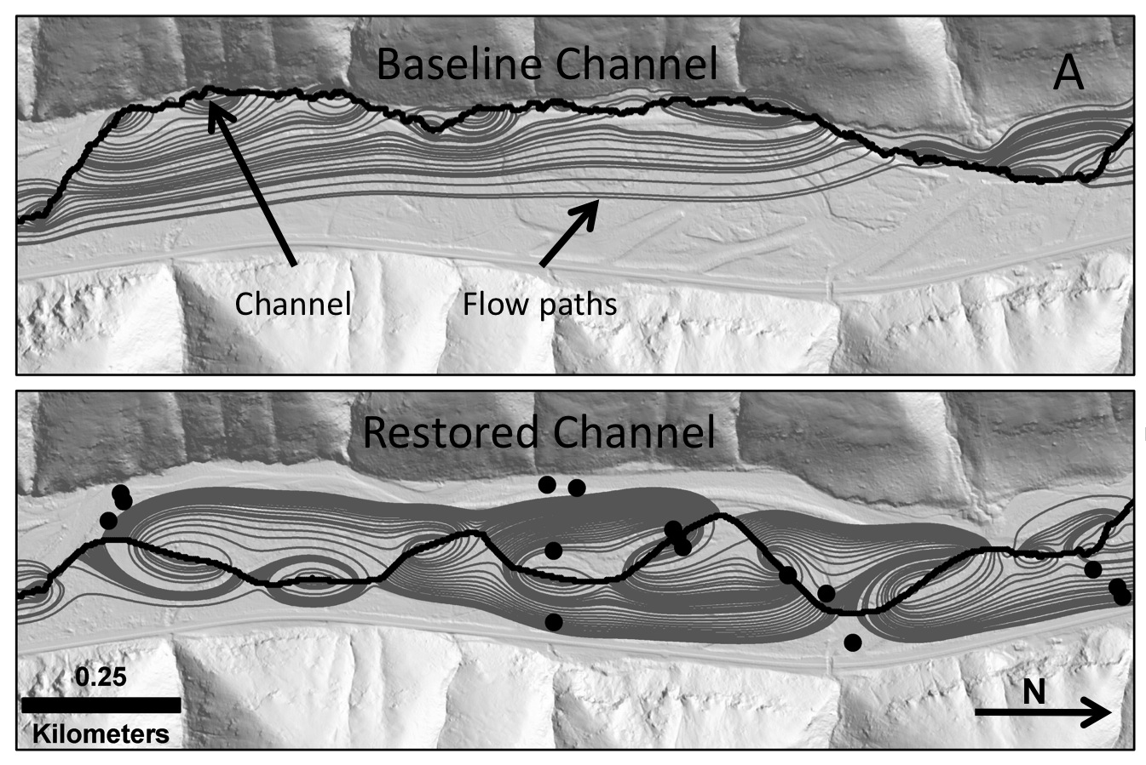
Figure 20. Results from MODFLOW simulation showing expected influence of restoration on hyporheic flow paths (grey lines) on the Meacham Cr. restoration site. Dots show locations of installed monitoring wells in the project site area.

Figure 21. Simulated hyporheic flow-path residence time distributions based on MODFLOW groundwater models depicted in Figure 1.

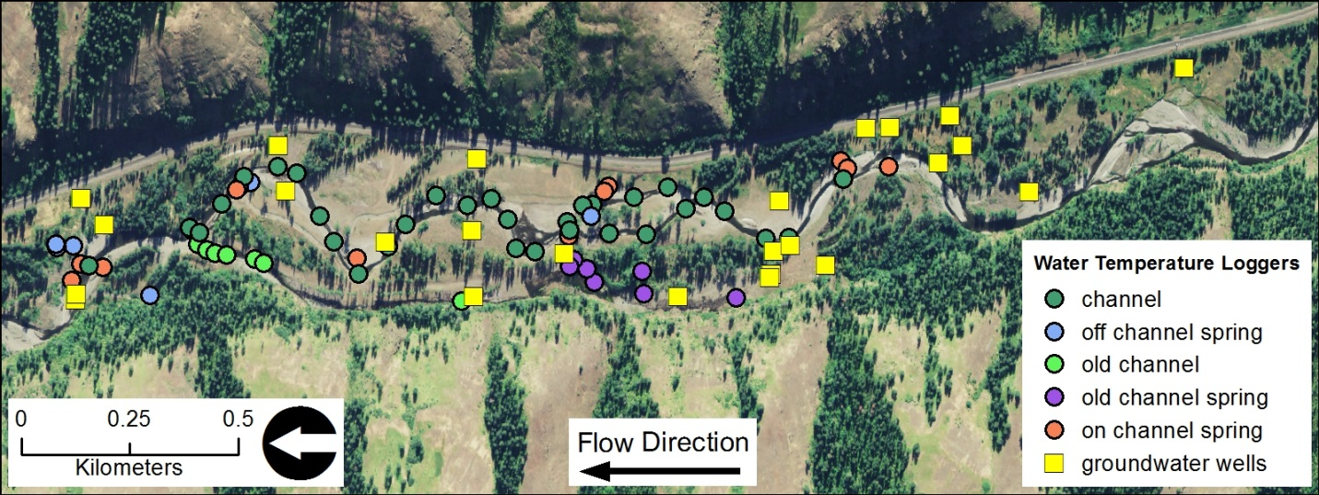
Figure 22. The location of surface water temperature logger and groundwater monitoring wells at the Meacham Creek Restoration site in 2012.

Radon-222 activity and geochemistry
To verify groundwater residence times predicted the hydrologic model will be to evaluate observed vs. simulated distributions of hyporheic water residence time across the site, post-restoration. Radon-222 concentration is a reliable indicator of subsurface water residence time up to ~20 days (Hoehn and Cirpka 2006, Lamontagne and Cook 2007). In October 2011, we measured Radon-222 activity and collected geochemistry samples at twenty wells, five open channel locations, and four spring brook source waters using methods described by Schubert et al. 2006. In March 2013 repeat sampling for radon-222 and geochemistry was repeated at all wells and three open channel locations. Geochemistry data will be used to determine the magnitude of mixing between hyporheic and deep groundwater (Freeze and Cheery 1979, Hoehn and Cirpka 2006, Jones et al. 2008), a prerequisite for estimating hyporheic residence time from Radon-222. An additional value that is required to determine residence time using radon-222 is the equilibrium concentration of the dissolved gas on the aquifer of interest. This value is related to radon-222 production by the aquifer material, and is generally idiosyncratic to the system in question; hence literature values do not serve well. Therefore, 8 250 ml pickling jars have been filled up completely with aquifer material from the study material and degassed tap water. After six weeks, samples from the middle of the volume of sediment will collected and the concentration of radon will be measure by scintillation counter. This method has proved reliable in similar studies (Sebastian LaMontange, personal communication, March 2013).

Database

A database containing over 1.7 million records has been created from the data collected to date. The database software being used is PostgreSQL 9.1.8 (www.postgresql.org), a powerful enterprise-capable database that is spatially-enabled, allowing retrieval of data in ESRI shapefile format. The database has been carefully designed to allow retrieval of temperature or water level information by date range, location, data logger serial number, data logger make, etc.

A database containing over 1.7 million records has been created from the data collected to date. The database software being used is PostgreSQL 9.1.8 (www.postgresql.org), a powerful enterprise-capable database that is spatially-enabled, allowing retrieval of data in ESRI shapefile format. The database has been carefully designed to allow retrieval of temperature or water level information by date range, location, data logger serial number, data logger make, etc. Surface water temperature data through 2012 were added to a PostgreSQL database. All groundwater temperature and water level data through 2012 were added to a PostgreSQL database. Subsequent to data upload, any irregularities and errors revealed via QA/QC were corrected. An optional for a geospatial field for each measurement point has been added to the database, though not yet fully implemented. The addition of the spatial field allows straightforward extraction of spatially-referenced measurements for use in a GIS. By the end of 2012 there were 1.7 million temperature and water level records in the database; these data are the sum of continuous hourly measurements in 22 wells, and about 30 surface water locations each summer since 2011.

Since PostgreSQL adheres to the SQL standard (http://www.postgresql.org/docs/current/interactive/features.html), this database can easily be transferred to any SQL-based webserver to enable sharing of the data collected.

Synthesis of Findings: Discussion/Conclusions

Results to Date: Work on the Groundwater and Surface Water Hydrologic and Temperature Monitoring is ongoing, and aside from the preliminary hydrologic modeling, no substantive results are yet available. However, observation of over 25 groundwater upwelling features along the restored channel demonstrated that there has been a shift in groundwater hydrology at the restoration site (Figure 23). These features include a range of types from strongly flowing springs to seeps along the downstream margin of point bars marked by filamentous algae growing in these nutrient-enriched outflows. In addition, observations of groundwater flow into the exposed portions of the baseline channel and in other areas throughout the floodplain suggest substantial changes in groundwater hydrology (Figure 24). It is expected that there has been concomitant changes in the thermal processes of the aquifer as well. Cursory exploration of level logger confirms these observations.

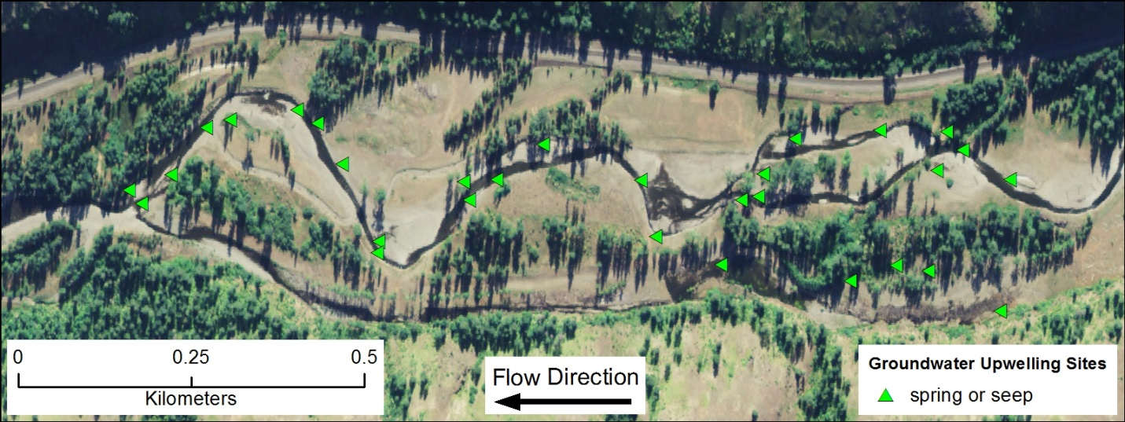
Figure 23. The location of easily observed groundwater upwelling features along the restored reach of Meacham Creek observed in summer 2012.

Macroinvertebrate Study

Abstract

Macroinvertebrate assemblage structure is being used as a tool for the bioassessment of the effectiveness of the Meacham Creek Floodplain Restoration and In-stream Enhancement Project (RM 6-7.1; Phase I) restoration. Macroinvertebrates have been sampled annually at six sites in Meacham Creek from 2005 and onward. In addition, in 2007 sites were sampled on the North Fork Umatilla River that serves as a relatively pristine reference site. Five macroinvertebrate metrics are being used to describe the condition of the stream reaches being sampled. The Meacham Creek sites and sampling follow a BACI (Before-Afer-Control-Impact) design with sites found both within (Impact) and outside (Control) of the restoration project area and sampling occurring both before and after restoration at all sites. At this time only the before restoration data has been analyzed, not enough data has been collected from the post-restoration period for analysis. The prediction for differences in macroinvertebrate metrics between impact and control sites before restoration is that the sites will not differ in either mean metric values or in trajectories of change through time. As predicted no significant differences were found between control and impact sites during the before restoration period in mean metric values. In addition, none of the metrics showed any significant linear changes through time for the before restoration period at either the impact or control sites. These results indicate that the BACI design is a robust design for examining the effectiveness of the Meacham Creek Phase I restoration. Macroinvertebrate samples were collected in 2013 and are currently being processed. Plans are being drawn up to continue sampling at the same six sites on Meacham Creek in the future allowing for post-restoration comparisons to be made.
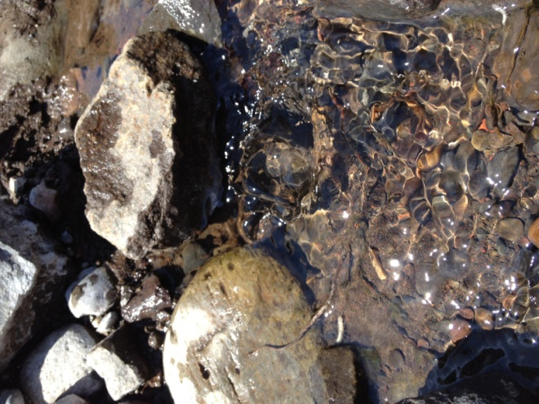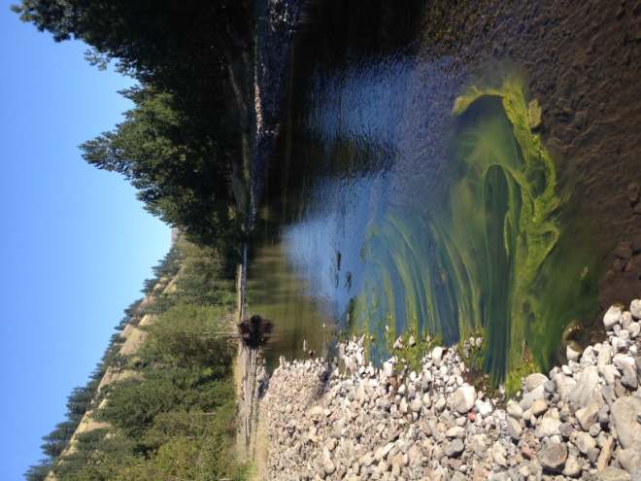
Figure 24. An actively flowing groundwater spring and seep (note filimentaous algae growing in nutrient-rich outflow) along the restored reach of Meacham Creek in summer 2012.

Intent of Research

The intent of the macroinvertebrate research is to assess the effectiveness of the Meacham Creek Phase I restoration efforts administered by the Confederated Tribes of the Umatilla Indian Reservation (CTUIR).

Macroinvertebrate assemblage structure can be used as an indicator of stream reach quality and is a useful tool for assessing the effectiveness of restoration projects (Miller et al. 210). In 2005 an agreement was reached between CTUIR and Oregon State University (OSU) to begin an assessment of the condition of Meacham Creek in the Phase I project area. Two types of sites and two periods of sampling were outlined at this time. The site types include three sites within the Phase I project area (i.e., “impact” sites) and three sites outside of the project area that are subject to standard management practices in the Meacham Creek drainage (i.e., “control” sites). The two time periods of sampling were before Phase I restoration commenced (from 2005 to 2010) and after restoration (from 2011 onward). On further consideration with CTUIR a third type of site (“reference” sites; sites that are in relatively pristine conditions) was added to the sampling program in 2007. These sites are located in the Umatilla subbasin on the North Fork Umatilla River.

This sampling program follows a Before-After-Control-Impact (BACI) design which provides a powerful means of inference in regards to the impact of land management and other human activities on ecosystems (Downes et al. 2002). The addition of the reference sites on the North Fork Umatilla provides an important comparison of the condition of Meacham Creek (both pre- and post-restoration) relative to the condition of a nearly pristine stream in the Umatilla subbasin. In addition, sampling in the North Fork Umatilla allows an examination of the temporal variability of macroinvertebrate assemblages in the absence of extensive human impacts as well as allowing for a tracking of any directional change through time resulting from climatic cycles (e.g., ENSO) and climate change.

Macroinvertebrate Site Locations

Six sites were located on Meacham Creek as macroinvertebrate collection sites. Three sites were located within the Phase I restoration area and three control sites were located outside that area. Two of the controls were located upstream of the restoration project area and one was located downstream. Control sites were located based upon land ownership, ease of access to the stream, and physical similarity of the reach to the project area. As a reference, two sites were located on the relatively pristine North Fork Umatilla River. Site locations are illustrated in Figure 25 and Figure 26, and their coordinates are given in Table 13.

Macroinvertebrates were sampled annually starting in 2005 with the exception of the North Fork Umatilla sites. Sampling did not begin at these sites until 2007; in addition, in 2011 it was decided that two sites on the North Fork Umatilla was redundant and therefore North Fork 2 was dropped from the sampling regimen. Macroinvertebrates were sampled in late summer (mid-August to late September) each year.

Methods

Macroinvertebrates were sampled in the field following modified EPA EMAP protocols for targeted riffle sampling (Peck et al. 2006). Study reaches were defined as 100m long stretches of stream with the downstream end at the GPS location. Eight sampling locations were randomly located in riffle habitat at each study reach. Macroinvertebrates were collected at each of these locations by placing a D-frame net (500 μm mesh) firmly against the substrate and scrubbing by hand all cobble and larger sized rocks in an 0.09m² area just upstream of the net. After these rocks had been scrubbed and set aside the same area was agitated by foot for 30 seconds. Each of the 8 samples was composited in the field into a single large sample for each study site and preserved in 90% ethanol. In the laboratory samples were spread over a 30x20 cm Caton sorting tray and subsamples representing 3% of the area of the tray were randomly taken. Invertebrates were picked from subsamples until at least 500 organisms had been counted from the subsamples. These invertebrates were identified to genus (for most insects) and order or family (for most non-insect invertebrates) using published keys (Merritt et al. 2008; Thorp and Covich 2010, Wiggins 2000).

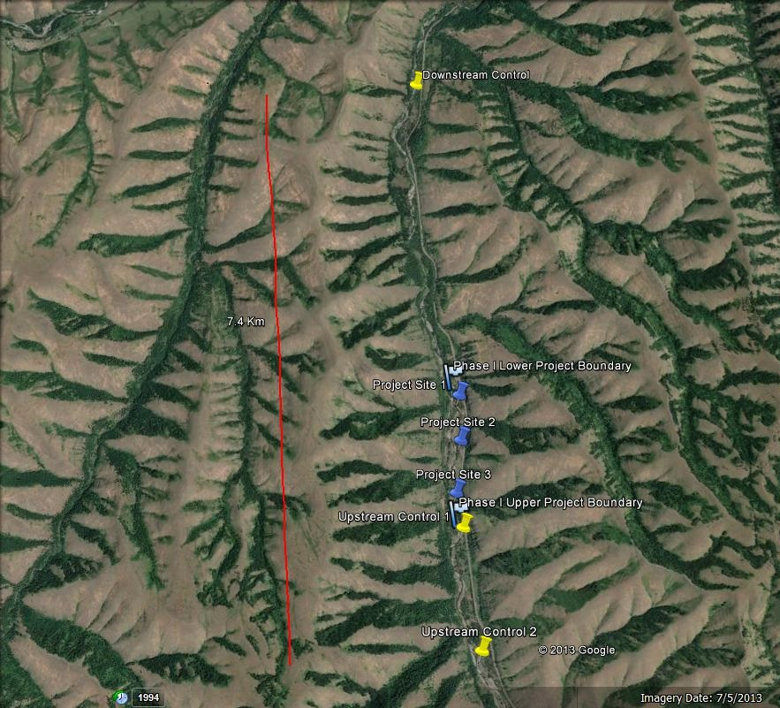
Figure 25. Google Earth image of the six macroinvertebrate sampling sites on Meacham Creek. Control sites are illustrated with yellow thumbtacks and sites within the Phase I project area with blue. The Phase I project boundaries are illustrated with flags. Image downloaded 3/18/14.

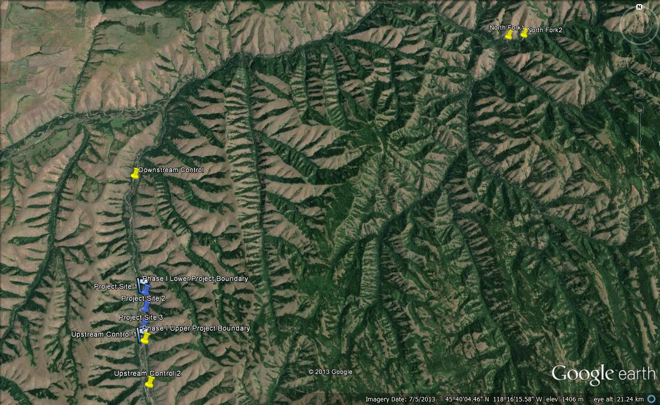
Figure 26. An expanded Google Earth image of the Meacham Creek macroinvertebrate study sites designed to show the location of two study sites on the North Fork Umatilla River. Image downloaded on 3/18/14.
Table 10. Location of the six macroinvertebrate sites on Meacham Creek, the Phase I project boundaries, and the two macroinvertebrate sites on the North Fork Umatilla River.

Name | Location
Downstream Control | 45° 40’ 34.58” 118° 21’ 56.47”
Phase I Lower Project Boundary | 45° 38’ 21.55” 118° 21’ 25.19”
Project Site 1 | 45° 38’ 15.36” 118° 21’ 23.66”
Project Site 2 | 45° 37’ 56.70” 118° 21’ 22.10”
Project Site 3 | 45° 37’ 35.38” 118° 21’ 23.71”
Phase I Upper Project Boundary | 45° 37’ 25.69” 118° 21’ 19.79”
Upstream Control 1 | 45° 37’ 21.74” 118° 21’ 19.16”
Upstream Control 2 | 45° 36’ 34.40” 118° 21’ 06.90”
North Fork Umatilla 1 | 45° 43’ 36.24” 118° 10’ 57.57”
North Fork Umatilla 2 | 45° 43’ 38.33” 118° 10’ 29.88”

Metrics: Five macroinvertebrate metrics are being used to characterize the condition of Meacham Creek at each of the study site locations. These metrics are all expected to change in response to the Phase I restoration. One metric in particular, Inferred Temperature, is relevant to one of the major goals of the Phase I restoration which is reduction in stream temperature. The metrics and their calculations are:

1) Assemblage Tolerance Index (ATI). This metric was developed by the US Environmental Protection Agency using macroinvertebrate and human disturbance data from the US EPA EMAP survey of over 1100 sites in the western US (Whittier and Van Sickle 2010). To develop this metric tolerance values were assigned to individual macroinvertebrate taxa by relating their abundance to a synthetic human disturbance index. The human disturbance index was based upon nine variables from three general classes related to the lotic environment – water quality, physical habitat at the sample reach, and human activity in the sampled watershed above the sample reach (Whittier and Van Sickle 2010). The ATI is an average tolerance value for the macroinvertebrate assemblage at a study site weighted by the relative abundance of each taxon:
ATI = Σ(TV_{i} x RA_{i}),
where TV_{i} is the tolerance value of taxon “i” and RA_{i} is its relative abundance within the assemblage.

Tolerance values for taxa are scaled from 0 to 10 with sensitive taxa having low tolerance values and tolerant taxa having high tolerance values. With improvement of conditions within a restored reach the ATI score is expected to decrease (as the relative abundance of sensitive taxa increases).

2) Inferred Temperature. This metric was developed by the Oregon Department of Environmental Quality using macroinvertebrate and temperature data from 328 sites throughout Oregon (Huff et al. 2006). This metric was developed and is calculated in a similar fashion as the ATI. From the 328 sites, invertebrate taxa were assigned an optimal temperature based upon their abundance and the average of the daily maximum water temperature for the warmest 7-day period. The inferred temperature metric is calculated as:
Inferred Temperature = Σ(TempOpt_{i} x RA_{i}),
where TempOpt_{i} is the temperature optima for taxon “i” and RA_{i} is its relative abundance.

Summing these values across all taxa within an assemblage provides an “inferred temperature,” which is the water temperature estimated based upon a site’s assemblage composition. Huff et al. (2006) found a good fit between inferred temperatures and actual water temperatures (measured using dataloggers) for the Oregon data set. However, they found that in relatively warm systems, macroinvertebrate assemblages tended to underestimate actual maximum water temperatures and in cold systems macroinvertebrates tended to overestimate maximum water temperatures. In his bio-assessment of a restoration project in the Grande Ronde watershed that involved channel reconstruction, Whitney (2007) found this metric to be responsive to the restoration efforts. Given that temperature reduction is one of the major goals of the Phase I Meacham Creek restoration, this metric is particularly relevant to our bio-assessment.

3) Assemblage Diversity. Assemblage diversity is a function of both taxa richness and the relative abundance of each taxon. Shannon diversity (H’) is the specific diversity metric calculated for the Meacham Creek macroinvertebrate data:
H’ = -Σp_{i}log_{e}p_{i},
where p_{i} is the relative abundance of species “i”.

Diversity is predicted to increase with increasing habitat quality (Karr and Chu 1999).

4) Taxa Richness. This is a simple count of the number of taxa found in the macroinvertebrate assemblage at each reach. Taxa richness is predicted to increase with increasing environmental quality (Karr and Chu 1999; Whitney 2007).

5) Mayfly-Stonefly-Caddisfly (Ephemeroptera-Plecoptera-Trichoptera, EPT) Taxa Richness. This metric is a count of the number of taxa found within these three orders of aquatic insects. Taxa within these three groups are generally sensitive to a variety of human impacts, and thus their taxa richness is predicted to increase with increasing stream habitat quality (Karr and Chu 1999).

Statistical Analyses: Currently, only pre-restoration data have been analyzed. Not enough data has been collected at this time to conduct post restoration analyses. The statistical approach used follows the BACI design and makes comparisons between the project area sites (Impact sites) and the control sites during two time periods, pre-restoration (2005 to 2010) and post-restoration (2011 and on).

Before restoration takes place it is predicted that impact and control sites will not differ in either the mean value of the metrics or in the direction or rate of change through time in those metrics. In contrast, after restoration has occurred it is predicted that impact reaches will change through time (reflecting an improvement in stream reach conditions), while control reaches will show little to no differences through time.

To determine whether control and impact sites differed significantly in mean metric values before restoration, t-tests were conducted for each metric. Data were transformed to meet the assumptions of normality when necessary. To determine whether control and impact sites changed in condition through time during the pre-restoration period, simple linear regressions were conducted for each metric on control and impact sites separately. If neither the control or impact regression line was significant for a metric, the analysis stopped. However, if one or both of the regression lines was significant, a comparison of slopes between the two types of sites was made to determine whether the two types of sites differed in the rate and/or direction of change.

Results

During the pre-restoration period, average metric values did not differ between the control and impact sites for any of the metrics examined (Table 11). In addition, none of the regression lines during the pre-restoration period was significantly different from zero (Table 12). These results indicate that the control and impact reaches were similar in condition pre-restoration and did not show any linear change through time at either type of site.

Figure 27 illustrates the metric values through time for the control and impact sites as well as the sites at the North Fork Umatilla River reference area.

Table 11. T-test results comparing macroinvertebrate metrics between control and impact sites. Values are averaged over all six years of sampling (n=18).

Metric | Site Type | Mean Value (±1 SE) | t-value | p-value
ATI | Control | 4.8 ± 0.1 | 1.64 | 0.11
ATI | Impact | 5.2 ± 0.2 | 1.64 | 0.11
Inferred Temperature | Control | 18.4 ± 0.1 | 0.69 | 0.49
Inferred Temperature | Impact | 18.6 ± 0.1 | 0.69 | 0.49
Shannon Diversity | Control | 1.12 ± 0.02 | 0.11 | 0.91
Shannon Diversity | Impact | 1.12 ± 0.02 | 0.11 | 0.91
Taxa Richness | Control | 29.4 ± 0.9 | 0.91 | 0.37
Taxa Richness | Impact | 30.6 ± 0.8 | 0.91 | 0.37
EPT Richness | Control | 14.7 ± 0.7 | 0.86 | 0.40
EPT Richness | Impact | 15.6 ± 0.6 | 0.86 | 0.40

Table 12. Results of regression analyses for each metric and for control and impact sites separately. Analyses are for the pre-restoration period only with year as the independent variable.
Metric | Site Type | R² | Slope | p-value
ATI | Control | 0.08 | 0.08 | 0.26
ATI | Impact | 0.20 | -0.19 | 0.06
Inferred Temperature | Control | <0.01 | <0.01 | 0.96
Inferred Temperature | Impact | 0.07 | -0.06 | 0.29
Shannon Diversity | Control | 0.12 | -0.02 | 0.17
Shannon Diversity | Impact | <0.01 | <0.01 | 0.95
Taxa Richness | Control | 0.04 | -0.44 | 0.43
Taxa Richness | Impact | <0.01 | 0.13 | 0.79
EPT Richness | Control | 0.05 | -0.41 | 0.37
EPT Richness | Impact | 0.06 | 0.36 | 0.33

Figure 27. Values for each of the five macroinvertebrate metrics. The pre-restoration period was 2005 to 2010 and is separated from the post-restoration period (2011 and 2012) by the dashed vertical line. □ = Control Sites, ♦ = Project/Impact sites, x = North Fork Umatilla sites.

Figure 27. Continued.

Discussion

The intent of the macroinvertebrate research at Meacham Creek is to assess the effectiveness of the Meacham Creek Phase I restoration actions in improving stream reach conditions. Given that the restoration occurred in 2011, we do not have enough data yet to examine the effectiveness of this project.

However, an important aspect of using biological metrics to assess restoration effectiveness and of the BACI design is to understand whether control and impact sites are similar in condition based upon the biological metrics and whether they appear to be changing through time. The results for the macroinvertebrate metrics on Meacham Creek indicate that control and impact sites were in similar condition during the six years of pre-restoration sampling. In addition, based on the regression analyses, there was no indication of any significant directional change in condition for either type of site.

These results indicate that for the Meacham Creek assessment, the BACI design is robust and should provide strong inference that changes that increase stream reach condition in the restoration project area are the result of those restoration actions and not random chance. The 2013 data are currently being processed and further, annual macroinvertebrate sampling at the same sites is planned.

SUMMARY AND CONCLUSIONS

In accordance with the 2006 NPCC solicitation outline, the CTUIR UAFHP since 2007 focused its restoration activities primarily on Meacham Creek, Birch Creek, and mainstem Umatilla River. However, project restoration activities occur in other areas of the basin where floodplain and riverine processes are treated with outcomes that are beneficial to ecological processes, water quality and fish production. The Meacham Creek Watershed has long been a primary focal point of the CTUIR effort to improve habitat conditions in the Umatilla Basin because of its location, size, historical significance, and recovery potential. Table 13 highlights the CTUIR Umatilla Anadromous Fish Habitat Project restoration accomplishments since 2007.

Proposed restoration actions have focused on protection, enhancement, and restoration of functional floodplain, channel and watershed processes at multiple scales using passive and active restoration techniques. Over the past decade, the CTUIR Department of Natural Resources and UAFHP have transitioned from restoration toward a fixed endpoint to address symptoms to a restoration of processes. The CTUIR UAFHP currently operates under the 2008 Columbia Basin Fish Accords Memorandum of Agreement between the Three Treaty Tribes and FCRPS Action Agencies (Fish Accords 2008). Restoration of process is more likely to address causes of river ecosystem degradation, whereas restoration toward a fixed endpoint addresses only symptoms. Specific restoration actions proposed for completion by CTUIR, partnering agencies and hired independent contractors include levee and dike removal and or modification, floodplain and channel construction, in-stream and floodplain large wood debris additions, in-stream structure placement, wetland enhancement, floodplain and riparian plantings, noxious weed removal, riparian management through fencing, and removal of physical migration barriers. The UAFHP have and will continue to maintain project areas under secured conservation agreements with landowners on private properties for protection and enhancement of floodplain and riparian habitat and investments from past passage and in-stream structure projects. Completed project activities are described below in more detail in the context of the watershed with reference to annual progress reports.

The CTUIR UAFHP completed two primary habitat enhancement projects centered on improving fish passage and in-stream and riparian habitat complexity within the Birch Creek Watershed (Table 13). The projects included removal of three abandoned irrigation diversion providing unimpeded access to 7.7 river miles of stream, installation of rock and large wood structures, channel re-shaping and plantings over 1.6-miles of stream. In addition, the UAFHP completed maintenance work of ongoing riparian or passage projects continued at 23 pre-existing long-term easement properties with 19 individual landowners including watering, chemical and mechanical noxious weed control, structural maintenance and planting additional trees as necessary. Lastly, the UAFHP completed plantings associated in disturbed areas from the construction in 2011 of the Meacham Creek Floodplain Restoration and In-stream Enhancement Project RM 6-7.1. This intense project included levee removal and modification, channel and side-channel construction, installation of large wood and rock habitat features, connectivity to off-channel rearing habitat and floodplain and riparian plant restoration.

A principal strength and focus of the CTUIR UAFHP project is the ability to work cooperatively with the various entities throughout the restoration process. Staff participated and cooperated with multiple agencies and stakeholders in the Umatilla Basin Watershed including ODFW, USFS, Natural Resource Conservation Service, conservations districts, USFWS, Umatilla Basin Watershed Council and local stakeholders to enhance or protect natural resources, identify problems and solutions, coordinate efforts to prevent duplication, enhance communication and cooperation and identify funding and cost share opportunities within the Umatilla River Subbasin. This was magnified by the development of the Umatilla Basin Restoration Team. This forum was established to build a coordinated and strategic approach to the restoration of habitat in the Umatilla Basin.

The CTUIR continues to emphasize more attention toward project planning in regard to developing a systematic approach for site selection based on scientific data as well as to increase efforts towards effectiveness monitoring (both have been considered as shortfalls in the past from review committees). CTUIR emphasizes adaptive management as a means of maximizing success at each project site. With future years of monitoring data, the CTUIR will be able to track changes in the habitat quality and quantity of the restoration areas as compared to unrestored areas. This information will be useful in guiding future restoration actions and decisions in Meacham Creek but also within the Umatilla Subbasin, and will ultimately help to restore salmonid populations for both cultural and ecosystem benefits.

The Umatilla Anadromous Fisheries Habitat Project is an ongoing effort to protect, enhance and restore functional floodplain, channel and watershed processes to provide sustainable and healthy habitat for aquatic species in the Umatilla River Basin, including Threatened Mid-Columbia steelhead. Project work further supports the CTUIR Department of Natural Resource ecological and First Foods mission statements to sustain production. Applying the River Vision floodplain principles have been successfully applied in effort to reestablish the salmonids to self-sustaining levels. We expect an exponential response of salmonid populations once habitat floodplain and channel function is addressed and improved. We believe a positive correlation between habitat improvement, salmonid density, and fitness levels will shift the status of ESA-Listed species towards a safer level of sustainability in the Umatilla River Basin.
Table 13. The CTUIR UAFHP restoration project descriptions by location, treated primary limiting factors (NMFS 2009) by CTUIR River Vision touchstones (Jones et al. 2008) and accomplishments; 2007-2012.
Subbasin, Stream and Years | Project Description | Species | CTUIR River Vision Touchstones/ Habitat Limiting Factors (PLF’s shaded in yellow-NOAA BiOP) |  |  |  |  |  |  |  | Comment/  Accomplishments
Subbasin, Stream and Years | Project Description | Species | Biota-Connectivity | Geomorphology | Connectivity |  | Hydrology |  |  | Riparian Vegetation | Comment/  Accomplishments
Subbasin, Stream and Years | Project Description | Species | Passage Barriers/ Entrainment | In-channel Characteristics | Habitat Diversity (LWD) | Floodplain Confinement | High Temps | High  Turbidity | Low Flows | Riparian/  Floodplain | Comment/  Accomplishments
UMATILLA
Meacham Creek and Camp Creek, Tributary of Meacham Creek (2007) | Fish passage rectifications, pool development with rock structures, and plantings | STS | X |  |  |  | X |  |  | X | Rectified two diversion dams and one in-stream structure providing unimpeded access to the entire watershed, development of pools with boulder cross vanes, 335 ft of streambank stabilization with added wood complexity, 0.3 miles livestock exclusion fence, and 500 riparian plantings.
West Birch Creek (2007-2008) | Fish passage rectification, riparian protection fencing and plantings | STS | X |  | X |  | X |  |  | X | Rectification of the Cunningham and Hoeft Dams providing 2.4 miles unimpeded habitat, 335 ft of streambank stabilization with added wood complexity, 0.3 miles livestock exclusion fence, and 5,000 riparian plants.
Mainstem Umatilla River (Initiated 2008-2012) | Treated and maintained 3.5 miles of floodplain and channel; riparian and uplands | CHS, STS, Coho |  |  | X |  | X | X | X | X | Conservation easement on B&G Property to maintain 355 (61 riparian and 294 upland acres; installation of 60.7 acres of CREP tract’s), 2 off-channel water wells, 13,400 seedling trees planted, 1,335 lbs of native grass seed and noxious weed control; Installation of an access restriction fence (3 additional riparian acres protected).
Meacham Creek (2009) | Floodplain improvement with levee setback, initiation of off-channel rearing habitat, large wood placement, and riparian plantings | CHS, STS,BT, Pacific Lamprey | X | X | X | X | X |  | X | X | Restored 40 acres of floodplain connectivity over 1-mile of stream by removal or modification of 3 levees and 1 dike (3,200 linear ft, 24,000 cubic yards); distribution of large wood on floodplain; 15,000 planted hardwood and conifer seedlings (30acres).
Meacham Creek (Initiated 2008-2012) | Riparian protection fencing and plantings | CHS, STS,BT, Pacific Lamprey |  | X | X |  | X |  | X | X | Built 9.8 miles of livestock exclusion fence between RM 2.0-8.5 (~350 acres protected).
Birch Creek (2010) | Bank stabilization and large wood habitat complexity and riparian plantings | STS |  | X | X | X | X | X |  | X | Restoration of 335 ft of streambank stabilization with large wood and boulders over 0.1 miles of stream, 2 large wood in-channel habitat structures, and planted 5,000 riparian plantings over the 1-mile property.
Meacham Creek Floodplain Restoration and In-Stream Enhancement Phase I Project RM 6-7.1 (2011-2012) | Floodplain and channel improvement with levee setback, large wood placement, side-channel connectivity, wetland enhancement, and riparian plantings. | STS, CHS, BT, Pacific Lamprey |  | X | X | X | X | X | X | X | Restored 67 acres of floodplain over 1-mile of stream by removing a 2,800 foot levee and modification of two spur dikes (600 ft removed), realigned historic channel with meanders in the floodplain, developed 3 secondary channels and 3,568 ft of off-channel habitat, 12 large pool structures, 10 major and 286 medium rock and log features, and installed 38,290 plantings.
Birch Creek (2012) | Fish passage rectification and habitat restoration project. | STS, Coho | X | X |  | X | X | X |  | X | Removed two abandoned irrigation diversions (Taylor Property-ODFW lead agency) providing unimpeded access to 2.7 river miles of stream. Included channel reshaping, setback of leveed road adjacent to the channel; and reshaping of the channel and banks, two j-hook rock structure placements and riparian plantings over 0.6 miles of stream.
West Birch Creek (2012) | Fish passage rectification and habitat restoration project. | STS | X | X | X |  | X | X |  | X | Removed one abandoned irrigation diversion (Low Property-ODFW lead agency) providing unimpeded access to 5.0 river miles of stream, installation of rock and large wood structures, channel re-shaping and plantings over 1-mile of stream.
Basin-wide easements O&M  (2008-2012) | Ongoing maintenance of 27 riparian conservation agreements on 23 properties including livestock exclusion fencing, tree planting and weed control | CHS, CHF, STS, Coho, BT, Pacific Lamprey | X | X | X | X | X | X | X | X | 552 acres protected and maintained including noxious weed control, 15 miles of riparian fence protection (182 ac.), 7,000 planted hardwood seedling trees.

LITERATURE CITED

Alt, D. and D.W. Hyndman 1995. Northwest Exposures: A Geologic Story of the Northwest. Mountain Press Publishing Company, Missoula, MT.

Andrus, C. & J. Middel 2003. Meacham Creek Watershed Analysis and Action Plan; Final Report. pp. 125, Prepared for the Confederated Tribes of the Umatilla Indian Reservation.

Arrigoni, A.S., Alicia S.,Poole, G.C., M ertes, L.A.K., O'Daniel, S.J., Woessner, W.W., Thomas, S.A. 2008. Buffered, lagged, or cooled? Disentangling hyporheic influences on temperature cycles in stream channels. WATER RESOURCES RESEARCH, VOL. 44, W09418, 13 PP

Arscott, D. B., K. Tockner, and J. V. Ward. 2000. Aquatic habitat diversity along the corridor of an alpine floodplain river (the Fiume Tagliamento, Italy). Archiv Fur Hydrobiologie 149:679-704.

Arscott, D. B., K. Tockner, and J. V. Ward. 2001. Thermal heterogeneity along a braided floodplain river (Tagliamento River, northeastern Italy). Canadian Journal of Fisheries and Aquatic Sciences 58:2359-2373.

Baxter, C. V., and Hauer, F. R., 2000, Geomorphology, hyporheic exchange, and selection of spawning habitat by bull trout (Salvelinus confluentus): Canadian Journal of Fisheries and Aquatic Sciences 57:1470-1481.

Beechie, T., and Bolton, S., 1999, an approach to restoring salmonid habitat-forming processes in Pacific Northwest watersheds: Fisheries 24:6-15.

Beechie, T.J., G. R. Pess, P. Roni, G. Giannico. 2008. Setting river restoration priorities: a review of approaches and a general protocol for identifying and prioritizing actions. North American Journal of Fisheries Management 28:891-905.

Beechie, T.J., Sear, D.A., Olden, J.D., Pess, G.R., Buffington, J.M., Moir, H., Roni, P., and Pollock, M.M., 2010, Process-based principles for restoring river ecosystems: Bioscience, v. 60, p. 209-222.

Bencala, K.E., and Walters, R.A., 1983, Simulation of solute transport in a mountain pool-and-riffle stream: A transient storage model: Water Resources Research, v. 19, p. 718-724.

Bernhardt, E.S., Palmer, M.A., Allan, J.D., Alexander, G., Barnas, K., Brooks, S., Carr, J., Clayton, S., Dahm, C., Follstad-Shah, J., Galat, D., Gloss, S., Goodwin, P., Hart, D., Hassett, B., Jenkinson, R., Katz, S., Kondolf, G.M., Lake, P.S., Lave, R., Meyer, J.L., O'Donnell, T.K., Pagano, L., Powell, B., and Sudduth, E., 2005, Ecology - Synthesizing US river restoration efforts: Science, v. 308, p. 636-637.

Boulton, A.J., Datry, T., Kasahara, T., Mutz, M., and Stanford, J.A., 2010, Ecology and management of the hyporheic zone: stream-groundwater interactions of running waters and their floodplains: Journal of the North American Benthological Society, v. 29, p. 26-40.

BOR (Bureau of Reclamation). 1988. Umatilla Basin Project, Oregon. Planning report, final environmental impact statement. Boise, Idaho.
Boyce, R. R. 1986. A comprehensive plan for rehabilitation of anadromous fish stocks in the Umatilla river basin. Final report of the Oregon Department of Fish and Wildlife to Bonneville Power Administration, Portland, Oregon. Publication DOE/BP-18008-1.

Brown, A. G. 1997. Biogeomorphology and diversity in multiple-channel river systems.
Global Ecology and Biogeography Letters 6:179-185.

Buchanan, D.V. and S.V. Gregory 1997. Development of water temperature standards to protect and restore habitat for bull trout and other cold water species in Oregon. Proceedings of the Friends of the Bull Trout Conference. Calgary, Alberta.

Buffington, J.M., and Tonina, D., 2009. Hyporheic exchange in mountain rivers II: Effects of
channel morphology on mechanics, scales and rates of exchange: Geography Compass, 3(3): 1038–1062.

Burkholder, B. K., Grant, G. E., Haggerty, R., Khangaonkar, T., and Wampler, P. J., 2008,
Influence of hyporheic flow and geomorphology on temperature of a large, gravel-bed river, Clackamas River, Oregon, USA: Hydrological Processes 22: 941-953.

CHaMP (Columbia Habitat Monitoring Program). 2011. CHaMP 2011 training version 1.1.

CHaMP (Columbia Habitat Monitoring Program). 2012. Scientific protocol for salmonid habitat surveys within the Columbia Habitat Monitoring Program. Prepared by the Integrated Status and Effectiveness Monitoring Program and published by Terraqua, Inc., Wacounda, WA.

Contor, C. R. Editor. 2012. Umatilla Basin Natural Production Monitoring and Evaluation,
2011 Annual Progress Report. Confederated Tribes of the Umatilla Indian Reservation, 46411 Ti’Mine Way, Pendleton, OR. Report submitted to Bonneville Power Administration, Project No. 1990-005-01

Crispell, J.K., Endreny, T.A., 2009, Hyporheic exchange flow around constructed inchannel
structures and implications for restoration design: Hydrologic Processes: 23(8), 1158–1168.

CTUIR 1994. Umatilla Basin Natural Production Monitoring and Evaluation, Annual Progress Report 1992-1993. Prepared by Confederated Tribes of the Umatilla Indian Reservation and submitted to Bonneville Power Administration, Project No. 90-005-01.

CTUIR 1995. Umatilla Basin Natural Production Monitoring and Evaluation, Annual Report, 1993-1994, Prepared by Confederated Tribes of the Umatilla Indian Reservation for U.S. Department of Energy, Bonneville Power Administration, Environment, Fish and Wildlife, Portland, OR, April 1995, Project No. 90-005-01.

CTUIR 2000. Umatilla Basin Natural Production Monitoring and Evaluation Project, Annual Progress Report 1997-1998. Confederated Tribes of the Umatilla Indian Reservation, BPA Project No. 1990-005-01.

CTUIR 2005. Confederated Tribes of the Umatilla Indian Reservation Water Code. Prepared
by the Confederated Tribes of the Umatilla Indian Reservation, Department of Natural Resources, as amended through Resolution No. 05-027 (March 7, 2005).

CTUIR 2005. Confederated Tribes of the Umatilla Indian Reservation Total Maximum Daily Load For Temperature and Turbidity. Prepared by the Confederated Tribes of the Umatilla Indian Reservation, Department of Natural Resources, Issued by the US Environmental Protection Agency, Region 10, July 2005. Available online at URL:
http://yosemite.epa.gov/R10/WATER.NSF/TMDLs/Approved+TMDLs.

CTUIR 2007. Biological Assessment, Birch Creek Salmonid Passage Improvements, Umatilla River Basin. Prepared by the Confederated Tribes of the Umatilla Indian Reservation. July 2007.

CTUIR 2008. Umatilla River Basin Anadromous Fish Habitat Enhancement Project, Annual Report, February 1, 2007 – January 31, 2008, Fiscal Year 2007, Document ID# P109208, Contract # 32047. Confederated Tribes of the Umatilla Indian Reservation. Submitted to Bonneville Power Administration, January 2008. Available online as accessed January 22, 2009 at URL: http://pisces.bpa.gov/release/documents/documentviewer.aspx?doc=P109208.

CTUIR 2012. Meacham Creek Floodplain Restoration and In-stream Enhancement Project Completion Report. Published by Tetra Tech, Inc., Bothell, Washington. December 2012.

CTUIR 2012. Umatilla Basin Natural Production Monitoring and Evaluation, 2011 Annual Progress Report. Confederated Tribes of the Umatilla Indian Reservation, 46411 Ti’Mine Way, Pendleton, OR. Report submitted to Bonneville Power Administration, Project No. 1990-005-01

CTUIR, ODEQ and UBWC. 2000. Umatilla River Basin Water Quality Analysis in
Preparation for the Total Maximum Daily Load (TMDL). Umatilla Stakeholders and Technical Committee.

CTUIR, ODEQ and UBWC. 2000b. Public Comment Draft of the Umatilla River Basin Total
Maximum Daily Load (TMDL) and Water Quality Management Plan (WQMP).

CTUIR and ODFW 2006. Five-Year Action Plan for the Development and Maintenance of Habitat Improvement Projects in the Umatilla Subbasin: 2006-2010, Prepared for/Funded by: U.S. Department of Energy, Bonneville Power Administration, Division of Fish and Wildlife, March 2006.

Downes, B.J., L.A. Barmuta, P.G. Fairweather, D.P. Faith, M.J. Keough, P.S. Lake, B.C. Mapstone, G.P. Quinn. 2002. Monitoring Ecological Impacts: Concepts and Practices in Flowing Waters. Cambridge University Press, Cambridge, UK.

Ebersole, J. L., Liss, W. J., and Frissell, C. A., 2001, Relationship between stream temperature, thermal refugia, and rainbow trout Oncorhynchus mykiss abundance in arid-land streams in the northwestern United States: Ecology of Freshwater Fishes 10:1-10.

Environmental Protection Agency (1986). Quality Criteria for Water. http://water.epa.gov/scitech/swguidance/standards/criteria/aqlife/upload/2009_01_13_criteria_goldbook.pdf

Evans, E. C., and Petts, G. E., 1997, Hyporheic temperature patterns within riffles: Hydrological Sciences Journal 42:199-213.

Fernald, A. G., Landers, D. H., and Wigington, P. J., 2006, Water quality changes in hyporheic flow paths between a large gravel bed river and off-channel alcoves in Oregon, USA: River Research and Applications 22:1111-1124.

Fetter, C. W., Applied Hydrogeology, 3rd ed., 691 pp., Prentice-Hall, Englewood Cliffs, N. J., 1994. Geist, D. R. 2000. Hyporheic discharge of river water into fall Chinook salmon (Oncorhynchus tshawytscha) spawning areas in the Hanford Reach, Columbia River. Canadian Journal of Fisheries and Aquatic Sciences 57:1647-1656.

Freeze, A. R., and Cherry, J. A. (1979). Groundwater. Prentice Hall.

Geist, D. R., Hanrahna, T. P., Arntzen, E. V., McMichael, G. A., Murray, C. J., and Chien, Y., 2002, Physiochemical characteristics of the hyporheic zone affect redd site selection by chum salmon and fall Chinook salmon in the Columbia River: North American Journal of Fisheries Management, 22: 1107-1085.

Gooseff, M.N., Anderson, J.K., Wondzell, S., LaNier, J., and Haggerty, R., 2006, A modeling study of hyporheic exchange pattern and the sequence, size, and spacing of stream bedforms in mountain stream networks, Oregon, USA (Retraction of vol 19, pg 2915, 2005): Hydrological Processes, v. 20, p. 2441-+.

Haggerty, R., Wondzell, S.M., and Johnson, M.A., 2002, Power-law residence time distribution in the hyporheic zone of a 2nd-order mountain stream: Geophysical Research Letters, v. 29. Hanrahan, T. P., 2008, Effects of river discharge on hyporheic exchange flows in salmon spawning areas of a large gravel-bed river: Hydrological Processes 22:127-141.

Harbaugh, A.W., 2005, MODFLOW-2005, The U.S. Geological Survey modular ground-water model—the Ground-Water Flow Process: U.S. Geological Survey Techniques and Methods 6- A16

Harman, W., R. Starr, M. Carter, K. Tweedy, M. Clemmons, K. Suggs, C. Miller. 2012. A Function-Based Framework for Stream Assessment and Restoration Projects. US Environmental Protection Agency, Office of Wetlands, Oceans, and Watersheds, Washington, DC EPA 843-K-12-006.

Hester, E.T., and Gooseff, M.N., 2010, Moving Beyond the Banks: Hyporheic restoration is fundamental to restoring ecological services and functions of streams: Environmental Science and Technology: 44, 1521–1525.

Hester, E. T., Doyle, M. W., and Poole, G. C., 2009, The influence of in-stream structures on summer water temperature via induced hyporheic exchange: Limnology and Oceanography 51:355-367.

Hillman, T. W. 2003. Monitoring Strategy for the Upper Columbia Basin. BioAnalysts,
Inc., Eagle, Idaho.

Hoehn, E., and Cirpka, O.A., 2006, Assessing residence times of hyporheic ground water in two alluvial flood plains of the Southern Alps using water temperature and tracers: Hydrology and Earth System Sciences, v. 10, p. 553-563.

Hoverson, Eric D. and Webster, James G. 2009. CTUIR Umatilla Anadromous Fisheries Habitat Project Annual Report, Fiscal Year 2008. Confederated Tribes of the Umatilla Indian Reservation, report submitted to Bonneville Power Administration, Project No. 1987-100-01.

Hubler, S. 2008. PREDATOR: Development and use of RIVPACS-type macroinvertebrate models to assess the biotic condition of wadeable Oregon streams. DEQ08-LAB-0048-TR.

Huff D.D., S.L. Hubler, Y. Pan, and D.L. Drake. 2006. Detecting Shifts in Macroinvertebrate Community Requirements: Implicating Causes of Impairment in Streams. Oregon Department of Environmental Quality. DEQ06-LAB-0068-TR.

Jones, K. L., G. C. Poole, E. J. Quaempts, S. O’Daniel, T. Beechie, 2008. Umatilla River Vision. Prepared for the Confederated Tribes of the Umatilla Indian Reservation, 31 pp.
Karr, J.R. and E.W. Chu. 1999. Restoring Life in Running Waters: Better Biological Monitoring. Island Press, Covelo, California.

Kasahara, T., Hill, A.R., 2006, Hyporheic exchange flows induced by constructed riffles and steps in lowland streams in southern Ontario, Canada: Hydrologic Processes: 20 (20), 4287–4305.

Kondolf, G.M., D.R. Montgomery, H. Piegay, and L. Schmitt. 2003. Geomorphic classification of rivers and streams, in Tools in Fluvial Geomorphology, edited by G.M. Kondolf and H. Piegay, pp. 171-204, John Wiley, Hoboken, NJ.

Lambert, Michael B. and Keith Karoglanian. 2012. The Umatilla Anadromous Fish Habitat
Project: 2011 Annual Progress Report. Confederated Tribes of the Umatilla Indian Reservation, report submitted to Bonneville Power Administration, Project No. 1987-100-01.

Lambert, Michael B., James G. Webster, and Eric D. Hoverson. 2011. The Umatilla
Anadromous Fish Habitat Project: 2009-2010 Annual Report. Confederated Tribes of the Umatilla Indian Reservation, report submitted to Bonneville Power Administration, Project No. 1987-100-01.

Lamontagne, S., and Cook, P.G., 2007, Estimation of hyporheic water residence time in situ using Rn-222 disequilibrium: Limnology and Oceanography-Methods, v. 5, p. 407-416.

Lucier, A., M. Palmer, H. Mooney, K. Nadelhoffer, D. Ojima, and F. Chavez., 2006,
Ecosystems and Climate Change Research Priorities for the U.S. Climate Change
Science Program, Special Series No. SS-92-06 of the University of Maryland
Center for Environmental Science, Chesapeake Biological Laboratory, Ref. No.
[UMCES] CBL 06-038. 50 pp.

Malcolm, I. A., Soulsby, C., Youngson, A. F., and Petry, J., 2003, Heterogeneity in ground water-surface water interactions in the hyporheic zone of a salmonid spawning stream: Hydrological Processes 17:601-617.

Merritt, R.W., K.W. Cummins, and M.B. Berg (eds.) 2008. An Introduction to the Aquatic Insects of North America, 4th edition. Kendall/Hunt Publishing Company, Dubuque, IA.

Miller, S.W., P. Budy, and J.C. Schmidt. 2010. Quantifying macroinvertebrate responses to in-stream habitat restoration: applications of meta-analysis to river restoration. Restoration Ecology 18: 8-19.

Montgomery, D.R., and J.M. Buffington, 1997. Channel-reach morphology in mountain drainage basins. Geological Society of America Bulletin 109(5):596-611.

Montgomery, David R. 2003. King of Fish: The Thousand Year Run of Salmon. Westview Press, Perseus Books Group, Boulder, Colorado.

Moore, Kelley M.S., Jones, Kim, K. Dambacher, Jeffrey M. 2002. Methods for stream habitat surveys version 12.1: Oregon Department of Fish and Wildlife, Aquatic Inventory Project. Corvallis, OR 97730.

Morrill JC, Bales RC, Conklin MH (2005) Estimating stream temperature from air temperature: implications for future water quality. J Environ Eng 131:139–145

Nagle, G. 1998. Report on research project on environmental history of riparian areas in the Umatilla basin. U.S. Forest Service, Pacific Northwest Research Station, Corvallis, Oregon.

NMFS (National Marine Fisheries Service) Northwest Region. 2009a. Middle Columbia Steelhead distinct Population Segment ESA Recovery Plan. Final Listing November 30, 2009. Available on the internet: http://www.nwr.noaa.gov/Salmon-Recovery-Planning/Recovery-Domains/Interior-Columbia/Mid-Columbia/upload/Mid-C-Plan.pdf

NMFS 2008. National Marine Fisheries Service Northwest Region. Endangered Species Act – Section 7 Programmatic Consultation Biological Opinion and Magnuson-Stevens Fishery Conservation and Management Act Essential Fish Habitat Consultation. Habitat Improvement Program, Oregon, Washington, and Idaho, CY2007-CY2012 (HIP II).

NPPC 1990. Northwest Power Planning Council. Umatilla River Subbasin Salmon and Steelhead Production Plan. Northwest Power Planning Council and the Agencies of the Indian Tribes of the Columbia Basin Fish and Wildlife Authority.

NRC 1996. Upstream. Salmon and society in the Pacific Northwest. National Research Council, Washington D.C.

O'Daniel, S., J. 2005. Interactions between Regional-Scale Variation in Geomorphology and Potential for Hyporheic Exchange along the Umatilla River, Oregon. Geography. Santa Barbara, University of California.

O'Daniel, S.J., G.C. Poole and L.A.K. Mertes. 2003. Habitat diversity in alluvial rivers, Report to Bonneville Power Administration, #200100252, 39 pp.

ODEQ (Oregon Department of Environmental Quality) and Confederated Tribes of the Umatilla Indian Reservation. 2001. Umatilla River Basin Total Maximum Daily Load and Water Quality Management Plan. http://www.deq.state.or.us/wq/tmdls/docs/umatillabasin/umatilla/tmdl.pdf

ODFW/ODF (Oregon Department of Fish and Wildlife/Oregon Department of Forestry). 1995. A Guide to Placing Large Wood in Streams.

ODFW/ODF (Oregon Department of Fish and Wildlife/Oregon Department of Forestry). 1999. Oregon Aquatic Habitat Restoration and Enhancement Guide.

OWRD (Oregon Water Resource Department). 2006. Estimation of Peak Discharges for
Rural, Unregulated Streams in Eastern Oregon. Salem, OR.

Peck, D.V., A.T. Herlihy, B.H. Hill, R.M. Hughes, P.R. Kaufmann, D.J. Klemm, J.M. Lazorchak,
F.H. McCormick, S.A. Peterson, P.L. Ringold, T. Magee, and M.R. Cappaert. 2006. Environmental Monitoring and Assessment Program – Surface Waters; Western Pilot Study: Field Operations Manual for Wadeable Streams. U.S. Environmental Protection Agency 620/R-06/003. Office of Research and Development, U.S. Environmental Protection Agency, Washington D.C.

Pollock, D.W. 2008. User’s guide for MODPATH/MODPATH-PLOT, version 3: a particle
tracking post-processing package for MODFLOW, the U.S. Geological Survey finite-difference ground-water flow model. USGS Open-File Report 94-464.

Poole, G.C., O'Daniel, S.J., Jones, K.L., Woessner, W.W., Bernhardt, E.S., Helton, A.M.,
Stanford, J.A., Boer, B.R., and Beechie, T.J. 2008. Hydrologic spiraling: The role of multiple interactive flow paths in stream ecosystems: River Research and Applications, v. 24, p. 1018-1031.

Purser, Michael D. 1994. Non-point Sources of Water Pollution Assessment and
Management Plan. Submitted by the Confederated Tribes of the Umatilla Indian Reservation to the U.S. Environmental Protection Agency.

Rollins, P.A., Editor. 1935. The Discovery of the Oregon Trail. Robert Stuart’s Narratives of His Overland Trip Eastwards from Astoria in 1812-13. University of Nebraska Press, Lincoln, Nebraska.

Roni, Phil, Beechie T. J., Bilby R. E., Leonetti F. E., Pollock M. M., and Pess G. R. 2002. "A review of stream restoration techniques and a hierarchical strategy for prioritizing restoration in pacific northwest watersheds." North American Journal of Fisheries Management.

Roni, Phil, Hanson K., and Beechie T. 2008. "Global review of the physical and biological effectiveness of stream habitat restoration rehabilitation techniques." North American Journal of Fisheries Management.

Rosgen, D.L., 1994, A classification of natural rivers: Catena, v. 22, p. 169-199. Stanford, J. A., Ward, J. V., Liss, W. J., Frissell, C. A., Williams, R. N., Lichatowich, J. A., and Coutant, C. C., 1996, A general protocol for restoration of regulated rivers. Regulated Rivers: Research and Management 12:391-413.

Rosgen, D.L. (1996) Applied River Morphology. Wildland Hydrology, Pagosa Springs, CO.

Smith, E.P. 2002. BACI Design. pp. 141-148. In: A.H.E.-S.a.W.W. Piegorsc (ed.) Encyclopedia of Environmetrics, John Wiley & Sons, Ltd, Chichester, 2002.

Stanford, J. A., and Ward, J. V., 1993, An ecosystem perspective of alluvial rivers: connectivity and the hyporheic corridor: Journal of the North American Benthological Society 12:48-60.

Stonestrom, D. A. and Constantz, J. 2003. Heat as a tool for studying the movement of ground water near streams. U.S. Geological Survey Circular 1260, 96 p

Stillwater Sciences. 2011. Biological effectiveness monitoring and evaluation plan for
fisheries habitat enhancement in CTUIR subbasins. Draft Report. Prepared by Stillwater Sciences, Portland, Oregon for Confederated Tribes of the Umatilla Indian Reservation, Pendleton, Oregon.

Taylor, George H. 1993. Normal Annual Precipitation, State of Oregon, Period 1961-1990, Map. Oregon Climate Service, 326 Strand Ag. Hall, Oregon State University, Corvallis, Oregon 97331-2209.

Tetra Tech 2010. Final Biological Assessment Meacham Creek Floodplain Restoration and In-stream Enhancement Project River Mile 6 to 7. Prepared for the Confederated Tribes of the Umatilla Indian Reservation, Pendleton, OR.

Tetra Tech 2012. Meacham Creek Vegetation Monitoring Strategy and Survey Protocol. Prepared for the Confederated Tribes of the Umatilla Indian Reservation, Pendleton, OR.

Tetra Tech 2013. Meacham Creek Floodplain Restoration and In-Stream Enhancement Design (Phase II) Implementation Plan (100 percent) Revision 1 Package.

Tetra Tech. 2013a. Meacham Creek Columbia Habitat Monitoring Program (CHaMP) Monitoring 2012 Baseline Report. Prepared for the Confederated Tribes of the Umatilla Indian Reservation. January 2013.

Tetra Tech. 2013b. Meacham Creek Floodplain Restoration and In-Stream Enhancement 2012 Monitoring Data. Prepared for the Confederated Tribes of the Umatilla Indian Reservation. January 2013.

Thorp, J.H. and Covich, A.P. (eds.) 2010. Ecology and Classification of North American Freshwater Invertebrates, 3rd edition. Academic Press, Inc., San Diego, CA.

Three Treaty Tribes & FCRPS Action Agencies. 2008. Columbia Basin Fish Accords, Memorandum of Agreement Among the Umatilla, Warm Springs and Yakama Tribes, Bonneville Power Adminstration, U.S. Army Corps of Engineers, and U.S. Bureau of Reclamation. Prepared collectively “the Parties”, May, 2008. Available online from the following URL as accessed January 28, 2013: www.salmonrecovery.gov/Files/BiologicalOpinions/MOA_ROD.pdf

Tonina, D., and Buffington, J.M., 2007, Hyporheic exchange in gravel bed rivers with pool-
riffle morphology: Laboratory experiments and three-dimensional modeling: Water Resources Research, v. 43.

Tonina, D., and Buffington, J.M., 2009, Hyporheic exchange in mountain rivers I: mechanics
and environmental effects: Geography Compass 3(3): 1063–1086.

Torgersen, C. E., D. M. Price, H. W. Li, and B. A. McIntosh. 1999. Multiscale thermal refugia
and stream habitat associations of Chinook Salmon in northeastern
Oregon. Ecological Applications 9:301-319.

Toth, J., 1963, A theoretical analysis of groundwater flow in small drainage basins: Journal
of Geophysical Research, v. 68, p. 4795-4812.

Treaty of 1855. Treaty with the Wallawalla, Cayuse, etc., 1855, June 9, 1855, 12 Stats., 945, Ratified Mar. 8, 1859.

Umatilla National Forest. 2001. Umatilla and Meacham Ecosystem Analysis. https://scholarsbank.uoregon.edu/xmlui/bitstream/handle/1794/6779/Umatilla_Meacham_Vegetation_Analysis.pdf?sequence=1

Umatilla/Willow Subbasin Planning Team. 2004. Draft Willow/Umatilla Subbasin Plan, Prepared by the Umatilla/Willow Subbasin Planning Team. Prepared for the Northwest Power and Conservation Council, May 28, 2004. Available online from the following URL as accessed November 19, 2008: http://www.nwcouncil.org/fw/subbasinplanning/umatilla/plan/.

Umatilla/Willow Subbasin Planning Team. 2005. Final Umatilla Willow Subbasin Plan. Prepared by the Umatilla/Willow Subbasin Planning Team, for the Northwest Power and Conservation Council, May, 2005.

USFWS 2002. Bull Trout (Salvelinus confluentus) Draft Recovery Plan. U. S. Fish and Wildlife Service, Portland, Oregon. Paged by section. Available online from URL: http://ecos.fws.gov/docs/recovery_plans/2002/021129.pdf.

USFWS 2007. Biological Opinion and Letter of Concurrence, USDA Forest Service, USDI Bureau of Land Management and the Coquille Indian Tribe for Programmatic Aquatic Habitat Restoration Activities in Oregon and Washington that Affect ESA-listed Fish, Wildlife, and Plant Species and their Critical Habitats. US Fish and Wildlife Service, Lead Office: Oregon Fish and Wildlife Office, Portland, Oregon.

USGS (U.S. Geological Survey). 2006. User’s Manual for Program PeakFQ, Annual Flood-Frequency Analysis Using Bulletin 17B Guidelines.

USGS 2008. United States Geological Survey. “Columbia Plateau, Columbia River Basalt”, as accessed November 19, 2008 from URL: http://vulcan.wr.usgs.gov/Volcanoes/ColumbiaPlateau/description_columbia_plateau.html.

Walker, George W. and Norman S. MacLeod. 1991. Geologic Map of Oregon, U.S. Geological Survey, U.S. Department of the Interior, U.S. Geological Survey Map Distribution, Box 25286, Federal Center, Denver, CO 80225.

Ward, J. V., 1989, The four-dimensional nature of lotic ecosystems: Journal of the North American Benthological Society 8:2-8.

White, D. S., Elzinga, C. H., and Hendricks, S. P., 1987, Temperature patterns within the hyporheic zone of a northern Michigan river: Journal of the North American Benthological Society 6:85-91.

White, T., Jewett, S., Hanson, J., Carmichael, R., 1989, Evaluation of juvenile salmonid outmigration and survival in the lower Umatilla River basin: Project No. 1989- 02401, 122 electronic pages, (BPA Report DOE/BP-00004340-3).

Whitney, L. 2007. Upper Grande Ronde Basin, Section 319, National Monitoring Program Project: Summary Report. Oregon Department of Environmental Quality Technical Report DEQ07-LAB-0058-TR. Oregon Department of Environmental Quality, Portland, Oregon.

Whittier, T.R. and J. Van Sickle. 2010. Macroinvertebrate tolerance values and an assemblage tolerance index (ATI) for western USA streams and rivers. Journal of the North American Benthhological Society 29: 852-866.

Wiggins, G.B. 2000. Larvae of the North American Caddisfly General (Trichoptera), 2nd
edition. University of Toronto Press, Toronto.

Wilcock, Peter; John Pitlick; Yantao Cui. 2009. Sediment transport primer: estimating bed-
material transport in gravel-bed rivers. Gen. Tech. Rep. RMRS-GTR-226. Fort
Collins, CO: U.S. Department of Agriculture, Forest Service, Rocky Mountain Research
Station. 78 p.

Wohl, E., Angermeier, P.L., Bledsoe, B., Kondolf, G.M., MacDonnell, L., Merritt, D.M., Palmer, M.A., Poff, N.L., and Tarboton, D., 2005, River restoration: Water Resources Research, v. 41.

Wondzell, S.M., and Swanson, F.J., 1996, Seasonal and storm dynamics of the hyporheic zone of a 4th-order mountain stream .2. Nitrogen cycling: Journal of the North American Benthological Society, v. 15, p. 20-34.

Wondzell, S.M., LaNier, J., and Haggerty, R. 2009. Evaluation of alternative groundwater flow models for simulating hyporheic exchange in a small mountain stream. Journal of Hydrology, v. 364, p. 142-151.

APPENDIX A: USE OF DATA AND PRODUCTS

Umatilla Projects Review

http://pisces.bpa.gov/release/documents/documentviewer.aspx?doc=P130848

APPENDIX B: LIST OF METRICS AND INDICATORS

Category | Subcategory | Subcategory Focus 1 | Subcategory Focus 2 | Specific Metric Title
Classification of Ecological or Geological Attribute | Form/Morphology | Habitat Type: Channels |  | Channel Complexity
Classification of Ecological or Geological Attribute | Form/Morphology | Habitat Type: Channels |  | Channel Score
Classification of Ecological or Geological Attribute | Form/Morphology | Habitat Type: Channels |  | Channel Unit Volume
Classification of Ecological or Geological Attribute | Form/Morphology | Habitat Type: Channels |  | Residual Pool Volume
Fish | Prey Availability for Fish Species |  |  | Growth Potential
Hydrology/Water Quantity | Flow |  |  | Discharge
Hydrology/Water Quantity | Flow |  |  | Velocity Heterogeneity
Landscape Form & Geomorphology | Composition/Structure of Habitat Types | Habitat Type: Channels |  | Channel Unit Complexity
Landscape Form & Geomorphology | Composition/Structure of Habitat Types | Habitat Type: Channels |  | Channel Unit Volumes
Landscape Form & Geomorphology | Composition/Structure of Habitat Types | Habitat Type: Channels |  | Channel Unit Complexity
Landscape Form & Geomorphology | Cover | Habitat Type: Channels |  | Percent fish cover
Landscape Form & Geomorphology | Cover | Habitat Type: Channels |  | Fish Cover
Landscape Form & Geomorphology | Density of Habitat Type | Habitat Type: Channels |  | Pool Frequency
Landscape Form & Geomorphology | Density of Instream Wood |  |  | Channel unit large wood volume
Landscape Form & Geomorphology | Density of Instream Wood |  |  | Channel unit large wood volume/count in log jams
Landscape Form & Geomorphology | Density of Instream Wood |  |  | Site large wood volume
Landscape Form & Geomorphology | Depth: Bathymetry |  |  | Thalweg Profile
Landscape Form & Geomorphology | Depth: Pool |  |  | Residual Pool Depth
Landscape Form & Geomorphology | Distribution of Habitat Type | Habitat Type: Channel: Pools |  | Percent Pools
Landscape Form & Geomorphology | Distribution of Habitat Type | Habitat Type: Channel: Pools |  | Pool Frequency
Landscape Form & Geomorphology | Distribution of Instream Wood |  |  | LWD Volume
Landscape Form & Geomorphology | Edge/Density/Sinuosity | Habitat Type: Channels |  | Sinuosity
Landscape Form & Geomorphology | Gradient |  |  | Gradient
Landscape Form & Geomorphology | Size: Wood Structure |  |  | Residual Pool Volume
Landscape Form & Geomorphology | Width to Depth Ratio |  |  | Bankfull width-to-depth ratio
Landscape Form & Geomorphology | Width to Depth Ratio |  |  | Wetted width-to-depth ratio
Landscape Form & Geomorphology | Width: Bankfull |  |  | Bankfull Width
Light | Light Concentration |  |  | Riparian cover
Light | Light Concentration |  |  | Solar Input
Macroinvertebrates | Drift Density | Habitat Type: Channels |  | Drift biomass
Macroinvertebrates | Drift Density | Habitat Type: Channels |  | Total Drift Biomass
Sediment/Substrate/Soils | Composition: Substrate/Soil-Dominant Size |  |  | Percentage substrate composition
Sediment/Substrate/Soils | Composition: Substrate/Soil-Dominant Size |  |  | Riffle Particle Size (D16, D50, D84)
Sediment/Substrate/Soils | Composition: Substrate/Soil-Dominant Type |  |  | Percent Fines
Sediment/Substrate/Soils | Depth-Fines |  |  | Subsurface Fines
Sediment/Substrate/Soils | Distribution of Sediment |  |  | Riffle Particle Size (D16, D50, D84)
Sediment/Substrate/Soils | Embeddedness |  |  | Percent cobble embedded
Sediment/Substrate/Soils | Embeddedness |  |  | Embeddedness of Fast water Cobble
Vegetation/Plants | Composition: Vegetative Species Assemblage |  |  | Riparian Structure
Vegetation/Plants | Density of Vegetation |  |  | Riparian Structure
Water Quality | Alkalinity | Habitat Type: Channels |  | Alkalinity
Water Quality | Alkalinity | Habitat Type: Channels |  | Average Alkalinity
Water Quality | Conductivity |  |  | Conductivity
Water Quality | Conductivity |  |  | Average Conductivity
Hydrology/Water Quantity | Flow |  |  | Radon 222 Geochemistry
Hydrology/Water Quantity | Ground Water Level Change |  |  | Groundwater Surface Elevation
Hydrology/Water Quantity | Hyporheic Flow |  |  | Groundwater Budget Model
Water Quality | Water Temperature |  |  | Groundwater Temperature
Water Quality | Water Temperature |  |  | Surface Water Temperature

